Angela's Tools · Chapter 11: Scales of Change on Earth's Surface · Worksheet 2 of 10

Break, Carry, Drop, Lift: Putting the Scale Words to Work
Learning target: I can tell weathering, erosion, deposition and uplift apart in real situations, name the agent doing the work, and use the words for time scale, spatial scale and uniformitarianism correctly.
Vocabulary in action · about 30 minutes · individual · Standards: MS-ESS2-2 (supports), MS-ESS2-1 (supports)
Name: ____________________________ Date: ____________ Period: ______

Directions
Read the term box first. Every definition is written in plain words; read each one twice. Then work through the four parts in order. Part A asks you to decide which process is happening and what is doing the work. Part B asks you to complete a concept map. Part C asks which term fits a situation. Part D asks you to use the two scale words and to write a short paragraph. Use the exact terms from the box in your answers.
weathering: The breaking down of rock where it sits, either into smaller pieces by physical forces (frost, roots, grinding) or by chemical reactions that dissolve or change it. Weathering does not carry anything away.
erosion: The picking up and carrying away of loosened rock material by moving water, wind, ice or gravity.
deposition: The settling and piling up of carried rock material in a new place when the water, wind or ice slows down or the material stops sliding.
uplift: The raising of a large area of Earth's crust by forces deep underground. Usually very slow, though an earthquake can lift ground by several meters within minutes.
agent: Whatever does the work of weathering or erosion: water, ice, wind, gravity, living things or a chemical reaction.
spatial scale: How much space a change covers, from a single sand grain to the whole planet.
time scale: How long a change takes, from a fraction of a second to billions of years.
gradual change: A change that happens a little at a time over a long period, such as a river slowly deepening its channel.
sudden (catastrophic) event: A change that happens within seconds to weeks and can reshape a landscape quickly, such as a landslide, flash flood, eruption or asteroid impact. The conditions that make it possible often take a long time to build up.
uniformitarianism: The principle that the same kinds of natural processes we can observe today, following the same natural laws, also acted in the past and will act in the future. It does not say the processes always ran at the same speed.

Part A: Which process, and what is doing the work?
Each row below describes something happening to rock. Decide whether it is weathering, erosion, deposition or uplift, and name the agent (water, ice, wind, gravity, living things, a chemical reaction, or forces beneath the crust).
1. Complete the table. One row describes a chemical change; the other weathering rows describe physical changes. Mark the chemical one with a star.
Process (weathering, erosion, deposition or uplift) | Agent doing the work
1. Tree roots grow into a crack in a boulder and split it apart.
2. A muddy river carries sand downstream toward the sea.
3. Sand settles out at the river's mouth and builds a delta.
4. Forces beneath the crust slowly raise a plateau about 1 mm per year.
5. Slightly acidic rainwater dissolves limestone along a crack.
6. Wind drops sand on the sheltered side of a dune.
7. Loose rock on a steep slope slides downhill.
8. Water freezes in a crack each winter and widens it a little.

2. Rows 1 and 2 happen in that order in nature. Explain why erosion of a boulder is impossible until weathering has done its job first.
______________________________________________________________________________________
______________________________________________________________________________________
______________________________________________________________________________________

Part B: Complete the concept map
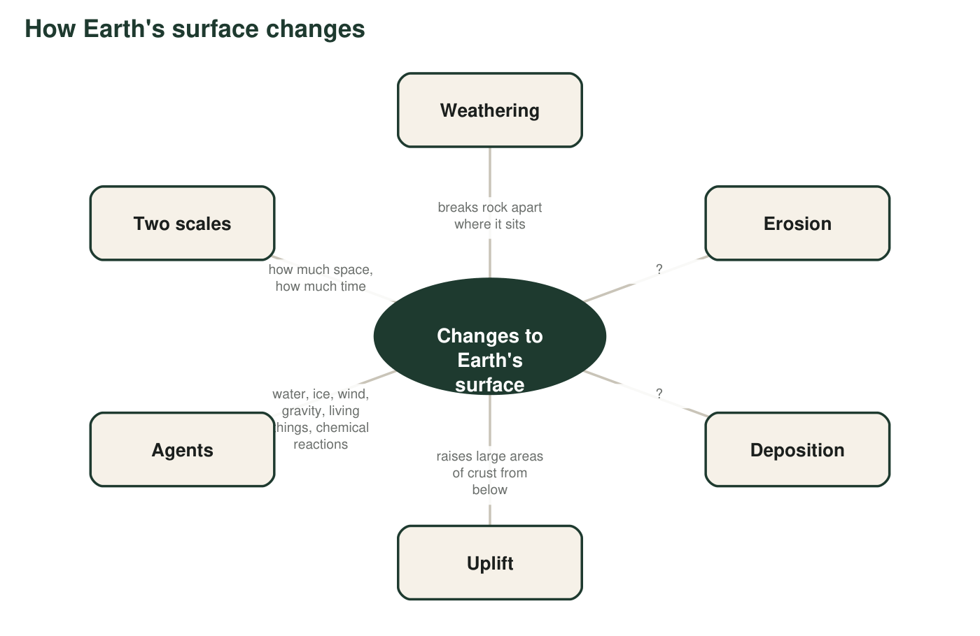
Two definitions are missing from the map. Write them in q3, then add the agents.
3. Write the two missing descriptions for Erosion and Deposition in your own words (not copied from the term box). Each must be short enough to fit in a map bubble.
______________________________________________________________________________________
______________________________________________________________________________________
______________________________________________________________________________________
4. Three of the bubbles (weathering, erosion, deposition) describe what happens to the same piece of rock at different moments. Which bubble is the 'before,' which is the 'during,' and which is the 'after'? Then explain why uplift does not belong in that chain.
______________________________________________________________________________________
______________________________________________________________________________________
______________________________________________________________________________________

Part C: Which term fits?
5. Two students describe valleys. Nadia: 'Water dissolved the rock a little each year, and over 50,000 years the valley got deeper.' Theo: 'The natural dam broke, and in three hours the flood scoured a gorge.' Label each description gradual change or sudden event. Then explain what it means to say that the conditions for Theo's event 'took a long time to build up.'
______________________________________________________________________________________
______________________________________________________________________________________
______________________________________________________________________________________
______________________________________________________________________________________
6. Which sentence uses uniformitarianism correctly? Circle one, then write one sentence explaining what is wrong with one of the other choices.
○ A. Because Earth's processes never change their speed, every canyon took exactly the same number of years to form.
○ B. Because the same processes that act today also acted in the past, we can use rates we measure today to estimate how long past changes took.
○ C. Because Earth's surface never really changes, the landscape we see today is the one that has always existed.
○ D. Because catastrophes never happened in the past, every landform must have formed slowly.
7. Three measurements: a boulder is 2 m across; a desert is 30,000 km² of sand; a grain of sand is 0.5 mm wide. Which ruler, spatial scale or time scale, does each one belong to? Do any of the three tell you anything about time? Then say which ruler this sentence uses, and why: 'The dune took 4,000 years to grow.'
______________________________________________________________________________________
______________________________________________________________________________________
______________________________________________________________________________________

Part D: Two rulers, and a grain's story
8. Every change has a place on both rulers. Give one example for each combination. Do not use the same example twice.
Your example (a real kind of change) | Process or event (use a term from the box)
Small space, short time
Small space, long time
Large space, short time
Large space, long time

9. Write the life story of one grain of sand, from a mountain to a layer of sandstone, as a paragraph of 5-7 sentences. Use at least five terms from the box, and underline each one. Include what has to happen to a buried sand layer before it becomes rock (packing the grains together is only the first half).
______________________________________________________________________________________
______________________________________________________________________________________
______________________________________________________________________________________
______________________________________________________________________________________
______________________________________________________________________________________
______________________________________________________________________________________
______________________________________________________________________________________
______________________________________________________________________________________

Three questions to sort any example
When you are unsure which process a sentence describes, ask in order: (1) Is the rock being broken or dissolved but staying put? That is weathering. (2) Is loose material being carried somewhere? That is erosion. (3) Is carried material settling and piling up? That is deposition. If none of the three fits and a whole region is rising, it is uplift. For the agent, look for the thing that moves or reacts: water, ice, wind, gravity, a living thing or a chemical.

Same words, different speeds
Uplift is usually described as slow, yet during the 1964 Alaska earthquake some coastal ground rose by about 11 meters in a few minutes. Write a short explanation of why that event still counts as uplift, then explain why it does not break uniformitarianism. Finish by proposing one more process from the box that can happen both gradually and suddenly, with an example of each.

