Angela's Tools · Chapter 11: Scales of Change on Earth's Surface · Worksheet 4 of 10

Two Rulers, One Chart, One Hoodoo: Reading Time and Space (Teacher answer key)
Learning target: I can read a time-and-space chart to compare Earth processes, explain why size and speed are separate, and build a labeled model of a hoodoo's life that places its slow stages and its sudden collapse on both rulers.
Diagrams and models · about 40 minutes · individual · Standards: MS-ESS2-2 (practice)

Standards connections
MS-ESS2-2 (practice): The PE asks for explanations of surface change 'at varying time and spatial scales.' Reading and then constructing the two-ruler chart gives students the scale reasoning those explanations depend on, without yet asking for a full evidence-based explanation.

Answers with reasoning
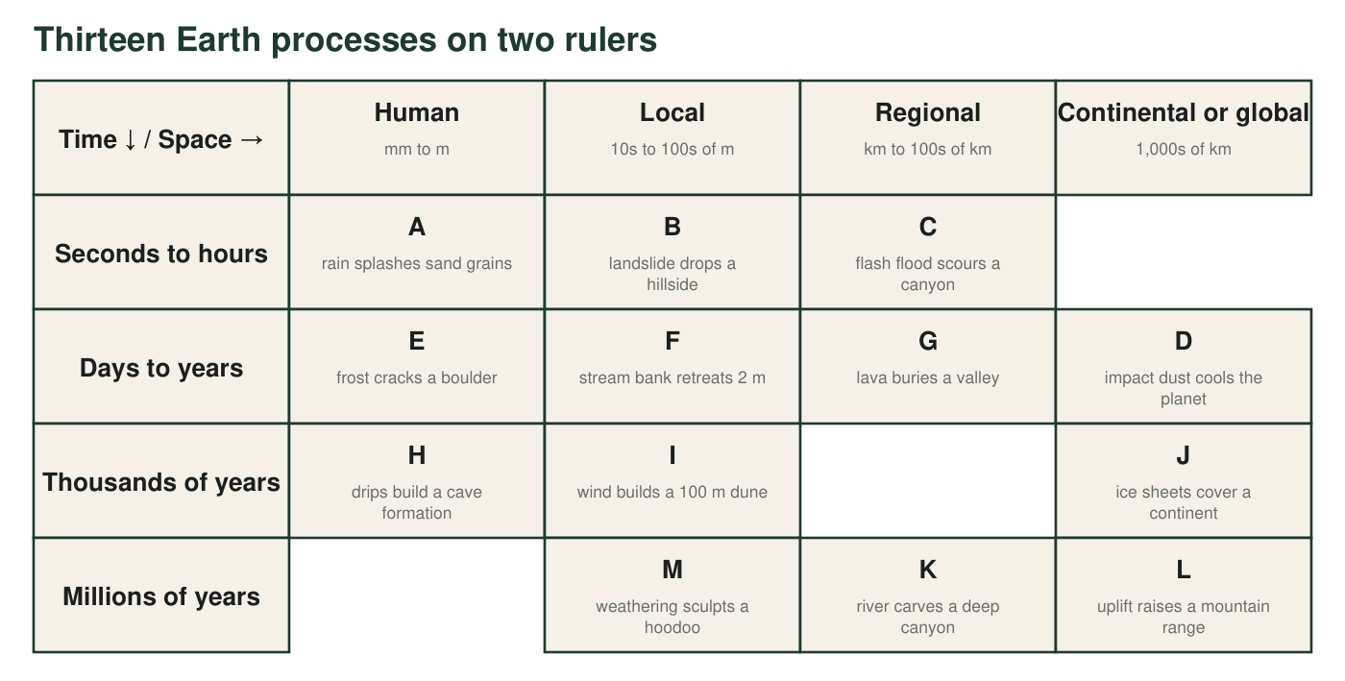
Columns are spatial scale; rows are time scale. Letters are the events in the key. Three cells are empty on purpose.
Event key
Letter | Event | Size | Time
A | Raindrops splash sand grains a few millimeters | mm | seconds
B | A landslide drops a hillside into a valley | hundreds of m | about a minute
C | A flash flood scours 20 km of desert canyon | 20 km | six hours
D | Dust from a large asteroid impact cools the whole planet | global | days to years
E | Water freezing in a crack splits a boulder | 1 m | a few winters
F | A stream bank retreats 2 m during one wet season | tens of m | months
G | Lava flows bury a valley under new rock | 10 km | several weeks
H | Dripping water builds a cave formation 30 cm long | 30 cm | thousands of years
I | Wind builds a dune 100 m tall | 100 m | thousands of years
J | Ice sheets spread over a continent during a glacial period | millions of km² | more than 10,000 years
K | A river carves a canyon 1.5 km deep | hundreds of km long | millions of years
L | Uplift raises a mountain range | thousands of km long | tens of millions of years
M | Weathering and erosion sculpt a hoodoo 20 m tall | 20 m | up to millions of years

Sizes and times are typical values from the lesson and from the kinds of events it describes, rounded for teaching.

Part A: Read the chart
1. List the letters in the 'Seconds to hours' row. What do these events have in common, and what is different about them?
Answer: A, B and C. They all happen within seconds to hours (fast). They differ in spatial scale: A affects millimeters, B hundreds of meters, and C about 20 km.
Reasoning: A row shares a time scale; movement across the row is movement in spatial scale only.
Also acceptable: Accept 'they are all sudden events' for the shared feature, though A is better described as a tiny fast change than a catastrophe.
Full credit must include:
• Lists A, B, C
• Shared feature: fast (seconds to hours)
• Difference: spatial scale
2. Events C and K are in the same column but different rows. What does that tell you about them? Use the words spatial scale and time scale in your answer.
Answer: C and K have about the same spatial scale (both regional, tens to hundreds of kilometers) but very different time scales: the flash flood does its work in hours, while the river takes millions of years to carve its canyon. Same size, very different speed.
Reasoning: Same column, different row means same spatial scale, different time scale.
Also acceptable: A student who adds that the flood may be one of many events in the canyon's long history is making a good connection.
Full credit must include:
• Same spatial scale identified
• Different time scale identified
• Both terms used correctly
3. Compare event D with event H. Which one covers more space? Which one takes more time? Explain what this pair proves about the idea that 'big changes are slow and small changes are fast.'
Answer: D covers more space (the whole planet) and takes less time (days to years). H covers far less space (30 cm) and takes far more time (thousands of years). So the biggest change here is one of the fastest, and one of the smallest is among the slowest. Size and speed are independent; you cannot guess one from the other, which is why the chart needs two rulers.
Reasoning: The pair is chosen to break the size-equals-slowness intuition.
Also acceptable: Accept 'the saying is false' with the correct comparison.
Full credit must include:
• D larger, H longer, both stated correctly
• Concludes that size and speed are separate
4. Three cells are empty. Choose one. Either propose a real kind of event that could fill it, or explain why that combination of size and time is rare or impossible.
Answer: Examples: Global, seconds to hours: a giant earthquake's shaking travels through the whole planet within minutes, but the visible surface change is local, so a truly global surface change in hours is very rare; an asteroid impact's crater forms in seconds but is regional, and only its dust becomes global over days. Human, millions of years: a change that stays tiny for millions of years is rare because over that much time small changes add up or get buried; one real case is a mineral crystal growing extremely slowly inside rock. Regional, thousands of years: a glacier carving a valley tens of kilometers long over tens of thousands of years fits here.
Reasoning: Any thoughtful proposal or explanation is acceptable; the regional-thousands cell has real examples (glacial valleys, large dune fields, deltas), the other two cells are genuinely rare.
Also acceptable: A student who argues the global-fast cell is filled by D's dust spreading is making a defensible point; D is placed in days-to-years because the cooling lasts that long.
Full credit must include:
• Chooses one empty cell
• Proposes a plausible event or gives a sound reason it is rare
5. The rows are not drawn to scale. Suppose you redrew the time ruler so that 1 millimeter stands for 1 hour. One hour would be 1 mm, and one day 24 mm. How long, in kilometers, would the line for one million years be? Use 365 days in a year and show every step.
Answer: Hours in a year: 24 h × 365 = 8,760 h. Hours in a million years: 8,760 × 1,000,000 = 8,760,000,000 h (8.76 × 10⁹ h). At 1 mm per hour: 8,760,000,000 mm = 8,760,000 m = 8,760 km. The line for one million years would be about 8,760 km long, roughly twice the width of the continental United States.
Reasoning: Three multiplications and two unit conversions (÷1,000 mm per m, ÷1,000 m per km). The absurd length is the point: the chart cannot be drawn to scale.
Also acceptable: Accept 8,760 km, 8,800 km or 'about 9,000 km' with the work shown. If a student uses 360 days: 8,640 km.
6. Which statement about the chart's time ruler is correct? Circle one.
Answer: B. Each row is a much bigger jump in time than the row above it, so the chart compresses time to fit the page.
Reasoning: Seconds-to-hours, days-to-years, thousands and millions of years are jumps of roughly a thousand times or more each; q5 shows why a true-scale chart is impossible. C is wrong because size does not cause slowness (see q3); D is wrong because the rows do not count how common processes are.
Also acceptable: None.
7. Event M (the hoodoo) sits in the 'Millions of years' row. But when the hoodoo's pillar becomes too thin, its cap boulder falls in about one second. In which cell would you place the fall of the cap? Explain how one landform can have an event in two different rows.
Answer: The fall of the cap belongs in the Local (10s of m), Seconds-to-hours cell, the same column as M but the top row. One landform can have events in two rows because the slow process (thousands to millions of years of weathering thinning the pillar) sets up the fast one (gravity drops the cap in a second once the pillar can no longer hold it). The sudden event is the last step of the gradual one.
Reasoning: This is the lesson's 'many small, slow changes add up to one sudden change' idea, placed on the chart.
Also acceptable: Accept 'human scale' for the column if the student argues the cap boulder is a few meters across.
Full credit must include:
• Correct cell (local, seconds to hours)
• Explains the slow process as the setup for the fast event

Part B: Model a hoodoo's life on two rulers
Event M on the chart is a hoodoo: a pillar of soft rock, about 20 m tall, wearing a slab of tougher rock as a cap. The chart gives the whole hoodoo one cell, but its life has several stages that belong in different cells. You will draw those stages and place them.
Draw a four-stage model of one hoodoo's life, left to right. Stage 1: flat layers of rock, soft layers below and one tougher layer on top, freshly raised by uplift and split by cracks. Stage 2: rain, frost and wind widening the cracks into gaps; the soft layers losing rock faster than the tough layer. Stage 3: a pillar of soft rock standing under its cap, narrower than it was. Stage 4: the cap lying on the ground beside a stump. Draw the tough layer with a pattern you can follow from stage to stage. Under each stage write the process at work (weathering, erosion or deposition) and its agent. On each arrow between stages write a time estimate (seconds, years, thousands of years or millions of years) and mark the arrow S for slow or X for sudden.
Expected drawing: Four panels in order. Stage 1: horizontal layers, a tougher layer on top (patterned), vertical cracks; process: uplift (forces inside Earth) followed by weathering as the cracks open. Stage 2: cracks widened into gaps, soft layers cut back farther than the tough layer; process: weathering (frost and rain) with erosion by water and gravity carrying the loose rock off. Stage 3: a narrow pillar of soft rock under the patterned cap; process: continued weathering and erosion thinning the pillar. Stage 4: the cap on the ground beside a stump, broken rock around it; process: erosion by gravity (the fall), then weathering and erosion of the debris. Arrows: 1 to 2, thousands of years, S (some students will write millions; accept); 2 to 3, thousands of years, S; 3 to 4, seconds, X. The cap must be drawn with the same pattern in every stage.
Reasoning: The model is correct if it shows the tough layer surviving as the cap while the soft rock around it is removed, the pillar narrowing over long times, and the fall as the only sudden arrow. The process labels should distinguish breaking (weathering) from carrying away (erosion).
8. Which arrow in your model is the sudden one (X)? Name the slow stage that made it possible, and explain why the storm or frosty night on the day the cap fell is only the trigger, not the real cause.
Answer: The sudden arrow is stage 3 to stage 4, the cap falling. It was made possible by stage 2 to 3, the thousands of years in which weathering and erosion narrowed the pillar until it could barely hold the cap. The storm or frost on the final day only added the last push; the same storm a thousand years earlier, when the pillar was thick, would have done nothing. The cause is the long thinning; the weather that day is the trigger.
Reasoning: This is the chapter's slow-build-up, sudden-release pattern applied to the model the student just drew.
Also acceptable: Accept 'gravity finally won' as the trigger if the thinning is named as the cause.
Full credit must include:
• Identifies the 3-to-4 arrow as sudden
• Names the slow thinning as what made it possible
• Separates trigger (that day's weather) from cause (the thinning)
9. Stages 2 and 3 look the same from one year to the next. Use a rate to explain why. Suppose the pillar loses 0.2 mm of rock from each side every year. How many years does it take to make a 3 m wide pillar 1 m narrower? Show the calculation, then name the row of the chart where that thinning belongs.
Answer: Rock lost from both sides: 0.2 mm + 0.2 mm = 0.4 mm narrower per year. 1 m = 1,000 mm. 1,000 mm ÷ 0.4 mm per year = 2,500 years. A change of 0.4 mm a year is far too small to see from one year to the next, so stages 2 and 3 look identical in any photograph, yet the pillar is 1 m narrower after about 2,500 years. That thinning belongs in the Thousands of years row.
Reasoning: Two steps: double the per-side loss, then divide the distance by the rate after converting meters to millimeters. The point of the question is that an invisible yearly rate produces a visible change on the chart's thousands-of-years row.
Also acceptable: A student who forgets to double gets 5,000 years; give partial credit if the unit conversion is right and the row is still Thousands of years. Accept 2,500 years written as 'about 2,500' or '2.5 thousand'.
10. Explain why a scientist needs both rulers to describe a change. Use the two events in your model that are the same size on the space ruler (the thinning of the pillar and the fall of the cap, both a few meters) but sit in different rows.
Answer: Size alone does not say how long a change took, and time alone does not say how much was changed. The pillar thinning and the cap falling are both changes of a few meters, so on the space ruler they sit in the same column (Local or Human). On the time ruler they could not be farther apart: the thinning takes thousands of years and the fall takes seconds. A scientist who reported only the size would have no way to tell a gradual process from a sudden event, and a scientist who reported only the time would not know whether the fall moved a pebble or a boulder.
Reasoning: The answer must give a reason for two rulers and use the same-size, different-time pair from the model.
Also acceptable: A student who instead pairs the cap fall with event A (same row, different size) has made the mirror-image argument; accept with the same criteria.
Full credit must include:
• States that size and time are independent pieces of information
• Uses the thinning and the fall as a same-size, different-time pair
• Says what would be lost with only one ruler

Teacher notes
Placements follow the lesson's Key Science Concept spread (landslide: minutes; asteroid cooling: global, days to years; glacial period: continental, more than 10,000 years; Grand Canyon-type canyon: millions of years; cave formations: thousands of years) with added events at the sizes and times the lesson describes. Hoodoos are listed in the Millions row because the lesson says they can take millions of years; the lesson elsewhere says thousands to millions, so a student placing M in the Thousands row with that reason is correct. The three empty cells are deliberate discussion points. Part B is the chapter's hoodoo model (it pairs with presentation slide 20 and can be built from stacked foam or clay instead of drawn); its answer key uses Bryce Canyon's recipe, where frost wedging during roughly two hundred freeze-thaw cycles a year and weakly acidic rain do most of the work, but any site-neutral version with a tougher cap and a softer pillar is correct. For the extension: the textbook's chart places stromatolite fossils at billions of years, which is their age, not their formation time; stromatolites are built by cyanobacteria (microbial mats trapping sediment), not true algae. The q5 answer (8,760 km) is a strong moment to say aloud that no chart of Earth time can be drawn to scale on paper.

