Angela's Tools · Chapter 11: Scales of Change on Earth's Surface · Worksheet 4 of 10

Two Rulers, One Chart, One Hoodoo: Reading Time and Space
Learning target: I can read a time-and-space chart to compare Earth processes, explain why size and speed are separate, and build a labeled model of a hoodoo's life that places its slow stages and its sudden collapse on both rulers.
Diagrams and models · about 40 minutes · individual · Standards: MS-ESS2-2 (practice)
Name: ____________________________ Date: ____________ Period: ______

Directions
Study the chart and the event key. Each column is a spatial scale (how much space a change covers) and each row is a time scale (how long it takes). The letters are events; the key below the chart describes each one. Warning: the rows are not drawn to scale. Each row is a far bigger jump in time than the one above it. Answer Part A by reading the chart. In Part B you will draw a model of one hoodoo's whole life and place its stages on the same two rulers.
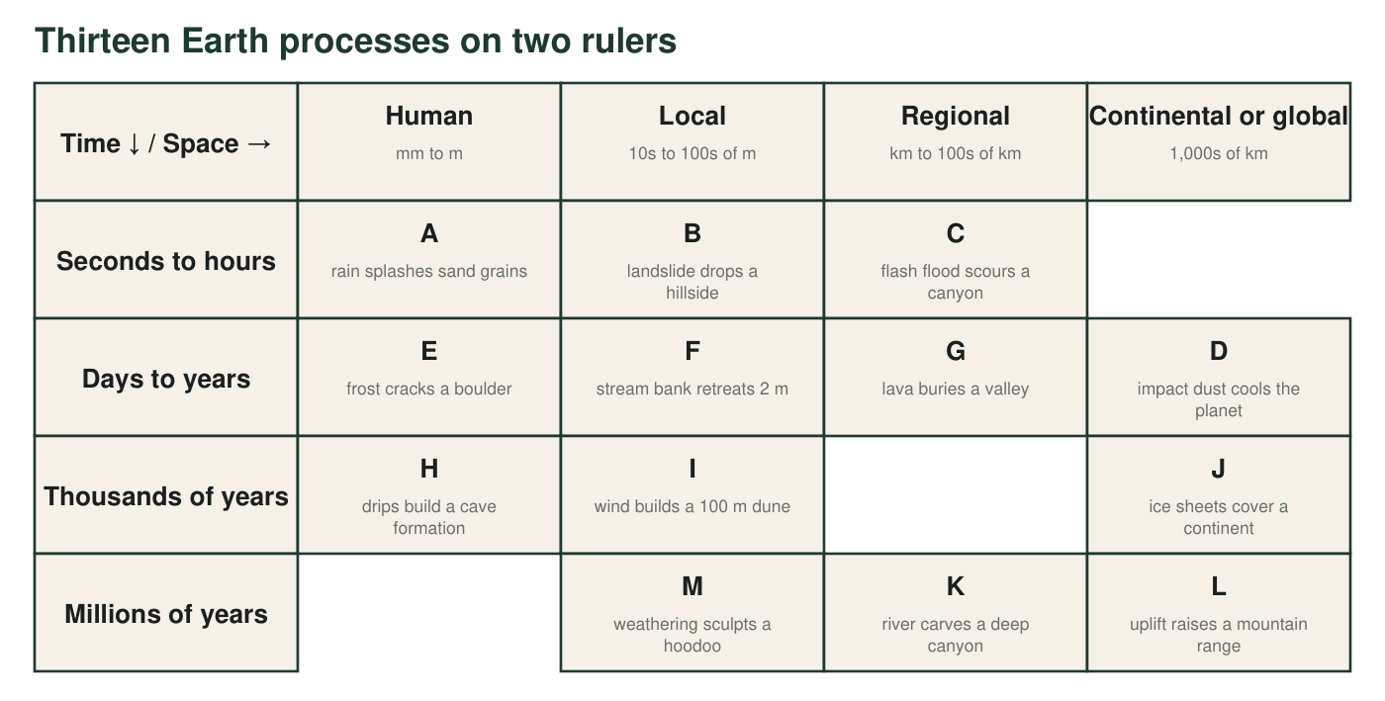
Columns are spatial scale; rows are time scale. Letters are the events in the key. Three cells are empty on purpose.
Event key
Letter | Event | Size | Time
A | Raindrops splash sand grains a few millimeters | mm | seconds
B | A landslide drops a hillside into a valley | hundreds of m | about a minute
C | A flash flood scours 20 km of desert canyon | 20 km | six hours
D | Dust from a large asteroid impact cools the whole planet | global | days to years
E | Water freezing in a crack splits a boulder | 1 m | a few winters
F | A stream bank retreats 2 m during one wet season | tens of m | months
G | Lava flows bury a valley under new rock | 10 km | several weeks
H | Dripping water builds a cave formation 30 cm long | 30 cm | thousands of years
I | Wind builds a dune 100 m tall | 100 m | thousands of years
J | Ice sheets spread over a continent during a glacial period | millions of km² | more than 10,000 years
K | A river carves a canyon 1.5 km deep | hundreds of km long | millions of years
L | Uplift raises a mountain range | thousands of km long | tens of millions of years
M | Weathering and erosion sculpt a hoodoo 20 m tall | 20 m | up to millions of years

Sizes and times are typical values from the lesson and from the kinds of events it describes, rounded for teaching.

Part A: Read the chart
1. List the letters in the 'Seconds to hours' row. What do these events have in common, and what is different about them?
______________________________________________________________________________________
______________________________________________________________________________________
______________________________________________________________________________________
2. Events C and K are in the same column but different rows. What does that tell you about them? Use the words spatial scale and time scale in your answer.
______________________________________________________________________________________
______________________________________________________________________________________
______________________________________________________________________________________
3. Compare event D with event H. Which one covers more space? Which one takes more time? Explain what this pair proves about the idea that 'big changes are slow and small changes are fast.'
______________________________________________________________________________________
______________________________________________________________________________________
______________________________________________________________________________________
______________________________________________________________________________________
4. Three cells are empty. Choose one. Either propose a real kind of event that could fill it, or explain why that combination of size and time is rare or impossible.
______________________________________________________________________________________
______________________________________________________________________________________
______________________________________________________________________________________
5. The rows are not drawn to scale. Suppose you redrew the time ruler so that 1 millimeter stands for 1 hour. One hour would be 1 mm, and one day 24 mm. How long, in kilometers, would the line for one million years be? Use 365 days in a year and show every step.
______________________________________________________________________________________
______________________________________________________________________________________
______________________________________________________________________________________
______________________________________________________________________________________
6. Which statement about the chart's time ruler is correct? Circle one.
○ A. Each row represents the same amount of time as the row above it.
○ B. Each row is a much bigger jump in time than the row above it, so the chart compresses time to fit the page.
○ C. Events in the bottom row are slower because they are larger.
○ D. The chart shows that most Earth processes take millions of years.
7. Event M (the hoodoo) sits in the 'Millions of years' row. But when the hoodoo's pillar becomes too thin, its cap boulder falls in about one second. In which cell would you place the fall of the cap? Explain how one landform can have an event in two different rows.
______________________________________________________________________________________
______________________________________________________________________________________
______________________________________________________________________________________
______________________________________________________________________________________

Part B: Model a hoodoo's life on two rulers
Event M on the chart is a hoodoo: a pillar of soft rock, about 20 m tall, wearing a slab of tougher rock as a cap. The chart gives the whole hoodoo one cell, but its life has several stages that belong in different cells. You will draw those stages and place them.
Draw a four-stage model of one hoodoo's life, left to right. Stage 1: flat layers of rock, soft layers below and one tougher layer on top, freshly raised by uplift and split by cracks. Stage 2: rain, frost and wind widening the cracks into gaps; the soft layers losing rock faster than the tough layer. Stage 3: a pillar of soft rock standing under its cap, narrower than it was. Stage 4: the cap lying on the ground beside a stump. Draw the tough layer with a pattern you can follow from stage to stage. Under each stage write the process at work (weathering, erosion or deposition) and its agent. On each arrow between stages write a time estimate (seconds, years, thousands of years or millions of years) and mark the arrow S for slow or X for sudden.

8. Which arrow in your model is the sudden one (X)? Name the slow stage that made it possible, and explain why the storm or frosty night on the day the cap fell is only the trigger, not the real cause.
______________________________________________________________________________________
______________________________________________________________________________________
______________________________________________________________________________________
______________________________________________________________________________________
9. Stages 2 and 3 look the same from one year to the next. Use a rate to explain why. Suppose the pillar loses 0.2 mm of rock from each side every year. How many years does it take to make a 3 m wide pillar 1 m narrower? Show the calculation, then name the row of the chart where that thinning belongs.
______________________________________________________________________________________
______________________________________________________________________________________
______________________________________________________________________________________
______________________________________________________________________________________
10. Explain why a scientist needs both rulers to describe a change. Use the two events in your model that are the same size on the space ruler (the thinning of the pillar and the fall of the cap, both a few meters) but sit in different rows.
______________________________________________________________________________________
______________________________________________________________________________________
______________________________________________________________________________________
______________________________________________________________________________________

Finger on the row, finger on the column
To place an event, ask the size question first: would the change fit in your hand, in a schoolyard, across a city, or across a continent? Put one finger on that column. Then ask the time question: did it happen while you watched, within a year, over many human lifetimes, or over a time no person could ever witness? Slide your other finger to that row. The cell where the fingers meet is the answer. For q5, do one conversion per line: hours in a day, hours in a year, hours in a million years, then millimeters to meters to kilometers. For Part B, draw the tough cap layer with stripes or dots at every stage so a reader can follow the same slab from stage 1 to the ground in stage 4; for q9, remember that rock lost from both sides counts twice toward the narrowing.

Add a fifth row
The chart stops at millions of years, but the lesson mentions changes that took billions of years, such as the slow reshaping of continents since early in Earth's history. Copy the chart's two rulers, add a 'Billions of years' row and place at least one event in it. Then write a paragraph on this problem: the oldest fossils (layered mounds built by microbes about 3.5 billion years ago) are often placed in that row, yet each mound grew in only thousands of years. Explain the difference between how old something is and how long it took to form, and say which one a time-scale chart should show.

