Angela's Tools · Chapter 12: Identifying Chemical Reactions · Worksheet 1 of 10

The Nail That Changed Color: What Happened in the Blue Jar? (Teacher answer key)
Learning target: I can record careful observations of a change, separate what I saw from what I think it means, and write a first explanation that says what evidence would confirm a new substance formed.
Phenomenon exploration · about 25 minutes · individual · Standards: MS-PS1-2 (practice)

Standards connections
MS-PS1-2 (practice): Students observe a change (color, a new coating, a small temperature rise) and are pushed to ask which measured properties, compared before and after, would show whether a new substance formed. This activates the before-and-after reasoning the PE assesses without yet analyzing a dataset.

Answers with reasoning

The demonstration
Ms. Okafor sets three identical glass jars on the front bench. She half-fills Jar 1 and Jar 3 with the same bright blue liquid, a solution of copper sulfate in water, and half-fills Jar 2 with plain water. Into Jar 1 she lowers a clean iron nail. Into Jar 2 she lowers a second clean iron nail from the same box. Into Jar 3 she lowers a thin strip of copper metal. A thermometer in each jar reads 22.0 °C. She asks the class to watch for twenty minutes and to write down anything that changes, and anything that does not.
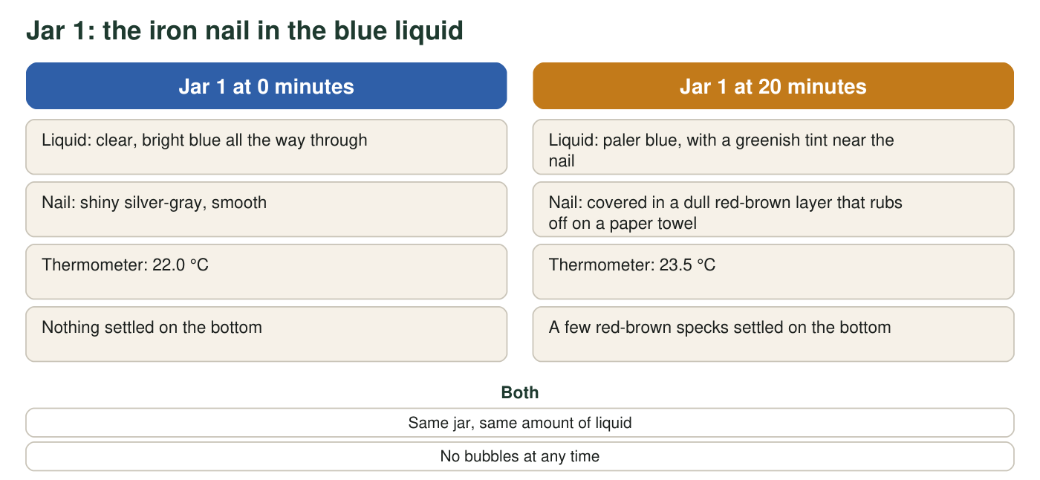
Observations are a realistic teaching set, not measurements from a real trial.
All three jars after 20 minutes (teaching observations)
Simulated teaching dataset (not real measurements).
Jar | Solid placed in it | Liquid | What changed in 20 minutes
1 | Iron nail | Blue copper sulfate solution | Nail turned red-brown; liquid paler and greenish near the nail; 22.0 °C to 23.5 °C; a few red-brown specks on the bottom
2 | Iron nail | Plain water | No change seen; nail still shiny; water clear; 22.0 °C
3 | Copper strip | Blue copper sulfate solution | No change seen; strip still shiny copper-colored; liquid still bright blue; 22.0 °C

After twenty minutes Ms. Okafor lifts the nail from Jar 1, scrapes some of the red-brown layer onto a white dish, and lets the class look at it with a hand lens. The flakes are soft. When she presses one with the back of a spoon, it flattens into a thin shiny sheet instead of crumbling. She drops a few flakes into a cup of water; they sink and do not dissolve.

Part A: Notice and wonder
1. List four things you notice. Use only facts that were seen or measured. At least one must be about a jar that did not change, and at least one must include a number.
Answer: Any four observations, for example: the liquid in Jar 1 went from bright blue to paler blue with a greenish tint near the nail; the nail in Jar 1 became covered in a dull red-brown layer; the thermometer in Jar 1 rose from 22.0 °C to 23.5 °C; red-brown specks settled on the bottom of Jar 1; there were no bubbles; the nail in Jar 2 (plain water) did not change; the copper strip and the liquid in Jar 3 did not change; the flakes flattened into a shiny sheet under a spoon; the flakes sank and did not dissolve.
Reasoning: The purpose is to separate observation from explanation. 'Copper came out of the liquid' is an explanation and should be redirected to Part C. Noticing the two unchanged jars is deliberately required because the no-change cases carry evidence.
Also acceptable: Accept observations taken from the figure, the table or the flake description.
Full credit must include:
• Four observations with no explanations mixed in
• At least one about Jar 2 or Jar 3 not changing
• At least one number (22.0 °C, 23.5 °C or 20 minutes)
2. Write two questions you wonder about. At least one must be a question that could be answered by making another measurement or running another test.
Answer: Any two genuine questions, for example: Is the red-brown layer copper? Would the liquid keep getting paler if the nail stayed longer? Did the nail gain or lose mass? Would a zinc strip or an aluminum strip do the same thing? Why did the temperature rise? Would the layer form faster in warmer liquid? Testable examples include weighing the nail before and after, measuring the density or melting point of the flakes, or repeating with a different metal.
Reasoning: At least one question must be answerable by a measurement or test, not only by asking an expert.
Also acceptable: Accept 'Is it a chemical reaction?' only if paired with a testable question.
Full credit must include:
• Two questions about the phenomenon
• At least one is testable by a measurement or a new trial

Part B: What do you already think?
3. Which statement is closest to what you believe right now about the red-brown layer on the nail in Jar 1? Circle one. (This is a snapshot of your thinking, not a test.)
Answer: No wrong answer for this snapshot. The best-supported choice is B: copper that was dissolved in the liquid came out and built up on the nail, and the liquid lost some of its dissolved copper (which is why it became paler). Record the class distribution to revisit at the end of the chapter.
Reasoning: In the real reaction, iron atoms from the nail go into the solution while copper from the solution forms a metallic coating on the nail. The greenish tint is dissolved iron compound. Option A is a stain idea, C is the rust idea, D denies the change.
Also acceptable: Accept any choice; score only for completion.
4. Look at Jar 2 and at the flakes on the dish. Which observations make the statement "the nail rusted because it got wet" hard to believe?
Answer: Jar 2 had a wet iron nail from the same box for the same 20 minutes and showed no change, so getting wet alone cannot explain the red-brown layer. Also, rust is crumbly, but the flakes flattened into a shiny sheet under a spoon, which is how a soft metal behaves, not how rust behaves.
Reasoning: This is the control-jar logic: same nail, same time, different liquid, different result. The spoon test adds a property argument.
Also acceptable: Accept 'rust takes days, not 20 minutes' as a supporting point if it is paired with the Jar 2 comparison.
Full credit must include:
• Uses Jar 2 as the comparison
• Uses the flattening or shiny-sheet observation, or the 20-minute time
5. Why do you think Ms. Okafor put a copper strip into blue liquid in Jar 3? What does its lack of change tell you?
Answer: Jar 3 tests whether the blue liquid changes anything it touches. Copper in copper sulfate solution did not change and the liquid stayed bright blue, so the liquid does not simply coat or stain every metal. The change in Jar 1 needs something that iron does and copper does not.
Reasoning: Students should see Jar 3 as a second control: it isolates the role of the iron.
Also acceptable: Accept 'to show the blue liquid does not stain metal by itself.'
Full credit must include:
• Says Jar 3 checks the effect of the liquid on a metal that is not iron
• Concludes that the change depends on the iron

Part C: Your first explanation
6. Explain what you think happened in Jar 1. Your explanation must (a) say what you think the red-brown layer is and where it came from, (b) say why the liquid became paler, and (c) name one property you would measure on the flakes to find out whether they are a new substance rather than a stain, and what result would convince you.
Answer: Model response: The red-brown layer is copper metal. The blue liquid contains dissolved copper; when iron touches it, copper comes out of the liquid as a solid on the nail while some iron goes into the liquid, which is why the blue fades and a greenish tint appears near the nail. A stain would not flatten into a shiny sheet, but copper would. To be sure the flakes are copper, I would measure their density: copper's is 8.96 g/cm³, iron's is 7.87 g/cm³ and rust's is about 5.2 g/cm³, so a value near 9 g/cm³ would convince me; a melting point near 1085 °C would also fit copper.
Reasoning: This is the activation sheet, so any coherent explanation that addresses (a), (b) and (c) earns full credit, even if the chemistry is partly wrong. The key skill is naming a measurable property (density, melting point, solubility, flammability, odor) and a result that would decide the question.
Also acceptable: A student who thinks the layer is rust but proposes a density or melting-point test with a stated expected result still meets the structure; note the misconception for the W7 lesson.
Full credit must include:
• States what the layer is and where it came from
• Explains the paler liquid
• Names a measurable property and the result that would show a new substance
7. Predict: if the nail were left in Jar 1 for a whole day, what would the nail, the liquid and the bottom of the jar look like? Give one reason for your prediction.
Answer: Likely prediction: a thicker red-brown layer on the nail, more specks on the bottom, and a liquid that is much paler blue or greenish because more copper has left the liquid and more iron has entered it. Reason: at 20 minutes neither the iron nail nor the blue color had run out, so the change should continue as long as both the nail and the dissolved copper remain.
Reasoning: Any prediction consistent with the 20-minute trend earns credit; the reason must connect to an observation.
Also acceptable: A student who predicts the change stops when the copper in the liquid runs out is thinking ahead to the 'reactant used up' idea; credit it.
Full credit must include:
• Prediction for nail, liquid and bottom
• A reason tied to the observed trend
8. A classmate says, "The liquid changed color, so that proves a chemical reaction happened." Is a color change by itself proof? What kind of measurement would make the case stronger?
Answer: No. A color change is evidence that something may have changed, but colors can change without a new substance forming (for example, diluting a dye makes it paler). A stronger case compares a characteristic property measured before and after, such as the density, melting point or solubility of the solid, and shows that the 'after' value is different from the 'before' value.
Reasoning: This is the chapter's central idea: clues suggest, property comparisons confirm.
Also acceptable: Accept 'repeat it and test the flakes' if a property is named.
Full credit must include:
• Says a color change alone is not proof
• Names a measured property comparison before and after

Teacher notes
The phenomenon is the reaction of iron with copper sulfate solution: copper metal deposits on the nail and iron goes into solution, giving the paler, greenish liquid and a small temperature rise. The observations are a realistic teaching set labeled simulated. If you demonstrate it, use about 0.5 M copper(II) sulfate, wear goggles, keep students from handling the solution, and follow district disposal rules; a 20-minute soak gives a visible coating. Do not confirm the answer at this stage; collect the q3 distribution and return to it after W6 or W10. The spoon test and the no-change jars are there to seed the ideas that evidence comes from comparisons and that soft metals flatten while rust crumbles.

