Angela's Tools · Chapter 12: Identifying Chemical Reactions · Worksheet 1 of 10

The Nail That Changed Color: What Happened in the Blue Jar?
Learning target: I can record careful observations of a change, separate what I saw from what I think it means, and write a first explanation that says what evidence would confirm a new substance formed.
Phenomenon exploration · about 25 minutes · individual · Standards: MS-PS1-2 (practice)
Name: ____________________________ Date: ____________ Period: ______

Directions
Read the description of the three jars and study the figure and the table. In Part A, write only what was seen or measured, not what it means. In Part B, take a snapshot of your current thinking; there is no penalty for a wrong choice. In Part C, write your first explanation. You will come back to this sheet at the end of the chapter and see how your explanation has changed.

The demonstration
Ms. Okafor sets three identical glass jars on the front bench. She half-fills Jar 1 and Jar 3 with the same bright blue liquid, a solution of copper sulfate in water, and half-fills Jar 2 with plain water. Into Jar 1 she lowers a clean iron nail. Into Jar 2 she lowers a second clean iron nail from the same box. Into Jar 3 she lowers a thin strip of copper metal. A thermometer in each jar reads 22.0 °C. She asks the class to watch for twenty minutes and to write down anything that changes, and anything that does not.
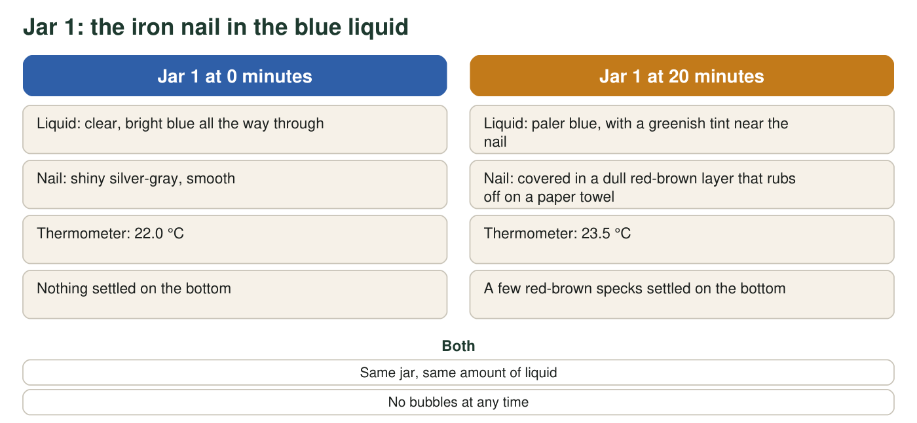
Observations are a realistic teaching set, not measurements from a real trial.
All three jars after 20 minutes (teaching observations)
Simulated teaching dataset (not real measurements).
Jar | Solid placed in it | Liquid | What changed in 20 minutes
1 | Iron nail | Blue copper sulfate solution | Nail turned red-brown; liquid paler and greenish near the nail; 22.0 °C to 23.5 °C; a few red-brown specks on the bottom
2 | Iron nail | Plain water | No change seen; nail still shiny; water clear; 22.0 °C
3 | Copper strip | Blue copper sulfate solution | No change seen; strip still shiny copper-colored; liquid still bright blue; 22.0 °C

After twenty minutes Ms. Okafor lifts the nail from Jar 1, scrapes some of the red-brown layer onto a white dish, and lets the class look at it with a hand lens. The flakes are soft. When she presses one with the back of a spoon, it flattens into a thin shiny sheet instead of crumbling. She drops a few flakes into a cup of water; they sink and do not dissolve.

Part A: Notice and wonder
1. List four things you notice. Use only facts that were seen or measured. At least one must be about a jar that did not change, and at least one must include a number.
______________________________________________________________________________________
______________________________________________________________________________________
______________________________________________________________________________________
______________________________________________________________________________________
______________________________________________________________________________________
______________________________________________________________________________________
2. Write two questions you wonder about. At least one must be a question that could be answered by making another measurement or running another test.
______________________________________________________________________________________
______________________________________________________________________________________
______________________________________________________________________________________
______________________________________________________________________________________
______________________________________________________________________________________

Part B: What do you already think?
3. Which statement is closest to what you believe right now about the red-brown layer on the nail in Jar 1? Circle one. (This is a snapshot of your thinking, not a test.)
○ A. The blue color in the liquid soaked into the nail and stained its surface.
○ B. Copper that was dissolved in the liquid came out of the liquid and built up on the nail, so the liquid lost some of its copper.
○ C. The nail rusted because it got wet.
○ D. Nothing really happened to the nail; the blue liquid just makes it look a different color.
4. Look at Jar 2 and at the flakes on the dish. Which observations make the statement "the nail rusted because it got wet" hard to believe?
______________________________________________________________________________________
______________________________________________________________________________________
______________________________________________________________________________________
5. Why do you think Ms. Okafor put a copper strip into blue liquid in Jar 3? What does its lack of change tell you?
______________________________________________________________________________________
______________________________________________________________________________________
______________________________________________________________________________________

Part C: Your first explanation
6. Explain what you think happened in Jar 1. Your explanation must (a) say what you think the red-brown layer is and where it came from, (b) say why the liquid became paler, and (c) name one property you would measure on the flakes to find out whether they are a new substance rather than a stain, and what result would convince you.
______________________________________________________________________________________
______________________________________________________________________________________
______________________________________________________________________________________
______________________________________________________________________________________
______________________________________________________________________________________
______________________________________________________________________________________
______________________________________________________________________________________
______________________________________________________________________________________
7. Predict: if the nail were left in Jar 1 for a whole day, what would the nail, the liquid and the bottom of the jar look like? Give one reason for your prediction.
______________________________________________________________________________________
______________________________________________________________________________________
______________________________________________________________________________________
8. A classmate says, "The liquid changed color, so that proves a chemical reaction happened." Is a color change by itself proof? What kind of measurement would make the case stronger?
______________________________________________________________________________________
______________________________________________________________________________________
______________________________________________________________________________________

Observation starters
An observation names what a sense or a tool reported. Try these frames for Part A: "At 0 minutes the ___ was ___; at 20 minutes it was ___." "The thermometer in Jar ___ read ___." "In Jar ___ nothing changed: the ___ still looked ___." If your sentence contains the words because, so or must be, it is probably an explanation; save it for Part C.

Design the deciding test
Reference values: copper has a density of 8.96 g/cm³ and melts at 1085 °C; iron has a density of 7.87 g/cm³ and melts at 1538 °C; rust (iron oxide) has a density of about 5.2 g/cm³ and is a crumbly powder that does not flatten into a sheet. Using these numbers, design a two-step test a student could run on a pile of the red-brown flakes to decide among the four choices in q3. Say which result would support each choice and which choice the spoon test in the description already weakens.

