Angela's Tools · Chapter 12: Identifying Chemical Reactions · Worksheet 2 of 10

Reactant, Product, Evidence: Sorting the Words of a Reaction (Teacher answer key)
Learning target: I can use the terms reactant, product, physical change, physical property, chemical property, precipitate, observation and conclusion correctly and explain how they connect to one another.
Vocabulary in action · about 30 minutes · individual · Standards: MS-PS1-2 (supports)

Standards connections
MS-PS1-2 (supports): The PE asks students to analyze property data before and after substances interact. This sheet builds the vocabulary that makes such an analysis possible: naming the substances before and after, telling an observation from a conclusion, and sorting physical from chemical properties.

Answers with reasoning
chemical reaction: A change in which one or more substances turn into one or more different substances. The atoms are regrouped; none are created or destroyed.
reactant: A substance that is present before a reaction and is used up or changed by it.
product: A substance that did not exist before the reaction and is made by it.
physical change: A change in the form, state or mixing of a substance that leaves it the same substance: melting, boiling, dissolving, cutting, bending.
physical property: A trait you can observe or measure without turning the substance into something else, such as color, density, melting point or solubility.
chemical property: A trait that describes whether and how a substance can change into new substances, such as whether it burns or whether it fizzes with an acid. You find it by trying the change.
solubility: How much of a substance can dissolve in a given amount of a liquid at a stated temperature, for example grams per 100 mL of water at 20 °C.
melting point: The temperature at which a solid becomes a liquid. A pure substance melts within a degree or two of one temperature.
precipitate: A solid that appears inside a liquid mixture, often because a reaction made a substance that barely dissolves.
scientific evidence: Observations and measurements that back up or challenge a claim.
observation: Something you notice with a sense or read from a tool: a color, a smell, a thermometer reading.
conclusion: An idea that explains observations, such as the claim that a new substance formed. It must be backed by evidence.

Part A: Observation or conclusion?
1. Label each statement an observation or a conclusion. For each conclusion, write one observation that would support it.
Answer: 1 observation. 2 conclusion (supported by, for example, a solid with a different melting point or solubility than the starting substances). 3 observation. 4 conclusion (supported by the gas putting out a flame and a limewater test turning cloudy). 5 observation. 6 observation. 7 conclusion (supported by the measured melting points before and after: 159 °C and 135 °C). 8 conclusion (supported by the fizz stopping while vinegar is still present, and by no powder being left in the glass).
Reasoning: Observations are 1, 3, 5, 6 (a camera or thermometer could record each). Conclusions are 2, 4, 7, 8 (each explains observations). Statement 7 contains both: 'it melts 24 °C lower' is an observation, 'is a different substance' is the conclusion; a student who notes this is reading carefully.
Also acceptable: Accept 7 labeled 'both' with the two parts identified.
Full credit must include:
• All eight sorted correctly
• Each conclusion paired with a supporting observation

Part B: Complete the concept map
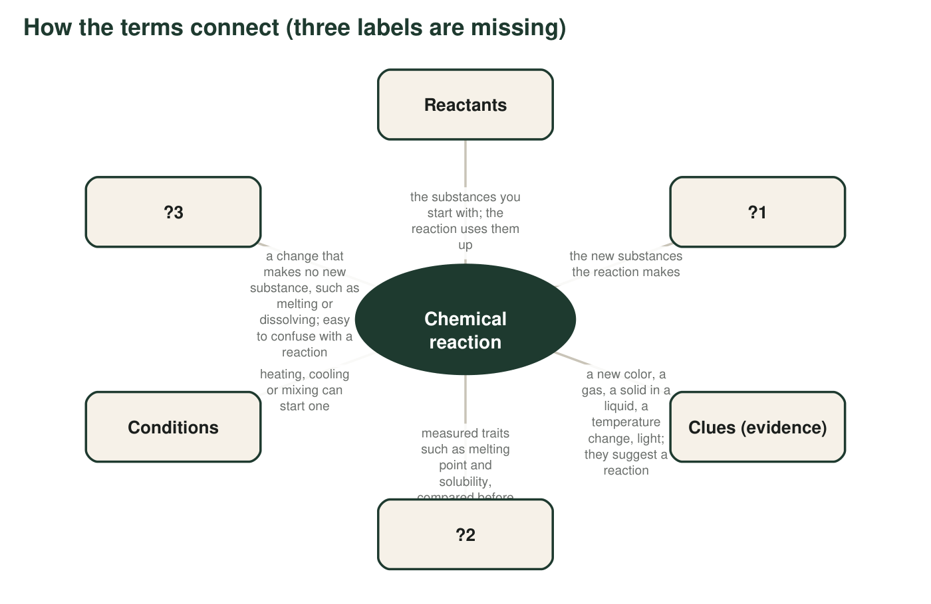
Each box connects to the center. Three box labels have been replaced by ?1, ?2 and ?3.
2. Fill in the missing labels from the term box: ?1 = ____________ ?2 = ____________ ?3 = ____________
Answer: ?1 = products. ?2 = physical properties (accept 'properties' or 'characteristic properties'). ?3 = physical change.
Reasoning: The descriptions match the term-box definitions: new substances made by the reaction; measured traits compared before and after; a change with no new substance.
Also acceptable: Accept 'melting point and solubility' written out for ?2 if the student also names them as properties.
3. The map says clues suggest a reaction but measured properties confirm one. Explain the difference using one clue that can appear even when no new substance forms.
Answer: A clue is something that often happens during a reaction but can also happen without one. Bubbles appear when water boils or when a soda is opened, yet no new substance forms; a temperature change happens when ice-melt pellets dissolve. So a clue tells you to look closer. A measured property, such as a melting point or solubility, belongs to a specific substance; if the 'after' value differs from the 'before' value, a different substance is present, which confirms the reaction.
Reasoning: Full credit needs one clue that can occur without a reaction and the idea that properties identify substances.
Also acceptable: Accept 'clues can be caused by physical changes; properties belong to substances.'
Full credit must include:
• Names a clue that occurs without a reaction (bubbles from boiling or a soda, warmth from dissolving, color from dilution)
• Explains that a changed characteristic property identifies a new substance

Part C: Physical property or chemical property?
4. Sort each trait. The test: if you can observe or measure it while the substance stays the same substance, it is physical; if you can only find it by trying to change the substance into something else, it is chemical.
Answer: a physical (melting leaves the same substance, now liquid). b chemical (you only find out by letting it react with vinegar, which makes new substances). c physical (dissolving leaves the same substance spread through the water). d chemical (burning turns it into a new substance). e physical (mass and volume are measured without change). f physical (smelling does not change the substance). g chemical (it describes whether a reaction happens, found by trying it). h chemical (rusting makes a new substance).
Reasoning: The deciding question is whether finding the trait requires changing the substance into something else. Odor is treated as a physical property because smelling a sample leaves it unchanged; it is one of the six properties in the assessment boundary of MS-PS1-2.
Also acceptable: Accept g labeled chemical with the reason 'it is about not reacting, which is still about reacting.'
Full credit must include:
• All eight sorted correctly
• Reasons use the 'does the substance stay the same?' test

Part D: Which term fits?
A student pours hydrogen peroxide into a cup and adds a pinch of yeast. Foam rises and the cup grows warm. She collects the gas and finds it makes a glowing splint burst into flame; afterward the liquid left in the cup no longer foams when fresh yeast is added.
5. Complete each sentence with a term from the box. (a) The hydrogen peroxide is a ____________. (b) The oxygen gas and the water that form are ____________. (c) The foam and the warmth are ____________ that a reaction may be happening. (d) Whether a gas makes a glowing splint flame up is a ____________ of that gas. (e) If she had only stirred sugar into water, that would be a ____________, not a reaction. (f) Her statement "a new substance formed" is a ____________, and it needs evidence.
Answer: (a) reactant. (b) products. (c) evidence (accept 'clues' or 'observations'). (d) chemical property. (e) physical change. (f) conclusion.
Reasoning: Hydrogen peroxide breaks down into water and oxygen; the yeast speeds the change but is not used up, which is why the liquid stops foaming only when the hydrogen peroxide is gone. Making a glowing splint flame up is how a gas behaves in a reaction, so it is a chemical property.
Also acceptable: For (d) accept 'property' alone with a half mark; the full answer is chemical property.
6. A strip of magnesium burns in air and leaves a white powder. Name the reactants and the product. Which reactant is easy to forget, and why?
Answer: Reactants: magnesium and oxygen (from the air). Product: magnesium oxide, the white powder. Oxygen is easy to forget because it is an invisible gas that was already around the strip; nobody added it on purpose. Leaving it out makes it look as if the powder came from the magnesium alone, which cannot explain why the powder has more mass than the strip did.
Reasoning: Students must name the gas reactant. The mass point is a bonus that previews conservation of mass.
Also acceptable: Accept 'air' for oxygen with a note that the part of air that reacts is oxygen.
Full credit must include:
• Names magnesium and oxygen as reactants
• Names the white powder (magnesium oxide) as the product
• Explains why oxygen is overlooked
7. Two clear solutions are mixed and a yellow solid appears and sinks. Give the term for the yellow solid's role in the reaction, the term for the kind of evidence it is, and the property that must differ between the yellow solid and the substances that were dissolved.
Answer: Role: product. Kind of evidence: a precipitate (a solid forming in a liquid). Property that must differ: solubility; the yellow solid barely dissolves in water while the starting substances dissolved easily. (Color also differs, but solubility is what makes it appear as a solid.)
Reasoning: This applies three terms to the lead iodide scenario without naming the chemicals. The accurate wording is 'barely dissolves,' not 'cannot dissolve.'
Also acceptable: Accept color as a second property but solubility must be named.
Full credit must include:
• product
• precipitate
• solubility
8. The terms physical change and physical property are easy to confuse. Write one sentence about ice or water that uses both terms correctly.
Answer: Example: Melting is a physical change, so the water from a melted ice cube keeps the physical properties of water, such as freezing at 0 °C and having a density of about 1 g/cm³.
Reasoning: Both terms must be used correctly: physical change for the process, physical property for a measurable trait.
Also acceptable: Any accurate sentence using both terms correctly.
Full credit must include:
• Physical change names a process (melting, freezing, boiling)
• Physical property names a measurable trait (melting point, density, color)

Teacher notes
Part A row 7 is intentionally mixed: the number is an observation and the 'different substance' part is a conclusion. Part C row f (odor) sometimes starts an argument; settle it with the rule that smelling leaves the sample unchanged. Part D uses hydrogen peroxide and yeast because the gas test (a glowing splint relights) is a chemical property students can picture. The extension's nitrogen dioxide point is deliberate: the textbook presents cooling as simply 'forming' the colorless gas, but both gases are present and cooling only shifts the balance; both gases are toxic and are never handled in class.

