Angela's Tools · Chapter 12: Identifying Chemical Reactions · Worksheet 2 of 10

Reactant, Product, Evidence: Sorting the Words of a Reaction
Learning target: I can use the terms reactant, product, physical change, physical property, chemical property, precipitate, observation and conclusion correctly and explain how they connect to one another.
Vocabulary in action · about 30 minutes · individual · Standards: MS-PS1-2 (supports)
Name: ____________________________ Date: ____________ Period: ______

Directions
Read the term box first; every definition is in plain words. Then work through Parts A to D in order. This is not a matching sheet: each part asks you to decide how terms relate to one another or to apply a term to a situation you have not seen before. Write complete sentences where a line is given.
chemical reaction: A change in which one or more substances turn into one or more different substances. The atoms are regrouped; none are created or destroyed.
reactant: A substance that is present before a reaction and is used up or changed by it.
product: A substance that did not exist before the reaction and is made by it.
physical change: A change in the form, state or mixing of a substance that leaves it the same substance: melting, boiling, dissolving, cutting, bending.
physical property: A trait you can observe or measure without turning the substance into something else, such as color, density, melting point or solubility.
chemical property: A trait that describes whether and how a substance can change into new substances, such as whether it burns or whether it fizzes with an acid. You find it by trying the change.
solubility: How much of a substance can dissolve in a given amount of a liquid at a stated temperature, for example grams per 100 mL of water at 20 °C.
melting point: The temperature at which a solid becomes a liquid. A pure substance melts within a degree or two of one temperature.
precipitate: A solid that appears inside a liquid mixture, often because a reaction made a substance that barely dissolves.
scientific evidence: Observations and measurements that back up or challenge a claim.
observation: Something you notice with a sense or read from a tool: a color, a smell, a thermometer reading.
conclusion: An idea that explains observations, such as the claim that a new substance formed. It must be backed by evidence.

Part A: Observation or conclusion?
1. Label each statement an observation or a conclusion. For each conclusion, write one observation that would support it.
Observation or conclusion? | If it is a conclusion, what observation would support it?
1. The liquid turned from bright blue to pale green.
2. A new substance formed.
3. The thermometer read 23.5 °C after 20 minutes.
4. The bubbles are carbon dioxide.
5. The gas put out the burning splint.
6. A yellow solid settled at the bottom of the beaker.
7. The white powder is a different substance because it melts 24 °C lower.
8. The fizzing stopped because the baking soda was used up.

Part B: Complete the concept map
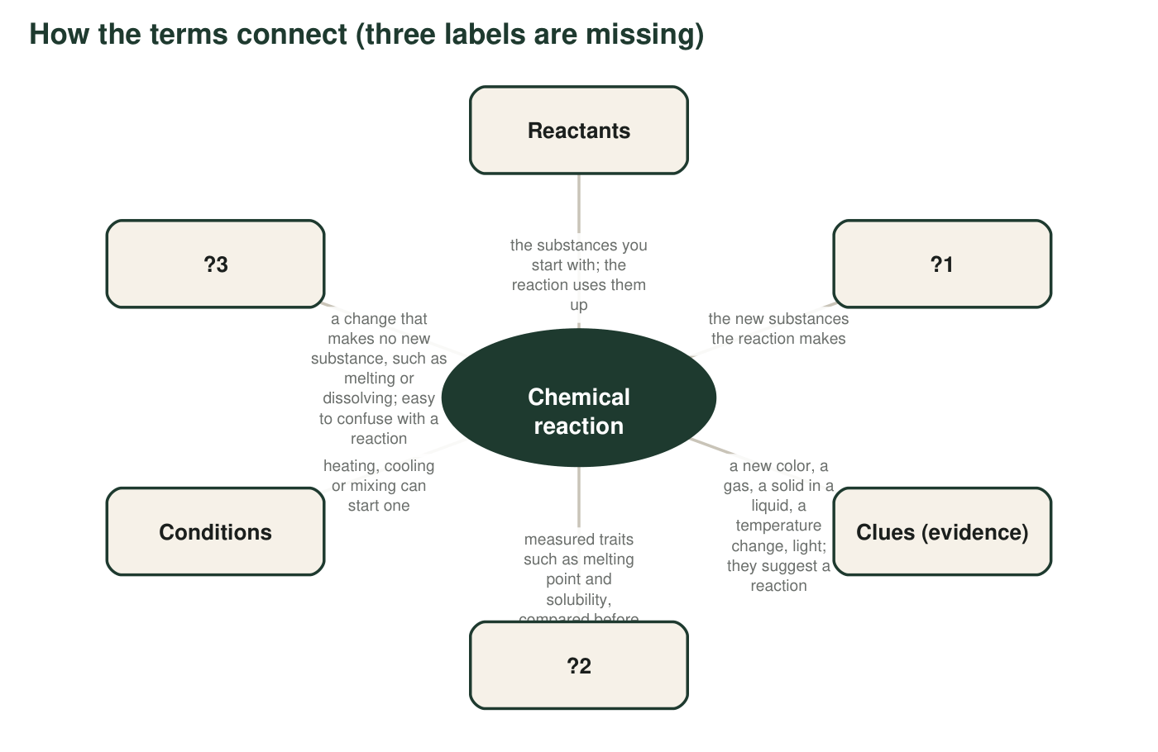
Each box connects to the center. Three box labels have been replaced by ?1, ?2 and ?3.
2. Fill in the missing labels from the term box: ?1 = ____________ ?2 = ____________ ?3 = ____________
______________________________________________________________________________________
______________________________________________________________________________________
______________________________________________________________________________________
3. The map says clues suggest a reaction but measured properties confirm one. Explain the difference using one clue that can appear even when no new substance forms.
______________________________________________________________________________________
______________________________________________________________________________________
______________________________________________________________________________________

Part C: Physical property or chemical property?
4. Sort each trait. The test: if you can observe or measure it while the substance stays the same substance, it is physical; if you can only find it by trying to change the substance into something else, it is chemical.
Physical or chemical? | Why (can you find it without changing the substance?)
a. Melts at 801 °C
b. Fizzes when it meets vinegar
c. Dissolves 36 g per 100 mL of water at 20 °C
d. Burns in air with a bright white light
e. Density of 7.14 g/cm³
f. Has a sharp, sour odor
g. Does not react with water
h. Turns to rust in damp air

Part D: Which term fits?
A student pours hydrogen peroxide into a cup and adds a pinch of yeast. Foam rises and the cup grows warm. She collects the gas and finds it makes a glowing splint burst into flame; afterward the liquid left in the cup no longer foams when fresh yeast is added.
5. Complete each sentence with a term from the box. (a) The hydrogen peroxide is a ____________. (b) The oxygen gas and the water that form are ____________. (c) The foam and the warmth are ____________ that a reaction may be happening. (d) Whether a gas makes a glowing splint flame up is a ____________ of that gas. (e) If she had only stirred sugar into water, that would be a ____________, not a reaction. (f) Her statement "a new substance formed" is a ____________, and it needs evidence.
______________________________________________________________________________________
______________________________________________________________________________________
______________________________________________________________________________________
6. A strip of magnesium burns in air and leaves a white powder. Name the reactants and the product. Which reactant is easy to forget, and why?
______________________________________________________________________________________
______________________________________________________________________________________
______________________________________________________________________________________
7. Two clear solutions are mixed and a yellow solid appears and sinks. Give the term for the yellow solid's role in the reaction, the term for the kind of evidence it is, and the property that must differ between the yellow solid and the substances that were dissolved.
______________________________________________________________________________________
______________________________________________________________________________________
______________________________________________________________________________________
8. The terms physical change and physical property are easy to confuse. Write one sentence about ice or water that uses both terms correctly.
______________________________________________________________________________________
______________________________________________________________________________________
______________________________________________________________________________________

Two quick tests
Observation or conclusion? Ask: could a camera or a thermometer have recorded it? If yes, it is an observation. If it needs a mind to explain what was recorded, it is a conclusion. Physical or chemical property? Ask: after I find it out, do I still have the same substance? Measuring a melting point leaves you with the same substance (now melted); finding out whether something burns leaves you with something new.

Add the conditions branch
Redraw the concept map on a separate page and expand the Conditions box into three branches: heating, cooling and mixing. Give each branch one example from this chapter and one example from your own life. For the cooling branch, explain in two sentences why a sealed tube of brown nitrogen dioxide gas grows paler in ice water but never becomes perfectly colorless: both the brown gas and the colorless gas it forms are present in the tube, and cooling only shifts the balance toward the colorless one.

