Angela's Tools · Chapter 12: Identifying Chemical Reactions · Worksheet 4 of 10

Reading the Reaction Map: From Clue to Confirmation (Teacher answer key)
Learning target: I can interpret a diagram that shows how scientists move from a clue to a confirmed reaction, and I can build my own before-and-after model of a reaction that labels reactants, products, the clue and the confirming property test.
Diagrams and models · about 40 minutes · individual · Standards: MS-PS1-2 (practice), MS-PS1-5 (supports)

Standards connections
MS-PS1-2 (practice): Students read a before-and-after property comparison for vinegar and baking soda and then construct one for burning magnesium, using density and melting point. This builds the comparison habit the PE assesses but uses supplied reference values rather than data the student analyzes.
MS-PS1-5 (supports): The comparison figure's shared box notes that the same atoms are present before and after and that mass is conserved when the gas is trapped. This previews the conservation idea without asking students to count atoms.

Answers with reasoning
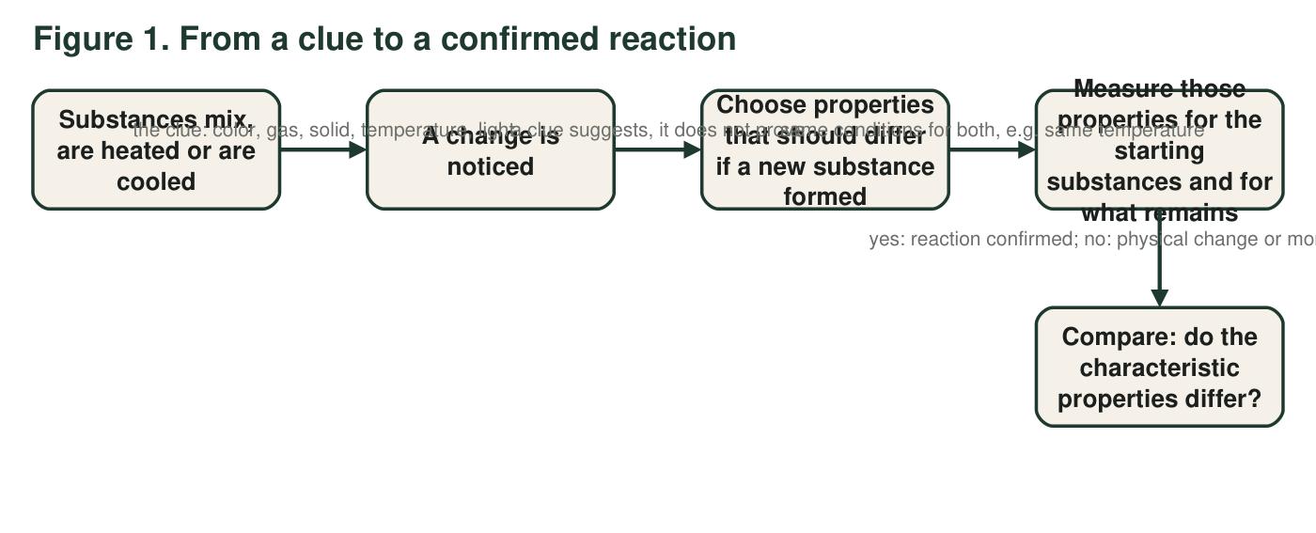
Each arrow label tells you what the step means. The last label gives the two possible conclusions.
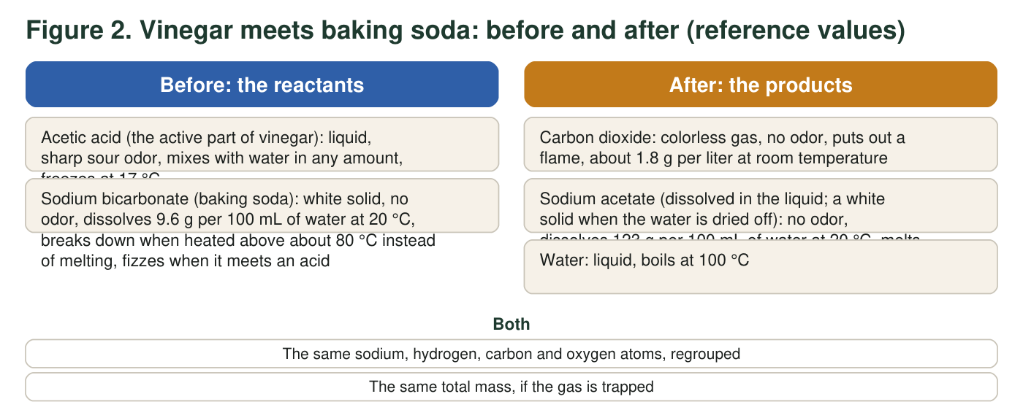
The clue in this reaction is the fizz. The confirming evidence is the difference in the solids' properties.

Part A: Read the diagrams
1. In Figure 1, the second arrow is labeled "a clue suggests, it does not prove." Give one example of a clue from the first arrow label that can appear when no new substance forms, and say what physical change causes it.
Answer: Examples: bubbles form when water boils (a state change, still water) or when a soda is opened (dissolved gas escaping); a temperature change happens when ice-melt pellets dissolve in water or when ice melts in a drink; a color change happens when a dye is diluted. Each is a physical change with no new substance.
Reasoning: Any clue from the arrow label paired with a correct physical cause earns credit.
Also acceptable: Accept 'a solid appears when salt water evaporates' for the solid clue.
Full credit must include:
• Names a clue from the first arrow label
• Gives a physical change that produces it without a new substance
2. The third arrow says the properties must be measured under the same conditions. Using the solubility values in Figure 2, explain what could go wrong if the 'before' solubility were measured at 20 °C and the 'after' solubility at 60 °C.
Answer: Solubility depends on temperature: most solids dissolve more in warmer water. If the 'before' test were at 20 °C and the 'after' test at 60 °C, the 'after' powder would dissolve more just because of the heat, and a student might wrongly conclude the solubility changed and a new substance formed, or the temperature effect could hide a real difference. Both tests must be at the same temperature for the comparison to mean anything.
Reasoning: The figure states 20 °C for both values on purpose. Students should recognize temperature as a condition that must be held the same.
Also acceptable: Accept 'the test would be unfair' with the temperature reason.
Full credit must include:
• States that solubility changes with temperature
• Explains that an unequal temperature could create or hide a difference
3. From Figure 2, name two properties that differ between sodium bicarbonate and sodium acetate, and one thing the shared box says is the same before and after.
Answer: Two differing properties (any two): solubility (9.6 versus 123 g per 100 mL at 20 °C); behavior when heated (breaks down above about 80 °C versus melts at 324 °C); behavior with vinegar (fizzes versus does not fizz). Same before and after: the same atoms (sodium, hydrogen, carbon, oxygen), regrouped, and the same total mass if the gas is trapped.
Reasoning: Reads the compare figure accurately; the 'same' item must come from the shared box.
Also acceptable: Accept 'no odor' as not a difference; it is shared, but it is not in the shared box, so it does not count for the third part.
Full credit must include:
• Two properties with values or descriptions from the figure
• One item from the shared box
4. Which observation belongs in the "A change is noticed" step of Figure 1 rather than in the "Compare" step?
Answer: B. Bubbles rise as soon as the vinegar touches the powder.
Reasoning: The fizz is the noticed change (the clue). The other three are measured or tested properties of the dried solid, which belong to the compare step.
Also acceptable: None.
5. Water is listed as a product in Figure 2, but the reaction happens in watery vinegar, so you cannot see any water appear. How do scientists know water is made, and why do they test the gas and the dried solid instead of the water to confirm the reaction?
Answer: Scientists know water forms from the atom accounting: the hydrogen and oxygen atoms in the reactants must go somewhere, and careful experiments done in dry conditions (no water present at the start) show water appearing. In a vinegar solution, new water is invisible among the existing water, so a property test on 'the water' would show nothing useful. The gas can be collected and tested (it puts out a flame) and the solid can be dried and tested (melting point and solubility), so those are the products scientists use to confirm the reaction.
Reasoning: This is a higher-order question. Full credit does not require the dry-conditions idea; it requires recognizing that water is undetectable here and that the testable products are chosen instead.
Also acceptable: Accept 'because the atoms have to add up' as the reason scientists know water forms.
Full credit must include:
• Explains that new water cannot be told apart from the water already present
• Explains that the gas and dried solid can be isolated and tested
6. Using the solubilities in Figure 2, calculate how many grams of sodium bicarbonate and how many grams of sodium acetate could dissolve in 250 mL of water at 20 °C. Show your work.
Answer: Sodium bicarbonate: 9.6 g per 100 mL × 2.5 = 24 g in 250 mL. Sodium acetate: 123 g per 100 mL × 2.5 = 307.5 g, about 308 g, in 250 mL.
Reasoning: 250 mL is 2.5 times 100 mL, so multiply each solubility by 2.5. Units stay grams.
Also acceptable: Accept 24 g and 307.5 g or 308 g; accept 300 g if the student rounded 123 to 120 and says so.

Part B: Build your own before-and-after model
A strip of magnesium metal is held in a flame. It catches, burns with a blinding white light, and leaves behind a white powder, magnesium oxide. Use the reference values below to build a two-panel model like Figure 2.
Reference properties for the magnesium model (real values, rounded)
Substance | Role | Appearance | Density | Melting point | Other
Magnesium | reactant | silvery metal strip, bends without breaking | 1.74 g/cm³ | 650 °C | burns in air once lit
Oxygen (from the air) | reactant | colorless gas, no odor | 1.3 g per liter at room temperature | −219 °C | makes a glowing splint burst into flame
Magnesium oxide | product | white powder, crumbles | 3.58 g/cm³ | about 2850 °C | does not burn; barely dissolves in water

Draw two side-by-side panels titled BEFORE and AFTER. In BEFORE, draw and label both reactants (do not forget the gas) and write two measured properties under each. In AFTER, draw and label the product with the same two properties. Between the panels draw an arrow and write the clue on it. Below the panels, circle the one property comparison that best confirms a new substance formed and write 'confirms' next to it. Give your model a title.
Expected drawing: Two titled panels. BEFORE: a labeled magnesium strip (density 1.74 g/cm³, melts at 650 °C, bends) and labeled oxygen gas drawn as scattered dots or a cloud (1.3 g per liter, relights a glowing splint). AFTER: a labeled pile of white magnesium oxide powder (density 3.58 g/cm³, melts at about 2850 °C, crumbles). An arrow between panels labeled with the clue: bright white light and heat. Below, a circled comparison such as 'melting point 650 °C → about 2850 °C' or 'density 1.74 → 3.58 g/cm³' marked 'confirms.' A title such as 'Magnesium burning in air.'
Reasoning: Check that both reactants appear (oxygen is the common omission), that the properties are copied correctly from the table, that the clue sits on the arrow and not inside a panel, and that the circled comparison is a characteristic property (density or melting point), not the light.
7. Label your model: which feature shows the clue, and which feature shows the confirming evidence? Explain why you chose the property you circled.
Answer: The clue is the label on the arrow (white light and heat): it is what you notice while the change happens. The confirming evidence is the circled property comparison: the density rises from 1.74 to 3.58 g/cm³ or the melting point rises from 650 °C to about 2850 °C. A property measured on the substance itself identifies it, while the light is something that happens during the change and can also come from a hot wire that is not reacting.
Reasoning: Students must separate 'what happened during' from 'what the substance is.'
Also acceptable: Accept 'the powder cannot be bent and does not burn' as supporting evidence.
Full credit must include:
• Clue identified as the arrow label
• Confirming evidence identified as a density or melting-point difference
• Reason: properties identify substances; a clue is not a property of the product
8. A student's model leaves oxygen out of the BEFORE panel. Using the reference table, explain one thing that model cannot explain about the white powder.
Answer: Without oxygen, the model cannot explain where the powder's extra mass came from (the powder has more mass than the strip did) or why the product contains oxygen at all. It also cannot explain why magnesium does not burn inside a sealed container with no air.
Reasoning: Any one of these is enough. The mass point connects to the shared box in Figure 2.
Also acceptable: Accept 'it makes it look like the powder came from nothing but the metal.'
Full credit must include:
• Names one specific thing the oxygen-free model cannot explain
9. Another student draws the magnesium strip 'turning into light.' What is wrong with that model? Where should the light go in a correct model, and what is the product?
Answer: Light is not a substance, so magnesium cannot turn into it; atoms are regrouped into a new substance, never into light. In a correct model the light belongs on the arrow as the clue (energy released during the change), and the product in the AFTER panel is magnesium oxide, made from the magnesium and the oxygen.
Reasoning: This targets a real misconception: that matter becomes energy in ordinary reactions.
Also acceptable: Accept 'the light is energy given off, not what the magnesium became.'
Full credit must include:
• States that light is not a substance or product
• Places light on the arrow as the clue
• Names magnesium oxide as the product

Teacher notes
Figure 2 values are reference data: acetic acid freezes at about 16.6 °C; sodium bicarbonate dissolves 9.6 g per 100 mL at 20 °C and decomposes on heating (noticeably from about 80 °C) rather than melting; sodium acetate (anhydrous) melts at 324 °C and dissolves about 123 g per 100 mL at 20 °C; carbon dioxide is about 1.8 g/L at 20 °C. Magnesium table: density 1.74 g/cm³, melting point 650 °C; oxygen about 1.3 g/L at 20 °C, melting point −219 °C; magnesium oxide density 3.58 g/cm³, melting point about 2852 °C. Do not burn magnesium for this sheet; the light can damage eyes and the sheet is a paper model. In the extension, the lead iodide value (about 0.08 g per 100 mL) corrects the textbook's 'not soluble': it barely dissolves, which is why it is seen as a solid.

