Angela's Tools · Chapter 12: Identifying Chemical Reactions · Worksheet 4 of 10

Reading the Reaction Map: From Clue to Confirmation
Learning target: I can interpret a diagram that shows how scientists move from a clue to a confirmed reaction, and I can build my own before-and-after model of a reaction that labels reactants, products, the clue and the confirming property test.
Diagrams and models · about 40 minutes · individual · Standards: MS-PS1-2 (practice), MS-PS1-5 (supports)
Name: ____________________________ Date: ____________ Period: ______

Directions
Study Figure 1 (the steps scientists follow) and Figure 2 (one reaction laid out before and after). Answer Part A using the figures. In Part B, build your own two-panel model for a different reaction, using the property table provided, then label it by answering the questions that follow.
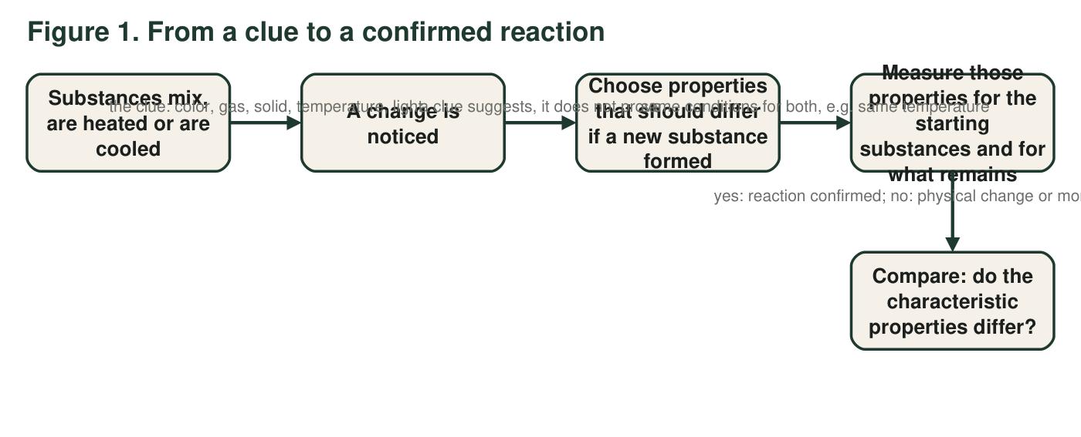
Each arrow label tells you what the step means. The last label gives the two possible conclusions.
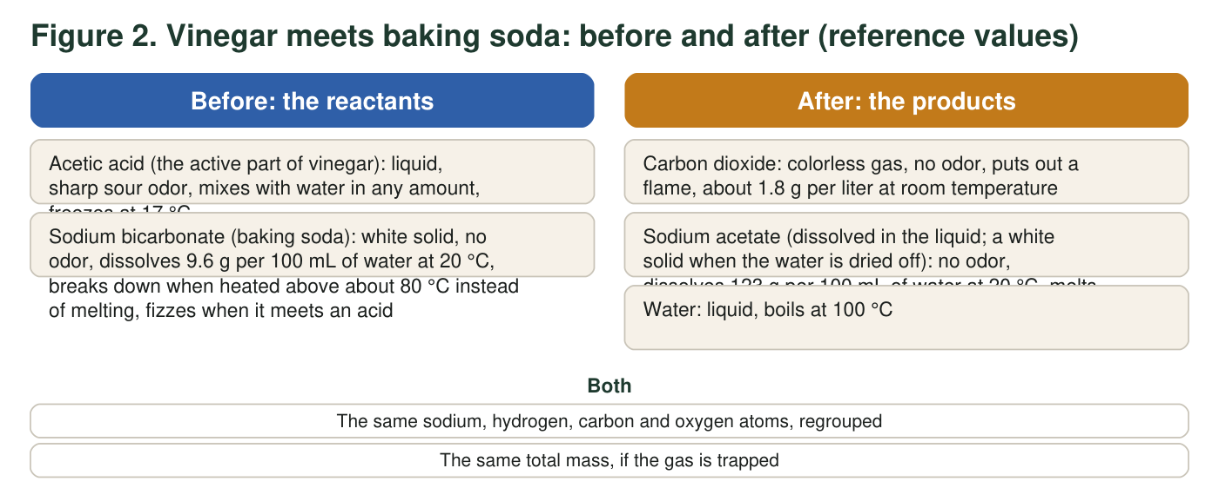
The clue in this reaction is the fizz. The confirming evidence is the difference in the solids' properties.

Part A: Read the diagrams
1. In Figure 1, the second arrow is labeled "a clue suggests, it does not prove." Give one example of a clue from the first arrow label that can appear when no new substance forms, and say what physical change causes it.
______________________________________________________________________________________
______________________________________________________________________________________
______________________________________________________________________________________
2. The third arrow says the properties must be measured under the same conditions. Using the solubility values in Figure 2, explain what could go wrong if the 'before' solubility were measured at 20 °C and the 'after' solubility at 60 °C.
______________________________________________________________________________________
______________________________________________________________________________________
______________________________________________________________________________________
3. From Figure 2, name two properties that differ between sodium bicarbonate and sodium acetate, and one thing the shared box says is the same before and after.
______________________________________________________________________________________
______________________________________________________________________________________
______________________________________________________________________________________
4. Which observation belongs in the "A change is noticed" step of Figure 1 rather than in the "Compare" step?
○ A. The dried white solid melts at 324 °C.
○ B. Bubbles rise as soon as the vinegar touches the powder.
○ C. The dried white solid dissolves 123 g per 100 mL at 20 °C.
○ D. The dried white solid does not fizz when fresh vinegar is added.
5. Water is listed as a product in Figure 2, but the reaction happens in watery vinegar, so you cannot see any water appear. How do scientists know water is made, and why do they test the gas and the dried solid instead of the water to confirm the reaction?
______________________________________________________________________________________
______________________________________________________________________________________
______________________________________________________________________________________
______________________________________________________________________________________
6. Using the solubilities in Figure 2, calculate how many grams of sodium bicarbonate and how many grams of sodium acetate could dissolve in 250 mL of water at 20 °C. Show your work.
______________________________________________________________________________________
______________________________________________________________________________________
______________________________________________________________________________________

Part B: Build your own before-and-after model
A strip of magnesium metal is held in a flame. It catches, burns with a blinding white light, and leaves behind a white powder, magnesium oxide. Use the reference values below to build a two-panel model like Figure 2.
Reference properties for the magnesium model (real values, rounded)
Substance | Role | Appearance | Density | Melting point | Other
Magnesium | reactant | silvery metal strip, bends without breaking | 1.74 g/cm³ | 650 °C | burns in air once lit
Oxygen (from the air) | reactant | colorless gas, no odor | 1.3 g per liter at room temperature | −219 °C | makes a glowing splint burst into flame
Magnesium oxide | product | white powder, crumbles | 3.58 g/cm³ | about 2850 °C | does not burn; barely dissolves in water

Draw two side-by-side panels titled BEFORE and AFTER. In BEFORE, draw and label both reactants (do not forget the gas) and write two measured properties under each. In AFTER, draw and label the product with the same two properties. Between the panels draw an arrow and write the clue on it. Below the panels, circle the one property comparison that best confirms a new substance formed and write 'confirms' next to it. Give your model a title.

7. Label your model: which feature shows the clue, and which feature shows the confirming evidence? Explain why you chose the property you circled.
______________________________________________________________________________________
______________________________________________________________________________________
______________________________________________________________________________________
8. A student's model leaves oxygen out of the BEFORE panel. Using the reference table, explain one thing that model cannot explain about the white powder.
______________________________________________________________________________________
______________________________________________________________________________________
______________________________________________________________________________________
9. Another student draws the magnesium strip 'turning into light.' What is wrong with that model? Where should the light go in a correct model, and what is the product?
______________________________________________________________________________________
______________________________________________________________________________________
______________________________________________________________________________________

Start with the boxes
If drawing feels hard, start by writing the words. Make a BEFORE column and an AFTER column and copy the names from the role column of the table: reactants on the left, product on the right. Add the density and melting point under each name. Then draw a simple shape for each substance (a strip, a cloud of dots for the gas, a pile for the powder). The arrow between the columns gets the clue: bright white light and heat.

Model the yellow solid
Build a third model for the reaction in which two clear solutions, one of lead nitrate and one of potassium iodide, are mixed and a yellow solid forms. Reference values: lead nitrate dissolves 52 g per 100 mL at 20 °C; potassium iodide dissolves 143 g per 100 mL at 20 °C; lead iodide is yellow and dissolves only about 0.08 g per 100 mL at 20 °C; potassium nitrate is white and dissolves 32 g per 100 mL at 20 °C. Your AFTER panel must show two products, one visible and one invisible, and your 'confirms' circle must explain why the yellow solid is seen even though a tiny amount of it does dissolve.

