Angela's Tools · Chapter 13: Atoms in Chemical Reactions · Worksheet 2 of 10

Same Atoms, New Partners: Putting the Words to Work (Teacher answer key)
Learning target: I can sort, connect and apply the words for chemical reactions, including telling a coefficient from a subscript and a scientific law from the model that explains it.
Vocabulary in action · about 30 minutes · individual · Standards: MS-PS1-5 (practice)

Standards connections
MS-PS1-5 (practice): Reading an equation correctly (coefficient versus subscript, reactants versus products) is the skill students need to count atoms before and after a reaction. The sheet builds that reading skill and the language of conservation; it does not yet ask for a full model.

Answers with reasoning
chemical reaction: A change in which bonds between atoms break and new bonds form, so the same atoms end up grouped into new substances with new properties.
reactant: A substance you start with. In an equation, reactants are written to the left of the arrow.
product: A substance that the reaction makes. In an equation, products are written to the right of the arrow.
chemical equation: A one-line shorthand that uses formulas, plus signs and an arrow to show which substances react and which form.
coefficient: The large number in front of a formula. It counts how many molecules or formula units of that substance take part. The 3 in 3O₂ means three oxygen molecules.
subscript: The small number after a symbol inside a formula. It counts atoms of that element inside one molecule or unit. The ₂ in O₂ means two oxygen atoms in each molecule.
molecule: A small group of atoms bonded together that moves as one particle, such as H₂O or O₂.
extended structure: A substance whose atoms link into a large repeating network instead of separate small molecules. Iron oxide and table salt are examples. Its formula gives the ratio of atoms in one repeating unit.
regroup: What atoms do in a reaction: they let go of old partners and bond to new ones. Atoms can break apart from a group, join a group, swap partners, or do a mix of these.
conserved: Kept the same in total. Atoms are conserved in a reaction: every atom that starts is still there at the end, just in a new group.
law of conservation of matter: The scientific law that ordinary chemical and physical changes never create or destroy matter, so the total mass after equals the total mass before.
scientific law: A statement, in words or math, of a pattern that has held every time it has been tested. A law describes what happens; a model or theory explains why.
closed system: A setup that matter cannot enter or leave, such as a sealed bottle. Heat can still pass in or out.
open system: A setup that matter can enter or leave, such as an uncovered cup. A gas can escape, and air can join in.

Part A: Sort the words into families
1. Sort these twelve words into the three families: reactant, product, coefficient, subscript, molecule, regroup, conserved, law of conservation of matter, scientific law, closed system, open system, chemical equation. Some columns will have more words than others; leave extra rows blank. Then put a star next to the one word that you think could belong in two families and write why below the table.
Answer: Parts of an equation: reactant, product, coefficient, subscript, chemical equation (5). What atoms do: molecule, regroup (2). The rule and the setup: conserved, law of conservation of matter, scientific law, closed system, open system (5). Star: 'molecule' or 'conserved' are both defensible. 'Molecule' names a thing that a formula in an equation stands for (parts of an equation) and a group that atoms form (what atoms do). 'Conserved' describes what atoms do and is also the rule.
Reasoning: The families are about use, so one or two words can reasonably sit in two columns. Credit any sort that matches the definitions, and credit any star with a reason that uses the definition.
Also acceptable: A student who places 'molecule' under 'parts of an equation' with a reason is correct.
Full credit must include:
• Equation words sorted together
• Rule and setup words sorted together
• A starred word with a reason tied to its definition

Part B: Complete the concept map
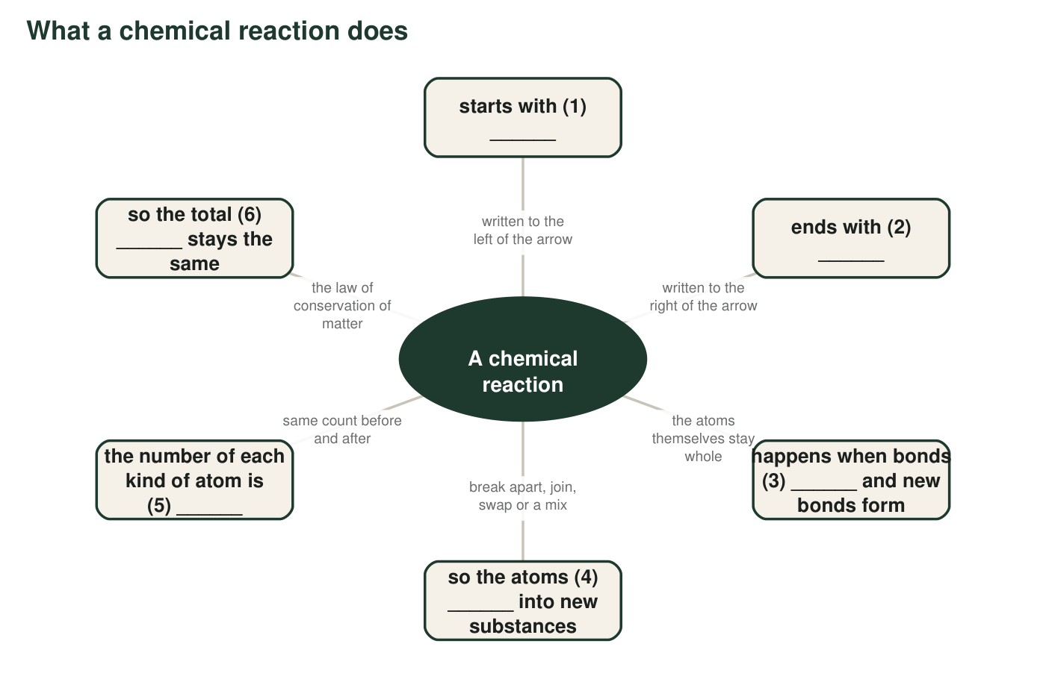
Six links are missing a word. Each blank is one word or short phrase from the word bank or from your own knowledge.
2. Write the six missing words in order: (1) ______ (2) ______ (3) ______ (4) ______ (5) ______ (6) ______
Answer: (1) reactants (2) products (3) break (4) regroup (5) conserved (6) mass.
Reasoning: Each blank follows from the description beside it in the map; (5) could also be 'the same' and (6) 'matter'.
Also acceptable: Accept 'the same' or 'kept' for (5); accept 'matter' for (6); accept 'rearrange' for (4).
3. Links 5 and 6 are connected by the word so. Explain in your own words why link 5 being true makes link 6 true. Your answer must mention that each atom has its own mass.
Answer: Every atom has its own mass, and no atom is lost or added during a reaction. If you still have the same atoms, you still have the same total mass; the atoms have only changed partners, which does not change what they weigh.
Reasoning: The link from 'same atoms' to 'same mass' is the logic of MS-PS1-5. Students must say atoms carry mass, not just that 'nothing disappears'.
Also acceptable: Accept 'the atoms are like bricks: rearranging the bricks does not change the weight of the pile.'
Full credit must include:
• States that each atom has mass
• States that the same atoms are present after as before
• Concludes the total mass is therefore unchanged

Part C: Which word fits?
4. In 2H₂O, the 2 in front is a ______ and tells you there are two water molecules; the small ₂ is a ______ and tells you there are two hydrogen atoms in each molecule. Altogether 2H₂O contains ______ hydrogen atoms and ______ oxygen atoms.
Answer: coefficient; subscript; 4 hydrogen atoms (2 × 2); 2 oxygen atoms (2 × 1).
Reasoning: Multiply the coefficient by each subscript; oxygen has an unwritten subscript of 1.
Also acceptable: None; the counts must be 4 and 2.
5. A fizzing tablet dropped into an uncovered glass of water is an ______ system, so the gas that forms can leave and the balance reading drops. The same tablet in a capped bottle is a ______ system, so the reading stays the same.
Answer: open; closed.
Reasoning: Matter (the gas) can leave the uncovered glass, so it is open; nothing can leave the capped bottle, so it is closed.
Also acceptable: None.
6. 'Mass before equals mass after' is a ______ because it describes a pattern seen in every careful test. 'Atoms are never created or destroyed, they only change partners' is the ______ that explains why the pattern holds.
Answer: scientific law; model (or theory, or explanation).
Reasoning: The first statement describes a tested pattern; the second explains the pattern with atoms. Students should not call the atom explanation a law.
Also acceptable: Accept 'atomic model', 'particle model' or 'theory' for the second blank.
7. Iron oxide (Fe₂O₃) is a network of iron and oxygen atoms with no separate small particles. Which word describes it best?
Answer: B, extended structure.
Reasoning: A network of atoms with no separate small particles is the definition of an extended structure; a molecule is a small separate group.
Also acceptable: None.

Part D: Use the words on a new reaction
A teacher heats a mixture of copper powder and yellow sulfur powder in a test tube with a loose plug of cotton in the top. The mixture glows, and a brittle gray-black solid forms. The class notes give the equation 2Cu + S → Cu₂S. The gray-black solid is copper sulfide, an extended structure. (This is a paper exercise; do not try it yourself.)
8. Name the reactants and the product. Then count the atoms of each element on each side of the arrow and write the totals.
Answer: Reactants: copper (Cu) and sulfur (S). Product: copper sulfide (Cu₂S). Left side: 2 Cu + 1 S = 3 atoms. Right side: 2 Cu + 1 S in each Cu₂S unit = 3 atoms. The counts match.
Reasoning: The coefficient 2 on Cu gives two copper atoms; the subscript 2 in Cu₂S gives two copper atoms per unit. Because copper sulfide is an extended structure, Cu₂S is one repeating unit, not a separate molecule.
Also acceptable: Accept 'copper and sulfur react; copper sulfide forms' for the names.
Full credit must include:
• Reactants and product named correctly
• Cu: 2 and 2; S: 1 and 1
• Totals 3 and 3
9. Write four sentences that explain what happened in the test tube at the atomic level. Use at least five words from the word bank and underline each one. One sentence must say which way the atoms regrouped (break apart, join, swap or a mix).
Answer: Model response: The reactants were copper and sulfur. When heated, bonds in the sulfur broke and new bonds formed between copper atoms and sulfur atoms, so the atoms regrouped into a new substance, the product copper sulfide. The atoms joined together: two substances became one, which is the joining pattern. Copper sulfide is an extended structure, a network of copper and sulfur atoms rather than separate molecules, and every atom is conserved, since the equation shows 3 atoms before and 3 after.
Reasoning: Look for five word-bank terms used correctly, a correct pattern (joining: two reactants become one product), and language that says bonds break, not atoms.
Also acceptable: A student who notes that sulfur in the solid is itself a ring of atoms that must break apart first is reasoning well; accept 'a mix of break apart and join'.
Full credit must include:
• Four sentences
• At least five word-bank terms, used correctly and underlined
• Pattern identified as joining
• Says bonds break and form; atoms stay whole
10. The cotton plug lets gases pass but keeps solids in. A little sulfur turns to vapor and escapes while heating. Use the words open system and conserved to explain why the test tube reads a bit lighter afterward even though no atoms were destroyed.
Answer: The test tube with a cotton plug is an open system: gases can leave through the cotton. The sulfur vapor that escaped still exists and still has mass, so the atoms are conserved; they just moved out of the tube. The balance reads lighter because it no longer weighs those atoms, not because any were destroyed.
Reasoning: This connects open system to a reading change while keeping conservation intact; the atoms are elsewhere, not gone.
Also acceptable: Accept 'if you could catch the vapor and weigh it, the totals would match.'
Full credit must include:
• Identifies the tube as an open system
• Says the escaped sulfur still exists and has mass
• Concludes the reading drops without any atoms being destroyed

Teacher notes
The word bank follows the textbook's terms but rewrites the definitions to stay accurate where the book simplifies: a coefficient counts molecules or formula units (not only molecules), bonds break rather than atoms, and the law of conservation of matter is limited to ordinary chemical and physical changes. Copper and sulfur heated together do form copper(I) sulfide; the demonstration gives off irritating sulfur vapor and must stay a paper exercise here. In Part A, expect debate over 'molecule'; the debate is the point. If students write 'theory' in q6, accept it, but note that in this chapter the explanation is the atomic model of matter. The extension answer: a catalyst takes part but is recovered unchanged, so it is neither consumed like a reactant nor made like a product, and its atoms are the same before and after, which is why it is left out of the equation (or written above the arrow).

