Angela's Tools · Chapter 13: Atoms in Chemical Reactions · Worksheet 2 of 10

Same Atoms, New Partners: Putting the Words to Work
Learning target: I can sort, connect and apply the words for chemical reactions, including telling a coefficient from a subscript and a scientific law from the model that explains it.
Vocabulary in action · about 30 minutes · individual · Standards: MS-PS1-5 (practice)
Name: ____________________________ Date: ____________ Period: ______

Directions
Read the word bank first. The definitions are written in plain language; the examples use reactions from this chapter. Then work through Parts A to D in order. Part A sorts the words into families, Part B completes a concept map, Part C asks which word fits, and Part D asks you to use the words on a reaction you have not seen before. Write in complete sentences wherever a question asks you to explain.
chemical reaction: A change in which bonds between atoms break and new bonds form, so the same atoms end up grouped into new substances with new properties.
reactant: A substance you start with. In an equation, reactants are written to the left of the arrow.
product: A substance that the reaction makes. In an equation, products are written to the right of the arrow.
chemical equation: A one-line shorthand that uses formulas, plus signs and an arrow to show which substances react and which form.
coefficient: The large number in front of a formula. It counts how many molecules or formula units of that substance take part. The 3 in 3O₂ means three oxygen molecules.
subscript: The small number after a symbol inside a formula. It counts atoms of that element inside one molecule or unit. The ₂ in O₂ means two oxygen atoms in each molecule.
molecule: A small group of atoms bonded together that moves as one particle, such as H₂O or O₂.
extended structure: A substance whose atoms link into a large repeating network instead of separate small molecules. Iron oxide and table salt are examples. Its formula gives the ratio of atoms in one repeating unit.
regroup: What atoms do in a reaction: they let go of old partners and bond to new ones. Atoms can break apart from a group, join a group, swap partners, or do a mix of these.
conserved: Kept the same in total. Atoms are conserved in a reaction: every atom that starts is still there at the end, just in a new group.
law of conservation of matter: The scientific law that ordinary chemical and physical changes never create or destroy matter, so the total mass after equals the total mass before.
scientific law: A statement, in words or math, of a pattern that has held every time it has been tested. A law describes what happens; a model or theory explains why.
closed system: A setup that matter cannot enter or leave, such as a sealed bottle. Heat can still pass in or out.
open system: A setup that matter can enter or leave, such as an uncovered cup. A gas can escape, and air can join in.

Part A: Sort the words into families
1. Sort these twelve words into the three families: reactant, product, coefficient, subscript, molecule, regroup, conserved, law of conservation of matter, scientific law, closed system, open system, chemical equation. Some columns will have more words than others; leave extra rows blank. Then put a star next to the one word that you think could belong in two families and write why below the table.
Words for the parts of an equation | Words for what atoms do | Words about the rule and the setup
Word 1
Word 2
Word 3
Word 4
Word 5

Part B: Complete the concept map
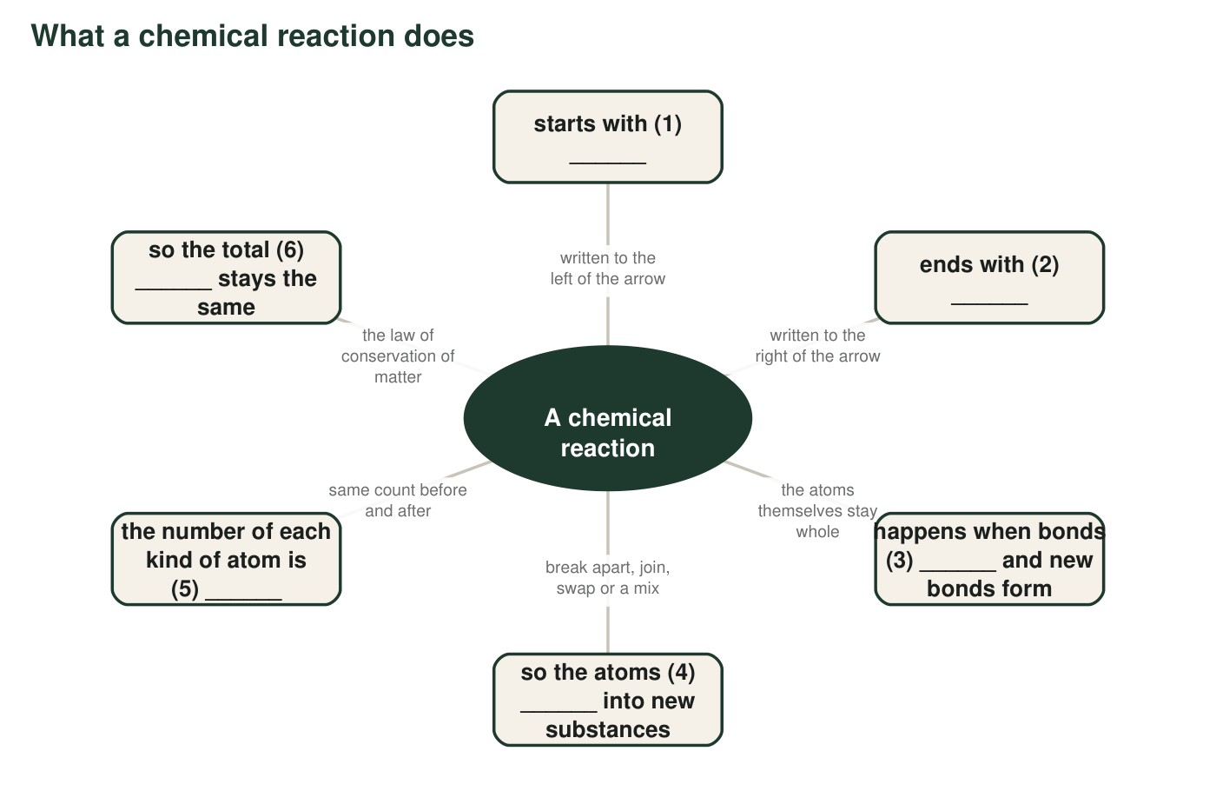
Six links are missing a word. Each blank is one word or short phrase from the word bank or from your own knowledge.
2. Write the six missing words in order: (1) ______ (2) ______ (3) ______ (4) ______ (5) ______ (6) ______
______________________________________________________________________________________
______________________________________________________________________________________
______________________________________________________________________________________
3. Links 5 and 6 are connected by the word so. Explain in your own words why link 5 being true makes link 6 true. Your answer must mention that each atom has its own mass.
______________________________________________________________________________________
______________________________________________________________________________________
______________________________________________________________________________________

Part C: Which word fits?
4. In 2H₂O, the 2 in front is a ______ and tells you there are two water molecules; the small ₂ is a ______ and tells you there are two hydrogen atoms in each molecule. Altogether 2H₂O contains ______ hydrogen atoms and ______ oxygen atoms.
______________________________________________________________________________________
______________________________________________________________________________________
______________________________________________________________________________________
5. A fizzing tablet dropped into an uncovered glass of water is an ______ system, so the gas that forms can leave and the balance reading drops. The same tablet in a capped bottle is a ______ system, so the reading stays the same.
______________________________________________________________________________________
______________________________________________________________________________________
______________________________________________________________________________________
6. 'Mass before equals mass after' is a ______ because it describes a pattern seen in every careful test. 'Atoms are never created or destroyed, they only change partners' is the ______ that explains why the pattern holds.
______________________________________________________________________________________
______________________________________________________________________________________
______________________________________________________________________________________
7. Iron oxide (Fe₂O₃) is a network of iron and oxygen atoms with no separate small particles. Which word describes it best?
○ A. molecule
○ B. extended structure
○ C. coefficient
○ D. closed system

Part D: Use the words on a new reaction
A teacher heats a mixture of copper powder and yellow sulfur powder in a test tube with a loose plug of cotton in the top. The mixture glows, and a brittle gray-black solid forms. The class notes give the equation 2Cu + S → Cu₂S. The gray-black solid is copper sulfide, an extended structure. (This is a paper exercise; do not try it yourself.)
8. Name the reactants and the product. Then count the atoms of each element on each side of the arrow and write the totals.
______________________________________________________________________________________
______________________________________________________________________________________
______________________________________________________________________________________
9. Write four sentences that explain what happened in the test tube at the atomic level. Use at least five words from the word bank and underline each one. One sentence must say which way the atoms regrouped (break apart, join, swap or a mix).
______________________________________________________________________________________
______________________________________________________________________________________
______________________________________________________________________________________
______________________________________________________________________________________
______________________________________________________________________________________
______________________________________________________________________________________
10. The cotton plug lets gases pass but keeps solids in. A little sulfur turns to vapor and escapes while heating. Use the words open system and conserved to explain why the test tube reads a bit lighter afterward even though no atoms were destroyed.
______________________________________________________________________________________
______________________________________________________________________________________
______________________________________________________________________________________

Coefficient or subscript? A quick test
Cover the formula with your finger and look only at the number. If the number is big and sits in front of the whole formula, it is a coefficient and it counts whole molecules or units: multiply everything inside by it. If the number is small, low and sits right after a symbol, it is a subscript and it counts atoms of that one element inside a single molecule. To count atoms, multiply coefficient by subscript: in 3H₂O there are 3 × 2 = 6 hydrogen atoms and 3 × 1 = 3 oxygen atoms.

Write the entry yourself
Write a word-bank entry for the term catalyst the way the entries above are written: a plain-language definition, one sentence on how it relates to conservation of atoms (is a catalyst a reactant, a product, or neither, and why), and an example from the ibuprofen story in the lesson. Then explain why a catalyst does not appear in the equation for the reaction it helps.

