Angela's Tools · Chapter 13: Atoms in Chemical Reactions · Worksheet 4 of 10

Count Before, Count After: Modeling a Reaction with Atoms (Teacher answer key)
Learning target: I can read a particle diagram and an equation for a reaction, tally the atoms of each element before and after, and build my own before-and-after model that shows why mass is conserved.
Diagrams and models · about 40 minutes · individual · Standards: MS-PS1-5 (assesses), MS-PS1-1 (supports)

Standards connections
MS-PS1-5 (assesses): Students tally atoms in a given particle diagram and then draw their own before-and-after model for a second reaction, explaining that equal atom counts mean equal mass. Equations are given already balanced, so the task stays inside the assessment boundary: counting, not balancing, and no atomic masses.
MS-PS1-1 (supports): Drawing water, hydrogen and oxygen as groups of labeled atoms uses the molecular-model skill from earlier in the unit; it is a tool here, not the thing being assessed.

Answers with reasoning

Part A: Read the model
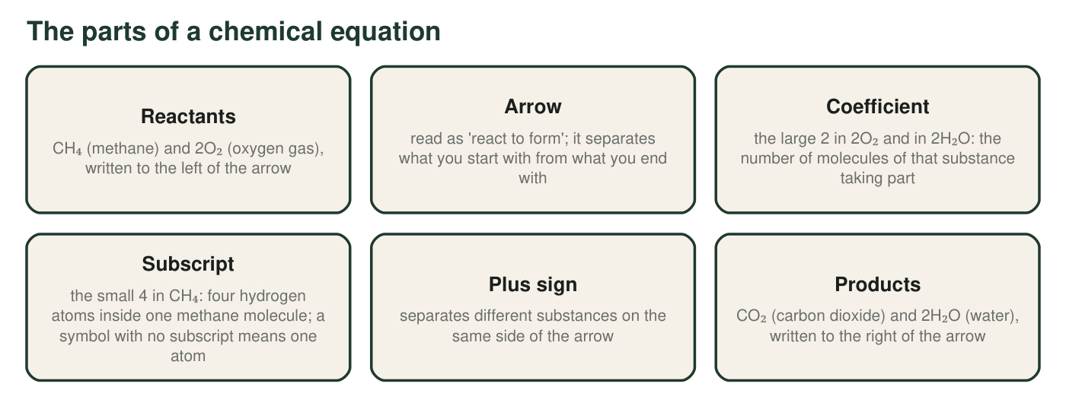
Methane is the main gas in a kitchen stove. When it burns, it reacts with oxygen from the air. Each label points to one part of the equation CH₄ + 2O₂ → CO₂ + 2H₂O.
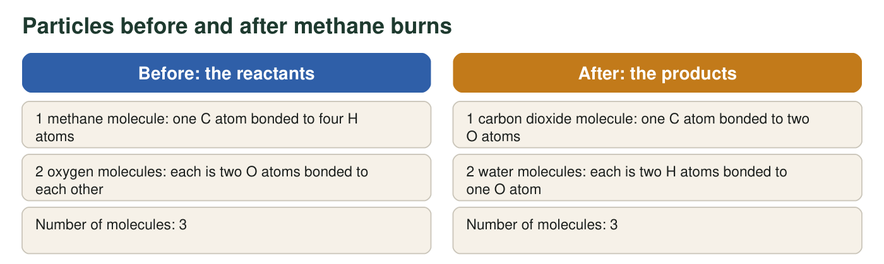
Picture each molecule as a cluster of labeled circles. The totals are left for you to count.
1. Tally the atoms of each element on each side using the particle figure. Show one multiplication for oxygen (coefficient × subscript) below the table.
Answer: Carbon: 1 before, 1 after, yes. Hydrogen: 4 before (1 × 4 in CH₄), 4 after (2 × 2 in 2H₂O), yes. Oxygen: 4 before (2 × 2 in 2O₂), 4 after (2 in CO₂ + 2 × 1 in 2H₂O = 4), yes. Total: 9 before, 9 after, yes. Example multiplication: 2O₂ = 2 molecules × 2 O atoms = 4 O atoms.
Reasoning: Each count is coefficient times subscript, summed over the substances on that side. The total of 9 on each side is the evidence of conservation.
Also acceptable: The multiplication may be shown for any oxygen term; accept '2 × 1 = 2 for the water oxygen plus 2 in CO₂.'
2. In 2H₂O, point to the coefficient and the subscript. Say what each number counts, and explain why 2H₂O contains 4 hydrogen atoms rather than 2.
Answer: The coefficient is the large 2 in front; it counts two water molecules. The subscript is the small 2 after H; it counts two hydrogen atoms inside each water molecule. Two molecules with two H atoms each is 2 × 2 = 4 hydrogen atoms.
Reasoning: Multiplying coefficient by subscript is the one calculation the chapter requires. The common error is to add (2 + 2) or to read only one of the numbers.
Also acceptable: None; the product must be 4.
Full credit must include:
• Identifies the coefficient as the large 2 in front and says it counts molecules
• Identifies the subscript as the small 2 and says it counts atoms per molecule
• Shows 2 × 2 = 4
3. There are 3 molecules before and 3 molecules after. A classmate says, 'So the number of molecules is always conserved too.' Use the reaction 2H₂O₂ → 2H₂O + O₂ (hydrogen peroxide breaking down) to test that claim: count the molecules and the atoms on each side, then say what is really conserved.
Answer: 2H₂O₂ → 2H₂O + O₂: molecules 2 before, 3 after, so the number of molecules is not conserved. Atoms: H 4 before, 4 after; O 4 before, 4 after (2 in the water + 2 in O₂); total 8 and 8. What is conserved is the number of atoms of each element (and therefore the mass), not the number of molecules.
Reasoning: The methane example happened to have 3 molecules on each side; the peroxide example breaks that coincidence while the atoms still match.
Also acceptable: Accept the claim being called 'a coincidence in the methane reaction.'
Full credit must include:
• Counts molecules 2 and 3
• Counts atoms 8 and 8 (H 4/4, O 4/4)
• Concludes atoms are conserved, molecules are not
4. Describe how the atoms regrouped when methane burned. Which bonds had to break? Which new groups formed? Is this breaking apart, joining, swapping, or a mix? Explain your choice.
Answer: The bonds between C and H in methane broke, and the bonds between the two O atoms in each oxygen molecule broke. New groups formed: the C atom bonded to two O atoms (carbon dioxide), and each pair of H atoms bonded to one O atom (water). This is a mix: the methane and oxygen molecules broke apart, and their atoms joined into new combinations, with hydrogen trading its carbon partner for an oxygen partner, which is like a swap.
Reasoning: The lesson's three patterns rarely occur alone; the correct answer recognizes breaking and joining (or a swap) together.
Also acceptable: Accept 'swap' alone if the student explains that hydrogen and carbon both ended up with oxygen; accept 'break apart then join'.
Full credit must include:
• Names the bonds that broke (C–H and O–O)
• Names the new groups (CO₂ and H₂O)
• Classifies as a mix with a reason
5. A student writes, 'The carbon atom broke apart to make carbon dioxide.' Correct the sentence so that it says what really broke.
Answer: 'The bonds between the carbon atom and its hydrogen atoms broke, and the carbon atom then bonded to two oxygen atoms to make carbon dioxide.' Atoms do not break apart in a chemical reaction; bonds do.
Reasoning: This is the chapter's central accuracy point: the atom stays whole; its connections change.
Also acceptable: Any rewording that keeps the atom whole and has bonds break earns credit.
Full credit must include:
• Replaces 'the carbon atom broke apart' with bonds breaking
• Keeps the carbon atom whole

Part B: Build your own model
Hydrogen gas and oxygen gas react to form water. The equation is 2H₂ + O₂ → 2H₂O. Each hydrogen molecule is two H atoms bonded together; each oxygen molecule is two O atoms bonded together; each water molecule is one O atom bonded to two H atoms.
Draw two boxes side by side, labeled BEFORE and AFTER, with an arrow between them. In BEFORE, draw every reactant molecule from 2H₂ + O₂ as circles labeled H or O, with short lines for bonds. In AFTER, draw every product molecule from 2H₂O the same way. Use the same size circle for every H and the same (slightly larger) size for every O in both boxes. Under each box write a tally: H = ___, O = ___, total = ___. Add a key and a title.
Expected drawing: BEFORE box: two H₂ molecules (each two H circles joined by a line) and one O₂ molecule (two O circles joined by a line); tally H = 4, O = 2, total = 6. AFTER box: two H₂O molecules (each one O circle with two H circles attached); tally H = 4, O = 2, total = 6. A key (small circle = H, larger circle = O, line = bond), a title, and an arrow between the boxes.
Reasoning: The model should contain exactly six atoms in each box with no leftovers and no extras; circle sizes should be consistent so that the same atoms are recognizable in both boxes.
6. Write the tallies from your drawing: hydrogen before and after, oxygen before and after, total before and after.
Answer: H: 4 before, 4 after. O: 2 before, 2 after. Total: 6 before, 6 after.
Reasoning: 2H₂ gives 2 × 2 = 4 H; O₂ gives 2 O; 2H₂O gives 2 × 2 = 4 H and 2 × 1 = 2 O.
Also acceptable: None.
7. A classmate's AFTER box shows three water molecules. Without changing the equation, explain what is wrong with the drawing and how the atom tally would reveal the mistake.
Answer: Three water molecules would contain 6 H atoms and 3 O atoms, but the BEFORE box only has 4 H and 2 O. The tally would show more atoms after than before, which is impossible, because a reaction cannot create atoms. The classmate has drawn atoms that never existed in the reactants; the AFTER box must use exactly the atoms from BEFORE, so it should show two water molecules.
Reasoning: The tally is the check on the model; this item assesses using the model to catch an error rather than balancing an equation.
Also acceptable: Accept 'where did the extra oxygen atom come from?' as the core argument.
Full credit must include:
• Counts 6 H and 3 O for three waters
• Compares with 4 H and 2 O before
• States that atoms cannot be created, so the drawing is wrong
8. The hydrogen and oxygen in your model react inside a sealed, rigid flask. The flask with everything inside reads 150.00 g before the reaction. What should it read after? Explain using your drawing, not a balance.
Answer: 150.00 g. The drawing shows the same six atoms in the AFTER box as in the BEFORE box, only connected differently. Each atom keeps its own mass, and the sealed flask lets nothing in or out, so the total mass is unchanged: 150.00 g before = 150.00 g after.
Reasoning: The number is unchanged; the explanation must come from the atom tally rather than from an appeal to a balance reading.
Also acceptable: Accept 'the same, 150.00 g' with the atoms-are-the-same explanation.
9. Explain how your BEFORE and AFTER drawing, by itself, shows that mass is conserved in this reaction. Your explanation must mention that every atom keeps its mass and must say what changed and what did not change between the two boxes.
Answer: Model response: Every atom has its own mass. My BEFORE box has 4 H atoms and 2 O atoms, and my AFTER box has the same 4 H atoms and the same 2 O atoms; I did not add or erase any circles, I only changed the lines that connect them. What changed is the grouping: two pairs of H and one pair of O became two groups of H–O–H. What did not change is the set of atoms, so the total mass, which is just the sum of the atoms' masses, is the same before and after. That is what conservation of mass means at the atomic level.
Reasoning: Full credit requires linking identical atom counts to identical mass via 'each atom keeps its mass', and distinguishing what changed (bonds, grouping, substances) from what did not (atoms, mass).
Also acceptable: A student who adds that the new substance (water) has different properties even though the atoms are the same is going beyond the question and should be credited.
Full credit must include:
• States that each atom keeps its mass
• Cites matching tallies from the drawing
• Names what changed (bonds or grouping) and what did not (atoms, total mass)

Teacher notes
All equations are given balanced, and students only count; this respects the MS-PS1-5 assessment boundary (no balancing, no atomic masses). Expected tallies: methane reaction 9 atoms per side (C 1, H 4, O 4); hydrogen peroxide 8 per side (H 4, O 4); water formation 6 per side (H 4, O 2). The extension (antacid reaction) tallies 9 per side: Ca 1, C 1, O 3, H 2, Cl 2; calcium carbonate and calcium chloride are ionic networks, so the drawing treats CaCO₃ and CaCl₂ as repeating units, and the sheet says so. Do not demonstrate hydrogen and oxygen reacting; the mixture is explosive and this is a paper model. Watch for drawings where the circle sizes change between boxes (students sometimes draw 'bigger' oxygen after the reaction to show it 'gained' something); point out that an atom's identity and mass do not change when its partners change, so the same kind of atom keeps the same circle.

