Angela's Tools · Chapter 13: Atoms in Chemical Reactions · Worksheet 4 of 10

Count Before, Count After: Modeling a Reaction with Atoms
Learning target: I can read a particle diagram and an equation for a reaction, tally the atoms of each element before and after, and build my own before-and-after model that shows why mass is conserved.
Diagrams and models · about 40 minutes · individual · Standards: MS-PS1-5 (assesses), MS-PS1-1 (supports)
Name: ____________________________ Date: ____________ Period: ______

Directions
Part A gives you a labeled equation and a before-and-after particle description for methane burning in oxygen. Read both figures carefully, then answer the questions by counting. Part B asks you to build your own model for a different reaction. Draw every atom as a circle with its symbol inside, draw bonds as short lines, and keep the 'before' and 'after' boxes separate. Count your atoms when you finish, and fix your drawing if the counts do not match. The equations on this sheet are already correct; your job is to count, not to change them.

Part A: Read the model
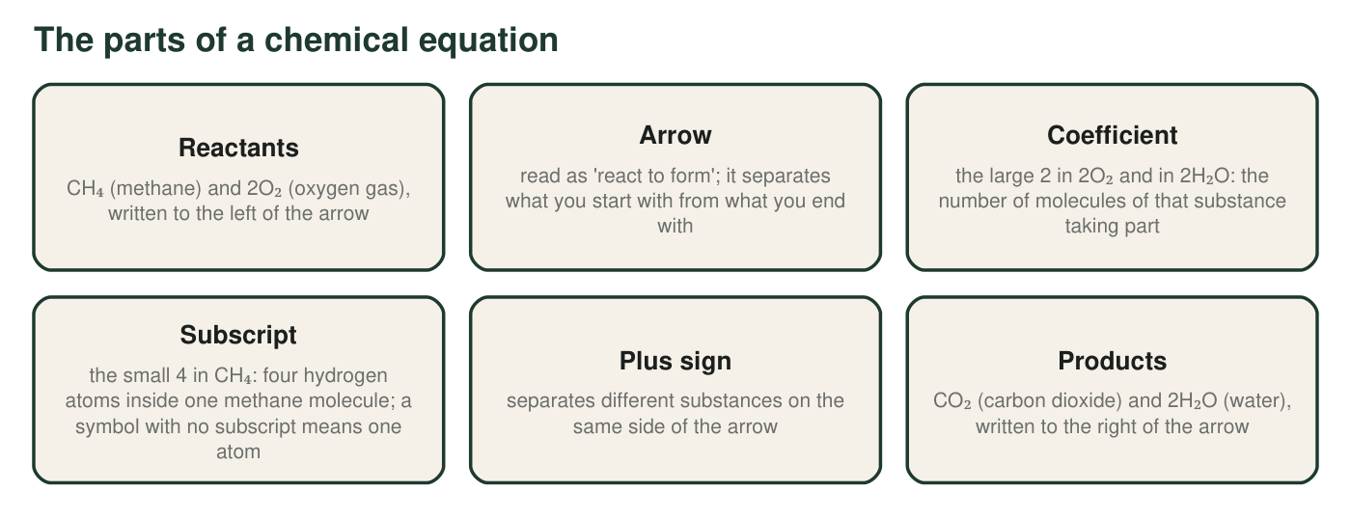
Methane is the main gas in a kitchen stove. When it burns, it reacts with oxygen from the air. Each label points to one part of the equation CH₄ + 2O₂ → CO₂ + 2H₂O.
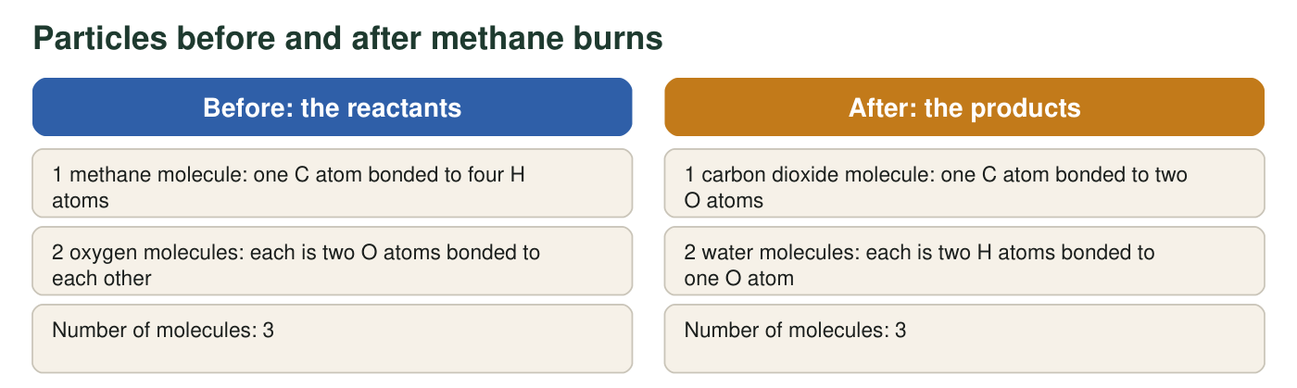
Picture each molecule as a cluster of labeled circles. The totals are left for you to count.
1. Tally the atoms of each element on each side using the particle figure. Show one multiplication for oxygen (coefficient × subscript) below the table.
Atoms before (reactants) | Atoms after (products) | Same? (yes/no)
Carbon (C)
Hydrogen (H)
Oxygen (O)
Total atoms

2. In 2H₂O, point to the coefficient and the subscript. Say what each number counts, and explain why 2H₂O contains 4 hydrogen atoms rather than 2.
______________________________________________________________________________________
______________________________________________________________________________________
______________________________________________________________________________________
3. There are 3 molecules before and 3 molecules after. A classmate says, 'So the number of molecules is always conserved too.' Use the reaction 2H₂O₂ → 2H₂O + O₂ (hydrogen peroxide breaking down) to test that claim: count the molecules and the atoms on each side, then say what is really conserved.
______________________________________________________________________________________
______________________________________________________________________________________
______________________________________________________________________________________
4. Describe how the atoms regrouped when methane burned. Which bonds had to break? Which new groups formed? Is this breaking apart, joining, swapping, or a mix? Explain your choice.
______________________________________________________________________________________
______________________________________________________________________________________
______________________________________________________________________________________
5. A student writes, 'The carbon atom broke apart to make carbon dioxide.' Correct the sentence so that it says what really broke.
______________________________________________________________________________________
______________________________________________________________________________________

Part B: Build your own model
Hydrogen gas and oxygen gas react to form water. The equation is 2H₂ + O₂ → 2H₂O. Each hydrogen molecule is two H atoms bonded together; each oxygen molecule is two O atoms bonded together; each water molecule is one O atom bonded to two H atoms.
Draw two boxes side by side, labeled BEFORE and AFTER, with an arrow between them. In BEFORE, draw every reactant molecule from 2H₂ + O₂ as circles labeled H or O, with short lines for bonds. In AFTER, draw every product molecule from 2H₂O the same way. Use the same size circle for every H and the same (slightly larger) size for every O in both boxes. Under each box write a tally: H = ___, O = ___, total = ___. Add a key and a title.

6. Write the tallies from your drawing: hydrogen before and after, oxygen before and after, total before and after.
______________________________________________________________________________________
______________________________________________________________________________________
7. A classmate's AFTER box shows three water molecules. Without changing the equation, explain what is wrong with the drawing and how the atom tally would reveal the mistake.
______________________________________________________________________________________
______________________________________________________________________________________
______________________________________________________________________________________
8. The hydrogen and oxygen in your model react inside a sealed, rigid flask. The flask with everything inside reads 150.00 g before the reaction. What should it read after? Explain using your drawing, not a balance.
______________________________________________________________________________________
______________________________________________________________________________________
______________________________________________________________________________________
9. Explain how your BEFORE and AFTER drawing, by itself, shows that mass is conserved in this reaction. Your explanation must mention that every atom keeps its mass and must say what changed and what did not change between the two boxes.
______________________________________________________________________________________
______________________________________________________________________________________
______________________________________________________________________________________
______________________________________________________________________________________
______________________________________________________________________________________

Count by molecule, then add
Make a small list before you tally. For each substance, write 'how many molecules' × 'atoms of each element in one molecule.' For 2O₂: 2 molecules × 2 O atoms = 4 O atoms. For 1 CH₄: 1 × 1 C = 1 C and 1 × 4 H = 4 H. Add the lists for everything on one side of the arrow before you look at the other side. In Part B, draw the BEFORE box first, count it, and then draw AFTER using exactly those atoms, as if you were cutting the bonds and re-sticking the same circles.

A reaction with a swap and a split
The antacid reaction CaCO₃ + 2HCl → CO₂ + H₂O + CaCl₂ mixes regrouping patterns. Draw BEFORE and AFTER boxes for it, treating CaCO₃ and CaCl₂ as single repeating units of an extended structure (draw each unit as a group, and note on your drawing that these substances are networks, not molecules). Tally all five elements, then explain which atoms swapped partners and which group split apart, and why the tally works even though some substances are networks rather than molecules.

