Angela's Tools · Chapter 14: Energy in Chemical Reactions · Worksheet 1 of 10

Warm Pouch, Cold Pouch: Energy Moving Two Ways (Teacher answer key)
Learning target: I can record what I notice about a pouch that heats itself and a pouch that chills itself, connect it to what I already know, and write a first explanation of where the energy goes.
Phenomenon exploration · about 25 minutes · individual · Standards: MS-PS1-6 (supports)

Standards connections
MS-PS1-6 (supports): Students observe two real devices that release or absorb thermal energy by chemical processes and ask their own questions about them. They do not yet design, test or modify anything; this sheet opens the chapter's puzzle that the design project in Lab 2 and W9 will answer.

Answers with reasoning

Equipment-table notes from a winter cross-country meet
Ms. Okafor runs the equipment table inside the warming tent at a winter cross-country meet. The tent is a steady 20 °C. In her bin are two kinds of pouches. The first is a flat cloth pouch of dark gray powder, sealed inside a plastic wrapper printed with the words do not open until ready to use. The second is a soft plastic bag of white granules with a thin inner bag of water floating in it. She has an infrared thermometer, a kitchen balance and a stopwatch, and she decides to keep notes while she waits for the runners.
She tears open the wrapper of the gray pouch and lays it on the table. It reads 20 °C, the same as the tent. Nothing seems to happen. Five minutes later it reads 31 °C. At ten minutes it is 42 °C, warm enough that she does not want to hold it still in her palm, and at twenty minutes it peaks at 46 °C. It stays close to that for about two hours, then slowly cools; at six hours it is 28 °C and at eight hours it is back to 20 °C. Afterward the powder inside has turned a rusty red-brown. Her balance shows the pouch gained mass: 32.0 g before opening, 35.1 g the next morning. At the bottom of the bin she finds a pouch whose wrapper tore in shipping. It is cold, red-brown and useless.
A runner asks for a cold drink, so Ms. Okafor squeezes the white-granule bag until the inner water bag bursts, shakes it, and leans a water bottle against it. The bag reads 20 °C at the moment she squeezes it. One minute later it reads 8 °C and at two minutes 5 °C; the outside of the bag is wet with droplets from the tent air. It then warms slowly: 9 °C at ten minutes, 13 °C at twenty, 17 °C at thirty and 20 °C at forty-five minutes. The granules are gone and the bag holds only a clear liquid. On the balance it is 118.0 g before and 118.0 g after. Squeezing it again does nothing.
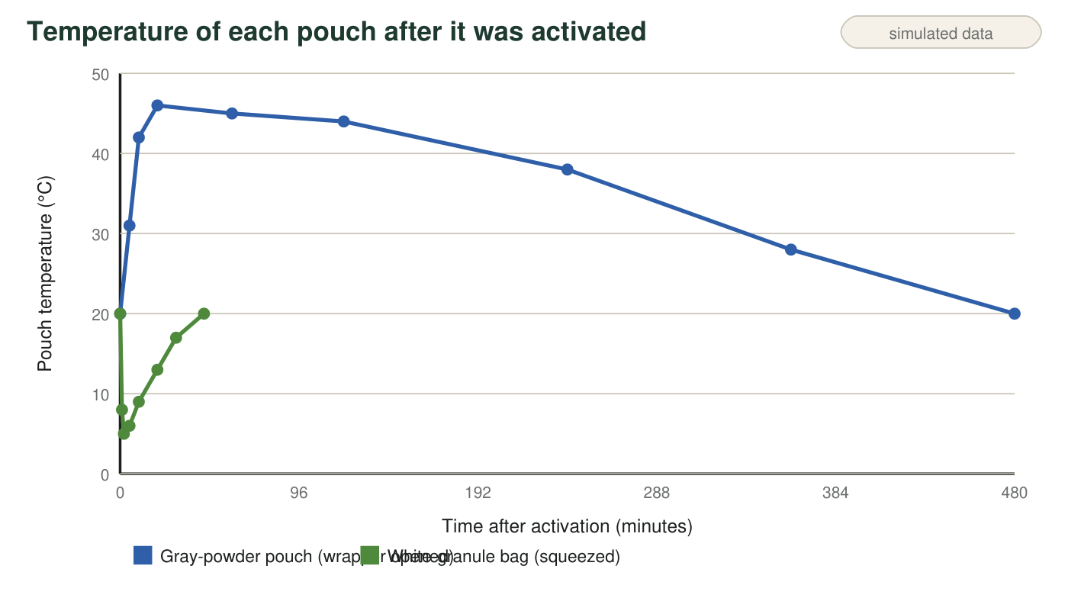
Teaching data: the readings on this page were invented to be realistic for an iron-powder hand warmer and an instant cold pack. They were not measured in a lab.
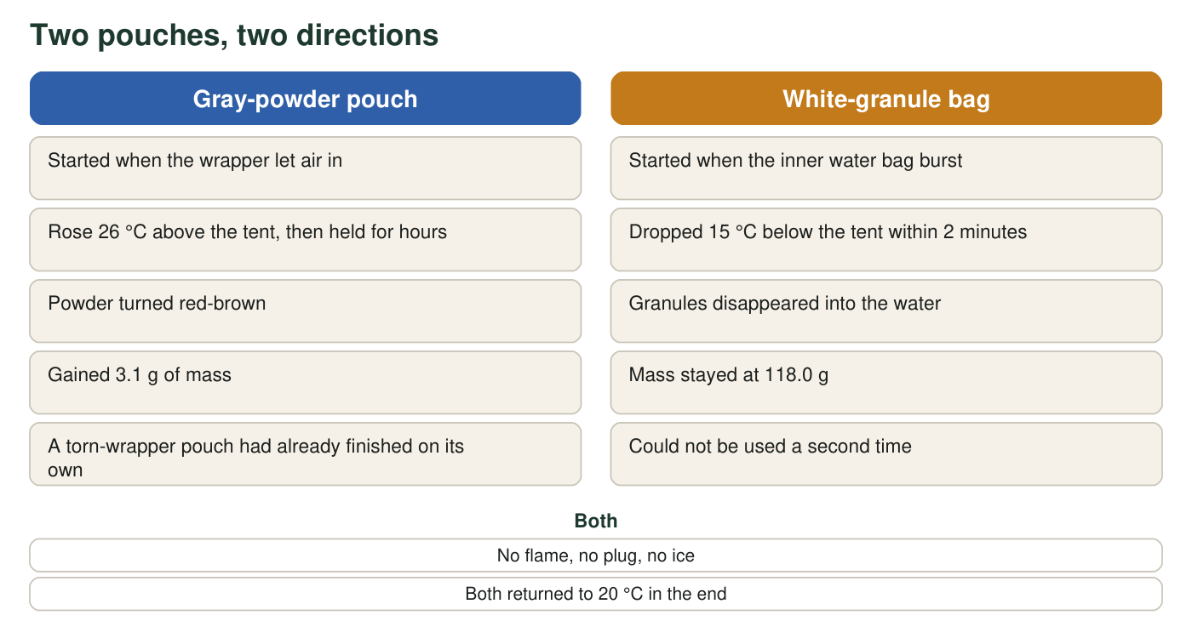
What the two pouches had in common and how they differed.
Infrared thermometer readings (teaching dataset)
Simulated teaching dataset (not real measurements).
Minutes after activation | Gray-powder pouch (°C) | White-granule bag (°C)
0 | 20 | 20
1 | not read | 8
2 | not read | 5
5 | 31 | 6
10 | 42 | 9
20 | 46 | 13
30 | not read | 17
45 | not read | 20
60 | 45 | not read
120 | 44 | not read
240 | 38 | not read
360 | 28 | not read
480 | 20 | not read

Simulated readings for a classroom scenario. The tent stayed at 20 °C throughout.

Part A: Notice and wonder
1. List three things you notice in the notes, the graph or the table. Use only facts that were observed, not explanations. Number them 1, 2, 3 and include at least one number.
Answer: Any three observable facts, for example: (1) the gray pouch rose from 20 °C to a peak of 46 °C at 20 minutes; (2) the white-granule bag dropped to 5 °C within 2 minutes; (3) the gray pouch gained 3.1 g (32.0 g to 35.1 g) while the white bag stayed at 118.0 g; (4) the gray powder turned red-brown; (5) the granules disappeared and left a clear liquid; (6) the gray pouch stayed warm for hours while the cold bag returned to 20 °C in 45 minutes; (7) the pouch with the torn wrapper was already cold and red-brown.
Reasoning: Full credit requires three separate facts drawn from the page, at least one with a number, and no explanations ('because it reacted') mixed in.
Also acceptable: Accept 'droplets formed on the outside of the cold bag' as an observation.
Full credit must include:
• Three distinct observations from the page
• At least one includes a number
• No explanation language
2. Write two questions you wonder about. A good wonder question could be tested with the tools on the table (thermometer, balance, stopwatch) or with one more simple tool.
Answer: Sample wonder questions: Would the gray pouch get hotter if the wrapper were cut into more openings? Does the gray pouch gain mass only while it is warm? Would the cold bag get colder if it held twice as many granules? Would the gray pouch work inside a sealed jar? What is the white powder, and does the clear liquid taste salty (do not test by tasting)? Why did the gray pouch gain mass but the cold bag did not?
Reasoning: Credit any genuine question connected to the observations; the best ones name a variable that could be changed and a reading that could be taken.
Also acceptable: A 'why' question that cannot be tested with the listed tools still earns credit if it is clearly about the observations.
Full credit must include:
• Two questions
• Each connects to something observed
• At least one is testable with simple tools
3. For each pouch, say whether energy was leaving the pouch or entering it. Then name the exact evidence from the thermometer readings that tells you which.
Answer: Gray pouch: energy was leaving the pouch and going into the tent air and the table, because the pouch got warmer than the 20 °C tent (up to 46 °C) and then cooled back down, which only happens if it is giving energy away. White-granule bag: energy was entering the bag from the tent air and the water bottle, because the bag went below the tent temperature (down to 5 °C) and then warmed back up to 20 °C; something colder than its surroundings is taking in energy from them.
Reasoning: Students should connect a temperature above the surroundings with energy flowing out and a temperature below the surroundings with energy flowing in. The thermometer readings are the evidence.
Also acceptable: Accept 'heat went out of the warm pouch and into the cold bag from the air' if both directions are correct. Do not accept 'cold came out of the bag.'
Full credit must include:
• Gray pouch: energy leaving, with the above-20 °C readings as evidence
• White bag: energy entering, with the below-20 °C readings as evidence

Part B: What you already know, and your first explanation
4. Describe one other time you have seen something get warm or cold without a flame, a heater, a freezer or ice touching it. What was it, and what do you think was happening?
Answer: Open. Possible examples: a compost pile or a bag of fresh lawn clippings feels warm inside; a bicycle pump gets warm when used (not chemical, still a fair example of warming without a heater); concrete in a bucket warms as it sets; a baking-soda-and-vinegar volcano feels a little cool; a phone battery warms while charging; sweat cooling skin on a hot day.
Reasoning: This item surfaces prior knowledge. Any honest example earns credit; the explanation attached to it can be wrong at this point.
Also acceptable: If a student has no example, accept a description of something they have heard of.
Full credit must include:
• Names a real experience
• Offers a reason, even a tentative one
5. Write your first explanation. Why did the gray pouch only begin warming after the wrapper was opened, and why did it stop after some hours? What was used up? Use the mass readings and the color change as clues. Then do the same for the white-granule bag: why did squeezing start it, and why can it not be used twice?
Answer: A strong first explanation: the gray powder needs something in the air to react; while the wrapper kept air out, nothing happened, and once air got in, the powder started combining with part of the air. The gain of 3.1 g shows that something from the air joined the powder (it did not lose anything), and the red-brown color shows a new substance formed, like rust. It stopped after hours because the powder had all been changed, so there was nothing left to react; the torn-wrapper pouch had finished early because air had been reaching it in the bin. For the white bag: the granules and the water were kept apart until squeezing mixed them; the granules dissolved in the water and took in energy from around them. Nothing left or entered the bag, so the mass stayed the same. It cannot run twice because the granules are already dissolved; there is no solid left to dissolve.
Reasoning: This is a first explanation, not a final one. Full credit requires using the clues (wrapper, mass gain, color, torn pouch; squeeze, same mass, granules gone) rather than restating the observations. Do not expect the words exothermic or endothermic yet.
Also acceptable: A student who says the gray powder 'absorbs oxygen' or 'rusts fast' is ahead of the chapter and correct. A student who thinks the warmth came from friction when the wrapper was torn has a testable idea that W6 will examine; credit the reasoning if it uses the clues.
Full credit must include:
• Links the start of warming to air reaching the powder
• Uses the mass gain or the color change as evidence of a new substance forming
• Explains stopping as reactants being used up
• Explains the cold bag's one-time use as the granules being dissolved

Part C: Predictions you could test
6. Suppose Ms. Okafor opened a fresh gray pouch and immediately dropped it into a jar that had been filled with nitrogen gas and sealed, so no air could reach it. Predict the reading after 20 minutes and explain your prediction.
Answer: Prediction: about 20 °C, essentially no change. Reason: the pouch only started warming when air reached it, so with the air replaced by nitrogen there should be nothing for the powder to react with. (A small rise of a degree or two is possible from the little air trapped in the pouch before the jar was sealed.)
Reasoning: The prediction tests whether the student has identified air, rather than the act of opening, as the trigger. Students who predict warming because 'opening the wrapper starts it' have a different hypothesis; credit a clear prediction with a reason that matches their q5 explanation, and revisit after W6.
Also acceptable: Accept 'a little above 20 °C because of the air already inside the pouch' as a strong answer.
Full credit must include:
• A specific predicted reading
• A reason linked to air being needed (or to the student's stated hypothesis)
7. Both pouches ended up at 20 °C, the tent's temperature. In one sentence each, say where the gray pouch's extra energy went and where the energy that re-warmed the white-granule bag came from.
Answer: Gray pouch: its extra energy flowed out into the tent air, the table and anything touching it, spreading until the pouch matched the tent's temperature. White-granule bag: the energy that re-warmed it flowed in from the tent air and the water bottle, which were warmer than the bag.
Reasoning: Energy flows from warmer to cooler until temperatures match. The point is that the surroundings are the other half of the story in both cases.
Also acceptable: Accept 'the tent' as the surroundings for both.
Full credit must include:
• Gray pouch: energy went into the surroundings (air, table)
• White bag: energy came from the surroundings (air, bottle)

Teacher notes
All numbers are invented but realistic: iron-powder hand warmers typically peak between 40 and 55 °C and last 4 to 10 hours; instant cold packs drop to roughly 0 to 10 °C and last 15 to 45 minutes. The 3.1 g mass gain is consistent with about 7 g of iron combining with 3.1 g of oxygen to make about 10 g of iron oxide (iron oxide is about 30 percent oxygen by mass); the cold pack keeps its mass because dissolving moves no matter in or out. The droplets on the cold bag are condensation from tent air, a nice side observation. Do not name the processes yet; the vocabulary sheet (W2) and reading (W3) introduce exothermic and endothermic. Watch for the idea that 'cold' flows out of the cold pack (W7 repairs it) and for the friction hypothesis for the hand warmer (W6 tests it). The nitrogen jar in q6 mirrors the lesson's prototype-testing method and sets up Lab 2.

