Angela's Tools · Chapter 14: Energy in Chemical Reactions · Worksheet 1 of 10

Warm Pouch, Cold Pouch: Energy Moving Two Ways
Learning target: I can record what I notice about a pouch that heats itself and a pouch that chills itself, connect it to what I already know, and write a first explanation of where the energy goes.
Phenomenon exploration · about 25 minutes · individual · Standards: MS-PS1-6 (supports)
Name: ____________________________ Date: ____________ Period: ______

Directions
Read the equipment-table notes, then study the graph, the comparison figure and the table of readings. Everything on this page is a teaching scenario: the people are invented and the numbers were made up to be realistic, not measured in a lab. Do not look anything up. Part A asks only for what you notice and wonder; use facts from the page. Part B asks what you already know and what you think right now; a wrong first idea is fine and expected. Part C asks for predictions you could test. Write in complete sentences. You will reread this page at the end of the chapter to see how your thinking changed.

Equipment-table notes from a winter cross-country meet
Ms. Okafor runs the equipment table inside the warming tent at a winter cross-country meet. The tent is a steady 20 °C. In her bin are two kinds of pouches. The first is a flat cloth pouch of dark gray powder, sealed inside a plastic wrapper printed with the words do not open until ready to use. The second is a soft plastic bag of white granules with a thin inner bag of water floating in it. She has an infrared thermometer, a kitchen balance and a stopwatch, and she decides to keep notes while she waits for the runners.
She tears open the wrapper of the gray pouch and lays it on the table. It reads 20 °C, the same as the tent. Nothing seems to happen. Five minutes later it reads 31 °C. At ten minutes it is 42 °C, warm enough that she does not want to hold it still in her palm, and at twenty minutes it peaks at 46 °C. It stays close to that for about two hours, then slowly cools; at six hours it is 28 °C and at eight hours it is back to 20 °C. Afterward the powder inside has turned a rusty red-brown. Her balance shows the pouch gained mass: 32.0 g before opening, 35.1 g the next morning. At the bottom of the bin she finds a pouch whose wrapper tore in shipping. It is cold, red-brown and useless.
A runner asks for a cold drink, so Ms. Okafor squeezes the white-granule bag until the inner water bag bursts, shakes it, and leans a water bottle against it. The bag reads 20 °C at the moment she squeezes it. One minute later it reads 8 °C and at two minutes 5 °C; the outside of the bag is wet with droplets from the tent air. It then warms slowly: 9 °C at ten minutes, 13 °C at twenty, 17 °C at thirty and 20 °C at forty-five minutes. The granules are gone and the bag holds only a clear liquid. On the balance it is 118.0 g before and 118.0 g after. Squeezing it again does nothing.
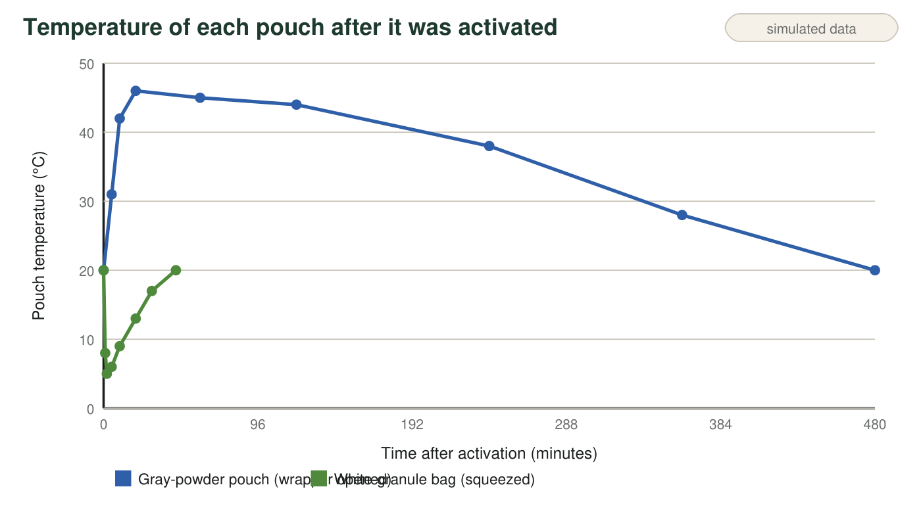
Teaching data: the readings on this page were invented to be realistic for an iron-powder hand warmer and an instant cold pack. They were not measured in a lab.
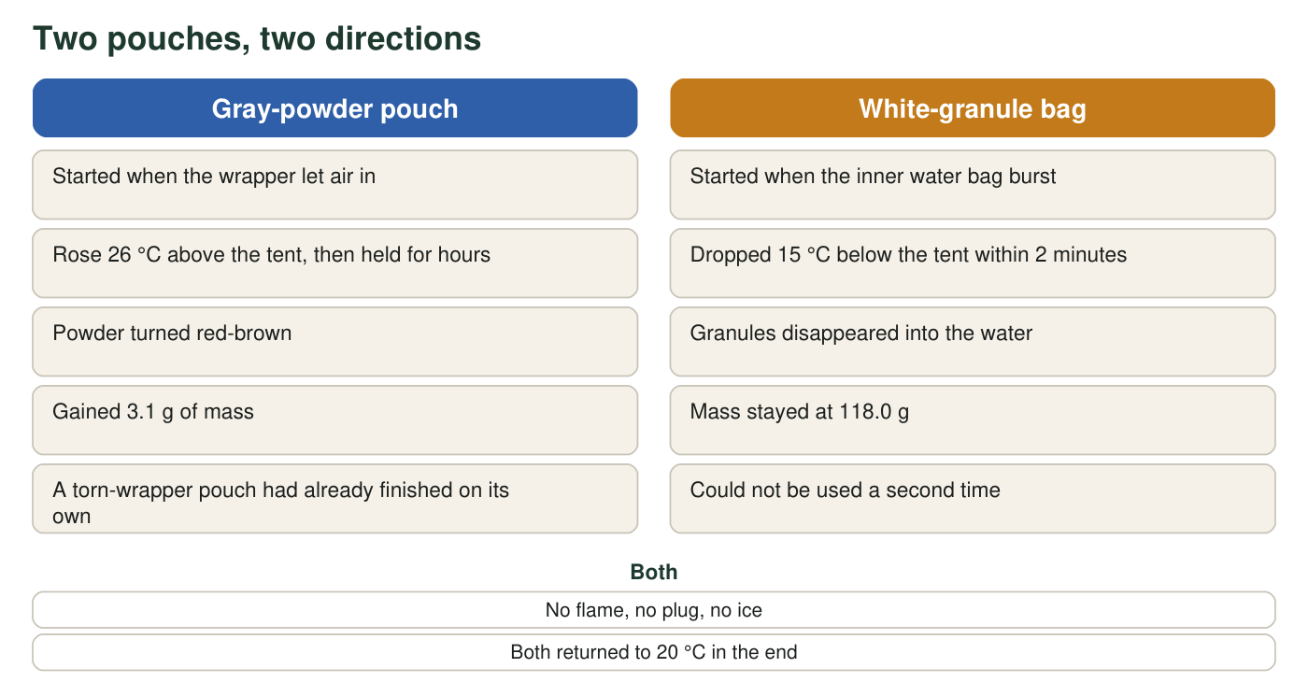
What the two pouches had in common and how they differed.
Infrared thermometer readings (teaching dataset)
Simulated teaching dataset (not real measurements).
Minutes after activation | Gray-powder pouch (°C) | White-granule bag (°C)
0 | 20 | 20
1 | not read | 8
2 | not read | 5
5 | 31 | 6
10 | 42 | 9
20 | 46 | 13
30 | not read | 17
45 | not read | 20
60 | 45 | not read
120 | 44 | not read
240 | 38 | not read
360 | 28 | not read
480 | 20 | not read

Simulated readings for a classroom scenario. The tent stayed at 20 °C throughout.

Part A: Notice and wonder
1. List three things you notice in the notes, the graph or the table. Use only facts that were observed, not explanations. Number them 1, 2, 3 and include at least one number.
______________________________________________________________________________________
______________________________________________________________________________________
______________________________________________________________________________________
______________________________________________________________________________________
______________________________________________________________________________________
2. Write two questions you wonder about. A good wonder question could be tested with the tools on the table (thermometer, balance, stopwatch) or with one more simple tool.
______________________________________________________________________________________
______________________________________________________________________________________
______________________________________________________________________________________
______________________________________________________________________________________
3. For each pouch, say whether energy was leaving the pouch or entering it. Then name the exact evidence from the thermometer readings that tells you which.
______________________________________________________________________________________
______________________________________________________________________________________
______________________________________________________________________________________

Part B: What you already know, and your first explanation
4. Describe one other time you have seen something get warm or cold without a flame, a heater, a freezer or ice touching it. What was it, and what do you think was happening?
______________________________________________________________________________________
______________________________________________________________________________________
______________________________________________________________________________________
5. Write your first explanation. Why did the gray pouch only begin warming after the wrapper was opened, and why did it stop after some hours? What was used up? Use the mass readings and the color change as clues. Then do the same for the white-granule bag: why did squeezing start it, and why can it not be used twice?
______________________________________________________________________________________
______________________________________________________________________________________
______________________________________________________________________________________
______________________________________________________________________________________
______________________________________________________________________________________
______________________________________________________________________________________

Part C: Predictions you could test
6. Suppose Ms. Okafor opened a fresh gray pouch and immediately dropped it into a jar that had been filled with nitrogen gas and sealed, so no air could reach it. Predict the reading after 20 minutes and explain your prediction.
______________________________________________________________________________________
______________________________________________________________________________________
______________________________________________________________________________________
7. Both pouches ended up at 20 °C, the tent's temperature. In one sentence each, say where the gray pouch's extra energy went and where the energy that re-warmed the white-granule bag came from.
______________________________________________________________________________________
______________________________________________________________________________________
______________________________________________________________________________________

Noticing is not explaining
A notice is something the thermometer, balance or your eyes could record: 'the gray pouch reached 46 °C at 20 minutes.' An explanation is a reason: 'because something in the powder reacted with air.' Part A wants only notices; save every 'because' for Part B. If you are stuck on q1, read down one column of the table and write the biggest change you see; then read the other column and do the same; then compare the two mass readings for your third notice.

Where did the 3.1 grams come from?
The gray pouch gained 3.1 g, but it was sealed inside a cloth pouch and nobody added anything to it. The only thing that touched it was air. Write a hypothesis about which part of the air joined the powder, and then design a test that uses the balance and the nitrogen-filled jar from q6 to check your hypothesis. Say what mass change you would expect in the jar if your hypothesis is right, and what you would expect if it is wrong.

