Angela's Tools · Chapter 14: Energy in Chemical Reactions · Worksheet 2 of 10

System, Surroundings and the Words Engineers Use (Teacher answer key)
Learning target: I can use the chapter's terms to sort the parts of a reaction into system and surroundings, name the direction of energy flow, and tell a design criterion from a constraint.
Vocabulary in action · about 30 minutes · individual · Standards: MS-PS1-6 (supports)

Standards connections
MS-PS1-6 (supports): The design project in this PE asks students to judge a device by amount, time and temperature and to talk about the energy it releases or absorbs. This sheet builds the vocabulary (system, surroundings, exothermic, endothermic, criteria, constraints, prototype, iteration) that the design record will use; it produces no device or test data.

Answers with reasoning
system: The matter you are tracking in a reaction: the substances that react and the new substances they become, inside an imaginary boundary.
surroundings: Everything outside the system that can exchange energy with it: the container, the nearby air, water in a cup, a hand holding a pack.
exothermic reaction: A reaction whose net energy transfer is out of the system to the surroundings, as heat, light or sound.
endothermic reaction: A reaction (or other change, such as some salts dissolving) whose net energy transfer is inward, from the surroundings into the system.
net energy transfer: The overall direction and size of the energy flow once everything absorbed and everything released has been counted.
chemical bond: An attraction holding atoms together. Pulling bonded atoms apart always takes energy in; forming a bond always gives energy out.
thermal energy: The energy a sample has because its particles are moving. The amount depends on the temperature and on how much matter there is.
temperature: A measure of how fast particles are moving on average, read with a thermometer. Not the same as the amount of thermal energy.
prototype: A working version of a design built so it can be tested, with the results used to decide what to change next.
criteria: The measurable goals a design must meet to count as a success.
constraints: The limits a design must stay within, such as a budget, a safety ceiling or the materials allowed.
iteration: One round of the build, test and modify cycle.

Part A: Drawing the boundary around a burning strip
A teacher holds a short strip of magnesium metal in metal tongs under a fume hood and lights it with a burner. The strip burns with a brilliant white light and leaves a crumbly white ash of magnesium oxide. The magnesium combined with oxygen from the air; almost none of the nitrogen in the air took part. Students watching from two meters away felt a little warmth on their faces and had to look away from the glare. (The teacher wore eye protection and nobody looked directly at the flame.)
1. For each item, write whether it belongs to the system, the surroundings, or neither because it is energy rather than matter. Give a reason in a few words.
Answer: Magnesium strip: system (a reactant). Oxygen that combined: system (a reactant). Magnesium oxide ash: system (the product; the same matter, regrouped). Nitrogen in the air: surroundings (matter that took essentially no part). Tongs: surroundings (they can gain energy but do not react). White light: neither; it is energy leaving the system. Warmth the students felt: neither; it is energy that crossed into the surroundings (their skin is surroundings, the warmth is the transfer). Tabletop: surroundings.
Reasoning: The system is the reacting matter plus the products it becomes; everything else that can exchange energy is surroundings; light and warmth are energy, not matter, so they belong to neither side and are the evidence that the reaction is exothermic.
Also acceptable: Accept 'surroundings' for the warmth if the student says it is energy now in the students' skin; the key idea is that it crossed the boundary.
Full credit must include:
• Strip, oxygen and ash all placed in the system
• Nitrogen, tongs and tabletop in the surroundings
• Light and warmth identified as energy, not matter
2. The ash and the magnesium strip look completely different, yet both belong to the same side of the boundary. Explain why, using the definition of system.
Answer: The system is defined as the matter being tracked: the reactants and whatever they turn into. The ash is made from the magnesium atoms and oxygen atoms that reacted, so it is the same matter regrouped, still inside the boundary.
Reasoning: Students must apply the definition rather than sort by appearance.
Also acceptable: Accept 'the atoms did not leave, they just joined up differently.'
Full credit must include:
• States that products belong to the system
• Connects ash to the same atoms as the strip and oxygen

Part B: Complete the concept map
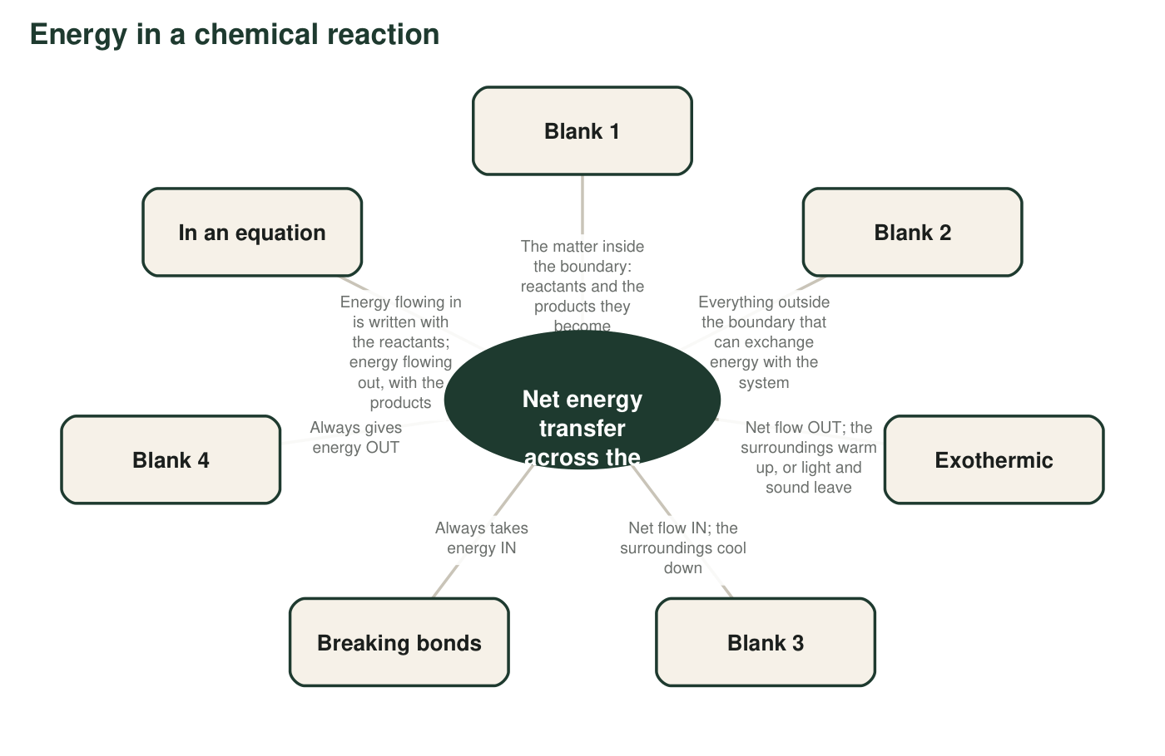
A concept map with four blanks. Each blank is a term or a short phrase from this chapter.
3a. Blank 1 is __________.
Answer: System
Reasoning: The description is the definition of the system.
Also acceptable: Accept 'the system (reactants and products)'.
3b. Blank 2 is __________.
Answer: Surroundings
Reasoning: Everything outside the boundary that can exchange energy is the surroundings.
Also acceptable: None.
3c. Blank 3 is __________.
Answer: Endothermic
Reasoning: Net flow in with cooling surroundings is the endothermic case.
Also acceptable: Accept 'endothermic reaction' or 'endothermic change'.
3d. Blank 4 is __________.
Answer: Forming bonds
Reasoning: Forming a bond always gives energy out, the partner of 'breaking bonds takes energy in.'
Also acceptable: Accept 'making new bonds' or 'bonds forming'.
4. Use the map to finish this rule in your own words: 'A reaction is exothermic when the energy given out by __________ is greater than the energy taken in by __________, so the extra energy __________.'
Answer: A reaction is exothermic when the energy given out by forming the new bonds in the products is greater than the energy taken in by breaking the old bonds in the reactants, so the extra energy flows out to the surroundings (as heat, light or sound).
Reasoning: This is the qualitative bond model; the third blank must say the energy leaves the system, not that it is created.
Also acceptable: Do not accept 'the extra energy is made' or 'is created.'
Full credit must include:
• Forming bonds in the first blank
• Breaking bonds in the second
• Energy leaves to the surroundings in the third
5. Two hand warmers are both at 44 °C. One holds 10 g of reacting powder; the other holds 30 g. Which has more thermal energy, and why can two objects at the same temperature hold different amounts of it?
Answer: The 30 g warmer has more thermal energy. Temperature tells how fast the particles are moving on average, but thermal energy also depends on how much matter is moving. Three times as many particles at the same average speed hold about three times the thermal energy, which is why the bigger pack can keep warming a hand for longer.
Reasoning: Distinguishing temperature from thermal energy is the idea behind testing time and temperature separately in the engineering half of the chapter.
Also acceptable: Accept 'more stuff at the same temperature means more energy stored in it.'
Full credit must include:
• Picks the 30 g warmer
• Explains that thermal energy depends on amount of matter as well as temperature

Part C: The engineering words in a design brief
Brief from a ski-patrol volunteer group
We need a pocket warmer for volunteers on the chairlift. It must reach at least 40 °C within 15 minutes and stay above 35 °C for at least 3 hours. It must never go above 50 °C, because it sits against skin. Each warmer must cost under one dollar and weigh under 60 g. Our first version used 10 g of iron powder; it peaked at 31 °C, so for the second version we doubled the iron. We will test every version the same way: thermometer readings every 15 minutes for 4 hours.
6. Label each line from the brief with the best term and say how you decided.
Answer: Reaches at least 40 °C within 15 minutes: criterion (a measurable goal). Never goes above 50 °C: constraint (a limit, for safety). Costs under one dollar: constraint (a budget limit). Stays above 35 °C for at least 3 hours: criterion (a goal for time). The first version with 10 g of iron: prototype (a working version built to be tested). Doubling the iron for the second version: iteration (one round of modify and retest).
Reasoning: Criteria are targets to reach; constraints are ceilings or floors the design may not cross; a prototype is the testable object; an iteration is one change-and-test round.
Also acceptable: A student who calls 'under one dollar' a criterion with the reason 'it is a measurable target' shows reasonable thinking; mark it and discuss that budgets are usually treated as limits, not goals.
Full credit must include:
• Two criteria and two constraints correctly sorted
• Prototype and iteration correctly labeled
• A reason for each
7. The brief gives a temperature the warmer must reach (40 °C) and a temperature it must not pass (50 °C). One is a criterion and one is a constraint. Explain the difference between the two kinds of statement using these two numbers.
Answer: Reaching 40 °C is a criterion: a goal the design is trying to achieve, and a warmer that reaches 44 °C does even better. Not passing 50 °C is a constraint: a limit the design must stay inside no matter what; a warmer at 55 °C fails even if it beats every goal. Criteria say what success looks like; constraints say what is not allowed.
Reasoning: The pair of numbers makes the distinction concrete: one is a floor to beat, the other a ceiling never to cross.
Also acceptable: Accept 'criteria are wants, constraints are must-nots' if the two numbers are placed correctly.
Full credit must include:
• 40 °C identified as a goal to meet or beat
• 50 °C identified as a limit never to cross
• Difference stated in general terms

Part D: Use the words together
8. A match has to be struck before it burns, and then it burns on its own. Write one or two sentences about the match that use both net energy transfer and exothermic correctly.
Answer: Sample: Striking the match gives the system a small amount of energy to break the first bonds, but once it burns, the net energy transfer is out of the system, so burning a match is exothermic.
Reasoning: The sentence must show that the start-up input is small and that the overall direction, not the start, decides the label.
Also acceptable: Two sentences are fine; accept 'overall' for 'net' if the term itself also appears.
Full credit must include:
• Uses both terms correctly
• States that the net transfer is outward
• Mentions that the strike is only the start
9. A sixth grader tells you, 'Endothermic just means you need a flame to make it happen.' Using the words system, surroundings and net, explain what endothermic really means and give one example of an endothermic change that happens with no flame at all.
Answer: Endothermic means the system takes in more energy from the surroundings than it gives out, so the net energy transfer is into the system and the surroundings get cooler. A flame is just one way energy can get in. An instant cold pack has no flame: when the salt dissolves in the water, the system absorbs energy from your hand and the air, which is why it feels cold. (Other no-flame examples: citric acid with baking soda in water; a plant using sunlight in photosynthesis.)
Reasoning: This repairs the textbook's 'needs a continuous energy source' rule, which students over-apply. Full credit needs the net idea, the direction, and a flame-free example.
Also acceptable: Accept 'cooking' as the flame example only if a flame-free example is also given.
Full credit must include:
• Uses system, surroundings and net
• States the direction is into the system
• Gives a flame-free endothermic example

Teacher notes
The magnesium burning in Part A is a described scenario only; the chapter has no flames, so do not demonstrate it (a video is a safe substitute). Burning magnesium in air also makes a little magnesium nitride, which is why the text says almost none of the nitrogen took part; placing the nitrogen in the surroundings is still correct. The 'neither' answers for light and warmth are the point of Part A: energy is not matter and does not sit on either side of the boundary; it crosses it. In Part C, the budget and the 50 °C ceiling are constraints and the two temperature-and-time targets are criteria; the same distinction is used in Lab 2, W9 and the exit ticket. The extension is accurate: endotherms keep warm through exothermic reactions inside their bodies, so the prefix refers to where the body's warmth comes from, not to the direction of a reaction's energy flow.

