Angela's Tools · Chapter 14: Energy in Chemical Reactions · Worksheet 2 of 10

System, Surroundings and the Words Engineers Use
Learning target: I can use the chapter's terms to sort the parts of a reaction into system and surroundings, name the direction of energy flow, and tell a design criterion from a constraint.
Vocabulary in action · about 30 minutes · individual · Standards: MS-PS1-6 (supports)
Name: ____________________________ Date: ____________ Period: ______

Directions
This sheet is about how the chapter's words relate to one another, not about memorizing definitions. The word bank below is the only reference you need. Part A sorts the parts of one real demonstration. Part B completes a concept map and some sentences. Part C applies the engineering words to a design brief. Part D asks you to use pairs of words together. Write in complete sentences wherever a question asks you to explain.
system: The matter you are tracking in a reaction: the substances that react and the new substances they become, inside an imaginary boundary.
surroundings: Everything outside the system that can exchange energy with it: the container, the nearby air, water in a cup, a hand holding a pack.
exothermic reaction: A reaction whose net energy transfer is out of the system to the surroundings, as heat, light or sound.
endothermic reaction: A reaction (or other change, such as some salts dissolving) whose net energy transfer is inward, from the surroundings into the system.
net energy transfer: The overall direction and size of the energy flow once everything absorbed and everything released has been counted.
chemical bond: An attraction holding atoms together. Pulling bonded atoms apart always takes energy in; forming a bond always gives energy out.
thermal energy: The energy a sample has because its particles are moving. The amount depends on the temperature and on how much matter there is.
temperature: A measure of how fast particles are moving on average, read with a thermometer. Not the same as the amount of thermal energy.
prototype: A working version of a design built so it can be tested, with the results used to decide what to change next.
criteria: The measurable goals a design must meet to count as a success.
constraints: The limits a design must stay within, such as a budget, a safety ceiling or the materials allowed.
iteration: One round of the build, test and modify cycle.

Part A: Drawing the boundary around a burning strip
A teacher holds a short strip of magnesium metal in metal tongs under a fume hood and lights it with a burner. The strip burns with a brilliant white light and leaves a crumbly white ash of magnesium oxide. The magnesium combined with oxygen from the air; almost none of the nitrogen in the air took part. Students watching from two meters away felt a little warmth on their faces and had to look away from the glare. (The teacher wore eye protection and nobody looked directly at the flame.)
1. For each item, write whether it belongs to the system, the surroundings, or neither because it is energy rather than matter. Give a reason in a few words.
System, surroundings, or neither (it is energy, not matter) | One reason
The magnesium strip
The oxygen that combined with the strip
The white magnesium oxide ash
The nitrogen in the air
The metal tongs
The white light leaving the flame
The warmth the students felt
The tabletop under the hood

2. The ash and the magnesium strip look completely different, yet both belong to the same side of the boundary. Explain why, using the definition of system.
______________________________________________________________________________________
______________________________________________________________________________________
______________________________________________________________________________________

Part B: Complete the concept map
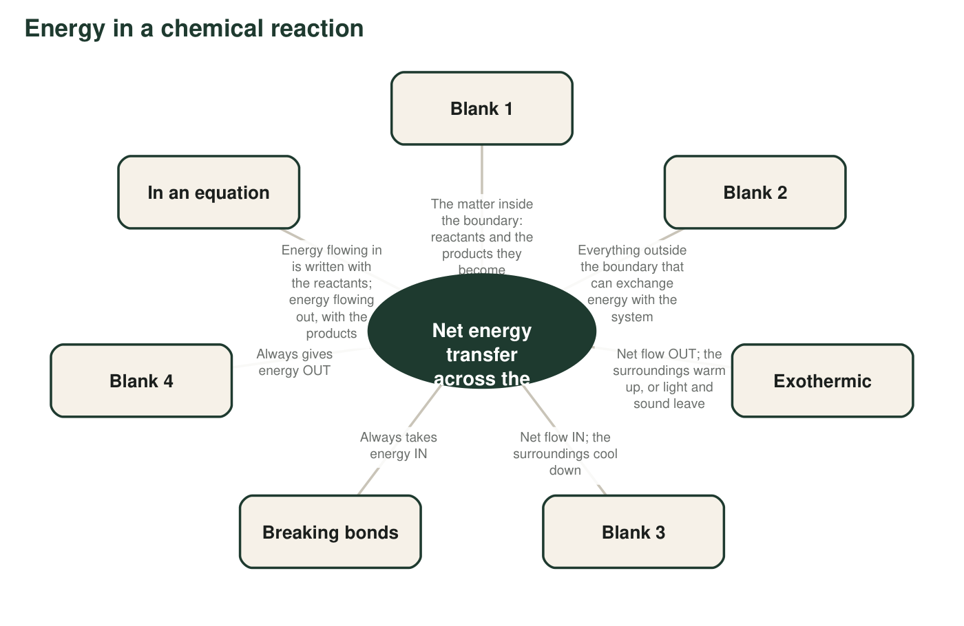
A concept map with four blanks. Each blank is a term or a short phrase from this chapter.
3a. Blank 1 is __________.
______________________________________________________________________________________
______________________________________________________________________________________
______________________________________________________________________________________
3b. Blank 2 is __________.
______________________________________________________________________________________
______________________________________________________________________________________
______________________________________________________________________________________
3c. Blank 3 is __________.
______________________________________________________________________________________
______________________________________________________________________________________
______________________________________________________________________________________
3d. Blank 4 is __________.
______________________________________________________________________________________
______________________________________________________________________________________
______________________________________________________________________________________
4. Use the map to finish this rule in your own words: 'A reaction is exothermic when the energy given out by __________ is greater than the energy taken in by __________, so the extra energy __________.'
______________________________________________________________________________________
______________________________________________________________________________________
______________________________________________________________________________________
5. Two hand warmers are both at 44 °C. One holds 10 g of reacting powder; the other holds 30 g. Which has more thermal energy, and why can two objects at the same temperature hold different amounts of it?
______________________________________________________________________________________
______________________________________________________________________________________
______________________________________________________________________________________

Part C: The engineering words in a design brief
Brief from a ski-patrol volunteer group
We need a pocket warmer for volunteers on the chairlift. It must reach at least 40 °C within 15 minutes and stay above 35 °C for at least 3 hours. It must never go above 50 °C, because it sits against skin. Each warmer must cost under one dollar and weigh under 60 g. Our first version used 10 g of iron powder; it peaked at 31 °C, so for the second version we doubled the iron. We will test every version the same way: thermometer readings every 15 minutes for 4 hours.
6. Label each line from the brief with the best term and say how you decided.
Criterion, constraint, prototype or iteration? | How you decided
Reaches at least 40 °C within 15 minutes
Never goes above 50 °C
Costs under one dollar
Stays above 35 °C for at least 3 hours
The first version with 10 g of iron
Doubling the iron for the second version

7. The brief gives a temperature the warmer must reach (40 °C) and a temperature it must not pass (50 °C). One is a criterion and one is a constraint. Explain the difference between the two kinds of statement using these two numbers.
______________________________________________________________________________________
______________________________________________________________________________________
______________________________________________________________________________________

Part D: Use the words together
8. A match has to be struck before it burns, and then it burns on its own. Write one or two sentences about the match that use both net energy transfer and exothermic correctly.
______________________________________________________________________________________
______________________________________________________________________________________
______________________________________________________________________________________
9. A sixth grader tells you, 'Endothermic just means you need a flame to make it happen.' Using the words system, surroundings and net, explain what endothermic really means and give one example of an endothermic change that happens with no flame at all.
______________________________________________________________________________________
______________________________________________________________________________________
______________________________________________________________________________________
______________________________________________________________________________________
______________________________________________________________________________________

Word parts as clues
Exo- means out and endo- means in; therm means heat. So exothermic is 'heat going out' of the system and endothermic is 'heat going in.' For the boundary questions, ask one test question about each item: 'Is this matter that reacts or matter that was made by the reaction?' If yes, it is system. If it is matter that did not take part, it is surroundings. If it is not matter at all (light, sound, warmth), it is energy crossing the boundary. For Part C, criteria are goals you aim for; constraints are limits you must not cross.

Endotherms and endothermic
Biologists call mammals and birds endotherms, because they keep themselves warm with energy released by reactions inside their own bodies. Compare the two uses of the word part endo-. In what sense is a bird's body an energy 'inside' story, and in what sense is a cold pack an energy 'inside' story? Then explain why the reactions that keep a bird warm must actually be exothermic, even though the animal is called an endotherm. Write a short paragraph that would clear up the confusion for a classmate.

