Angela's Tools · Chapter 14: Energy in Chemical Reactions · Worksheet 4 of 10

Boundaries, Bars and Arrows: Modeling Where the Energy Goes (Teacher answer key)
Learning target: I can read a system-and-surroundings diagram and an energy-bookkeeping bar chart, then build the matching model for a cold pack and show the energy term in each equation.
Diagrams and models · about 40 minutes · individual · Standards: MS-PS1-6 (practice)

Standards connections
MS-PS1-6 (practice): Before students can control the transfer of energy to the environment in a device, they need a model of that transfer. This sheet builds the boundary model and the bond-balance model for the two devices the design project uses, the iron hand warmer and the salt cold pack, without yet building or testing anything.

Answers with reasoning

Part A: The boundary around a hand warmer
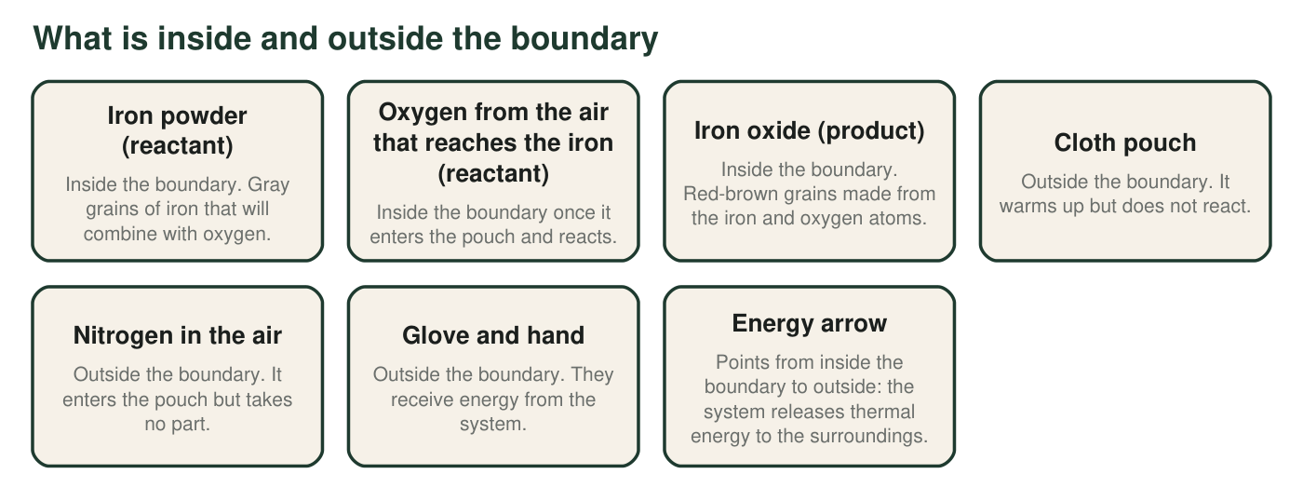
Figure 1. An iron-powder hand warmer resting in a gloved hand, with the boundary drawn around the reacting matter.
1. List the three items in Figure 1 that make up the system, and say in one sentence what the three have in common.
Answer: Iron powder, the oxygen that reaches and reacts with the iron, and the iron oxide product. All three are matter that takes part in the reaction: two are reactants and one is the product they become.
Reasoning: The system is the reacting matter plus the products; students must include the product and exclude the pouch.
Also acceptable: Accept 'the same atoms before and after the reaction' as the common feature.
Full credit must include:
• All three items named
• Common feature stated as reacting matter or products
2. Nitrogen enters the pouch just as oxygen does, yet the figure places nitrogen outside the boundary and oxygen inside it. Explain the difference.
Answer: Oxygen combines with the iron, so it is a reactant and part of the system. Nitrogen enters the pouch but does not react with anything; it is matter that can exchange energy but is not part of the chemical change, so it stays in the surroundings.
Reasoning: Being nearby is not the test; taking part in the reaction is.
Also acceptable: Accept 'nitrogen is just a bystander.'
Full credit must include:
• Oxygen reacts, nitrogen does not
• Reacting is the test for the boundary
3. Which way does the energy arrow point, and what single word describes a reaction whose arrow points that way?
Answer: From inside the boundary to outside (system to surroundings). Exothermic.
Reasoning: An outward net flow of energy is the definition of exothermic.
Also acceptable: None.
Full credit must include:
• Outward direction
• The word exothermic

Part B: Energy bookkeeping for the hand warmer
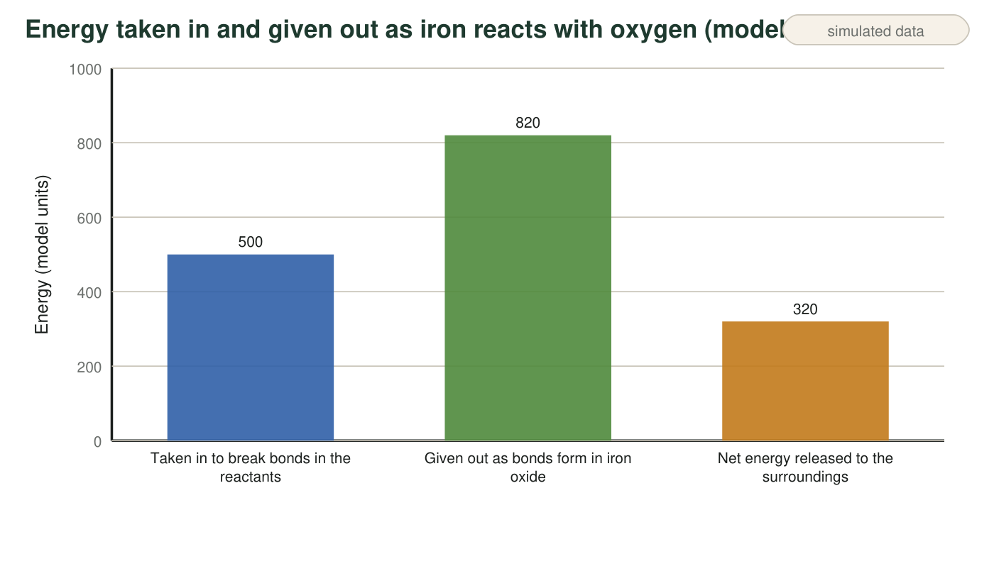
Figure 2. Teaching model with invented energy units: how much energy the hand-warmer reaction takes in and gives out. Real bond energies are not shown.
4. Show the subtraction that gives the third bar from the first two.
Answer: 820 units − 500 units = 320 units released to the surroundings.
Reasoning: The net is the energy given out by forming bonds minus the energy taken in by breaking bonds.
Also acceptable: Accept the subtraction written as 820 − 500 = 320 with units on the answer.
5. The first bar is not zero. What does that tell you about what happens to bonds even in a reaction that gives off energy? Why does the first bar being smaller than the second make the reaction exothermic?
Answer: Bonds in the reactants still have to be broken, and breaking always takes energy in; even an exothermic reaction pays that cost first. The reaction is exothermic because the second bar (energy given out as the new bonds form) is larger than the first bar (energy taken in), so after the cost is paid there is energy left over that flows out to the surroundings.
Reasoning: This checks the qualitative model: both processes happen in every reaction; the comparison decides the direction.
Also acceptable: Accept 'you have to pay to break before you get paid for forming.'
Full credit must include:
• Breaking bonds takes energy in even in an exothermic reaction
• Direction decided by comparing the two bars
6. A classmate says, 'The 320 units were created when the iron caught the oxygen.' Rewrite the sentence so it is correct, using the words released and surroundings.
Answer: Sample: 'The 320 units were released to the surroundings because forming the bonds in iron oxide gave out more energy than breaking the bonds in the iron and oxygen took in.' Energy was transferred, not created.
Reasoning: Energy is conserved; the net amount came from the difference between forming and breaking and left the system.
Also acceptable: Accept 'The 320 units were released out of the system into the surroundings when the iron reacted with oxygen.'
Full credit must include:
• Uses released and surroundings
• No creation language
• Explains the source as the bond balance or as a transfer out of the system

Part C: A cold pack, step by step
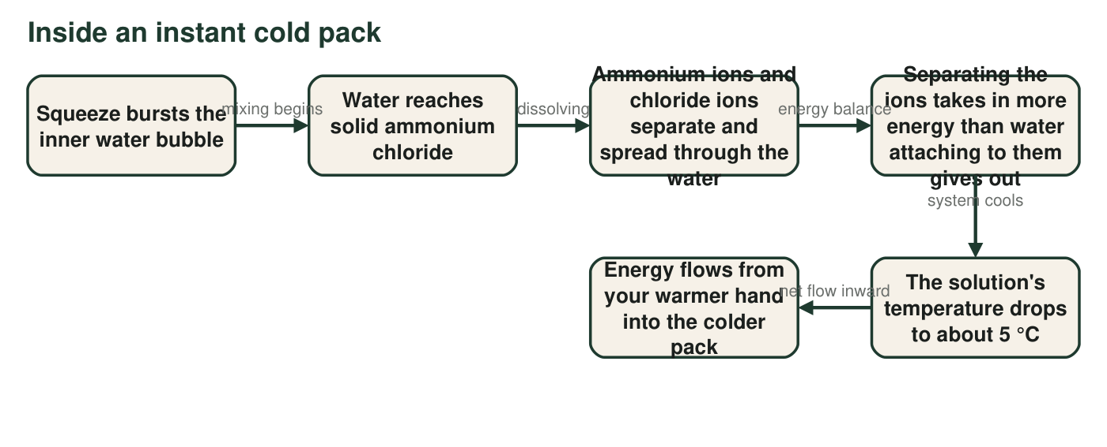
Figure 3. What happens from the squeeze to the cold feeling. In this figure the salt and the water it dissolves in are drawn as the system, and the bag, the air and your hand are the surroundings, so the thermometer in the water reads the system's temperature. (Labs 1 and 2 draw the water as surroundings instead; either boundary works if you use it consistently.)
7. Between which two boxes of Figure 3 does the pack actually become cold, and what is the energy balance that causes it?
Answer: Between the fourth box and the fifth box: separating the ions takes in more energy (700 model units in Part D) than water attaching to them gives out (640), so the solution's own thermal energy is used to make up the difference and its temperature drops.
Reasoning: The cooling is the result of the inward energy balance, which happens before any energy from the hand arrives.
Also acceptable: Accept 'at the energy balance step' with the correct comparison.
Full credit must include:
• Identifies the balance box leading to the temperature-drop box
• States that separating takes in more than attaching gives out
8. Your hand is part of the surroundings. Use the last box to explain why the pack feels cold without any 'cold' moving into your hand.
Answer: Your hand is warmer than the pack, and energy always flows on its own from warmer matter to cooler matter. So energy leaves your hand and enters the pack. Your skin senses that loss of energy as cold. Nothing moves from the pack into your hand; the only thing moving is energy, and it is moving out of you.
Reasoning: This repairs the 'cold flows in' misconception using the direction of transfer between warmer and cooler objects.
Also acceptable: Accept 'the pack takes heat from your hand' as long as the student says nothing travels the other way.
Full credit must include:
• Energy flows from hand to pack
• Cold is the sensation of losing energy, not a substance

Part D: Build the cold pack's model
Model numbers for your chart
Use these invented teaching values. Pulling the ammonium ions and chloride ions apart from one another takes in 700 units. Water molecules attaching to the separated ions gives out 640 units.
Draw two things, side by side. LEFT: a bar chart in the style of Figure 2 for the cold pack, with three labeled bars: energy taken in, energy given out, and the net energy. Label the third bar with its value and say whether it is absorbed from or released to the surroundings. RIGHT: a cold pack in a hand with a boundary drawn around the system, the surroundings labeled (hand, bag, air), and one energy arrow across the boundary pointing the correct way. Give your drawing a title that includes the word endothermic or exothermic.
Expected drawing: LEFT: three bars: taken in 700 units, given out 640 units, net 60 units absorbed from the surroundings (700 − 640 = 60). RIGHT: a boundary around the ammonium chloride and the water it dissolves in; the bag, hand and air labeled as surroundings; one arrow pointing from the hand or air into the boundary; a title such as 'Endothermic: cold pack absorbs energy from the surroundings.'
Reasoning: The first bar is taller, so the net is absorbed and the arrow points inward; the title must say endothermic.

Part E: Energy in the equation
9. Hand warmer: 4Fe + 3O₂ → 2Fe₂O₃. Rewrite the equation with the word energy on the correct side: __________________________________
Answer: 4Fe + 3O₂ → 2Fe₂O₃ + energy
Reasoning: Energy leaves the system, so it is written with the products.
Also acceptable: Accept '+ energy' written as '+ heat' with a note that light and sound would also count.
10. Cold pack: NH₄Cl → NH₄⁺ + Cl⁻. Rewrite the equation with the word energy on the correct side: __________________________________
Answer: NH₄Cl + energy → NH₄⁺ + Cl⁻
Reasoning: Energy enters the system, so it is written with the reactant. The products are the separated ions spread through water, not new compounds.
Also acceptable: Accept '(aq)' labels on the ions; do not accept energy on the right.
11. Count the iron atoms and the oxygen atoms on each side of your hand-warmer equation. Did adding the word energy change either count? Explain why not.
Answer: Left: 4 Fe and 3 × 2 = 6 O. Right: 2 × 2 = 4 Fe and 2 × 3 = 6 O. The counts match, and adding the word energy changed nothing because energy is not made of atoms; it is a record of what crossed the boundary, not a substance in the equation.
Reasoning: Students should count both elements and connect the unchanged count to energy not being matter.
Also acceptable: Accept 'energy has no atoms, so nothing to count.'
Full credit must include:
• Correct counts on both sides
• States energy is not matter so it adds no atoms

Teacher notes
Figure 2's values (500, 820, 320) and the cold-pack values (700, 640, 60) are invented model units chosen only to make the comparison visible; do not let students treat them as measurements or compute anything beyond the subtraction. The language 'taken in to break' and 'given out as bonds form' is deliberate; avoid 'energy stored in bonds.' For the cold pack the attractions being overcome are between ions (and between water molecules), not covalent bonds; the sheet says 'separating the ions' for that reason. This sheet draws the dissolving water inside the cold-pack system, so the thermometer in the water reads the system and the pack cools before any energy arrives from the hand; Labs 1 and 2 put the water in the surroundings instead, and the chapter accepts either boundary if a student uses it consistently (slide 5 notes). The cold-pack equation uses ions; the textbook's ammonium hydroxide version is incorrect and must not be shown.

