Angela's Tools · Chapter 14: Energy in Chemical Reactions · Worksheet 4 of 10

Boundaries, Bars and Arrows: Modeling Where the Energy Goes
Learning target: I can read a system-and-surroundings diagram and an energy-bookkeeping bar chart, then build the matching model for a cold pack and show the energy term in each equation.
Diagrams and models · about 40 minutes · individual · Standards: MS-PS1-6 (practice)
Name: ____________________________ Date: ____________ Period: ______

Directions
Study each figure before answering the questions about it. Figure 1 shows where the boundary goes for a hand warmer. Figure 2 is an energy bookkeeping chart for the same reaction; its numbers are model units invented for teaching, not real measurements. Figure 3 traces a cold pack step by step. In Part D you will draw the cold pack's own bookkeeping chart and boundary, and in Part E you will place the energy term in two equations. Label everything you draw.

Part A: The boundary around a hand warmer
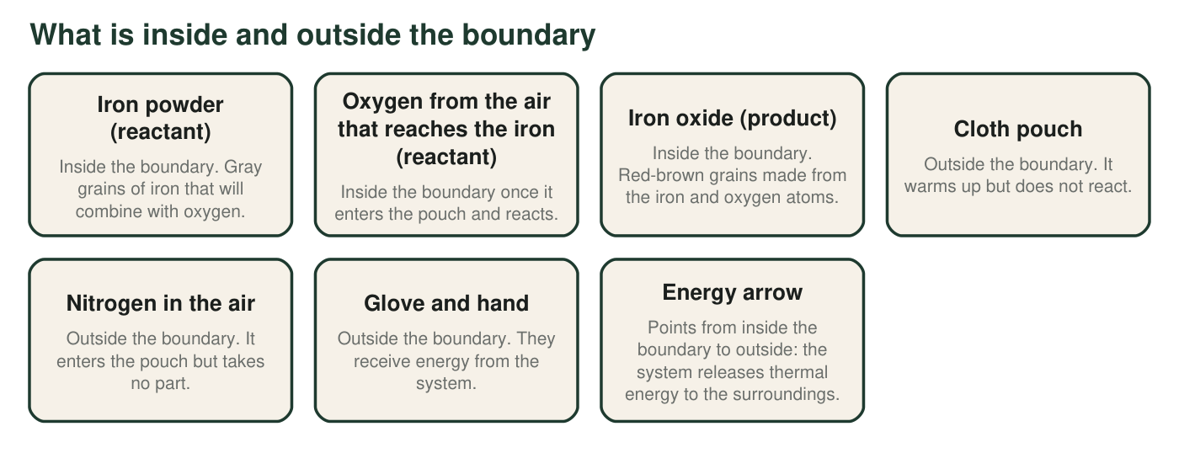
Figure 1. An iron-powder hand warmer resting in a gloved hand, with the boundary drawn around the reacting matter.
1. List the three items in Figure 1 that make up the system, and say in one sentence what the three have in common.
______________________________________________________________________________________
______________________________________________________________________________________
2. Nitrogen enters the pouch just as oxygen does, yet the figure places nitrogen outside the boundary and oxygen inside it. Explain the difference.
______________________________________________________________________________________
______________________________________________________________________________________
______________________________________________________________________________________
3. Which way does the energy arrow point, and what single word describes a reaction whose arrow points that way?
______________________________________________________________________________________
______________________________________________________________________________________

Part B: Energy bookkeeping for the hand warmer
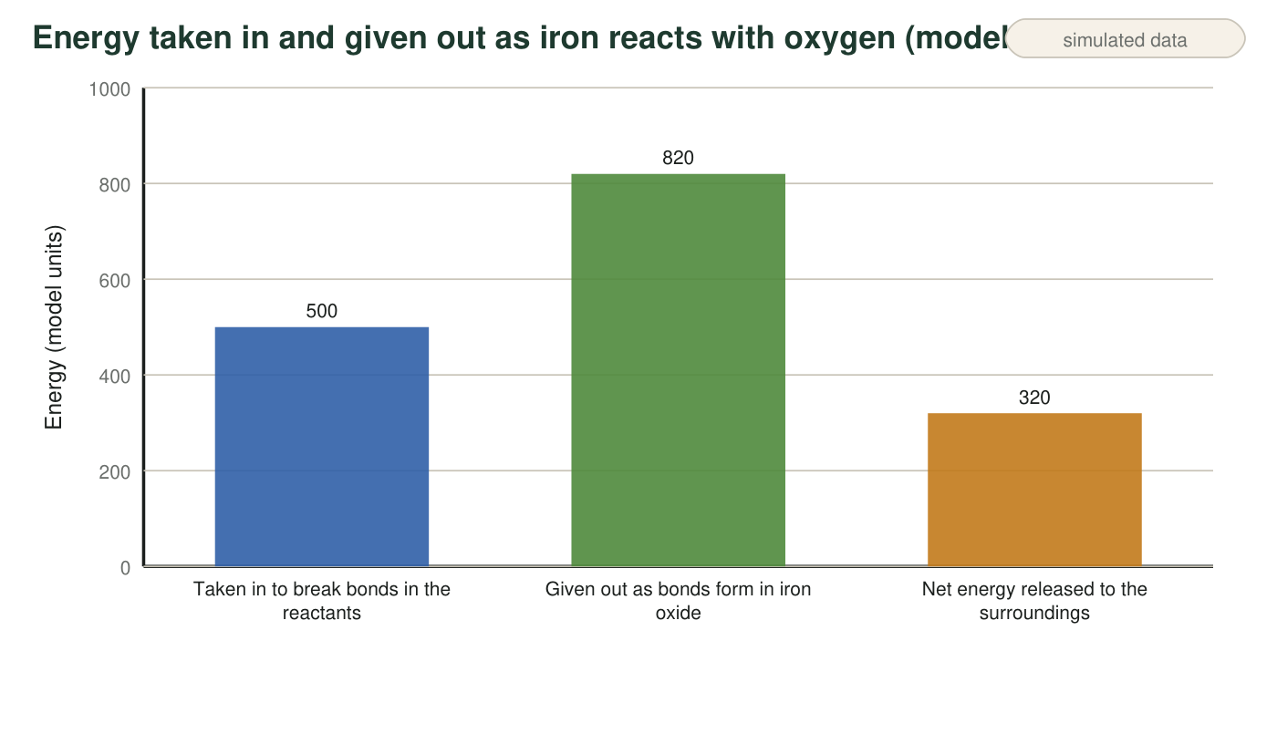
Figure 2. Teaching model with invented energy units: how much energy the hand-warmer reaction takes in and gives out. Real bond energies are not shown.
4. Show the subtraction that gives the third bar from the first two.
______________________________________________________________________________________
______________________________________________________________________________________
5. The first bar is not zero. What does that tell you about what happens to bonds even in a reaction that gives off energy? Why does the first bar being smaller than the second make the reaction exothermic?
______________________________________________________________________________________
______________________________________________________________________________________
______________________________________________________________________________________
6. A classmate says, 'The 320 units were created when the iron caught the oxygen.' Rewrite the sentence so it is correct, using the words released and surroundings.
______________________________________________________________________________________
______________________________________________________________________________________
______________________________________________________________________________________

Part C: A cold pack, step by step
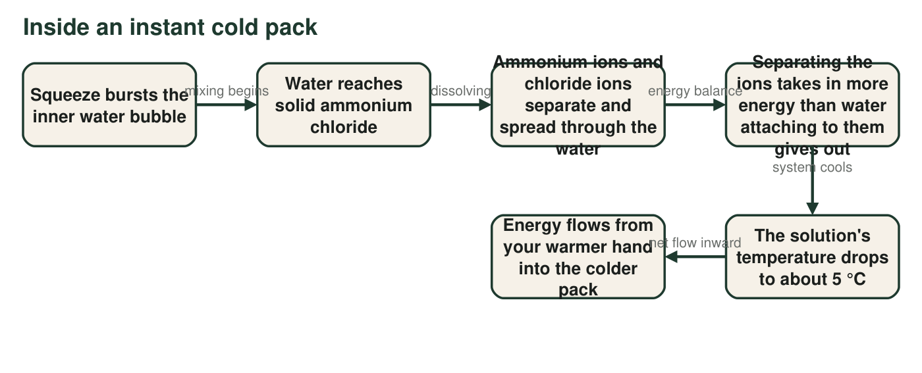
Figure 3. What happens from the squeeze to the cold feeling. In this figure the salt and the water it dissolves in are drawn as the system, and the bag, the air and your hand are the surroundings, so the thermometer in the water reads the system's temperature. (Labs 1 and 2 draw the water as surroundings instead; either boundary works if you use it consistently.)
7. Between which two boxes of Figure 3 does the pack actually become cold, and what is the energy balance that causes it?
______________________________________________________________________________________
______________________________________________________________________________________
______________________________________________________________________________________
8. Your hand is part of the surroundings. Use the last box to explain why the pack feels cold without any 'cold' moving into your hand.
______________________________________________________________________________________
______________________________________________________________________________________
______________________________________________________________________________________

Part D: Build the cold pack's model
Model numbers for your chart
Use these invented teaching values. Pulling the ammonium ions and chloride ions apart from one another takes in 700 units. Water molecules attaching to the separated ions gives out 640 units.
Draw two things, side by side. LEFT: a bar chart in the style of Figure 2 for the cold pack, with three labeled bars: energy taken in, energy given out, and the net energy. Label the third bar with its value and say whether it is absorbed from or released to the surroundings. RIGHT: a cold pack in a hand with a boundary drawn around the system, the surroundings labeled (hand, bag, air), and one energy arrow across the boundary pointing the correct way. Give your drawing a title that includes the word endothermic or exothermic.

Part E: Energy in the equation
9. Hand warmer: 4Fe + 3O₂ → 2Fe₂O₃. Rewrite the equation with the word energy on the correct side: __________________________________
______________________________________________________________________________________
______________________________________________________________________________________
______________________________________________________________________________________
10. Cold pack: NH₄Cl → NH₄⁺ + Cl⁻. Rewrite the equation with the word energy on the correct side: __________________________________
______________________________________________________________________________________
______________________________________________________________________________________
______________________________________________________________________________________
11. Count the iron atoms and the oxygen atoms on each side of your hand-warmer equation. Did adding the word energy change either count? Explain why not.
______________________________________________________________________________________
______________________________________________________________________________________
______________________________________________________________________________________

Two questions for every item
To decide whether something is inside the boundary, ask: 'Does it react, or was it made by the reaction?' If yes, it is system. For the bar charts, the rule is always the same: taken in (breaking apart) on the first bar, given out (joining) on the second, and the net is the difference. If the second bar is taller, the net is released and the arrow points out; if the first bar is taller, the net is absorbed and the arrow points in. For Part D, your first bar (700) is taller than your second (640), so decide which way the arrow goes before you draw it.

A reaction with a push to start
A match needs a scrape of energy before it burns, but burning is strongly exothermic. Draw a third bookkeeping chart for the match with a small extra bar labeled 'start-up energy from the scrape' before the two main bars, and explain in a few sentences why the start-up bar is not part of the net calculation once the match is burning. Then explain why the textbook's rule 'a reaction that needs a continuous supply of energy is endothermic' is safer to state as 'a reaction whose net transfer is inward is endothermic.'

