Angela's Tools · Chapter 14: Energy in Chemical Reactions · Worksheet 9 of 10

A Cold Pack for the Cross-Country Kit: Define, Evaluate, Modify (Teacher answer key)
Learning target: I can turn a user's needs into precise criteria and constraints, evaluate four cold-pack designs against them with test data, and propose a modified design with predicted temperature, time, cost and mass.
Transfer and design · about 50 minutes · pairs · Standards: MS-ETS1-1 (assesses), MS-ETS1-2 (assesses), MS-PS1-6 (practice)

Standards connections
MS-ETS1-1 (assesses): Students read a school nurse's letter and write the criteria and constraints themselves, each with a number, including a safety limit that protects people and a no-toxic-leak rule that considers people and the environment. That is the PE's task of defining a design problem with precision.
MS-ETS1-2 (assesses): Students evaluate four competing cold-pack designs with a pass/fail decision table against the criteria and constraints they defined, a systematic process that produces evidence toward this PE.
MS-PS1-6 (practice): The device absorbs thermal energy by a chemical process and is judged by amount, time and temperature, inside the PE's assessment boundary. Students modify a design on paper from supplied test data rather than constructing and testing it themselves, so this is practice; Lab 2 produces the hands-on evidence.

Answers with reasoning
Letter from the school nurse
Thanks for taking this on. When a runner rolls an ankle, I need to start icing within a minute or two, and one icing session lasts about 20 minutes, so a pack has to get down to 10 °C or colder within 2 minutes and stay below 15 °C for at least 20 minutes. It must never go below 0 °C, because a pack that cold can injure skin. I restock ten packs each season and my budget for them is $8.00. Each pack must weigh 200 g or less, since the kit is carried to the course. If a pack leaks in the kit or on a runner's skin, the contents must not be harmful to anyone or to the field, and nothing inside may build up gas, because a pack that swells or bursts in the kit is useless. Single-use is fine.

Part A: Define the problem
1. Turn the nurse's letter into six precise statements. Each needs a number or a clear limit, and each must be labeled as a criterion (a goal to meet) or a constraint (a limit not to cross). For the cost row, calculate the limit per pack from the budget.
Answer: Temperature to reach: at or below 10 °C within 2 minutes; criterion. Time to stay cold: below 15 °C for at least 20 minutes; criterion. Lowest allowed temperature: never below 0 °C; constraint (safety). Cost per pack: $8.00 ÷ 10 packs = $0.80 or less per pack; constraint. Mass per pack: 200 g or less; constraint. Contents and gas: no harmful contents if it leaks and no gas build-up; constraint.
Reasoning: Each statement must carry its number and be labeled; the cost limit must be computed from the budget.
Also acceptable: Accept 'single-use allowed' noted as neither a criterion nor a constraint. A student who labels the 20-minute rule a constraint ('must last at least 20 min') shows a defensible reading; discuss that targets to meet are usually treated as criteria.
Full credit must include:
• All six statements with numbers or clear limits
• Two criteria and four constraints correctly labeled
• Cost limit computed as $0.80
2. Two of the nurse's rules protect people or the environment rather than describe how well the pack cools. Name them and say who or what each one protects.
Answer: The 0 °C floor protects the runner's skin from cold injury. The no-harmful-contents, no-gas rule protects anyone the pack leaks on and the field or ground it leaks into, and protects the kit from a burst pouch.
Reasoning: ETS1-1 asks students to consider impacts on people and the environment; both rules are of that kind.
Also acceptable: Accept 'the nurse and the kit' as protected by the no-gas rule.
Full credit must include:
• Both rules named
• Who or what each protects

Part B: Evaluate last year's four designs
Ingredient prices and masses used by last year's team (teaching scenario)
Simulated teaching dataset (not real measurements).
Item | Cost | Note
Ammonium chloride | 1.7 cents per gram | Dissolves and absorbs energy; a common fertilizer ingredient; not harmful on skin in small amounts
Urea | 1.0 cent per gram | Dissolves and absorbs energy; a common fertilizer ingredient
Citric acid | 1.5 cents per gram | Food acid
Baking soda | 0.5 cent per gram | Reacts with citric acid in water, producing carbon dioxide gas
Empty pouch with inner water bubble | 5 cents each | Mass 10 g empty
Water | free | 1 mL has a mass of 1 g

Test results for four designs, pouch pressed against a 33 °C skin-temperature plate (teaching dataset)
Simulated teaching dataset (not real measurements).
Design | Contents | Lowest temperature (°C) | Minute of lowest reading | Below 15 °C for (min) | Cost ($) | Mass (g) | Other notes
D1 | 30 g ammonium chloride + 100 mL water | 4 | 2 | 18 | 0.56 | 140 | No gas; stayed flat
D2 | 60 g ammonium chloride + 150 mL water | 1 | 3 | 33 | 1.07 | 220 | No gas; very cold to hold
D3 | 40 g urea + 100 mL water | 8 | 2 | 17 | 0.45 | 150 | No gas
D4 | 15 g citric acid + 15 g baking soda + 100 mL water | 12 | 1 | 5 | 0.35 | 140 | Pouch swelled with gas; test stopped at 6 min

Simulated results. Room and pouch started at 22 °C. 'Below 15 °C for' is the time from the squeeze until the pouch warmed back past 15 °C.
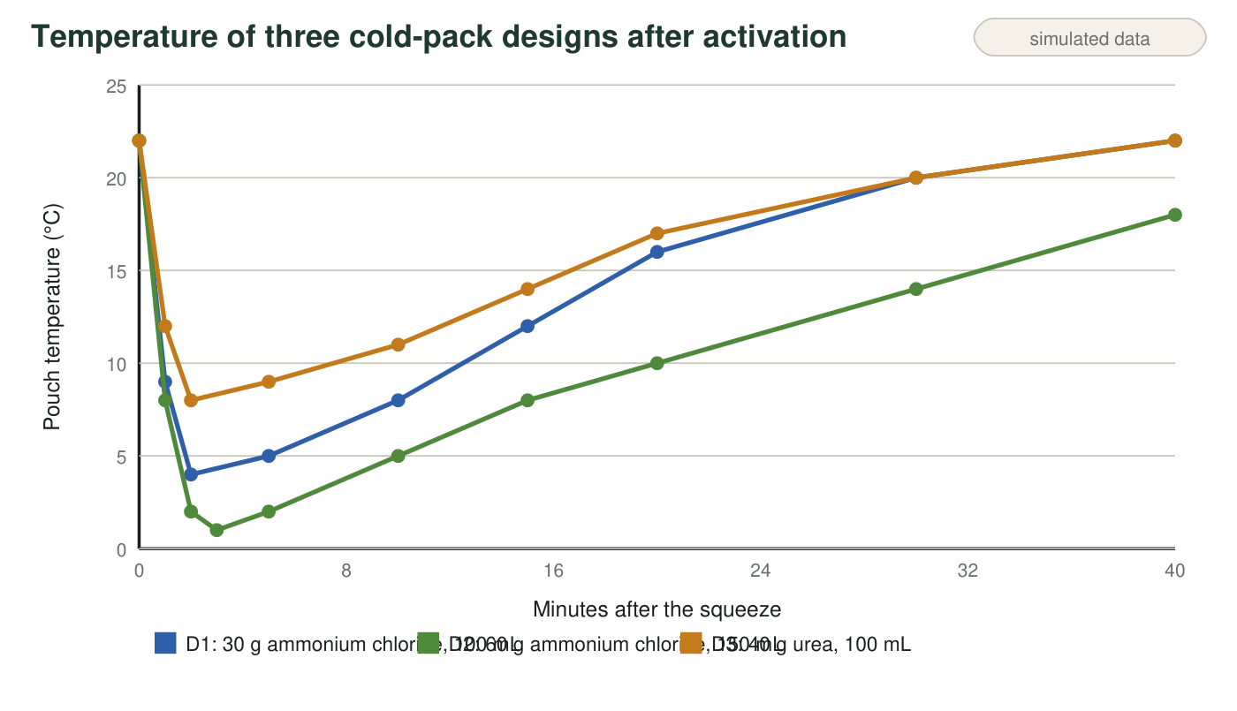
Teaching data: pouch temperature after the squeeze for designs D1, D2 and D3. D4 is not plotted because its test was stopped when the pouch swelled.
3. Check two of last year's costs using the price table: show that D1 costs about $0.56 and D2 about $1.07. Then show that D1's mass is 140 g.
Answer: D1: 30 g × $0.017/g = $0.51; + $0.05 pouch = $0.56. D2: 60 g × $0.017/g = $1.02; + $0.05 = $1.07. D1 mass: 30 g salt + 100 g water (100 mL × 1 g/mL) + 10 g pouch = 140 g.
Reasoning: Unit price times grams plus the pouch; mass is salt plus water plus empty pouch.
Also acceptable: Accept costs rounded to the cent.
4. Write PASS or FAIL in every cell, using the dataset and the graph.
Answer: D1: PASS (4 °C at 2 min), FAIL (18 min), PASS, PASS ($0.56), PASS (140 g), PASS. D2: PASS (2 °C at 2 min), PASS (33 min), PASS (1 °C is not below 0), FAIL ($1.07), FAIL (220 g), PASS. D3: PASS (8 °C), FAIL (17 min), PASS, PASS ($0.45), PASS (150 g), PASS. D4: FAIL (12 °C), FAIL (5 min), PASS, PASS ($0.35), PASS (140 g), FAIL (gas).
Reasoning: Each cell follows from the dataset; D2's 1 °C low passes the 0 °C floor narrowly.
Also acceptable: Accept D2's temperature criterion read from the 2-minute graph point (2 °C) or the 3-minute low; both pass.
5. No design passes everything. Which design comes closest, how many cells did it fail, and which single criterion or constraint stands between it and success?
Answer: D1 comes closest: it fails only one cell, the 20-minute time criterion (it stayed below 15 °C for 18 minutes). D3 also fails only one cell (17 minutes) but is warmer and shorter than D1, so D1 is the better base.
Reasoning: Students should count failures and identify the single gap.
Also acceptable: Accept D3 as closest if the student argues from its lower cost, as long as the failed time criterion is named.
Full credit must include:
• Names D1 (or D3 with a reason)
• One failed cell
• The time criterion identified
6. D2 is the coldest and lasts the longest, yet it is a poor choice for this kit. Name every criterion or constraint it fails and explain why 'colder and longer' is not the same as 'better' here.
Answer: D2 fails the cost constraint ($1.07 against $0.80) and the mass constraint (220 g against 200 g), and its 1 °C low is uncomfortably close to the 0 °C safety floor. Colder and longer is not better because the nurse's problem includes limits the pack must stay inside; a pack that cannot be afforded or carried does not solve her problem no matter how well it cools.
Reasoning: Constraints are part of the problem; exceeding criteria does not excuse breaking constraints.
Also acceptable: Accept the note about the 0 °C margin as an additional point, not a required one.
Full credit must include:
• Both failed constraints named
• Explains that constraints define the problem as much as criteria do

Part C: Modify and predict
7. The budget allows $0.80 per pack and the empty pouch costs $0.05. Calculate the most ammonium chloride, in grams, that a pack can hold and stay inside the budget. Show your work.
Answer: Money left for salt: $0.80 − $0.05 = $0.75. Grams: $0.75 ÷ $0.017 per g = 44.1 g, so at most 44 g of ammonium chloride.
Reasoning: Subtract the pouch cost, then divide by the unit price; round down because 45 g would exceed the budget.
Also acceptable: Accept 44 g; accept 44.1 g with a note that 44 g is the practical limit.
8. Propose your modified design, changing D1 by one main factor (amount of ammonium chloride, amount of water, or both in proportion). State the grams of salt and milliliters of water. Calculate its cost and its mass. Then predict its lowest temperature and its time below 15 °C, and justify both predictions using the trend from D1 to D2. Finally, check your design against all six cells of your table.
Answer: Sample: 40 g ammonium chloride + 110 mL water. Cost: 40 × $0.017 = $0.68; + $0.05 = $0.73 (≤ $0.80, PASS). Mass: 40 + 110 + 10 = 160 g (≤ 200 g, PASS). Predictions: lowest temperature about 3 °C, because going from D1 (30 g) to D2 (60 g) lowered the minimum from 4 °C to 1 °C, and 40 g is a third of the way from 30 g toward 60 g with a little more water to cool; time below 15 °C about 23-25 minutes, because D2's doubled salt lengthened the time from 18 to 33 minutes, and a third of that increase added to 18 min gives about 23 min (a bit more because the salt-to-water ratio also rose). Check: reaches ≤ 10 °C within 2 min (PASS, like D1 and D2); below 15 °C for ≥ 20 min (PASS by prediction, to be tested); never below 0 °C (PASS, 3 °C); cost PASS; mass PASS; no gas or harmful contents PASS.
Reasoning: A strong answer changes D1 by one main factor, computes cost and mass correctly, interpolates both predictions between D1 and D2 with explicit reference to the trend, and checks all six cells. Any salt mass from about 36 g to 44 g with proportionate water is reasonable.
Also acceptable: A design that keeps 30 g of salt but reduces water to 80 mL (raising concentration) is a different valid single-factor change; its predictions should say colder but not necessarily longer, since less water holds less thermal energy to absorb. A design above 44 g of salt fails the budget and should be marked down on the cost check.
Full credit must include:
• States grams of salt and mL of water
• Cost and mass calculated correctly and inside the limits
• Lowest temperature predicted between D1's and D2's values with a reason from the trend
• Time predicted at or above 20 min with a reason from the trend
• All six cells checked
9. Which way does energy flow when your pack is pressed on a runner's ankle, and what is the system? Write the process as an equation with the energy term on the correct side.
Answer: Energy flows from the ankle (and the air) into the pack. The system is the ammonium chloride and the water it dissolves in; the pouch, the ankle and the air are the surroundings. Equation: NH₄Cl + energy → NH₄⁺ + Cl⁻ (ions spread through the water).
Reasoning: The pack is endothermic: energy is written with the reactant; the products are separated ions, not new compounds.
Also acceptable: Accept '(aq)' labels. Do not accept energy on the product side or the textbook's ammonium hydroxide equation.
Full credit must include:
• Direction: surroundings (ankle) into the pack
• System named
• Energy on the reactant side with ions as products
10. You get to build and test your design once before the season. Name the two measurements you would make, and describe one result that would send you back to modify the design again, and what you would change.
Answer: Measurements: the lowest temperature and the minute it occurs (checked against 10 °C within 2 min and the 0 °C floor), and the time until the pouch warms back past 15 °C (checked against 20 min). A result that sends you back: the pouch warms past 15 °C at, say, 19 minutes. Change: add a few more grams of salt (staying under 44 g) or a little more water in proportion, and retest; if instead the low dipped below 0 °C, reduce the salt or add water.
Reasoning: The two measurements match the PE's amount-time-temperature boundary; the modification must follow from the failed measurement.
Also acceptable: Accept mass or cost as a measurement if the student also names a temperature and a time.
Full credit must include:
• Both measurements named
• A specific failing result
• A change that addresses that result and stays inside the constraints

Scoring rubric
Criterion | 4 Exemplary | 3 Proficient | 2 Developing | 1 Beginning
Defining criteria and constraints | Six precise statements, each with a number or clear limit, correctly sorted; the cost limit is computed; the two people-and-environment rules are identified with who or what they protect. | Six statements with numbers; one mislabeled, or the protection question answered for only one rule. | Statements copied from the letter without numbers, or several mislabeled. | Criteria and constraints missing or not distinguished.
Evaluating the designs | Every cell of the decision table correct and based on the data; cost and mass checks shown; the closest design and its single gap identified; D2's failures explained in terms of constraints. | Table correct with one or two slips; the closest design identified; D2 explanation incomplete. | Table judged on temperature alone, ignoring cost, mass or gas. | No systematic evaluation.
Modifying and predicting | One main factor changed; cost and mass calculated inside the limits; both predictions justified from the D1-to-D2 trend; all six cells rechecked. | Design and calculations correct; one prediction unjustified or one cell unchecked. | Design stated without calculations, or predictions guessed without the trend. | No design, or a design that breaks a constraint without noticing.
Science of the device | Correct direction of energy flow, system and surroundings named, equation with energy on the reactant side and ions as products, and a test plan tied to amount, time and temperature. | Direction and equation correct; system or test plan vague. | Direction correct but the equation places energy on the wrong side, or says cold flows. | Energy direction wrong or missing.

Teacher notes
All prices, masses and test results are simulated but realistic: ammonium chloride solutions can cool by 15-20 °C at these concentrations, urea somewhat less; both are common fertilizer ingredients and are not hazardous on skin in small amounts, which is why the nurse's leak rule accepts them. D4 (citric acid and baking soda) is included to make the no-gas constraint bite; it does cool, but carbon dioxide inflates a sealed pouch. The 33 °C skin plate in the test caption is why the packs warm back up within tens of minutes. The budget calculation in q7 (44 g) is the hinge of Part C: it caps the obvious 'add more salt' modification, so students must reason about proportion rather than just doubling. If students who did Lab 2 ask whether their calcium chloride warming pack could be adapted, point out that this brief needs an endothermic process. Do not let students test ammonium chloride without the Lab 2 safety sheet; this worksheet is a paper design task.

