Angela's Tools · Chapter 14: Energy in Chemical Reactions · Worksheet 9 of 10

A Cold Pack for the Cross-Country Kit: Define, Evaluate, Modify
Learning target: I can turn a user's needs into precise criteria and constraints, evaluate four cold-pack designs against them with test data, and propose a modified design with predicted temperature, time, cost and mass.
Transfer and design · about 50 minutes · pairs · Standards: MS-ETS1-1 (assesses), MS-ETS1-2 (assesses), MS-PS1-6 (practice)
Name: ____________________________ Date: ____________ Period: ______

Directions
You are the student engineering team for a middle-school cross-country program in California's Central Valley, where August practices are hot and sprained ankles are common. The school nurse has written to you. Part A turns her letter into criteria and constraints with numbers. Part B uses the test results from four designs built last year to decide how well each one does. Part C asks you to modify the closest design and predict what it will do. All test numbers and prices are a teaching scenario, invented to be realistic; the nurse is fictional. Show every calculation with units.
Letter from the school nurse
Thanks for taking this on. When a runner rolls an ankle, I need to start icing within a minute or two, and one icing session lasts about 20 minutes, so a pack has to get down to 10 °C or colder within 2 minutes and stay below 15 °C for at least 20 minutes. It must never go below 0 °C, because a pack that cold can injure skin. I restock ten packs each season and my budget for them is $8.00. Each pack must weigh 200 g or less, since the kit is carried to the course. If a pack leaks in the kit or on a runner's skin, the contents must not be harmful to anyone or to the field, and nothing inside may build up gas, because a pack that swells or bursts in the kit is useless. Single-use is fine.

Part A: Define the problem
1. Turn the nurse's letter into six precise statements. Each needs a number or a clear limit, and each must be labeled as a criterion (a goal to meet) or a constraint (a limit not to cross). For the cost row, calculate the limit per pack from the budget.
Statement from the letter, written with its number | Criterion or constraint?
Temperature to reach
Time to stay cold
Lowest allowed temperature
Cost per pack
Mass per pack
Contents and gas

2. Two of the nurse's rules protect people or the environment rather than describe how well the pack cools. Name them and say who or what each one protects.
______________________________________________________________________________________
______________________________________________________________________________________
______________________________________________________________________________________

Part B: Evaluate last year's four designs
Ingredient prices and masses used by last year's team (teaching scenario)
Simulated teaching dataset (not real measurements).
Item | Cost | Note
Ammonium chloride | 1.7 cents per gram | Dissolves and absorbs energy; a common fertilizer ingredient; not harmful on skin in small amounts
Urea | 1.0 cent per gram | Dissolves and absorbs energy; a common fertilizer ingredient
Citric acid | 1.5 cents per gram | Food acid
Baking soda | 0.5 cent per gram | Reacts with citric acid in water, producing carbon dioxide gas
Empty pouch with inner water bubble | 5 cents each | Mass 10 g empty
Water | free | 1 mL has a mass of 1 g

Test results for four designs, pouch pressed against a 33 °C skin-temperature plate (teaching dataset)
Simulated teaching dataset (not real measurements).
Design | Contents | Lowest temperature (°C) | Minute of lowest reading | Below 15 °C for (min) | Cost ($) | Mass (g) | Other notes
D1 | 30 g ammonium chloride + 100 mL water | 4 | 2 | 18 | 0.56 | 140 | No gas; stayed flat
D2 | 60 g ammonium chloride + 150 mL water | 1 | 3 | 33 | 1.07 | 220 | No gas; very cold to hold
D3 | 40 g urea + 100 mL water | 8 | 2 | 17 | 0.45 | 150 | No gas
D4 | 15 g citric acid + 15 g baking soda + 100 mL water | 12 | 1 | 5 | 0.35 | 140 | Pouch swelled with gas; test stopped at 6 min

Simulated results. Room and pouch started at 22 °C. 'Below 15 °C for' is the time from the squeeze until the pouch warmed back past 15 °C.
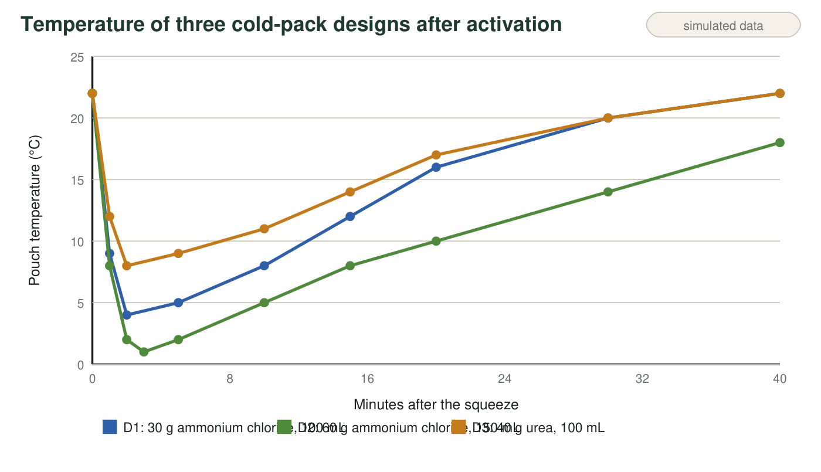
Teaching data: pouch temperature after the squeeze for designs D1, D2 and D3. D4 is not plotted because its test was stopped when the pouch swelled.
3. Check two of last year's costs using the price table: show that D1 costs about $0.56 and D2 about $1.07. Then show that D1's mass is 140 g.
______________________________________________________________________________________
______________________________________________________________________________________
______________________________________________________________________________________
______________________________________________________________________________________
4. Write PASS or FAIL in every cell, using the dataset and the graph.
Reaches ≤ 10 °C within 2 min | Below 15 °C for ≥ 20 min | Never below 0 °C | Cost ≤ $0.80 | Mass ≤ 200 g | No gas, nothing harmful
D1
D2
D3
D4

5. No design passes everything. Which design comes closest, how many cells did it fail, and which single criterion or constraint stands between it and success?
______________________________________________________________________________________
______________________________________________________________________________________
______________________________________________________________________________________
6. D2 is the coldest and lasts the longest, yet it is a poor choice for this kit. Name every criterion or constraint it fails and explain why 'colder and longer' is not the same as 'better' here.
______________________________________________________________________________________
______________________________________________________________________________________
______________________________________________________________________________________

Part C: Modify and predict
7. The budget allows $0.80 per pack and the empty pouch costs $0.05. Calculate the most ammonium chloride, in grams, that a pack can hold and stay inside the budget. Show your work.
______________________________________________________________________________________
______________________________________________________________________________________
______________________________________________________________________________________
8. Propose your modified design, changing D1 by one main factor (amount of ammonium chloride, amount of water, or both in proportion). State the grams of salt and milliliters of water. Calculate its cost and its mass. Then predict its lowest temperature and its time below 15 °C, and justify both predictions using the trend from D1 to D2. Finally, check your design against all six cells of your table.
______________________________________________________________________________________
______________________________________________________________________________________
______________________________________________________________________________________
______________________________________________________________________________________
______________________________________________________________________________________
______________________________________________________________________________________
______________________________________________________________________________________
______________________________________________________________________________________
9. Which way does energy flow when your pack is pressed on a runner's ankle, and what is the system? Write the process as an equation with the energy term on the correct side.
______________________________________________________________________________________
______________________________________________________________________________________
______________________________________________________________________________________
10. You get to build and test your design once before the season. Name the two measurements you would make, and describe one result that would send you back to modify the design again, and what you would change.
______________________________________________________________________________________
______________________________________________________________________________________
______________________________________________________________________________________

Criteria are goals, constraints are limits
The nurse's letter mixes goals and limits. Read it once marking every number. A number the pack is trying to reach or beat (10 °C within 2 minutes; 20 minutes of cold) is a criterion. A number the pack must not cross (0 °C; $0.80; 200 g) is a constraint, and so is the no-gas, no-harm rule even though it has no number. For q8, remember that D2 has twice the salt of D1 and got 3 °C colder and lasted 15 minutes longer; your change will be smaller than doubling, so your predictions should land between D1's results and D2's.

Ratio versus amount
D1 used 30 g of salt in 100 mL of water (0.30 g per mL) and D2 used 60 g in 150 mL (0.40 g per mL). Two things changed at once: the total amount of salt and the concentration. Design two more test packs that would separate the two effects: one that keeps D1's concentration but increases the total amount, and one that keeps D1's total salt but raises the concentration. Predict which pack gets colder and which lasts longer, and explain your predictions using thermal energy, temperature and the amount of water that has to be cooled.

