Angela's Tools · Chapter 15: Chemical Engineering and Society · Worksheet 1 of 10

Two Black Jackets: Where Did Each One Come From? (Teacher answer key)
Learning target: I can observe two materials that do the same job, ask questions about where each one came from, and write a first explanation of why people make materials that nature does not.
Phenomenon exploration · about 25 minutes · individual · Standards: MS-PS1-3 (practice)

Standards connections
MS-PS1-3 (practice): Students begin tracing a synthetic material (faux leather) and a natural one (leather) back to their starting resources and listing effects on people, which is the information-gathering this PE asks for. No evidence is produced yet; this sheet opens the questions.

Answers with reasoning

The scene
On a rack at a thrift store hang two black jackets. From across the room they look identical: same cut, same shine, same silver zipper. Up close, the tags tell different stories. Jacket A's tag says 100% leather, made from cowhide. Jacket B's tag says faux leather: polyurethane coating on a polyester knit. The store owner, Ms. Delgado, says customers pick each jacket up, bend the sleeve, sniff the collar, look at the price, and then argue with their friends about which one is 'real.' She has started keeping a list of what people say.
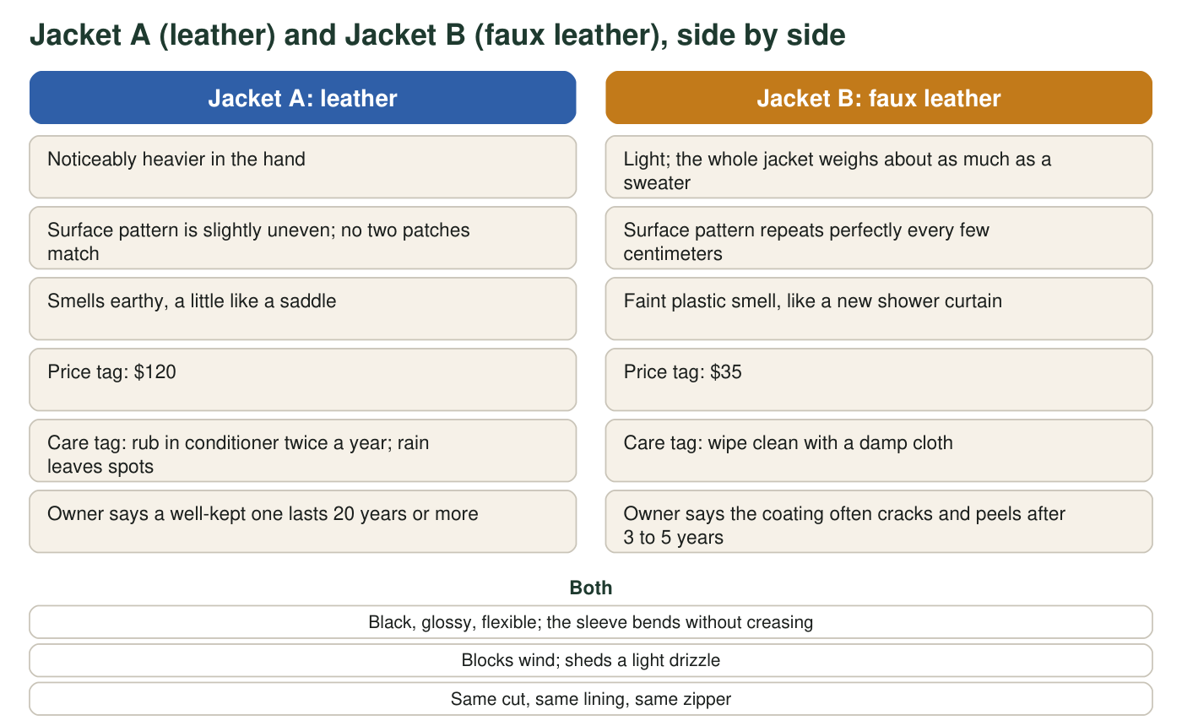
A described scene for discussion. The observations are the kind a careful shopper could make; no measurements were taken.

Part A: Notice and wonder
1. I notice... Write at least four observations from the figure. Include at least one thing the jackets share and at least one way they differ.
Answer: Any four accurate observations, for example: both jackets are black, glossy and flexible; both block wind; Jacket A is heavier while B is light; A's surface pattern is uneven while B's repeats; A smells earthy while B smells like plastic; A costs $120 and B costs $35; A needs conditioner while B wipes clean; A can last 20 years while B's coating cracks in 3 to 5 years.
Reasoning: Part A is for activating attention, not for grading accuracy. Credit any observation that comes from the figure; the requirement is at least one shared feature and at least one difference.
Also acceptable: Observations phrased as comparisons ('B is lighter than A') count as one observation each.
Full credit must include:
• At least four observations drawn from the figure
• At least one shared feature
• At least one difference
2. I wonder... Write at least three questions this scene raises for you. Try to include one question that starts with 'Where does' and one that starts with 'Why would'.
Answer: Sample questions: Where does the polyurethane in Jacket B come from? Where does the polyester knit come from? Why would a company make a copy of leather? Why would someone pay $120 when $35 does the same job? Why does the fake one crack? What happens to each jacket in a landfill? Does making leather or faux leather use more water or energy? Is one of them better for animals, workers or the air?
Reasoning: Look for genuine questions about origin, choice and consequences; these are the chapter's three threads (natural resources, chemical processes, impacts on society).
Also acceptable: Questions about animals, cost, or waste are all on target.
Full credit must include:
• At least three questions
• One begins with 'Where does' and one with 'Why would', or close equivalents
3. Faux leather costs about one third as much as leather but tends to wear out about four to seven times faster. Using the owner's numbers, estimate how many faux jackets a person might buy in the time one leather jacket lasts, and say what that suggests about which is really cheaper.
Answer: If a leather jacket lasts about 20 years and a faux jacket lasts about 3 to 5 years, a person might buy 20 ÷ 5 = 4 to 20 ÷ 3 ≈ 7 faux jackets in that time. At $35 each that is 4 × $35 = $140 to 7 × $35 = $245, compared with $120 for one leather jacket. So the faux jacket is cheaper today but may cost more over 20 years, and it produces more worn-out jackets to throw away.
Reasoning: The estimate uses only the owner's numbers from the figure. The point is that 'cheaper' depends on the time frame, which previews life-cycle thinking in W5.
Also acceptable: Accept any answer between 4 and 7 jackets; accept a conclusion that leather is cheaper over time, or that it depends on whether the person keeps a jacket that long.
Full credit must include:
• A count of faux jackets between about 4 and 7 with the division shown
• A comparison of total cost or waste over the same time

Part B: What do you already think?
4. Which statement best matches what you believe right now about the word synthetic?
Answer: B: Synthetic means made by people using chemical processes, starting from things found in nature.
Reasoning: This is a prior-knowledge probe; many students will choose A or C. Record the class distribution and return to it after Section 1 of the lesson. A synthetic material can even be identical to a natural one (lab-grown sapphire), so 'fake' is wrong; every synthetic material starts from natural resources, so 'out of nothing' is wrong; many synthetic materials (alloys, medicines, dyes) are not plastics, so D is wrong.
Also acceptable: Do not mark this item wrong at this stage; use it diagnostically.
5. Jacket A can be traced back to a living animal and the grass it ate. Try to trace Jacket B back the same way. What do you think polyurethane and polyester are made from, and where in nature did that starting material come from? It is fine to guess; write 'guess' next to anything you are unsure of.
Answer: Polyurethane and polyester are both plastics (polymers) made by chemical reactions from substances separated out of petroleum (crude oil), which was pumped from underground and took millions of years to form from the buried remains of ancient living things, mostly tiny ocean organisms. So Jacket B also traces back to living things, just very old ones.
Reasoning: Students are not expected to know this yet. Credit any attempt to trace backward and any honest 'guess' labels. The accurate chain is given so the teacher can preview it in the debrief: petroleum, chemical processing, polymer, coating and fabric.
Also acceptable: A student who says 'oil' or 'chemicals from a factory' has the right direction; 'plastic' alone is a start but does not reach a natural resource.
Full credit must include:
• Attempts a backward chain of at least two steps
• Marks uncertain steps as guesses
6. List three objects you touched this morning before school that you think are made of synthetic materials. For each one, name a natural resource you think it might have started from.
Answer: Examples: toothbrush (plastic handle and nylon bristles; petroleum), polyester or nylon clothing (petroleum), phone case (petroleum), a cereal bag (petroleum), a synthetic-rubber shoe sole (petroleum), a painkiller tablet (often petroleum-derived substances), a biodegradable cup (corn). Any reasonable source guess earns credit.
Reasoning: The goal is to make students notice how many everyday objects are synthetic and that most trace to petroleum, which the lesson's Key Science Concept spread develops.
Also acceptable: Accept 'plants' or 'corn' for compostable items and 'metal ore' for alloys.
Full credit must include:
• Three plausible synthetic objects
• A natural-resource guess for each

Part C: Your first explanation
7. Why would a company go to the trouble of making faux leather when leather already exists and does the job? Write a first explanation that names at least one benefit for the people who buy it, one benefit for the people who make it, and one possible cost to someone or something.
Answer: Sample explanation: Companies make faux leather because it can be made in large amounts from petroleum-based materials without raising and slaughtering animals, so it is cheaper for buyers (about $35 instead of $120) and lets people who object to animal products have a leather look. For makers, it can be produced in any color and pattern, in sheets of any size, and more quickly than raising cattle. A cost is that it wears out faster, so more jackets end up in landfills, and the petroleum it comes from is a limited resource whose extraction and processing can pollute. Making leather has costs too, such as land and water for cattle and chemicals used in tanning.
Reasoning: This is a first explanation; full credit is for structure and honest reasoning, not for complete accuracy. Look for one buyer benefit, one maker benefit and one cost. Students who mention costs on both sides are already thinking in trade-offs, which is the heart of the chapter.
Also acceptable: A student who argues leather is the better product overall is fine as long as the three required parts appear.
Full credit must include:
• A benefit for buyers
• A benefit for makers
• A cost to someone or something
• Written as an explanation, not a list
8. Suppose two shoppers argue about which jacket is 'better.' List three pieces of information you would want to look up before you could take a side. Be specific: not 'more facts' but, for example, 'how much water it takes to make each one.'
Answer: Examples: how much water, energy and land each material takes to make; what chemicals are used in tanning versus in making polyurethane and what happens to them; how long each jacket lasts on average; whether either can be recycled or will break down in a landfill; how workers are treated in each industry; how cattle farming affects the environment; whether the petroleum used could have gone to something else.
Reasoning: Specific, checkable questions are the point; 'more facts' earns no credit. This list previews the source checking students do with W8's evidence cards.
Also acceptable: Accept questions about price over time, animal welfare, or pollution if they are specific.
Full credit must include:
• Three specific pieces of information
• Each could actually be looked up

Teacher notes
This sheet mirrors the textbook's faux-leather phenomenon with an original scene; the observations are qualitative and described, not measured, which the figure caption states. The price and lifetime figures are typical ranges and are presented as the shop owner's experience, not as statistics. Use q4 as a show-of-hands diagnostic: 'synthetic means fake' and 'made from nothing' are the two misconceptions the chapter will dismantle (see W7). When discussing q7, avoid letting the class settle on 'natural good, synthetic bad' or the reverse; both jackets have benefits and costs, which is exactly the lesson's claim. Keep the completed sheet; W10's synthesis asks students to revise this first explanation.

