Angela's Tools · Chapter 15: Chemical Engineering and Society · Worksheet 1 of 10

Two Black Jackets: Where Did Each One Come From?
Learning target: I can observe two materials that do the same job, ask questions about where each one came from, and write a first explanation of why people make materials that nature does not.
Phenomenon exploration · about 25 minutes · individual · Standards: MS-PS1-3 (practice)
Name: ____________________________ Date: ____________ Period: ______

Directions
Read the scene and study the comparison figure. In Part A, write what you notice and what you wonder; there are no wrong answers in Part A. In Part B, use what you already know. In Part C, write your first explanation in complete sentences. You will come back to this sheet at the end of the chapter to see how your thinking changed.

The scene
On a rack at a thrift store hang two black jackets. From across the room they look identical: same cut, same shine, same silver zipper. Up close, the tags tell different stories. Jacket A's tag says 100% leather, made from cowhide. Jacket B's tag says faux leather: polyurethane coating on a polyester knit. The store owner, Ms. Delgado, says customers pick each jacket up, bend the sleeve, sniff the collar, look at the price, and then argue with their friends about which one is 'real.' She has started keeping a list of what people say.
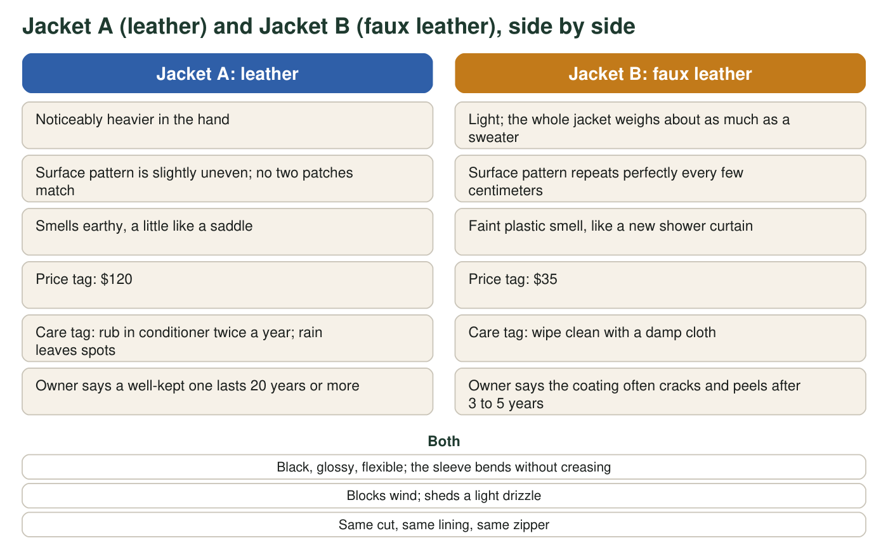
A described scene for discussion. The observations are the kind a careful shopper could make; no measurements were taken.

Part A: Notice and wonder
1. I notice... Write at least four observations from the figure. Include at least one thing the jackets share and at least one way they differ.
______________________________________________________________________________________
______________________________________________________________________________________
______________________________________________________________________________________
______________________________________________________________________________________
______________________________________________________________________________________
2. I wonder... Write at least three questions this scene raises for you. Try to include one question that starts with 'Where does' and one that starts with 'Why would'.
______________________________________________________________________________________
______________________________________________________________________________________
______________________________________________________________________________________
______________________________________________________________________________________
______________________________________________________________________________________
3. Faux leather costs about one third as much as leather but tends to wear out about four to seven times faster. Using the owner's numbers, estimate how many faux jackets a person might buy in the time one leather jacket lasts, and say what that suggests about which is really cheaper.
______________________________________________________________________________________
______________________________________________________________________________________
______________________________________________________________________________________

Part B: What do you already think?
4. Which statement best matches what you believe right now about the word synthetic?
○ A. Synthetic means fake, so a synthetic material is a cheap imitation of a real one.
○ B. Synthetic means made by people using chemical processes, starting from things found in nature.
○ C. Synthetic means made in a laboratory out of nothing; it has no connection to nature.
○ D. Synthetic means made from plastic.
5. Jacket A can be traced back to a living animal and the grass it ate. Try to trace Jacket B back the same way. What do you think polyurethane and polyester are made from, and where in nature did that starting material come from? It is fine to guess; write 'guess' next to anything you are unsure of.
______________________________________________________________________________________
______________________________________________________________________________________
______________________________________________________________________________________
6. List three objects you touched this morning before school that you think are made of synthetic materials. For each one, name a natural resource you think it might have started from.
______________________________________________________________________________________
______________________________________________________________________________________
______________________________________________________________________________________

Part C: Your first explanation
7. Why would a company go to the trouble of making faux leather when leather already exists and does the job? Write a first explanation that names at least one benefit for the people who buy it, one benefit for the people who make it, and one possible cost to someone or something.
______________________________________________________________________________________
______________________________________________________________________________________
______________________________________________________________________________________
______________________________________________________________________________________
______________________________________________________________________________________
______________________________________________________________________________________
8. Suppose two shoppers argue about which jacket is 'better.' List three pieces of information you would want to look up before you could take a side. Be specific: not 'more facts' but, for example, 'how much water it takes to make each one.'
______________________________________________________________________________________
______________________________________________________________________________________
______________________________________________________________________________________

Sentence starters for Part A
If the blank lines feel hard to start, use these frames. For q1: 'Both jackets ______, but only Jacket A ______.' For q2: 'Where does ______ come from?' 'Why would someone choose ______ even though ______?' 'What happens to ______ when it is thrown away?' Write the frame, then fill it in with details from the figure.

A third tag
Some new jackets carry a tag reading 'plant-based leather made from pineapple leaf fibers' or 'mushroom leather.' Write a paragraph predicting where such a material would fall on the comparison figure: which observations would match Jacket A, which would match Jacket B, and which might be new. Then write the single question you would most want answered before calling it the better choice.

