Angela's Tools · Chapter 15: Chemical Engineering and Society · Worksheet 2 of 10

Resource, Process, Material: Words That Trace a Product Back to Nature (Teacher answer key)
Learning target: I can use the chapter's vocabulary to trace a product back to its natural resource and the chemical process that made it, and tell apart terms that are often confused.
Vocabulary in action · about 30 minutes · individual · Standards: MS-PS1-3 (practice)

Standards connections
MS-PS1-3 (practice): Sorting real products into natural resources and synthetic materials, and naming the process between them, is the qualitative tracing this PE asks students to do. The sheet practices the vocabulary the later evidence-gathering sheets depend on.

Answers with reasoning
natural resource: A useful material that people take from nature, such as wood, gold, nitrogen from the air, corn, or crude oil. Taking it out of the ground or harvesting it does not turn it into a new substance.
synthetic material: A material that people make from natural resources by chemical processes. Some are new substances; others, like lab-grown sapphire, are the same substance nature makes. 'Synthetic' describes how it was made, not whether it is 'real'.
chemical process: One or more chemical reactions in which the atoms of the starting substances are regrouped into different molecules with different properties.
petroleum: Crude oil: a liquid mixture of many carbon-and-hydrogen substances, pumped from underground, that took millions of years to form from the buried remains of ancient living things.
polymer: A substance whose molecules are very long chains built from repeating units. Plastics such as PLA and polyester are polymers; so are natural materials like cellulose in wood.
biofuel: A fuel made from recently living things, such as ethanol made from corn or algae, instead of from fossil fuels.
food additive: Any substance added to food to improve its taste, color, freshness, nutrition or safety. It can be natural (salt, sugar) or synthetic (sucralose, Blue No. 1).
renewable resource: A resource that nature replaces in a fairly short time, such as a crop or tree leaves. It can still run short if people use it faster than it grows back.
nonrenewable resource: A resource that forms so slowly that, for human purposes, there is a fixed amount of it. Petroleum, coal and metal ores are examples.
biodegradable: Able to be broken into smaller, simpler substances by living things, mainly bacteria and fungi. How fast this happens depends on conditions such as heat, moisture and oxygen.
criteria: The things a design must do to count as a success, such as 'holds a hot drink without leaking.'
constraint: A limit the design must stay within, such as a budget, available materials, time, or a rule that protects people or the environment.

Part A: Complete the concept map
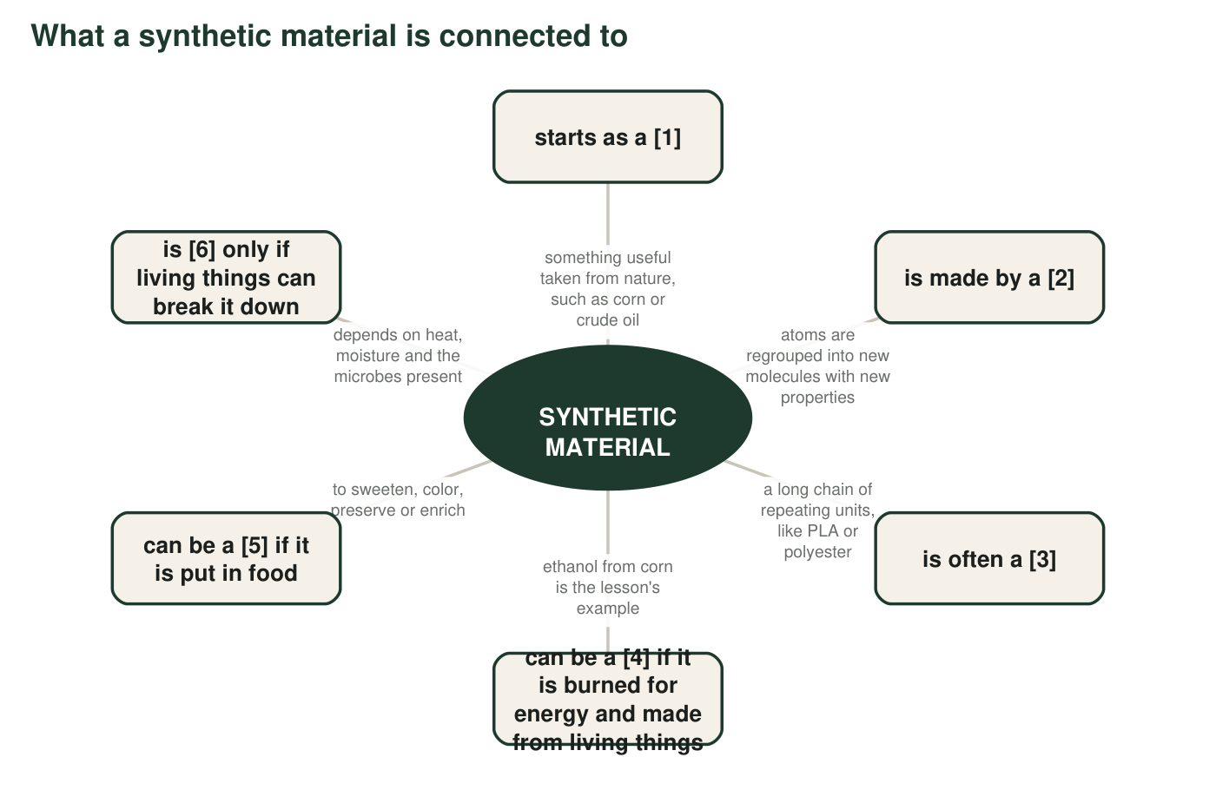
Six boxes have a missing term, shown as a number in brackets. Every missing term is in the word bank. The hub is filled in for you.
1. Write the six missing terms: [1] ______ [2] ______ [3] ______ [4] ______ [5] ______ [6] ______
Answer: [1] natural resource; [2] chemical process; [3] polymer; [4] biofuel; [5] food additive; [6] biodegradable.
Reasoning: Each box's description points to one bank word: 'taken from nature' (natural resource), 'atoms regrouped' (chemical process), 'long chain of repeating units' (polymer), 'burned for energy, from living things' (biofuel), 'put in food' (food additive), 'living things break it down' (biodegradable).
Also acceptable: None; the map is designed to have one answer per box.
2. Two words in the bank did not fit anywhere on the map: renewable resource and constraint. Pick one and write a new box for it: which existing box would it connect to, and what would the arrow say?
Answer: Renewable resource: connects to the 'natural resource' box; arrow could read 'is called a ______ if nature replaces it quickly, like corn.' Constraint: connects to the hub or to a new 'engineers design it' box; arrow could read 'engineers must stay within a ______ such as cost when they design it.'
Reasoning: Either term is acceptable. Look for a sensible connection and an arrow label that uses the term's meaning.
Also acceptable: Connecting 'constraint' to 'biodegradable' (a rule requiring breakdown could be a constraint) is a thoughtful answer.
Full credit must include:
• Names a box to connect to
• Arrow label matches the term's definition

Part B: Sort the examples
For each item, write N if it is a natural resource (taken from nature, not chemically changed into a new substance) or S if it is a synthetic material (made from natural resources by chemical processes). Then, for every S, name the natural resource it most likely started from.
3. A gold nugget panned from a river: ____
Answer: N
Reasoning: Panning removes gold from the river; the gold is the same substance it was underground.
Also acceptable: None.
4. A nylon climbing rope: ____ started from: ______
Answer: S; started from petroleum (crude oil).
Reasoning: Nylon is a polymer made by chemical reactions from substances derived from petroleum.
Also acceptable: Accept 'oil' or 'crude oil'.
5. A pine board cut from a log: ____
Answer: N
Reasoning: Sawing changes the shape of wood, not the substance.
Also acceptable: None.
6. Vanillin flavoring made in a factory from petroleum substances: ____ started from: ______
Answer: S; started from petroleum.
Reasoning: The item states that the vanillin was made from petroleum substances by factory reactions. Vanillin itself also occurs in vanilla beans; this is a case where the synthetic and natural substance are the same molecule, which does not change the sorting.
Also acceptable: Accept 'crude oil'.
7. Nitrogen gas separated out of air: ____
Answer: N
Reasoning: Separating nitrogen from air does not change the nitrogen; it is the same gas that was in the air.
Also acceptable: None.
8. A clear PLA cup: ____ started from: ______
Answer: S; started from corn (its starch, which is broken into sugar and then turned into lactic acid and PLA).
Reasoning: PLA is a polymer built by chemical processes from a substance made by fermenting corn sugar.
Also acceptable: Accept 'corn' or 'plants'; sugarcane is also used industrially.
9. A sapphire grown in a laboratory for a laser: ____ started from: ______
Answer: S; started from aluminum oxide (made from aluminum ore) plus a trace of other elements for color.
Reasoning: The sapphire is grown by people through a chemical and melting process, so it is synthetic even though it is the same substance as a mined sapphire. This is the chapter's key example that synthetic does not mean fake. Students are unlikely to know the exact ore; any mineral or ore answer is fine.
Also acceptable: Accept 'minerals', 'a mined ore' or 'aluminum and oxygen'.
10. Fish oil pressed from fish: ____
Answer: N
Reasoning: Pressing the oil out of fish separates it from the fish without making a new substance.
Also acceptable: None.
11. The blue food dye Blue No. 1: ____ started from: ______
Answer: S; started from petroleum.
Reasoning: Blue No. 1 is made by chemical reactions from substances obtained from petroleum, as the lesson's Key Science Concept spread shows.
Also acceptable: Accept 'crude oil'.
12. A bronze statue (copper mixed with tin): ____ started from: ______
Answer: S; started from copper ore and tin ore (copper and tin are natural resources).
Reasoning: An alloy is made by melting metals together into a material with new properties; the lesson calls copper alloys among the first synthetic materials. Smelting the ores into metal is itself a chemical process.
Also acceptable: Accept 'copper and tin' or 'metal ores'.

Part C: Which term fits?
Each situation below matches one term better than any other. Write the term, then one sentence explaining why the look-alike term does not fit.
13. Corn is harvested every fall and planted again every spring. The word for corn as a resource is ______ (renewable resource / biodegradable).
Answer: Renewable resource. 'Biodegradable' describes whether living things can break a material down, not whether nature can grow more of it.
Reasoning: Renewable is about replacement rate; biodegradable is about breakdown.
Also acceptable: None.
Full credit must include:
• Correct term
• States why the other term does not fit
14. A tree's bark is stripped to make a medicine, and the tree dies. New trees take about a century to mature. For the way it was being used, the bark was acting as a ______ (renewable resource / nonrenewable resource).
Answer: Nonrenewable resource. Although trees are living things, taking the bark kills the tree and replacements take about 100 years, so the bark was being used faster than it could be replaced; a renewable resource is one nature replaces in a fairly short time.
Reasoning: This is the paclitaxel case. The subtle idea is that 'renewable' depends on the rate of use compared with the rate of replacement.
Also acceptable: Accept 'renewable in theory but nonrenewable in practice' with the reason given.
Full credit must include:
• Nonrenewable (or 'acting as nonrenewable')
• Explains the mismatch between use rate and regrowth
15. A cup made from corn starch is placed in a hot, moist industrial composter and is mostly gone in a few months. The cup is ______ (biodegradable / renewable resource).
Answer: Biodegradable. The cup is not a resource at all; it is a product. The corn it came from is the renewable resource.
Reasoning: Students must separate the product from its starting material.
Also acceptable: None.
Full credit must include:
• Biodegradable
• Explains that renewable describes the corn, not the cup
16. A design team writes: 'The new container must cost the company no more than 4 cents to make.' This statement is a ______ (criterion / constraint).
Answer: Constraint. A cost limit is a boundary the design must stay inside, not a job the container must do.
Reasoning: The textbook lists cheapness among the criteria for plastics; accurate engineering language treats cost as a constraint, which is the version taught here.
Also acceptable: If a student argues it is a criterion because the company 'requires' it, use the debrief to clarify: criteria describe what the solution must do, constraints describe limits on how it can be done.
Full credit must include:
• Constraint
• Explains cost as a limit rather than a function
17. The same team writes: 'The container must keep juice fresh for 30 days.' This statement is a ______ (criterion / constraint).
Answer: Criterion. Keeping juice fresh for 30 days is something the container must accomplish to succeed.
Reasoning: A function the product must perform is a criterion.
Also acceptable: None.
Full credit must include:
• Criterion
• Explains it as a required function
18. Yeast turn glucose from corn into ethanol and carbon dioxide. The ethanol is a ______ (biofuel / food additive), and the change from glucose to ethanol is a ______ (chemical process / natural resource).
Answer: Biofuel; chemical process. Ethanol is burned for energy and comes from living things, so it is a biofuel, not a food additive. Glucose molecules are turned into different molecules (ethanol and carbon dioxide), so the change is a chemical process, not a natural resource.
Reasoning: Two terms must be chosen. Note the accurate version of fermentation: yeast carry out the reactions, and carbon dioxide is also produced.
Also acceptable: Ethanol is also added to some foods in tiny amounts, but in this situation it is clearly a fuel.
Full credit must include:
• Both terms correct
• Reason given for at least one rejected term

Part D: Apply the terms
19. A classmate says, 'Sucralose is synthetic, so it is fake sugar.' Using the definitions of synthetic material and food additive, rewrite the sentence so that it is accurate.
Answer: Sample rewrite: 'Sucralose is a synthetic food additive: people make it from sugar by a chemical process, it tastes sweet, and it is a real substance, just a different one from table sugar.'
Reasoning: The rewrite must drop 'fake' and show that synthetic describes how the substance was made. Sucralose is in fact made from sucrose in several reaction steps that swap three oxygen-hydrogen groups for chlorine atoms.
Also acceptable: Accept a rewrite that says sucralose 'is not sugar but is a real sweetener made by chemistry'.
Full credit must include:
• Removes 'fake'
• Uses synthetic to mean made by a chemical process
• Uses food additive correctly
20. Write one sentence that uses natural resource, chemical process and synthetic material correctly, in that order, about a product of your choice.
Answer: Sample: 'Corn is the natural resource; fermentation by yeast is the chemical process; and ethanol fuel is the synthetic material.' Or: 'Crude oil is a natural resource that a chemical process turns into the synthetic material polyester.'
Reasoning: Check that the three terms are used in the stated order and that the chain is real.
Also acceptable: Any accurate chain from the lesson or from the student's own knowledge.
Full credit must include:
• All three terms in order
• A real resource-to-material chain
21. Explain why 'made from plants' and 'biodegradable' are not the same thing. Use PLA, or another example you know, to show that one does not guarantee the other.
Answer: 'Made from plants' says where a material came from; 'biodegradable' says whether living things can break it down, which depends on the material's molecules and the conditions. PLA is made from corn, yet it breaks down quickly only in a hot industrial composter; in a landfill or on the ground it lasts for years, so plant origin did not guarantee breakdown where it ends up. A paper bag made from wood is both plant-based and biodegradable in moist soil. (Some plastics made partly from sugarcane do not biodegrade at all, and some petroleum-based plastics are made to be biodegradable.)
Reasoning: This is the bio-based versus biodegradable distinction the textbook blurs. PLA is the lesson's own example of the gap: plant-based, but conditional in its breakdown.
Also acceptable: A student who uses 'a plastic bottle made partly from sugarcane that lasts for decades' is correct.
Full credit must include:
• Defines the two ideas as origin versus breakdown
• Uses PLA or another accurate example to show that plant origin does not guarantee breakdown

Teacher notes
The word bank definitions are written to be accurate where the textbook simplifies: synthetic is defined by how a material is made (so lab-grown sapphire counts); petroleum formed over millions of years, not hundreds; cost is a constraint rather than a criterion; biodegradable depends on conditions. Part B deliberately omits gasoline and ethylene, which the textbook calls synthetic but which are produced by separating and cracking petroleum; the extension handles those edge cases. Expect debate on q9 (sapphire) and q12 (bronze); both are synthetic because people made them by chemical or melting processes from natural resources. If students ask whether vanillin from petroleum is 'the same' as vanillin from beans, the answer is yes: the molecule is identical; what differs is the origin.

