Angela's Tools · Chapter 15: Chemical Engineering and Society · Worksheet 2 of 10

Resource, Process, Material: Words That Trace a Product Back to Nature
Learning target: I can use the chapter's vocabulary to trace a product back to its natural resource and the chemical process that made it, and tell apart terms that are often confused.
Vocabulary in action · about 30 minutes · individual · Standards: MS-PS1-3 (practice)
Name: ____________________________ Date: ____________ Period: ______

Directions
Start with the word bank; every definition is written in student language. In Part A, fill the numbered gaps in the concept map using words from the bank. In Part B, sort the examples. In Part C, choose the term that fits each situation and explain your choice in one sentence. In Part D, use the terms in your own writing. Several terms are easy to mix up; the point of this sheet is to be able to say exactly how they differ.
natural resource: A useful material that people take from nature, such as wood, gold, nitrogen from the air, corn, or crude oil. Taking it out of the ground or harvesting it does not turn it into a new substance.
synthetic material: A material that people make from natural resources by chemical processes. Some are new substances; others, like lab-grown sapphire, are the same substance nature makes. 'Synthetic' describes how it was made, not whether it is 'real'.
chemical process: One or more chemical reactions in which the atoms of the starting substances are regrouped into different molecules with different properties.
petroleum: Crude oil: a liquid mixture of many carbon-and-hydrogen substances, pumped from underground, that took millions of years to form from the buried remains of ancient living things.
polymer: A substance whose molecules are very long chains built from repeating units. Plastics such as PLA and polyester are polymers; so are natural materials like cellulose in wood.
biofuel: A fuel made from recently living things, such as ethanol made from corn or algae, instead of from fossil fuels.
food additive: Any substance added to food to improve its taste, color, freshness, nutrition or safety. It can be natural (salt, sugar) or synthetic (sucralose, Blue No. 1).
renewable resource: A resource that nature replaces in a fairly short time, such as a crop or tree leaves. It can still run short if people use it faster than it grows back.
nonrenewable resource: A resource that forms so slowly that, for human purposes, there is a fixed amount of it. Petroleum, coal and metal ores are examples.
biodegradable: Able to be broken into smaller, simpler substances by living things, mainly bacteria and fungi. How fast this happens depends on conditions such as heat, moisture and oxygen.
criteria: The things a design must do to count as a success, such as 'holds a hot drink without leaking.'
constraint: A limit the design must stay within, such as a budget, available materials, time, or a rule that protects people or the environment.

Part A: Complete the concept map
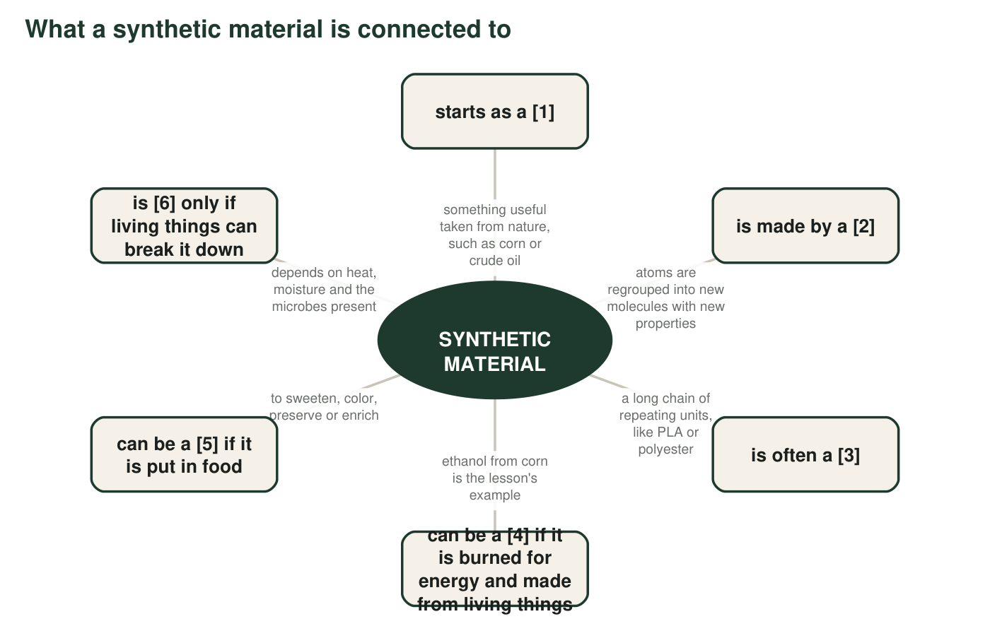
Six boxes have a missing term, shown as a number in brackets. Every missing term is in the word bank. The hub is filled in for you.
1. Write the six missing terms: [1] ______ [2] ______ [3] ______ [4] ______ [5] ______ [6] ______
______________________________________________________________________________________
______________________________________________________________________________________
______________________________________________________________________________________
2. Two words in the bank did not fit anywhere on the map: renewable resource and constraint. Pick one and write a new box for it: which existing box would it connect to, and what would the arrow say?
______________________________________________________________________________________
______________________________________________________________________________________
______________________________________________________________________________________

Part B: Sort the examples
For each item, write N if it is a natural resource (taken from nature, not chemically changed into a new substance) or S if it is a synthetic material (made from natural resources by chemical processes). Then, for every S, name the natural resource it most likely started from.
3. A gold nugget panned from a river: ____
______________________________________________________________________________________
______________________________________________________________________________________
______________________________________________________________________________________
4. A nylon climbing rope: ____ started from: ______
______________________________________________________________________________________
______________________________________________________________________________________
______________________________________________________________________________________
5. A pine board cut from a log: ____
______________________________________________________________________________________
______________________________________________________________________________________
______________________________________________________________________________________
6. Vanillin flavoring made in a factory from petroleum substances: ____ started from: ______
______________________________________________________________________________________
______________________________________________________________________________________
______________________________________________________________________________________
7. Nitrogen gas separated out of air: ____
______________________________________________________________________________________
______________________________________________________________________________________
______________________________________________________________________________________
8. A clear PLA cup: ____ started from: ______
______________________________________________________________________________________
______________________________________________________________________________________
______________________________________________________________________________________
9. A sapphire grown in a laboratory for a laser: ____ started from: ______
______________________________________________________________________________________
______________________________________________________________________________________
______________________________________________________________________________________
10. Fish oil pressed from fish: ____
______________________________________________________________________________________
______________________________________________________________________________________
______________________________________________________________________________________
11. The blue food dye Blue No. 1: ____ started from: ______
______________________________________________________________________________________
______________________________________________________________________________________
______________________________________________________________________________________
12. A bronze statue (copper mixed with tin): ____ started from: ______
______________________________________________________________________________________
______________________________________________________________________________________
______________________________________________________________________________________

Part C: Which term fits?
Each situation below matches one term better than any other. Write the term, then one sentence explaining why the look-alike term does not fit.
13. Corn is harvested every fall and planted again every spring. The word for corn as a resource is ______ (renewable resource / biodegradable).
______________________________________________________________________________________
______________________________________________________________________________________
14. A tree's bark is stripped to make a medicine, and the tree dies. New trees take about a century to mature. For the way it was being used, the bark was acting as a ______ (renewable resource / nonrenewable resource).
______________________________________________________________________________________
______________________________________________________________________________________
15. A cup made from corn starch is placed in a hot, moist industrial composter and is mostly gone in a few months. The cup is ______ (biodegradable / renewable resource).
______________________________________________________________________________________
______________________________________________________________________________________
16. A design team writes: 'The new container must cost the company no more than 4 cents to make.' This statement is a ______ (criterion / constraint).
______________________________________________________________________________________
______________________________________________________________________________________
17. The same team writes: 'The container must keep juice fresh for 30 days.' This statement is a ______ (criterion / constraint).
______________________________________________________________________________________
______________________________________________________________________________________
18. Yeast turn glucose from corn into ethanol and carbon dioxide. The ethanol is a ______ (biofuel / food additive), and the change from glucose to ethanol is a ______ (chemical process / natural resource).
______________________________________________________________________________________
______________________________________________________________________________________

Part D: Apply the terms
19. A classmate says, 'Sucralose is synthetic, so it is fake sugar.' Using the definitions of synthetic material and food additive, rewrite the sentence so that it is accurate.
______________________________________________________________________________________
______________________________________________________________________________________
______________________________________________________________________________________
20. Write one sentence that uses natural resource, chemical process and synthetic material correctly, in that order, about a product of your choice.
______________________________________________________________________________________
______________________________________________________________________________________
______________________________________________________________________________________
21. Explain why 'made from plants' and 'biodegradable' are not the same thing. Use PLA, or another example you know, to show that one does not guarantee the other.
______________________________________________________________________________________
______________________________________________________________________________________
______________________________________________________________________________________

The two-question test for Part B
For each item ask: (1) Did people take it from nature and use it more or less as found, maybe after cutting, pressing or separating it? If yes, it is a natural resource. (2) Did a chemical process rearrange its atoms into a different substance? If yes, it is a synthetic material. Pressing oil from fish or sawing a log changes the shape, not the substance. Making bronze, nylon or PLA makes a material that was not there before.

Edge cases
Some products do not sort neatly. Gasoline is separated from crude oil by boiling, but the refinery also breaks large molecules into smaller ones. Paper is pressed from wood fibers, but the fibers are first cooked with chemicals that remove other parts of the wood. For each of these two products, write a short argument for calling it a natural resource and a short argument for calling it a synthetic material, then say which argument you find stronger and why. The goal is to notice that the labels mark the ends of a range, not two sealed boxes.

