Angela's Tools · Chapter 15: Chemical Engineering and Society · Worksheet 4 of 10

From Oil Well to Jersey: Reading and Building a Resource-to-Product Trace (Teacher answer key)
Learning target: I can read a flow diagram that traces a synthetic material back to its natural resource, tell physical separation steps from chemical reaction steps, and build my own trace for a product made from corn.
Diagrams and models · about 40 minutes · individual · Standards: MS-PS1-3 (assesses)

Standards connections
MS-PS1-3 (assesses): Students read a trace from crude oil to polyester, identify which steps are chemical processes, compare the natural and synthetic version of the same product, and then construct their own resource-to-product trace for corn ethanol or PLA. The products are qualitative, which matches the assessment boundary.

Answers with reasoning
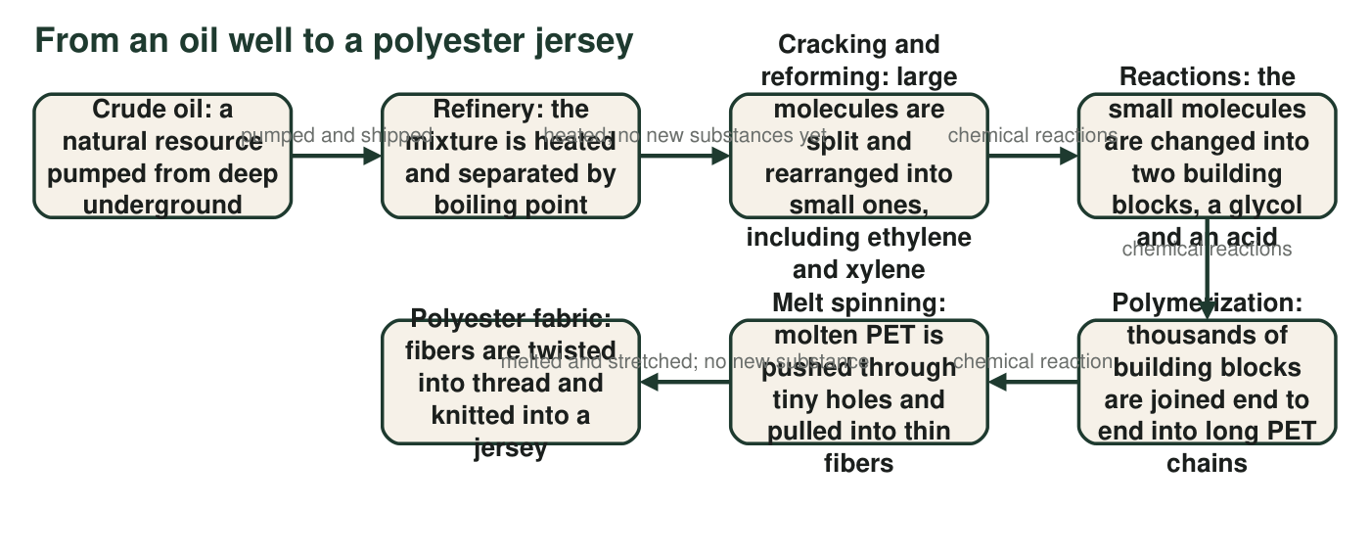
Figure 1. Each box is a stage; each arrow says what happens between stages. Some stages only separate or reshape a material; others change its molecules into new substances.
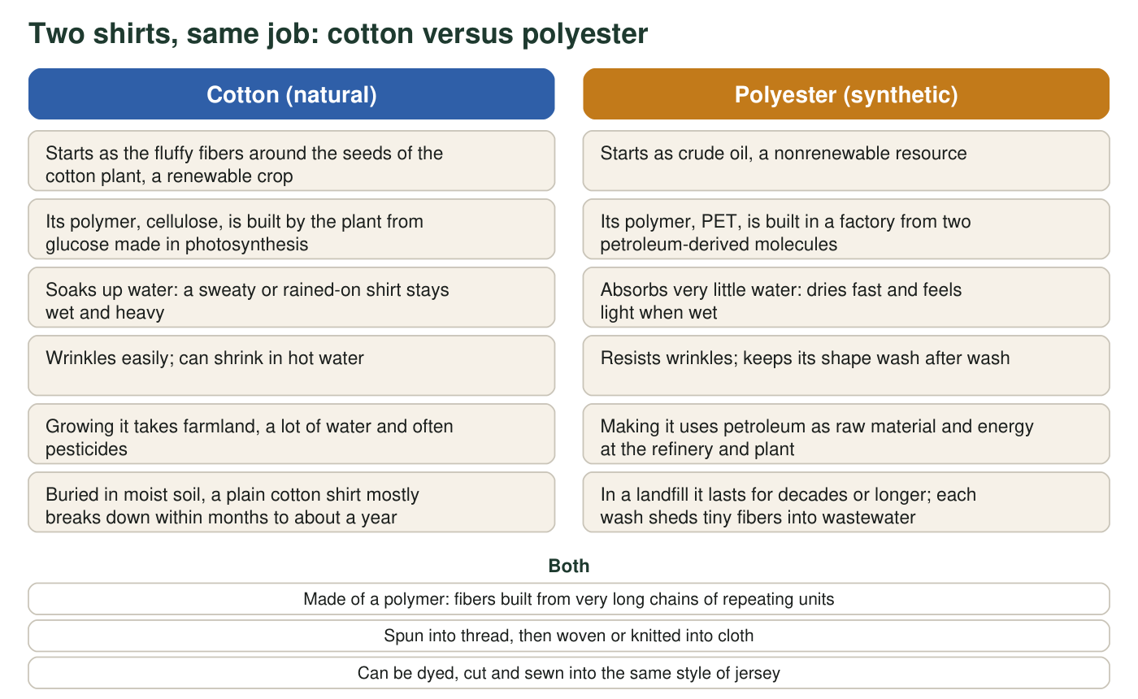
Figure 2. Two shirts that do the same job. The left shirt is made from a natural fiber; the right shirt is made from a synthetic one. Items in the middle are true of both.

Part A: Read the diagrams
1. In Figure 1, which box is the natural resource and which box is the finished synthetic material? What is the name of the polymer in between?
Answer: The natural resource is the first box, crude oil. The finished synthetic material is the last box, polyester fabric. The polymer in between is PET.
Reasoning: Students must read the ends of the flow and name the polymer stage.
Also acceptable: Accept 'the PET chains' or 'the polyester fibers' as the synthetic material if the student also names polyester fabric; the fibers are already PET.
2. Use the arrow labels in Figure 1. Which arrows mark steps that only separate, melt or reshape the material, and which arrows mark chemical reactions? Explain how you can tell the two kinds of step apart.
Answer: Separation or reshaping only: arrow 1 (pumped and shipped), arrow 2 (heated; no new substances yet) and arrow 6 (melted and stretched; no new substance). Chemical reactions: arrows 3, 4 and 5 (cracking and reforming, making the building blocks, and polymerization). You can tell because a chemical reaction produces a substance that was not there before, while separating, melting or stretching leaves the same substances in a new place or shape.
Reasoning: The arrow labels state it directly; the explanation is the accurate distinction the textbook blurs when it calls gasoline synthetic.
Also acceptable: Accept an answer that calls cracking 'partly separating', since the refinery also collects the small molecules; the key point is that new molecules are made.
Full credit must include:
• Correctly sorts the six arrows
• Explains the difference as new substance versus same substance
3. The first box in Figure 1 calls crude oil a resource 'pumped from deep underground.' Figure 2 calls it nonrenewable. Explain what nonrenewable means here and what it implies for every product further along the chain.
Answer: Nonrenewable means crude oil took millions of years to form from buried remains of ancient organisms, so it is being used far faster than Earth makes more; for practical purposes there is a fixed amount. Every product down the chain, including the jersey, uses up some of that fixed supply and cannot be regrown the way cotton can.
Reasoning: Students should connect the start of the chain to the whole chain. Watch for the textbook's 'hundreds of years' error; the accurate statement is millions.
Also acceptable: Accept 'once it is used it is gone' with the connection to the jersey.
Full credit must include:
• Defines nonrenewable in terms of replacement time
• Applies it to the products down the chain
4. Which property of the polyester jersey in Figure 2 is best explained by the fact that PET is made of very long chains?
Answer: B: Thin fibers of it are strong and can be stretched without snapping.
Reasoning: Long, tangled chains hold together along their length, which gives strength and lets thin fibers flex. Fast drying comes from PET repelling water, nonrenewability comes from the resource, and dyeability is shared with cotton.
Also acceptable: None.
5. Using Figure 2, write one benefit and one cost of the cotton shirt and one benefit and one cost of the polyester shirt. Then say which shirt you would recommend to a soccer player and which to a gardener, and why, using the properties in the figure.
Answer: Cotton benefit: renewable crop that breaks down in soil; cost: takes farmland, water and pesticides, and stays wet and heavy. Polyester benefit: dries fast and keeps its shape; cost: nonrenewable source, lasts for decades in a landfill and sheds fibers into wastewater. Soccer player: polyester, because sweat dries quickly and the shirt stays light. Gardener: either answer with a property-based reason, for example cotton because it is comfortable and can go in the compost when worn out, or polyester because it resists wrinkles and dries after rain.
Reasoning: Full credit is for using the figure's properties on both sides, not for the particular recommendation.
Also acceptable: Any recommendation supported by properties in the figure earns credit.
Full credit must include:
• One benefit and one cost for each shirt, from the figure
• Recommendations justified by named properties
6. Both shirts are made of polymers, yet the cotton one breaks down in soil within about a year and the polyester one lasts for decades. Using what the figure says about where each polymer was built, explain what must be different between the two polymers for soil microbes to take one apart and not the other.
Answer: Cellulose was built by a plant, so soil microbes have had a very long time to develop the tools (enzymes) that cut its chains apart, and the glucose units they release are food for them. PET was built in a factory from petroleum-derived units that no organism makes, so very few microbes have enzymes that fit its chains, and they take it apart extremely slowly. The difference is in the repeating units and the links between them, not in the chain length.
Reasoning: This is the structure-decides-breakdown idea at a seventh-grade level: biodegradability depends on the chemical structure of the polymer, not on whether it is a polymer or where its fiber was spun.
Also acceptable: Accept 'microbes recognize cellulose as food but not PET' as the core idea.
Full credit must include:
• Identifies that the chains are built from different units
• Connects breakdown to microbes being able (or unable) to take the units apart

Part B: Build your own trace
Choose one product: ethanol fuel made from corn, or PLA plastic made from corn. Facts you may use: corn kernels store starch, a polymer of glucose. Enzymes cut starch into glucose. For ethanol, yeast ferment glucose into ethanol and carbon dioxide; the ethanol is separated from the water by distilling (boiling it off) and is blended into gasoline. For PLA, bacteria ferment glucose into lactic acid; chemical reactions then join lactic acid units into long PLA chains, which are melted and molded into cups or forks. Ethanol burns in an engine and is gone; a PLA cup breaks down in weeks to months only in a hot industrial composter and lasts for years in a landfill.
Draw a flow diagram in the style of Figure 1 with five boxes in a row and labeled arrows between them: (1) the natural resource, (2) a preparation step that gets the corn ready, such as grinding the kernels or cutting starch into glucose, (3) the chemical process, naming the living thing or reaction that does it, (4) the product, with one property that makes it useful, and (5) what happens to the product at the end of its use. Write on each arrow whether it is a chemical reaction or not. Circle the one box that is a synthetic material.
Expected drawing: Ethanol version: (1) Corn kernels, a renewable natural resource; arrow: ground and mixed with water, not a reaction. (2) Enzymes cut starch into glucose; arrow: fermentation, a chemical reaction. (3) Yeast ferment glucose into ethanol and carbon dioxide (C₆H₁₂O₆ → 2 C₂H₅OH + 2 CO₂); arrow: distilling separates ethanol from water, not a reaction. (4) Ethanol fuel, a liquid that burns and releases energy, blended into gasoline; arrow: burned in an engine, a chemical reaction. (5) Ending: the ethanol is gone, turned into carbon dioxide and water vapor in the exhaust. Circled: ethanol. PLA version: (1) Corn kernels; (2) enzymes cut starch into glucose, not a reaction (strictly, enzyme breakdown of starch is itself a chemical change; accept either label if explained); (3) bacteria ferment glucose into lactic acid, then reactions join lactic acid units into long PLA chains, chemical reactions; (4) PLA, a stiff, clear plastic that can be molded into cups and forks; arrow: melted and molded, not a reaction; (5) Ending: breaks down in weeks to months in a hot industrial composter; lasts for years in a landfill. Circled: PLA.
Reasoning: Both versions show the chain: natural resource, preparation, chemical process by a living thing (yeast or bacteria) and then by reactions, product with a property, and an ending. The hydrolysis of starch to glucose is a chemical change; the text block calls it 'cutting' to keep the focus on fermentation, so accept either label for box 2 when the student gives a reason.
7. Which box in your drawing is the chemical process? What goes in, what comes out, and what happened to the atoms?
Answer: Ethanol: box 3, fermentation. Glucose goes in; ethanol and carbon dioxide come out. The atoms of glucose (6 carbon, 12 hydrogen, 6 oxygen) are regrouped into two ethanol molecules and two carbon dioxide molecules; no atoms are created or lost. PLA: box 3, fermentation plus polymerization. Glucose goes in; lactic acid comes out and is then joined into PLA chains; the atoms are rearranged into new molecules and then linked into a long chain.
Reasoning: The core idea is that a chemical process regroups atoms into different molecules with different properties, the PS1.B idea beneath this chapter.
Also acceptable: Accept 'the atoms got rearranged into new molecules' without the atom counts.
Full credit must include:
• Names the chemical-process box
• Names inputs and outputs
• States that atoms were regrouped, not created or destroyed
8. Compare your trace with Figure 1. Name one way the two chains are alike and one way they are different. (Hint: look at the resource and at who or what does the chemistry.)
Answer: Alike: both start with a natural resource and pass through at least one chemical process to reach a product with useful properties, and both have preparation steps that make no new substance. Different: Figure 1 starts with a nonrenewable resource (crude oil) and the chemistry is done by heat, pressure and catalysts in a plant; the corn trace starts with a renewable crop and the key chemistry is done by living things (yeast or bacteria) before people finish the job.
Reasoning: The question targets the difference between a renewable and a nonrenewable starting point and between industrial and biological chemistry.
Also acceptable: A student who says 'both end with a product people use once and throw away' has a valid similarity for the PLA version.
Full credit must include:
• One accurate similarity
• One accurate difference about the resource or who does the chemistry
9. Your fifth box shows the product's ending. Explain why 'made from corn' does not by itself tell you what that ending will be.
Answer: The ending depends on what the product's molecules are and where it goes, not on where it came from. Ethanol from corn is burned and becomes exhaust gases. PLA from the same corn is a plastic that microbes can take apart only when it is kept hot and moist for weeks in an industrial composter; in a landfill it lasts for years. A material's origin and its breakdown are two separate properties.
Reasoning: This is the bio-based-versus-biodegradable distinction the textbook blurs. The two corn products have completely different endings, which makes the point concrete.
Also acceptable: Accept an answer that uses cotton versus polyester from Figure 2 to make the same point.
Full credit must include:
• States that origin and ending are separate properties
• Uses the conditions PLA needs, or the contrast between ethanol and PLA

Teacher notes
Figure 1 is simplified but accurate: PET is made by reacting ethylene glycol (from ethylene) with terephthalic acid (from p-xylene), both petroleum-derived; the refinery separates crude oil by boiling point, then cracking and reforming rearrange molecules, which are chemical reactions. Figure 2's statements are qualitative and true: cellulose and PET are both polymers; plain cotton decomposes in moist soil over months, while PET persists for decades or longer; polyester garments shed microfibers in the wash. In the drawing key, the hydrolysis of starch to glucose is strictly a chemical change; the worksheet text calls it 'cutting' to keep attention on fermentation, so accept either label for box 2 when the student gives a reason. Yeast do the fermentation chemistry; people grow the corn, run the tanks and distill the product. Do not let students conclude that corn products are always better: q9 exists to break that link.

