Angela's Tools · Chapter 15: Chemical Engineering and Society · Worksheet 4 of 10

From Oil Well to Jersey: Reading and Building a Resource-to-Product Trace
Learning target: I can read a flow diagram that traces a synthetic material back to its natural resource, tell physical separation steps from chemical reaction steps, and build my own trace for a product made from corn.
Diagrams and models · about 40 minutes · individual · Standards: MS-PS1-3 (assesses)
Name: ____________________________ Date: ____________ Period: ______

Directions
Study Figure 1 one step at a time, reading the arrow labels as well as the boxes. Then read Figure 2, which puts a natural shirt and a synthetic shirt side by side. Answer Part A from the figures. In Part B you will draw your own trace for a product made from corn, using the same kind of boxes and arrows as Figure 1, then answer the labeling questions about your drawing. Every box in your drawing needs a label and at least one fact.
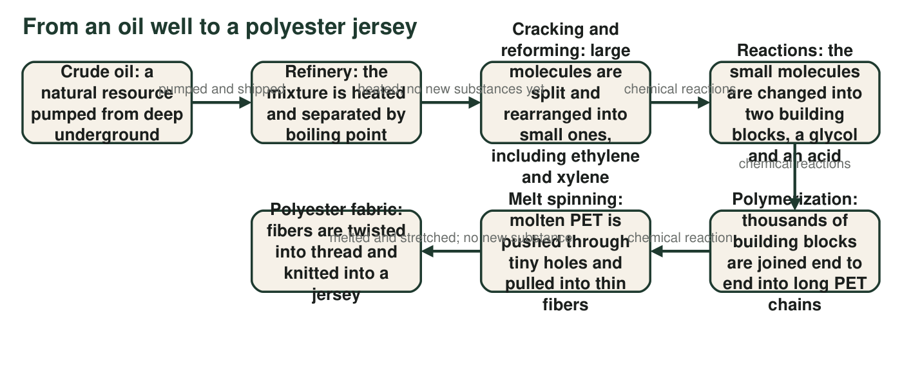
Figure 1. Each box is a stage; each arrow says what happens between stages. Some stages only separate or reshape a material; others change its molecules into new substances.
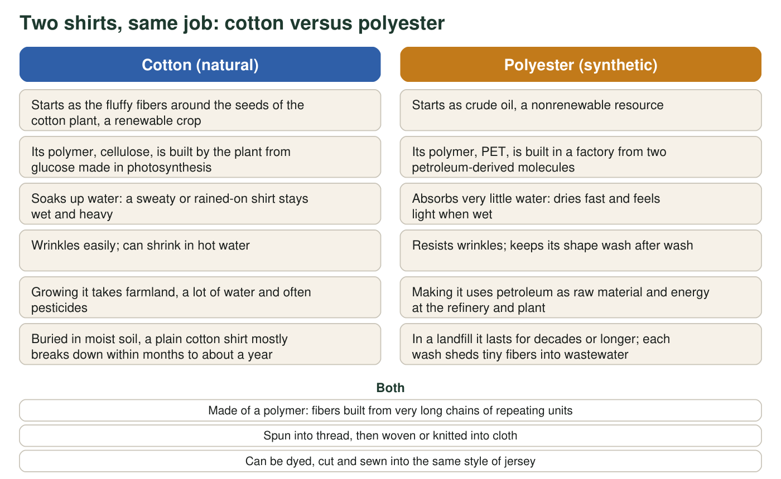
Figure 2. Two shirts that do the same job. The left shirt is made from a natural fiber; the right shirt is made from a synthetic one. Items in the middle are true of both.

Part A: Read the diagrams
1. In Figure 1, which box is the natural resource and which box is the finished synthetic material? What is the name of the polymer in between?
______________________________________________________________________________________
______________________________________________________________________________________
2. Use the arrow labels in Figure 1. Which arrows mark steps that only separate, melt or reshape the material, and which arrows mark chemical reactions? Explain how you can tell the two kinds of step apart.
______________________________________________________________________________________
______________________________________________________________________________________
______________________________________________________________________________________
3. The first box in Figure 1 calls crude oil a resource 'pumped from deep underground.' Figure 2 calls it nonrenewable. Explain what nonrenewable means here and what it implies for every product further along the chain.
______________________________________________________________________________________
______________________________________________________________________________________
______________________________________________________________________________________
4. Which property of the polyester jersey in Figure 2 is best explained by the fact that PET is made of very long chains?
○ A. It dries quickly after washing.
○ B. Thin fibers of it are strong and can be stretched without snapping.
○ C. It comes from a nonrenewable resource.
○ D. It can be dyed the same colors as cotton.
5. Using Figure 2, write one benefit and one cost of the cotton shirt and one benefit and one cost of the polyester shirt. Then say which shirt you would recommend to a soccer player and which to a gardener, and why, using the properties in the figure.
______________________________________________________________________________________
______________________________________________________________________________________
______________________________________________________________________________________
______________________________________________________________________________________
______________________________________________________________________________________
6. Both shirts are made of polymers, yet the cotton one breaks down in soil within about a year and the polyester one lasts for decades. Using what the figure says about where each polymer was built, explain what must be different between the two polymers for soil microbes to take one apart and not the other.
______________________________________________________________________________________
______________________________________________________________________________________
______________________________________________________________________________________
______________________________________________________________________________________

Part B: Build your own trace
Choose one product: ethanol fuel made from corn, or PLA plastic made from corn. Facts you may use: corn kernels store starch, a polymer of glucose. Enzymes cut starch into glucose. For ethanol, yeast ferment glucose into ethanol and carbon dioxide; the ethanol is separated from the water by distilling (boiling it off) and is blended into gasoline. For PLA, bacteria ferment glucose into lactic acid; chemical reactions then join lactic acid units into long PLA chains, which are melted and molded into cups or forks. Ethanol burns in an engine and is gone; a PLA cup breaks down in weeks to months only in a hot industrial composter and lasts for years in a landfill.
Draw a flow diagram in the style of Figure 1 with five boxes in a row and labeled arrows between them: (1) the natural resource, (2) a preparation step that gets the corn ready, such as grinding the kernels or cutting starch into glucose, (3) the chemical process, naming the living thing or reaction that does it, (4) the product, with one property that makes it useful, and (5) what happens to the product at the end of its use. Write on each arrow whether it is a chemical reaction or not. Circle the one box that is a synthetic material.

7. Which box in your drawing is the chemical process? What goes in, what comes out, and what happened to the atoms?
______________________________________________________________________________________
______________________________________________________________________________________
______________________________________________________________________________________
8. Compare your trace with Figure 1. Name one way the two chains are alike and one way they are different. (Hint: look at the resource and at who or what does the chemistry.)
______________________________________________________________________________________
______________________________________________________________________________________
______________________________________________________________________________________
9. Your fifth box shows the product's ending. Explain why 'made from corn' does not by itself tell you what that ending will be.
______________________________________________________________________________________
______________________________________________________________________________________
______________________________________________________________________________________

The reaction test
To decide whether a step is a chemical reaction, ask: is there a new substance at the end that was not there at the start? Heating crude oil so that its parts boil off at different temperatures gives you the same substances, just sorted, so it is not a reaction. Joining ethylene molecules into a chain gives you a substance that did not exist before, so it is. For Part B, write the five box titles first (resource, preparation, chemical process, product, ending), then fill each box with one fact from the text block.

The chain that goes around
Figure 1 is a straight line, but some chains loop. Used PET bottles can be chopped, washed, melted and spun into polyester fleece. Redraw Figure 1 as a cycle diagram that includes this loop: add a 'used PET bottles' box with an arrow into the melt-spinning box. Then write three sentences: which steps the loop skips, why skipping them saves petroleum, and one reason the loop does not run forever (for example, what happens to the chains each time they are melted, or how many bottles actually get collected).

