Angela's Tools · Chapter 16: Earth's Tectonic Plates · Worksheet 1 of 10

Leaves Under the Ice: Fossils Antarctica Should Not Have (Teacher answer key)
Learning target: I can describe a puzzling fossil pattern, connect it to what I already know about climate and continents, and write a first explanation that I can test later.
Phenomenon exploration · about 25 minutes · individual · Standards: MS-ESS2-3 (practice)

Standards connections
MS-ESS2-3 (practice): Students meet the distribution of fossils across continents as a puzzle and start forming an explanation; this activates the evidence-interpretation practice without yet producing a full analysis toward the PE.

Answers with reasoning

Antarctica today
Antarctica is the coldest, driest and windiest continent. An ice sheet about two kilometers thick covers almost all of it. Winter temperatures in the interior often drop below minus 60 degrees Celsius, and the coldest air temperature ever recorded on Earth, minus 89 degrees Celsius, was measured there. There are no trees and no land animals bigger than a tiny insect. The only plants are mosses, lichens and two small flowering plants that cling to the warmer coast of the Antarctic Peninsula.

What the rocks say
In February 1912, members of Robert Scott's expedition hauled 16 kilograms of rock across the Beardmore Glacier on their way back from the South Pole. The rocks held fossil leaves, tongue-shaped and as long as your hand, from a plant called Glossopteris. The same leaves are found in India, Australia, southern Africa and South America. Nearby, geologists later found seams of coal, which forms only from thick layers of dead plants, and fossil tree trunks with growth rings, which form when a tree's growth stops and starts again with the seasons. In December 1969 a team working at Coalsack Bluff in the Transantarctic Mountains dug up the bones of Lystrosaurus, a pig-sized, land-living reptile that could not swim across an ocean. Lystrosaurus bones are also found in South Africa, India, China and Russia. The Glossopteris forests grew roughly 250 to 300 million years ago; Lystrosaurus lived about 250 million years ago.
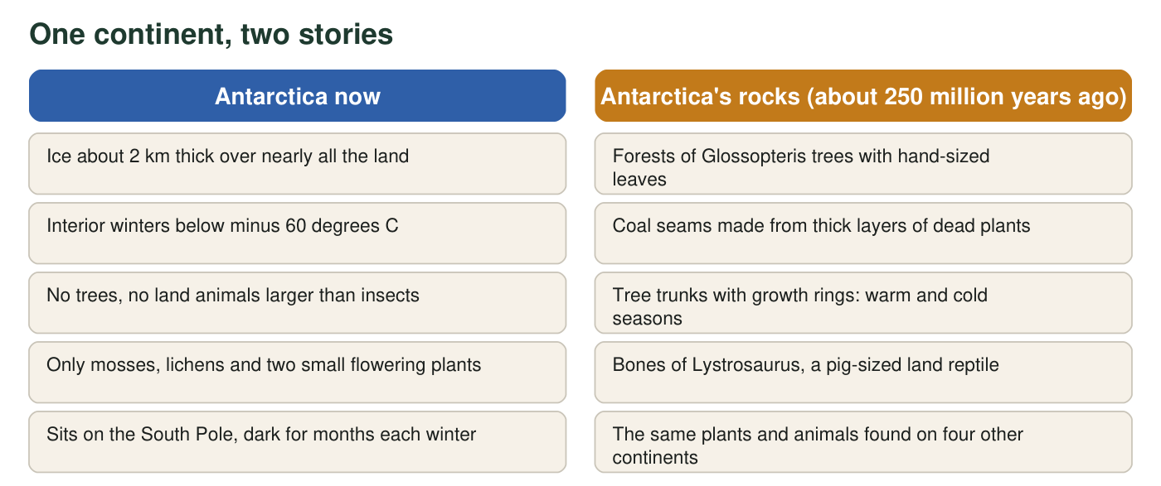
The two columns describe the same place. The left column is what you would see if you visited today. The right column is what is preserved in the rock.
Where the same fossils are found (real distributions)
Fossil | What it was | Lands where it is found | Could it cross an ocean?
Glossopteris | Extinct seed plant (a tree) with tongue-shaped leaves; shed its leaves each year | Antarctica, Australia, India, Africa, South America | Its seeds were too large and heavy to blow across an ocean
Lystrosaurus | Pig-sized plant-eating reptile that lived on land | Antarctica, Africa, India, China, Russia | No; it walked, it did not swim long distances
Mesosaurus | Small reptile about 1 m long that lived in shallow coastal and inland waters | South America, Africa | No; it was built for shallow water, not the open ocean

Part A: Notice and wonder
1. Write three things you notice in the text, figure or table. Use only observations, not explanations. (Example of an observation: 'The same plant is found on five continents.')
Answer: Any three accurate observations, for example: Antarctica is covered by ice about 2 km thick; Glossopteris leaves are found on five continents; Antarctic fossil wood has growth rings; a pig-sized land reptile (Lystrosaurus) is found in Antarctica, Africa, India, China and Russia; Antarctica has coal seams; Mesosaurus is found only in South America and Africa.
Reasoning: The point of this item is to separate observing from explaining. An observation can be checked against the sheet; an explanation ('the continents moved') cannot.
Also acceptable: If a student writes an explanation, ask them to rewrite it as the observation that led to it.
Full credit must include:
• Three statements
• Each can be checked against the text, figure or table
• No explanations mixed in
2. Write three things you wonder. Each should be a question that could be answered with evidence.
Answer: Any three testable questions, for example: How did the same plant reach five continents? Was Antarctica ever warm, or was it somewhere else? How old are the fossils, and are they the same age on every continent? Do the rocks that hold the fossils match from continent to continent? How could a land animal get from Africa to Antarctica?
Reasoning: A testable question points toward evidence someone could collect. 'Why is Antarctica so cold?' is fine; 'Is Antarctica scary?' is not testable.
Also acceptable: Accept questions about timing, climate, rock matching, animal movement or how scientists know the ages.
Full credit must include:
• Three questions
• Each could be answered by collecting evidence
3. What do you already know about what trees need in order to grow? Name two things Antarctica lacks today that a Glossopteris forest would have needed.
Answer: Trees need liquid water, soil, warmth above freezing for a growing season, and sunlight. Antarctica today lacks liquid water (it is frozen), soil (it is covered by ice), warmth, and sunlight for months each winter. Any two earn credit.
Reasoning: This retrieves prior knowledge from life science and sets up the contradiction: whatever the explanation, the place where these fossils formed had the conditions a forest needs.
Also acceptable: Accept 'no growing season' or 'too dark in winter' as a lack of sunlight.
Full credit must include:
• Two needs of trees named
• Each matched to something Antarctica lacks today

Part B: What do you already think?
4. Right now, before any more evidence, which explanation seems most likely to you? (You will test your choice later in this chapter.)
Answer: No single correct answer at this stage; the best-supported choice is B, because the land has moved and was once joined to the other southern continents. The Antarctic forests still grew near the South Pole, so the full answer also needs part of A: a much milder climate than today's. Record which option each student picked so they can revisit it after Worksheets 5 and 6.
Reasoning: Option A is partly right (the polar climate was much milder then), but on its own it cannot explain how the same land reptile and the same heavy-seeded plant reached continents that oceans now separate. Option C fails for a pig-sized land reptile and for heavy seeds. Option D fails because the fossils are in the same rock layers as the coal and tree trunks, so they formed in place. Do not reveal this yet; let the chapter's evidence do the work.
Also acceptable: Credit any choice with an honest reason.
5. A plant fossil is a good clue, but scientists call the Lystrosaurus bones an even stronger clue. Using the table, explain why a land animal makes a stronger case than a plant.
Answer: Plant seeds or spores can sometimes travel by wind, water or birds, so finding the same plant on two continents could have another explanation. Lystrosaurus lived on land, was the size of a pig and could not swim an ocean. The only ways for it to be on several continents are that the continents were connected or that something carried it, and nothing could carry a population of pig-sized animals across an ocean.
Reasoning: The strength of a clue depends on how many other explanations it allows. A land animal allows fewer.
Also acceptable: Accept 'Glossopteris seeds were too heavy to blow across the ocean, so the plant is strong evidence too, but the animal is stronger.'
Full credit must include:
• Notes that plants have possible alternative ways to spread
• Notes that a land animal cannot cross an ocean
• Concludes the land-animal clue allows fewer explanations
6. Suppose a continent crept along at 2 centimeters per year, about the speed your fingernails grow. How far would it travel in 250 million years? Give your answer in kilometers and show every step of the unit conversion. (1 km = 100,000 cm.)
Answer: 2 cm/yr × 250,000,000 yr = 500,000,000 cm. 500,000,000 cm ÷ 100,000 cm/km = 5,000 km.
Reasoning: This is the chapter's central idea in numbers: a tiny yearly motion becomes a continent-sized distance over geologic time. Five thousand kilometers is more than the straight-line distance from Los Angeles to New York (about 3,900 km).
Also acceptable: Accept 5,000 km, or 5 × 10³ km, with the multiplication and the conversion both shown. A student who converts first (2 cm = 0.00002 km, then × 250,000,000 = 5,000 km) is also correct.

Part C: Your first explanation
7. Write your first explanation for how the same land plants and land animals ended up on continents that are now separated by thousands of kilometers of ocean, including one that is frozen. Your explanation must account for both the fossils and the tree rings (seasons).
Answer: Model response: About 250 million years ago the land that is now Antarctica was joined to Africa, India, Australia and South America. The world was warmer then and there was no ice sheet, so forests could grow even close to the South Pole. Glossopteris trees and Lystrosaurus could spread across the joined lands by growing and walking, which is why the same fossils are on all of them. The trees grew in the bright summers and stopped in the cold, dark winters, which is why the trunks show growth rings. Since then the other lands have split away and moved north, while Antarctica stayed near the pole and froze over as Earth's climate cooled.
Reasoning: A full-credit explanation does not have to be correct; it has to be a mechanism that accounts for both named pieces of evidence and could be tested. Watch for explanations that account for the fossils but ignore the seasons.
Also acceptable: A 'warm Earth' explanation can earn full credit if it is testable and addresses both pieces of evidence, even though later worksheets will show it is insufficient.
Full credit must include:
• Gives a mechanism for the same organisms being on separated continents
• Accounts for the growth rings (seasons) in the fossil wood
• Is testable (someone could look for evidence for or against it)
8. What is one piece of evidence that, if someone found it, would make you give up your explanation? What is one piece that would make you more confident?
Answer: Depends on the student's explanation. For 'the continents moved': giving up if the fossils on each continent turned out to be very different ages, or if the rock layers holding them did not match; more confident if the rock layers, ages and other fossils all match across the continents, or if the ocean between them turned out to be much younger than the fossils.
Reasoning: This item checks that students understand explanations must be open to evidence. It previews the chapter: seafloor age data (Worksheet 5) is exactly the kind of evidence that can settle the question.
Also acceptable: Any evidence that logically bears on the student's own explanation earns credit.
Full credit must include:
• Names one specific finding that would count against the explanation
• Names one specific finding that would support it

Teacher notes
Historical details are accurate: Scott's party collected about 16 kg of rock, including Glossopteris, near the Beardmore Glacier in February 1912, and the specimens were recovered with the bodies that November; Lystrosaurus was found at Coalsack Bluff in December 1969; Antarctic Glossopteris wood shows clear growth rings. Two corrections to the textbook: Glossopteris was a seed plant (not a fern) that grew in cool, seasonal climates at high latitudes, so its Antarctic fossils show a joined landmass and a changed climate rather than an equator position; and Lystrosaurus is also known from China and Russia, not only Antarctica, Africa and India. Mesosaurus's exact water type is debated (shallow, sometimes salty coastal waters), so the sheet says only that it could not cross an open ocean. Keep q4 open; collect the class tally and return to it after Worksheet 6.

