Angela's Tools · Chapter 16: Earth's Tectonic Plates · Worksheet 1 of 10

Leaves Under the Ice: Fossils Antarctica Should Not Have
Learning target: I can describe a puzzling fossil pattern, connect it to what I already know about climate and continents, and write a first explanation that I can test later.
Phenomenon exploration · about 25 minutes · individual · Standards: MS-ESS2-3 (practice)
Name: ____________________________ Date: ____________ Period: ______

Directions
Read the two descriptions and study the figure and the table. Write what you notice before you try to explain anything. There are no wrong answers in Parts A and B; your job is to think carefully and write your honest first ideas. In Part C, write an explanation you could test, and list the questions you would need answered to test it.

Antarctica today
Antarctica is the coldest, driest and windiest continent. An ice sheet about two kilometers thick covers almost all of it. Winter temperatures in the interior often drop below minus 60 degrees Celsius, and the coldest air temperature ever recorded on Earth, minus 89 degrees Celsius, was measured there. There are no trees and no land animals bigger than a tiny insect. The only plants are mosses, lichens and two small flowering plants that cling to the warmer coast of the Antarctic Peninsula.

What the rocks say
In February 1912, members of Robert Scott's expedition hauled 16 kilograms of rock across the Beardmore Glacier on their way back from the South Pole. The rocks held fossil leaves, tongue-shaped and as long as your hand, from a plant called Glossopteris. The same leaves are found in India, Australia, southern Africa and South America. Nearby, geologists later found seams of coal, which forms only from thick layers of dead plants, and fossil tree trunks with growth rings, which form when a tree's growth stops and starts again with the seasons. In December 1969 a team working at Coalsack Bluff in the Transantarctic Mountains dug up the bones of Lystrosaurus, a pig-sized, land-living reptile that could not swim across an ocean. Lystrosaurus bones are also found in South Africa, India, China and Russia. The Glossopteris forests grew roughly 250 to 300 million years ago; Lystrosaurus lived about 250 million years ago.
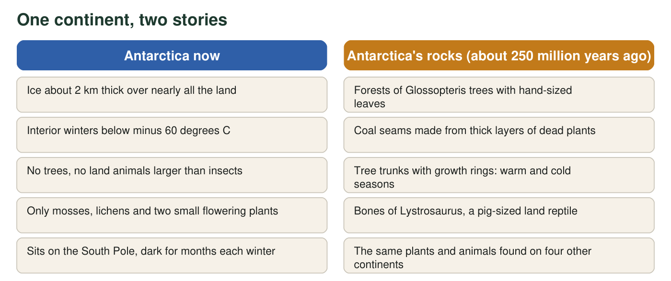
The two columns describe the same place. The left column is what you would see if you visited today. The right column is what is preserved in the rock.
Where the same fossils are found (real distributions)
Fossil | What it was | Lands where it is found | Could it cross an ocean?
Glossopteris | Extinct seed plant (a tree) with tongue-shaped leaves; shed its leaves each year | Antarctica, Australia, India, Africa, South America | Its seeds were too large and heavy to blow across an ocean
Lystrosaurus | Pig-sized plant-eating reptile that lived on land | Antarctica, Africa, India, China, Russia | No; it walked, it did not swim long distances
Mesosaurus | Small reptile about 1 m long that lived in shallow coastal and inland waters | South America, Africa | No; it was built for shallow water, not the open ocean

Part A: Notice and wonder
1. Write three things you notice in the text, figure or table. Use only observations, not explanations. (Example of an observation: 'The same plant is found on five continents.')
______________________________________________________________________________________
______________________________________________________________________________________
______________________________________________________________________________________
______________________________________________________________________________________
______________________________________________________________________________________
2. Write three things you wonder. Each should be a question that could be answered with evidence.
______________________________________________________________________________________
______________________________________________________________________________________
______________________________________________________________________________________
______________________________________________________________________________________
______________________________________________________________________________________
3. What do you already know about what trees need in order to grow? Name two things Antarctica lacks today that a Glossopteris forest would have needed.
______________________________________________________________________________________
______________________________________________________________________________________
______________________________________________________________________________________

Part B: What do you already think?
4. Right now, before any more evidence, which explanation seems most likely to you? (You will test your choice later in this chapter.)
○ A. The whole Earth was once so warm that forests grew even at the South Pole.
○ B. The land that is now Antarctica was once somewhere warmer, and it has moved.
○ C. Seeds and animals crossed the oceans on floating logs or ice.
○ D. The fossils were carried to Antarctica later by water or glaciers.
5. A plant fossil is a good clue, but scientists call the Lystrosaurus bones an even stronger clue. Using the table, explain why a land animal makes a stronger case than a plant.
______________________________________________________________________________________
______________________________________________________________________________________
______________________________________________________________________________________
6. Suppose a continent crept along at 2 centimeters per year, about the speed your fingernails grow. How far would it travel in 250 million years? Give your answer in kilometers and show every step of the unit conversion. (1 km = 100,000 cm.)
______________________________________________________________________________________
______________________________________________________________________________________
______________________________________________________________________________________

Part C: Your first explanation
7. Write your first explanation for how the same land plants and land animals ended up on continents that are now separated by thousands of kilometers of ocean, including one that is frozen. Your explanation must account for both the fossils and the tree rings (seasons).
______________________________________________________________________________________
______________________________________________________________________________________
______________________________________________________________________________________
______________________________________________________________________________________
______________________________________________________________________________________
______________________________________________________________________________________
______________________________________________________________________________________
8. What is one piece of evidence that, if someone found it, would make you give up your explanation? What is one piece that would make you more confident?
______________________________________________________________________________________
______________________________________________________________________________________
______________________________________________________________________________________

Sentence starters for Part C
If q7 is hard to begin, start with: 'About 250 million years ago, the land that is now Antarctica was ______. The same plants and animals could live on several continents because ______. The tree rings show that the forests had seasons, which means ______. Since then, ______.' Fill each blank with your own idea, then read the paragraph aloud to check that it makes sense.

Hold the explanation to a harder test
Explanation A in q4 says the whole planet was once warm enough for forests at the pole. The growth rings suggest part of that may be true: the trees grew in summer and stopped in long, dark winters, as trees near a pole would. But a warm Earth alone would not explain one detail in the table. Find that detail (hint: look at where Lystrosaurus and Glossopteris are found, and whether they could cross an ocean) and write a paragraph explaining why a warm Earth alone is not enough. Then describe what a scientist would have to compare in the rocks of Antarctica and the other continents to decide whether the lands were once joined.

