Angela's Tools · Chapter 16: Earth's Tectonic Plates · Worksheet 2 of 10

Things, Processes and Ideas: Sorting the Language of Moving Plates (Teacher answer key)
Learning target: I can tell apart the structures, processes and science ideas in the plate tectonics story and use each term correctly in a new situation.
Vocabulary in action · about 30 minutes · individual · Standards: MS-ESS2-3 (supports)

Standards connections
MS-ESS2-3 (supports): Students need precise language for ridges, trenches, shelves and seafloor spreading before they can read data about those structures as evidence of plate motion. This sheet builds that language; it does not yet ask students to interpret data.

Answers with reasoning
hypothesis: A possible explanation built from limited evidence. It is useful because it makes predictions that someone can check.
scientific theory: An explanation that has passed many tests and ties together many separate lines of evidence. It can still be refined when new evidence arrives, but it is not a guess.
continental drift: Wegener's hypothesis that the continents were once joined in one landmass, Pangaea, and have slowly moved apart since it broke up.
plate tectonics: The theory that Earth's rigid outer shell is broken into plates that move slowly, with new seafloor made at ridges and old seafloor destroyed at trenches.
lithosphere: Earth's rigid outer shell: the crust plus the cool, stiff top of the mantle. A tectonic plate is a piece of lithosphere.
seismic wave: A vibration that travels through Earth from an earthquake. Its changes in speed and direction reveal layers no drill can reach.
mid-ocean ridge: A long chain of underwater volcanic mountains along the line where two plates move apart.
trench: A long, narrow valley in the seafloor, several kilometers deep, where one plate bends down beneath another.
continental shelf: The shallow, drowned rim of a continent. It marks the true edge of the landmass, which is wider than the coastline.
seafloor spreading: The process in which plates pull apart at a mid-ocean ridge, molten rock rises and hardens in the gap, and the new seafloor moves outward on both sides.
subduction: The process in which the denser of two converging plates sinks beneath the other and is carried down into the mantle.
plate boundary: The edge where two plates meet. The plates can move apart (divergent), toward each other (convergent) or sideways past each other (transform).

Part A: Three bins
Every term above is one of three kinds. A structure is a thing you could point to on a map or a cross-section. A process is something that happens over time. An idea about science is an explanation scientists have proposed, or a word for how well tested an explanation is. Sort all twelve terms. Each term goes in exactly one bin.
1. Write each of the twelve terms in one bin. Then circle the one term that was hardest to place and write one sentence below the table explaining why.
Answer: Structures: lithosphere, seismic wave, mid-ocean ridge, trench, continental shelf, plate boundary. Processes: seafloor spreading, subduction. Ideas about science: hypothesis, scientific theory, continental drift, plate tectonics. Hardest-to-place terms are usually seismic wave (it is a vibration, not a landform, but you can point to its path on a cross-section, so it counts as a thing) or continental drift (students want to call it a process; it is the name of Wegener's hypothesis).
Reasoning: The sort checks whether students separate the names of explanations from the names of the things those explanations describe. Continental drift and plate tectonics are both names of explanations; the moving itself is described by seafloor spreading and subduction.
Also acceptable: Accept seismic wave in the process bin if the student explains that a wave is energy traveling, which is something happening. Accept continental drift in the process bin only if the student says they are naming the movement rather than Wegener's hypothesis, and point them to the definition.
Full credit must include:
• All twelve terms placed
• At most one misplacement
• A sentence that gives a reason for the hard term

Part B: Which term fits?
Each situation below is described without using the term. Write the single term from the list that fits best.
2. A sonar survey finds a line of volcanic mountains running down the middle of an ocean, with a narrow valley along its crest and small earthquakes all along it. The feature is a ______.
Answer: mid-ocean ridge
Reasoning: A line of volcanic mountains down the middle of an ocean with a crest valley and shallow earthquakes is the description of a ridge, the divergent boundary structure.
Also acceptable: None; 'plate boundary' is too general because the situation describes the structure itself.
3. A ship drills cores at four sites on one side of a ridge. The farther a site is from the ridge, the older the volcanic rock in its core. The process that explains this pattern is ______.
Answer: seafloor spreading
Reasoning: Age increasing with distance from the ridge is the prediction that seafloor spreading makes and the pattern the drill cores confirmed.
Also acceptable: Do not accept 'plate tectonics' here; the question asks for the process, not the theory.
4. In 1912 Wegener had fossil, rock and shape evidence that the continents had moved, but he could not say what moved them, and only a few scientists agreed with him. At that point his idea was a ______.
Answer: hypothesis
Reasoning: Evidence without a working mechanism and without wide acceptance is the definition of a hypothesis in this chapter. Continental drift is the name of that particular hypothesis, so 'continental drift' is also correct.
Also acceptable: Accept 'continental drift'. Do not accept 'scientific theory'.
5. A map of a continent's edge drawn at a water depth of about 900 meters shows a wider outline than the coastline, and that wider outline fits the facing continent better. The map is showing the ______.
Answer: continental shelf
Reasoning: The drowned rim of the continent is the shelf; drawing the outline at about 900 m depth is how the 1965 computer fit of the Atlantic continents was made, and it matched better than the coastlines.
Also acceptable: None.
6. Off the coast of South America, the seafloor bends down into a valley 8 kilometers deep, and earthquakes get deeper and deeper the farther inland you go. The plate carrying the seafloor is going through ______.
Answer: subduction
Reasoning: A plate bending down into a deep valley with earthquakes that deepen inland is the signature of a plate sinking beneath another. The valley is the trench; the process the plate is going through is subduction.
Also acceptable: The question asks what the plate is going through, so 'trench' is the structure, not the answer.

Part C: Finish the concept map
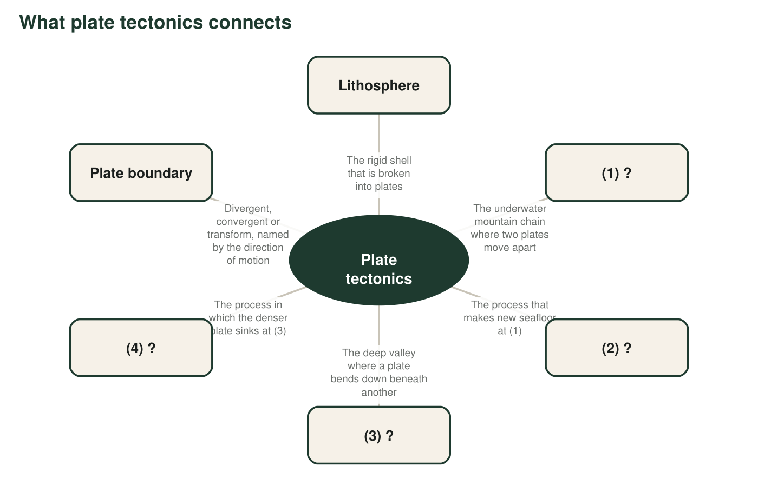
The hub is the theory. Four items have been blanked out and replaced with a number. Each blank item has a description that tells you what belongs there.
7. Write the four missing terms: (1) ______ (2) ______ (3) ______ (4) ______.
Answer: (1) mid-ocean ridge, (2) seafloor spreading, (3) trench, (4) subduction.
Reasoning: Each description matches one definition from the list. Items 1 and 3 are structures; 2 and 4 are the processes that happen at them.
Also acceptable: Accept 'ridge' for (1).
8. Items (1) and (3) are structures, and items (2) and (4) are processes. In one or two sentences, explain how a structure and its process are related. Use the pair (1) and (2) as your example.
Answer: A structure is where a process leaves its mark, and the process is what builds or shapes the structure. The mid-ocean ridge is the place where plates move apart; seafloor spreading is what happens there, as molten rock rises into the gap and hardens into new seafloor. Without the process there would be no ridge, and the ridge is where you go to see the process.
Reasoning: This item makes the structure-process pairing explicit so that students stop treating 'ridge' and 'spreading' as interchangeable.
Also acceptable: Accept the trench-subduction pair as the example if the student reasons the same way.
Full credit must include:
• States that the process happens at the structure
• Names ridge and spreading together
• Says the process makes or shapes the structure

Part D: Use the terms in new places
9. In East Africa, a long valley is slowly getting wider. It has active volcanoes, frequent small earthquakes, and lakes along its floor. Using at least two terms from the list, describe what kind of plate boundary this is and what structure could eventually form there if the motion continues for millions of years.
Answer: It is a divergent plate boundary: the plates are moving apart, molten rock rises to feed the volcanoes, and the stretching causes the earthquakes. If the motion continues for millions of years, the valley could drop below sea level and flood, and a new mid-ocean ridge could form in its middle, with seafloor spreading making a new ocean. The Red Sea is a real example of a later stage.
Reasoning: The East African Rift is a real divergent boundary on land. The question checks that students can apply 'divergent', 'mid-ocean ridge' and 'seafloor spreading' to a place that is not yet an ocean.
Also acceptable: Accept 'a new ocean' or 'a sea like the Red Sea' without the word ridge if seafloor spreading is named.
Full credit must include:
• Names the boundary as divergent or plates moving apart
• Uses at least two terms from the list correctly
• Predicts a widening sea or new ridge over long times
10. A classmate says, 'A plate is just a continent.' Use the terms lithosphere and mid-ocean ridge to explain why this is wrong. (Hint: what is a plate made of, and where do plate edges run?)
Answer: A plate is a piece of the lithosphere, which includes oceanic crust, continental crust and the rigid top of the mantle. Most plates carry both ocean floor and continent, and the Pacific Plate is almost all ocean floor. Plate edges do not follow coastlines; the mid-ocean ridge, for example, is a plate edge that runs down the middle of the Atlantic with ocean floor on both sides, thousands of kilometers from any continent. So a continent is a passenger on a plate, not the plate itself.
Reasoning: This targets the plate-equals-continent misconception. The ridge is the clearest counterexample because it is an edge with no continent near it.
Also acceptable: Accept 'the plate edge of South America is at the ridge, far out in the Atlantic, not at the coast'.
Full credit must include:
• Says a plate is lithosphere, including ocean floor
• Uses the ridge as a plate edge with no continent
• Concludes continents ride on plates
11. Continental drift and plate tectonics are not the same term, and scientists are careful not to swap them. Explain the difference in two ways: (a) what each one says about why the continents move, and (b) which one is a hypothesis and which one is a theory, and what evidence made the difference.
Answer: (a) Continental drift says only that the continents have moved apart from Pangaea; Wegener could not say what force moved them. Plate tectonics says the continents move because they ride on rigid plates of lithosphere, and the plates move as new seafloor forms at ridges and old seafloor sinks at trenches, over a hot mantle that creeps slowly. (b) Continental drift stayed a hypothesis because it had evidence but no tested mechanism. Plate tectonics became a theory in the 1960s when independent lines of evidence (earthquake belts outlining plates, a world-circling ridge, deep trenches, and drill cores showing seafloor ages increasing away from the ridge) all pointed to the same moving plates and the predictions of seafloor spreading came true.
Reasoning: Full credit needs both the 'why' contrast (no mechanism versus plates made and destroyed) and the hypothesis-theory contrast tied to specific evidence from the chapter.
Also acceptable: A student who says plate tectonics 'includes' continental drift as one of its consequences is reasoning well.
Full credit must include:
• States that drift lacked a mechanism and plate tectonics supplies one
• Labels drift a hypothesis and plate tectonics a theory
• Names at least two pieces of evidence that made the difference

Teacher notes
All twelve definitions are original and chosen to be accurate where the textbook simplifies: the mantle beneath the lithosphere is solid rock that creeps, so no definition says plates float on liquid. Expect the Part A argument about 'continental drift'; the point of the discussion is that the term names Wegener's explanation, while the moving is described by the two process terms. The 900 m figure in q5 refers to the 1965 computer fit of the Atlantic continents at the 500-fathom line; students do not need the number, only the idea that the drowned edge is the true edge. In q9 the East African Rift is a real divergent boundary; if students ask, the Red Sea and Gulf of Aden are the next stage, with the southern Red Sea widening by about 15 mm a year. The extension term, asthenosphere, is not in the textbook and is never assessed.

