Angela's Tools · Chapter 16: Earth's Tectonic Plates · Worksheet 2 of 10

Things, Processes and Ideas: Sorting the Language of Moving Plates
Learning target: I can tell apart the structures, processes and science ideas in the plate tectonics story and use each term correctly in a new situation.
Vocabulary in action · about 30 minutes · individual · Standards: MS-ESS2-3 (supports)
Name: ____________________________ Date: ____________ Period: ______

Directions
Read the twelve definitions first; they are written in plain words, and you may use them while you work. In Part A you will sort the terms into three bins. In Part B you will choose the one term that fits each situation. In Part C you will finish a concept map. In Part D you will use the terms to explain places you have not seen before. Write in full sentences wherever a line is given.
hypothesis: A possible explanation built from limited evidence. It is useful because it makes predictions that someone can check.
scientific theory: An explanation that has passed many tests and ties together many separate lines of evidence. It can still be refined when new evidence arrives, but it is not a guess.
continental drift: Wegener's hypothesis that the continents were once joined in one landmass, Pangaea, and have slowly moved apart since it broke up.
plate tectonics: The theory that Earth's rigid outer shell is broken into plates that move slowly, with new seafloor made at ridges and old seafloor destroyed at trenches.
lithosphere: Earth's rigid outer shell: the crust plus the cool, stiff top of the mantle. A tectonic plate is a piece of lithosphere.
seismic wave: A vibration that travels through Earth from an earthquake. Its changes in speed and direction reveal layers no drill can reach.
mid-ocean ridge: A long chain of underwater volcanic mountains along the line where two plates move apart.
trench: A long, narrow valley in the seafloor, several kilometers deep, where one plate bends down beneath another.
continental shelf: The shallow, drowned rim of a continent. It marks the true edge of the landmass, which is wider than the coastline.
seafloor spreading: The process in which plates pull apart at a mid-ocean ridge, molten rock rises and hardens in the gap, and the new seafloor moves outward on both sides.
subduction: The process in which the denser of two converging plates sinks beneath the other and is carried down into the mantle.
plate boundary: The edge where two plates meet. The plates can move apart (divergent), toward each other (convergent) or sideways past each other (transform).

Part A: Three bins
Every term above is one of three kinds. A structure is a thing you could point to on a map or a cross-section. A process is something that happens over time. An idea about science is an explanation scientists have proposed, or a word for how well tested an explanation is. Sort all twelve terms. Each term goes in exactly one bin.
1. Write each of the twelve terms in one bin. Then circle the one term that was hardest to place and write one sentence below the table explaining why.
Structure (a thing) | Process (something happening) | Idea about science (an explanation, or how well tested it is)
Terms

Part B: Which term fits?
Each situation below is described without using the term. Write the single term from the list that fits best.
2. A sonar survey finds a line of volcanic mountains running down the middle of an ocean, with a narrow valley along its crest and small earthquakes all along it. The feature is a ______.
______________________________________________________________________________________
______________________________________________________________________________________
______________________________________________________________________________________
3. A ship drills cores at four sites on one side of a ridge. The farther a site is from the ridge, the older the volcanic rock in its core. The process that explains this pattern is ______.
______________________________________________________________________________________
______________________________________________________________________________________
______________________________________________________________________________________
4. In 1912 Wegener had fossil, rock and shape evidence that the continents had moved, but he could not say what moved them, and only a few scientists agreed with him. At that point his idea was a ______.
______________________________________________________________________________________
______________________________________________________________________________________
______________________________________________________________________________________
5. A map of a continent's edge drawn at a water depth of about 900 meters shows a wider outline than the coastline, and that wider outline fits the facing continent better. The map is showing the ______.
______________________________________________________________________________________
______________________________________________________________________________________
______________________________________________________________________________________
6. Off the coast of South America, the seafloor bends down into a valley 8 kilometers deep, and earthquakes get deeper and deeper the farther inland you go. The plate carrying the seafloor is going through ______.
______________________________________________________________________________________
______________________________________________________________________________________
______________________________________________________________________________________

Part C: Finish the concept map
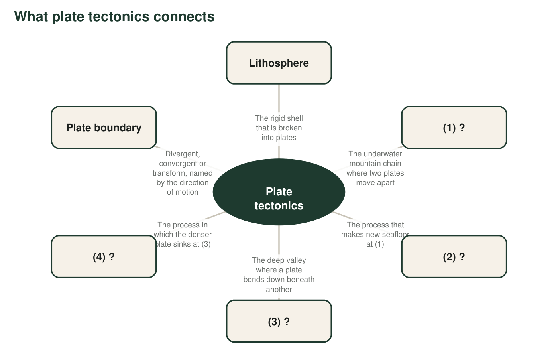
The hub is the theory. Four items have been blanked out and replaced with a number. Each blank item has a description that tells you what belongs there.
7. Write the four missing terms: (1) ______ (2) ______ (3) ______ (4) ______.
______________________________________________________________________________________
______________________________________________________________________________________
______________________________________________________________________________________
8. Items (1) and (3) are structures, and items (2) and (4) are processes. In one or two sentences, explain how a structure and its process are related. Use the pair (1) and (2) as your example.
______________________________________________________________________________________
______________________________________________________________________________________
______________________________________________________________________________________

Part D: Use the terms in new places
9. In East Africa, a long valley is slowly getting wider. It has active volcanoes, frequent small earthquakes, and lakes along its floor. Using at least two terms from the list, describe what kind of plate boundary this is and what structure could eventually form there if the motion continues for millions of years.
______________________________________________________________________________________
______________________________________________________________________________________
______________________________________________________________________________________
______________________________________________________________________________________
10. A classmate says, 'A plate is just a continent.' Use the terms lithosphere and mid-ocean ridge to explain why this is wrong. (Hint: what is a plate made of, and where do plate edges run?)
______________________________________________________________________________________
______________________________________________________________________________________
______________________________________________________________________________________
______________________________________________________________________________________
11. Continental drift and plate tectonics are not the same term, and scientists are careful not to swap them. Explain the difference in two ways: (a) what each one says about why the continents move, and (b) which one is a hypothesis and which one is a theory, and what evidence made the difference.
______________________________________________________________________________________
______________________________________________________________________________________
______________________________________________________________________________________
______________________________________________________________________________________
______________________________________________________________________________________
______________________________________________________________________________________

A test for each bin
Not sure which bin a term belongs in? Ask three questions in order. Can you point to it on a cross-section drawing? Then it is a structure. Does it describe something changing over time, so that the sentence 'It is happening right now' makes sense? Then it is a process. Is it an explanation, or a word for how much evidence an explanation has? Then it is an idea about science. For Part B, cross out any term you have already used; each term fits only one situation.

Write the thirteenth card
The list has no term for the strip of hot, solid mantle below the lithosphere that creeps slowly and lets the plates move over it. Scientists call it the asthenosphere. Write a definition for it in the same style as the twelve above, decide which bin it belongs in, and then rewrite your answer to q10 so that it uses the new term correctly. Finally, explain in two sentences why a plate can move over the asthenosphere even though the asthenosphere is solid rock.

