Angela's Tools · Chapter 16: Earth's Tectonic Plates · Worksheet 4 of 10

From Ridge to Trench: Reading and Drawing the Life of Seafloor (Teacher answer key)
Learning target: I can interpret diagrams of Earth's outer layers and the ridge-to-trench cycle, and draw a labeled cross-section that shows where seafloor is made, how it ages and where it is destroyed.
Diagrams and models · about 40 minutes · individual · Standards: MS-ESS2-3 (practice)

Standards connections
MS-ESS2-3 (practice): Reading a cross-section of ridge, aging seafloor and trench builds the model students need to interpret seafloor structures and age data as evidence of plate motion. The diagram shows the process; the assessed data analysis comes in Worksheets 5 and 6.

Answers with reasoning

Figure A: Earth's outer layers under an ocean
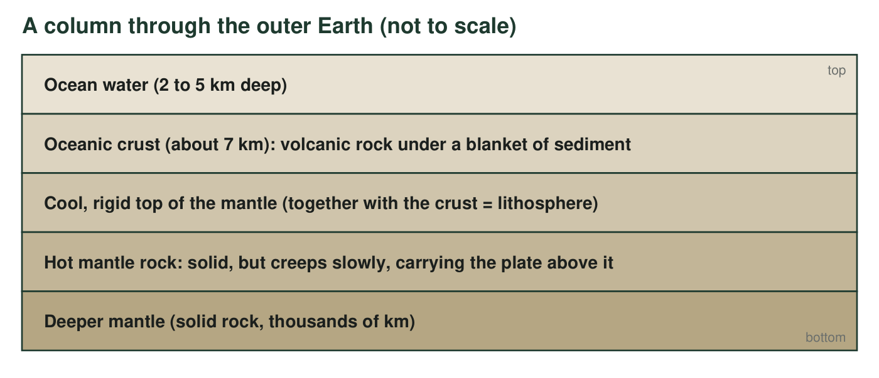
A column through the outer Earth beneath the ocean, top to bottom. The crust and the rigid top of the mantle move together as one stiff slab; that slab is the lithosphere, and a tectonic plate is a piece of it. Below it the mantle is still solid rock, but it is hot enough to creep very slowly, a few centimeters a year.
1. Which two layers in Figure A together make up the lithosphere? Using the figure, explain why 'the crust' and 'a tectonic plate' are not the same thing.
Answer: The oceanic crust and the cool, rigid top of the mantle together make the lithosphere. A tectonic plate is a piece of lithosphere, so it includes the crust and the stiff upper mantle beneath it; the crust alone is only the top part of the plate. A plate can also carry both oceanic and continental crust.
Reasoning: This separates two terms students often merge. Figure A's third layer explicitly says 'together with the crust = lithosphere.'
Also acceptable: Accept 'the plate is the crust plus some mantle, so the crust is only part of it.'
Full credit must include:
• Names crust plus rigid upper mantle
• States that a plate is thicker than the crust because it includes part of the mantle
2. The fourth layer is labeled 'solid, but creeps slowly.' Many people picture plates floating on liquid magma. Using the figure, explain what is wrong with that picture, and suggest an everyday material that is solid yet slowly changes shape.
Answer: The picture is wrong because the mantle beneath the lithosphere is solid rock, not a liquid; the figure says 'solid, but creeps slowly.' Liquid rock (magma) exists only in small pockets, such as under the ridge. The mantle moves like a solid that flows very slowly over millions of years. Everyday comparisons: a glacier (solid ice that flows downhill), warm wax, a block of cold tar, or silly putty left on a table (it slumps over hours).
Reasoning: Seismic waves of the kind that cannot pass through liquid travel through the mantle, which is how scientists know it is solid. Students need only the idea that a solid can creep; any sensible comparison earns credit.
Also acceptable: Accept 'a glacier' or 'very thick putty.' Do not accept 'lava' or 'honey' because both are liquids.
Full credit must include:
• States the mantle is solid, not liquid
• Gives a solid-that-flows comparison

Figure B: The life of a piece of seafloor
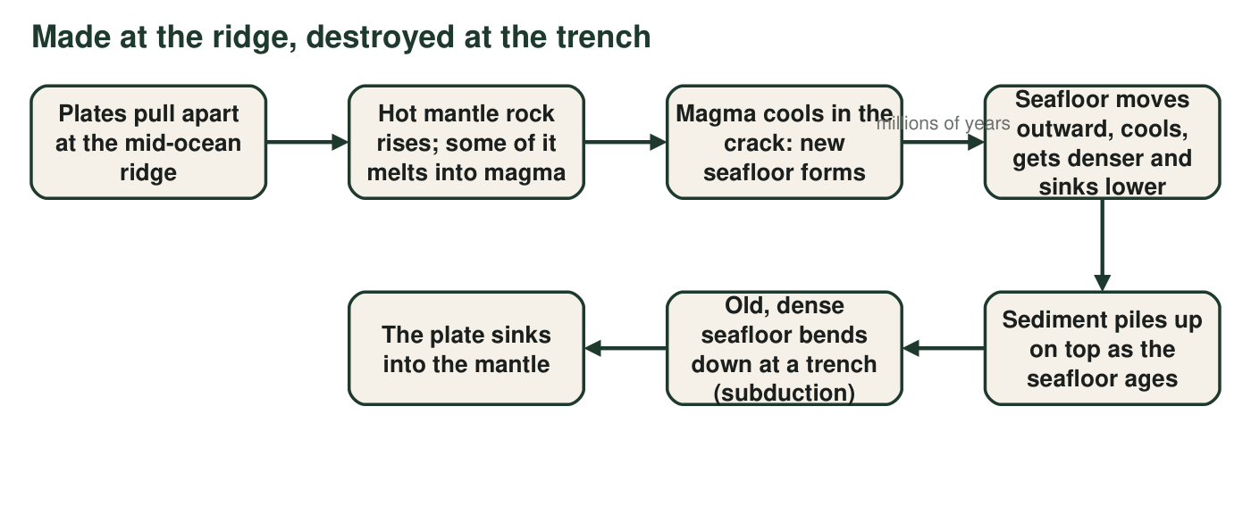
Follow one piece of seafloor from the moment it forms to the moment it sinks. Each arrow stands for millions of years.
3. At which step in Figure B is new seafloor made, and at which step is old seafloor destroyed? Name the process that happens at each of those two steps.
Answer: New seafloor is made at step 3 ('Magma cools in the crack: new seafloor forms'); the process is seafloor spreading, which includes steps 1 to 3. Old seafloor is destroyed at step 6 ('Old, dense seafloor bends down at a trench'); the process is subduction.
Reasoning: Students should connect the two named processes from the vocabulary to the specific nodes in the flow.
Also acceptable: Accept steps 1-3 together for seafloor spreading.
Full credit must include:
• Identifies the ridge step as where seafloor forms
• Identifies the trench step as where it is destroyed
• Names seafloor spreading and subduction
4. Figure B says the seafloor 'cools, gets denser and sinks lower' as it moves away from the ridge. Using that step and the sediment step, predict two things that should be different about the ocean floor 1,000 km from a ridge compared with the ocean floor at the ridge crest.
Answer: At 1,000 km from the ridge the ocean floor should be (1) deeper, because the seafloor has cooled, contracted and grown denser, so it sinks lower; and (2) covered by a much thicker blanket of sediment, because it has been collecting mud and shells for far longer. It would also be older and colder.
Reasoning: Both predictions are real and were confirmed by surveys: ocean depth increases with seafloor age, and sediment thickens away from ridges. Either of the two extra points (older, colder) can replace one of the first two.
Also acceptable: Accept 'older' as one of the two differences if a reason is given.
Full credit must include:
• Deeper water far from the ridge
• Thicker sediment far from the ridge
• A reason for each

Figure C: Parts of a ridge-to-trench cross-section
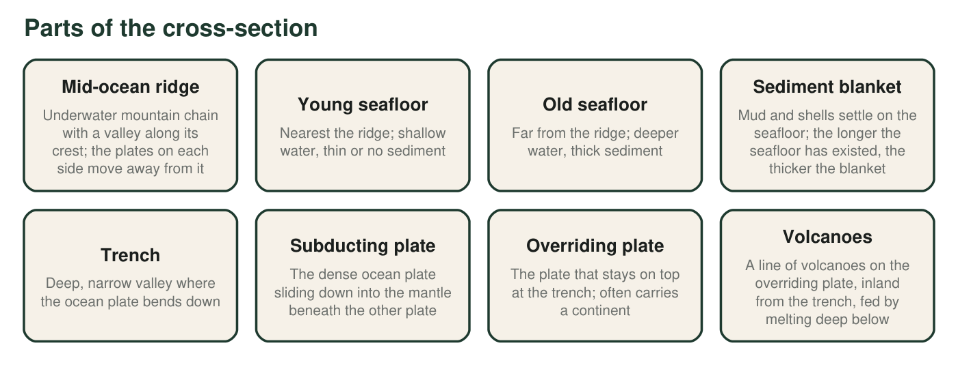
The eight parts you would label on a side view that runs from a mid-ocean ridge (left) across an ocean to a trench (right). Read each description; you will place these parts in your own drawing.
5. A drilling ship takes rock samples at four spots on the cross-section. Which sample should contain the youngest volcanic rock?
Answer: C: A sample taken from the crest of the mid-ocean ridge.
Reasoning: Seafloor forms at the ridge, so the youngest volcanic rock is at the crest. The trench holds the oldest seafloor in this cross-section, and the overriding plate's volcanic rock belongs to a different plate.
Also acceptable: None.
6. Two drill sites are 100 km and 800 km from the ridge. Which site must drill through more sediment before it reaches volcanic rock? Explain using the description of the sediment blanket in Figure C.
Answer: The site 800 km from the ridge must drill through more sediment. Figure C says the sediment blanket is thicker the longer the seafloor has existed, and seafloor 800 km away has been collecting sediment far longer than seafloor 100 km away.
Reasoning: This prepares students for Worksheet 9, where sediment thickness is a design constraint for drilling.
Also acceptable: Accept 'the 800 km site is older so it has more sediment.'
Full credit must include:
• Chooses the 800 km site
• Links thickness to the age of the seafloor

Your model
Draw a side view (cross-section) that runs from a mid-ocean ridge on the LEFT to a trench on the RIGHT. Include and label all eight parts from Figure C. Add: arrows showing which way the seafloor moves on each side of the ridge; the word YOUNG near the ridge and OLD near the trench; a thicker sediment line as the seafloor gets older; and the solid, slowly creeping mantle beneath everything. Shade the subducting plate so it is clear which plate goes down.
Expected drawing: A complete drawing shows: a ridge with a crest valley at the left; seafloor sloping gently deeper toward the right; a sediment line that thickens to the right; the ocean plate bending sharply down at a trench on the right; the subducting plate shaded and labeled as it slides beneath the overriding plate; a line of volcanoes on the overriding plate, inland from the trench; arrows pointing away from the ridge on both sides (the left-side arrow points left, off the page); YOUNG near the ridge and OLD near the trench; and a labeled band of solid, slowly creeping mantle under everything. All eight labels from Figure C present.
Reasoning: Grade for correctness of placement and direction more than for artistic quality. The three most common errors are arrows pointing toward the ridge, volcanoes placed in the trench or on the ocean side, and the sediment drawn thickest at the ridge.
7. Look at your drawing. On which side of the trench did you place the volcanoes, and why does that side make sense? (Think about which plate is sinking and where the melting happens.)
Answer: The volcanoes belong on the overriding plate, inland from the trench. The ocean plate sinks beneath that plate, and the melting that feeds the volcanoes happens deep below the overriding plate, above the sinking slab, so the magma rises through the overriding plate, not through the trench floor.
Reasoning: Which rock melts (the sinking plate, the mantle above it, or both) is still debated, so the key says only that melting happens deep below and feeds the volcanoes.
Also acceptable: Accept 'the sinking plate causes melting underneath the top plate, so the volcanoes come up through the top plate.'
Full credit must include:
• Volcanoes on the overriding plate side
• Reason connects melting above the sinking plate to the rising magma
8. A student asks, 'If new seafloor keeps forming at ridges, why isn't Earth getting bigger?' Use your drawing and Figure B to write a complete answer. Name the structure and the process that balance the new seafloor.
Answer: Earth does not grow because seafloor is destroyed as fast as it is made. New seafloor forms at mid-ocean ridges by seafloor spreading, but old, cold, dense seafloor bends down at trenches and sinks into the mantle by subduction. The amount created at ridges is balanced by the amount removed at trenches, so the planet's surface area stays the same even though the plates keep moving.
Reasoning: This is the chapter's Stability and Change idea. Full credit names both the structure (trench) and the process (subduction) that remove seafloor.
Also acceptable: A student who adds that this is why no seafloor is older than about 200 million years has gone beyond the question and is correct.
Full credit must include:
• States that seafloor is removed as well as made
• Names trenches and subduction
• Says the two balance so the size stays the same
9. Every model leaves something out. Name two things your cross-section cannot show well (for example about size, speed or time), and say why each one is hard to draw.
Answer: Any two, with reasons: (1) Scale: the ridge rises only 2 to 3 km above the seafloor while the plates are thousands of kilometers across, so a true-scale drawing would be a nearly flat line; the drawing exaggerates heights. (2) Speed and time: plates move a few centimeters a year and a piece of seafloor takes tens of millions of years to travel from ridge to trench; a still drawing cannot show motion or duration. (3) Three dimensions: the ridge and trench are long lines running into the page, and plates move sideways along transform boundaries that a cross-section cannot show. (4) The mantle's slow creep is invisible in a still picture.
Reasoning: Recognizing a model's limits is part of modeling. Any two accurate limitations with reasons earn full credit.
Also acceptable: Accept 'it cannot show how hot each layer is' or 'it cannot show the earthquakes along the sinking plate.'
Full credit must include:
• Two limitations named
• Each explained with a reason

Teacher notes
Figure A's numbers are rounded: open-ocean depth 2 to 5 km, oceanic crust about 7 km, oceanic lithosphere thin near the ridge and about 100 km thick under old seafloor. The mantle is solid rock throughout; keep correcting 'liquid magma ocean' whenever it appears. The flow in Figure B ends with the plate sinking into the mantle and does not trace a return path to the ridge, because the driving forces of plate motion are still debated and MS-ESS2-3 does not assess mechanisms. The volcanoes in Figure C are placed on the overriding plate inland from the trench, as in the Andes; the key avoids saying which rock melts. The extension uses a real contrast: the Atlantic's oldest seafloor (about 180 million years) lies against the continental margins because the ocean has almost no trenches, while the Pacific's oldest seafloor is consumed at its trenches.

