Angela's Tools · Chapter 16: Earth's Tectonic Plates · Worksheet 4 of 10

From Ridge to Trench: Reading and Drawing the Life of Seafloor
Learning target: I can interpret diagrams of Earth's outer layers and the ridge-to-trench cycle, and draw a labeled cross-section that shows where seafloor is made, how it ages and where it is destroyed.
Diagrams and models · about 40 minutes · individual · Standards: MS-ESS2-3 (practice)
Name: ____________________________ Date: ____________ Period: ______

Directions
Study the three figures in order. Figure A shows Earth's outer layers in a column. Figure B shows the steps in the life of a piece of seafloor. Figure C names the parts of a cross-section from a mid-ocean ridge to a trench. Answer the questions for each figure, then draw your own cross-section in the box and finish the questions that follow it. Your drawing does not need to be beautiful; it needs to be labeled and correct.

Figure A: Earth's outer layers under an ocean
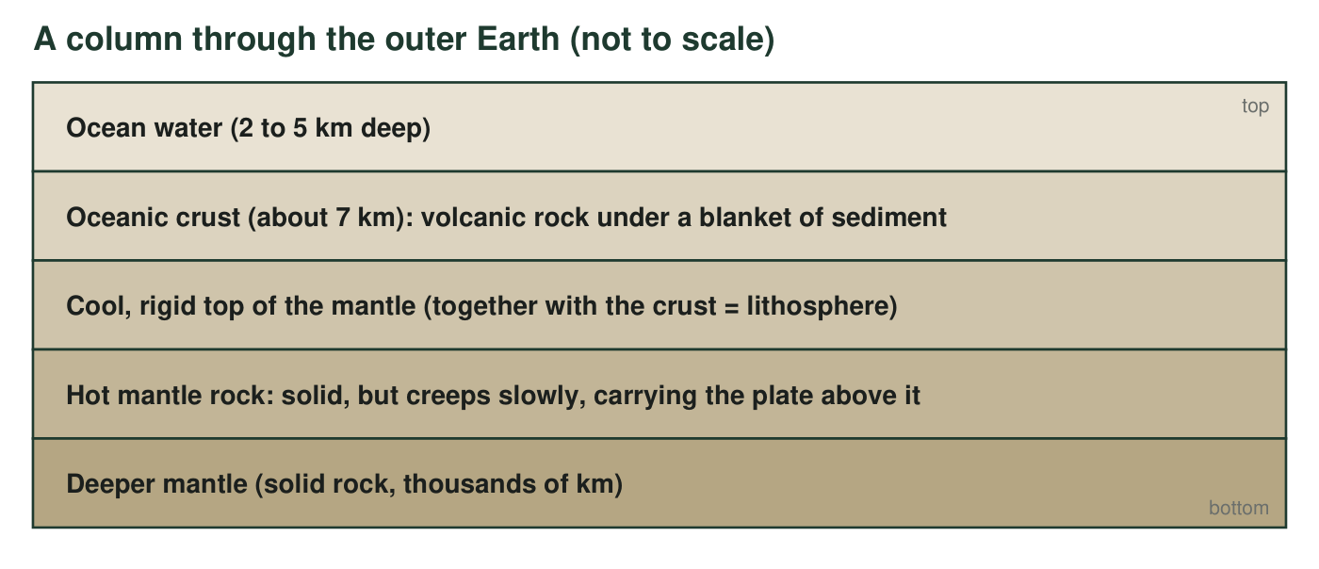
A column through the outer Earth beneath the ocean, top to bottom. The crust and the rigid top of the mantle move together as one stiff slab; that slab is the lithosphere, and a tectonic plate is a piece of it. Below it the mantle is still solid rock, but it is hot enough to creep very slowly, a few centimeters a year.
1. Which two layers in Figure A together make up the lithosphere? Using the figure, explain why 'the crust' and 'a tectonic plate' are not the same thing.
______________________________________________________________________________________
______________________________________________________________________________________
______________________________________________________________________________________
2. The fourth layer is labeled 'solid, but creeps slowly.' Many people picture plates floating on liquid magma. Using the figure, explain what is wrong with that picture, and suggest an everyday material that is solid yet slowly changes shape.
______________________________________________________________________________________
______________________________________________________________________________________
______________________________________________________________________________________
______________________________________________________________________________________

Figure B: The life of a piece of seafloor
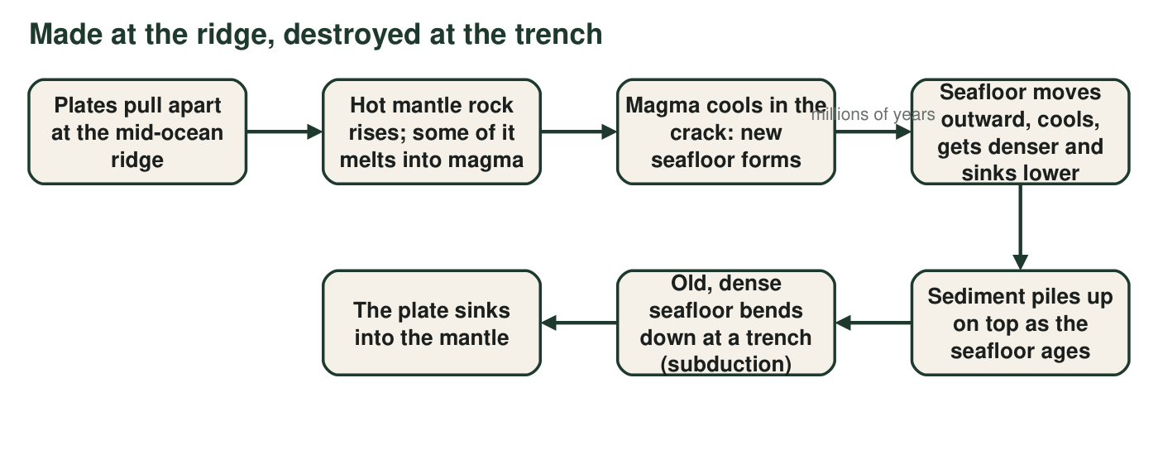
Follow one piece of seafloor from the moment it forms to the moment it sinks. Each arrow stands for millions of years.
3. At which step in Figure B is new seafloor made, and at which step is old seafloor destroyed? Name the process that happens at each of those two steps.
______________________________________________________________________________________
______________________________________________________________________________________
______________________________________________________________________________________
4. Figure B says the seafloor 'cools, gets denser and sinks lower' as it moves away from the ridge. Using that step and the sediment step, predict two things that should be different about the ocean floor 1,000 km from a ridge compared with the ocean floor at the ridge crest.
______________________________________________________________________________________
______________________________________________________________________________________
______________________________________________________________________________________
______________________________________________________________________________________

Figure C: Parts of a ridge-to-trench cross-section
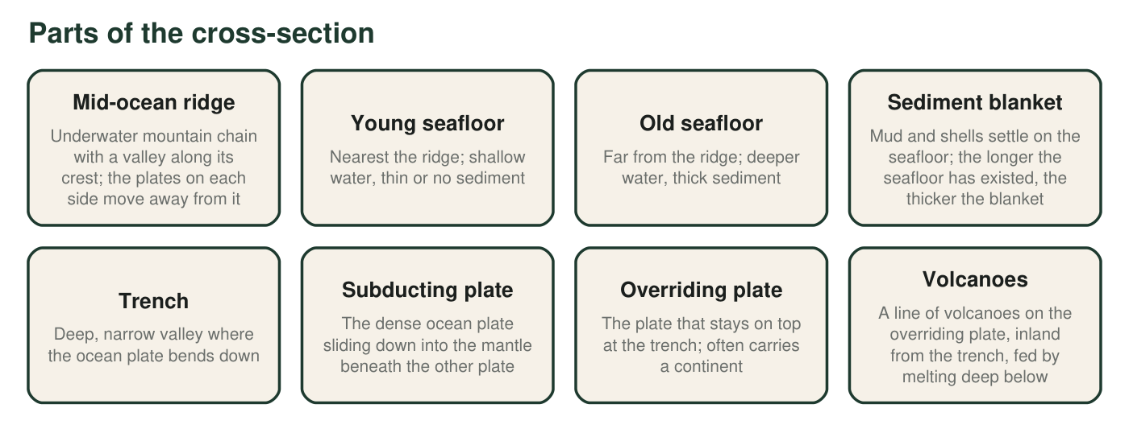
The eight parts you would label on a side view that runs from a mid-ocean ridge (left) across an ocean to a trench (right). Read each description; you will place these parts in your own drawing.
5. A drilling ship takes rock samples at four spots on the cross-section. Which sample should contain the youngest volcanic rock?
○ A. A sample taken from the floor of the trench
○ B. A sample taken halfway between the ridge and the trench
○ C. A sample taken from the crest of the mid-ocean ridge
○ D. A sample taken from the overriding plate near the volcanoes
6. Two drill sites are 100 km and 800 km from the ridge. Which site must drill through more sediment before it reaches volcanic rock? Explain using the description of the sediment blanket in Figure C.
______________________________________________________________________________________
______________________________________________________________________________________
______________________________________________________________________________________

Your model
Draw a side view (cross-section) that runs from a mid-ocean ridge on the LEFT to a trench on the RIGHT. Include and label all eight parts from Figure C. Add: arrows showing which way the seafloor moves on each side of the ridge; the word YOUNG near the ridge and OLD near the trench; a thicker sediment line as the seafloor gets older; and the solid, slowly creeping mantle beneath everything. Shade the subducting plate so it is clear which plate goes down.

7. Look at your drawing. On which side of the trench did you place the volcanoes, and why does that side make sense? (Think about which plate is sinking and where the melting happens.)
______________________________________________________________________________________
______________________________________________________________________________________
______________________________________________________________________________________
8. A student asks, 'If new seafloor keeps forming at ridges, why isn't Earth getting bigger?' Use your drawing and Figure B to write a complete answer. Name the structure and the process that balance the new seafloor.
______________________________________________________________________________________
______________________________________________________________________________________
______________________________________________________________________________________
______________________________________________________________________________________
______________________________________________________________________________________
______________________________________________________________________________________
9. Every model leaves something out. Name two things your cross-section cannot show well (for example about size, speed or time), and say why each one is hard to draw.
______________________________________________________________________________________
______________________________________________________________________________________
______________________________________________________________________________________
______________________________________________________________________________________

Build the drawing in five layers
Draw in this order so nothing gets crowded. (1) A light horizontal line for sea level across the whole box. (2) The mantle as a wide band along the bottom, labeled 'solid mantle, creeps slowly.' (3) The seafloor as a line that starts high at the ridge on the left, slopes gently down to the right, and bends sharply down at the trench. (4) The ridge bump with its crest valley, the sediment line that gets thicker to the right, and the overriding plate with its volcanoes on the far right. (5) Arrows and the words YOUNG and OLD last.

Two oceans, two endings
The Pacific has trenches around most of its edges. The Atlantic has almost none; its seafloor runs right up to the continental shelves of the Americas, Africa and Europe. Draw a second cross-section for an Atlantic-type ocean with a ridge in the middle and a continental shelf at each edge instead of a trench. Then write a paragraph answering: where is the oldest seafloor in each ocean, and why does the textbook's rule 'the oldest rocks are at the trenches' work for one ocean but not the other?

