Angela's Tools · Chapter 17: The Rock Cycle · Worksheet 1 of 10

The Dome, the Cobbles and the Sand Bar: Where Is the Rock Going? (Teacher answer key)
Learning target: I can record observations about rock that is breaking down and moving along a creek, and write a first explanation of where the material came from, where it is going and what energy moves it.
Phenomenon exploration · about 25 minutes · individual · Standards: MS-ESS2-1 (supports)

Standards connections
MS-ESS2-1 (supports): Students meet the phenomenon that will anchor their rock-cycle model: solid rock turning into sediment, moving downhill and piling up in layers. This sheet surfaces prior ideas and questions; it does not yet produce the model the PE calls for.

Answers with reasoning

Field notes from Pine Creek Canyon
A student science club spends a Saturday walking Pine Creek from its headwaters down to the reservoir it flows into. Site 1, at the top, is a bare, rounded dome of pink-and-gray rock. Up close the rock is made of large interlocking grains: pink, white, gray and black, each a few millimeters across. The surface is flaking off in thin curved sheets, and the ground around the dome is covered with sharp-cornered chunks and coarse, gritty crumbs of the same colors. Site 2, about three kilometers downstream, is a stretch of creek bed full of rounded cobbles the size of fists and grapefruits. Most are pink-and-gray with the same four colors of grains, but their corners are gone. Site 3 is a sand bar where the creek enters the reservoir. The sand grains are pink, white, gray and black. A club member pushes a clear tube into the reservoir mud beside the bar and pulls up a core 60 cm long. It shows about 40 thin layers of mud, one on top of another. The dam that made the reservoir was finished 40 years ago.
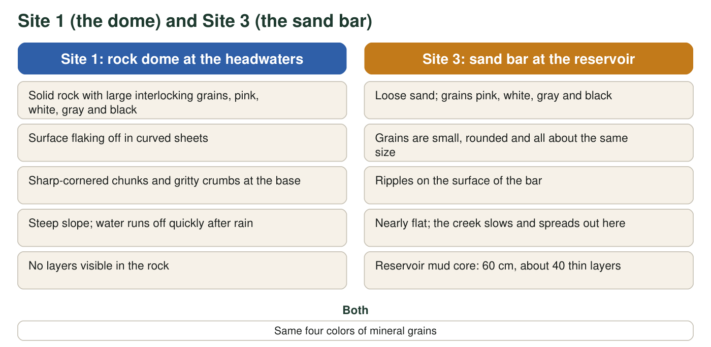
Observations recorded at the top and bottom of Pine Creek. Compare the two columns line by line.

Part A: Notice and wonder
1. I notice... Write at least four observations from the notes or the figure. Use only things that were actually observed, not guesses about causes. At least one observation must compare two sites.
Answer: Any four observed facts, for example: the dome rock has large interlocking grains in four colors; the surface is flaking off in sheets; chunks at the base have sharp corners; cobbles at Site 2 are rounded; the sand at Site 3 has the same four colors as the dome; the sand grains are small, rounded and similar in size; the creek slows where it enters the reservoir; the mud core has about 40 layers in 60 cm.
Reasoning: Observations must be things that were seen or measured, not explanations. At least one must compare sites (for example, sharp chunks at Site 1 versus rounded cobbles at Site 2, or same colors at Sites 1 and 3).
Also acceptable: Accept 'the water runs off fast at Site 1 but slows at Site 3' as a comparison.
Full credit must include:
• Four or more statements drawn from the notes or figure
• No causes or explanations mixed in
• At least one statement compares two sites
2. I wonder... Write at least three questions the scene raises for you. Try to include one question about where material came from, one about what moves it, and one about how long something takes.
Answer: Any three genuine questions, for example: Did the sand come from the dome? What breaks the dome into chunks? Why are the cobbles rounded but the chunks sharp? How long does it take a chunk to travel three kilometers? Why does the creek drop its sand at the reservoir? Will the layers in the mud ever become rock? What made the dome in the first place?
Reasoning: Look for one question each about source, movement and time, as the prompt asks, but accept any three curious, answerable questions.
Also acceptable: Questions about the dome's origin or the reservoir's age are acceptable even if they do not fit the three suggested types.
Full credit must include:
• Three or more questions
• Questions connect to the scene rather than being general
3. The chunks at Site 1 have sharp corners. The cobbles at Site 2 are rounded. Describe what could happen to a chunk between Site 1 and Site 2 that would explain the difference.
Answer: Moving water pushes the chunk along the creek bed, where it bumps, rolls and scrapes against other rocks. Each collision knocks off a corner or a grain. Over many trips downstream the sharp edges wear away and the chunk gets smaller and rounder.
Reasoning: Students are describing abrasion during transport without needing the term. The key idea is repeated collisions during movement by water.
Also acceptable: Accept 'the corners break off when it tumbles' or 'the water grinds it against other rocks.'
Full credit must include:
• Says the chunk moves (by water or gravity)
• Says collisions or rubbing wear away corners

Part B: What do you already think?
4. Which statement is closest to what you believe right now about where sand comes from? Circle one. There is no penalty for any choice.
Answer: B is the scientifically accurate choice: sand is made of small pieces broken from larger rock (though some sand elsewhere is made of shell fragments). Any choice earns credit here because the item records prior belief.
Reasoning: This is a diagnostic item. Note which students chose A or C; they will need the evidence that the sand and the dome share the same four mineral colors.
Also acceptable: Full credit for any circled option. Option D is partly true for some beaches (shell sand) but not for this creek.
5. The reservoir core is 60 cm long with about 40 layers, and the dam is 40 years old. Calculate how much mud piles up in a typical year. Then estimate how many years after the dam was finished the mud would reach 3 m (300 cm) deep if the rate stays the same. Show your work.
Answer: Rate: 60 cm ÷ 40 years = 1.5 cm per year (also 60 cm ÷ 40 layers = 1.5 cm per layer, about one layer per year). Time to reach 300 cm: 300 cm ÷ 1.5 cm per year = 200 years.
Reasoning: The core gives both a thickness and a time, so the rate is thickness divided by years. The 3 m estimate assumes the rate stays constant, which the prompt states.
Also acceptable: Accept 1.5 cm/year and 200 years; accept 'about 200 years' with the division shown. A student who uses 40 layers instead of 40 years gets the same numbers and should say one layer forms per year. A student who answers 160 more years from today has found the remaining time; accept it if the work shows 200 − 40 = 160.

Part C: Your first explanation
6. Write your best explanation of the sand bar at Site 3. Where did the grains come from? What evidence from the notes supports that? What moved them from Site 1 to Site 3, and what supplies the energy for that movement?
Answer: Model response: The sand came from the rock dome at Site 1. The evidence is that the sand grains are the same four colors as the grains in the dome, and that the dome is already flaking and crumbling into gritty pieces, while the cobbles in between are made of the same rock with their corners worn off. Rain, freezing and temperature changes break the dome apart, and gravity and the flowing creek carry the pieces downhill, wearing them smaller as they go. The creek drops the sand where it slows down at the reservoir. The energy comes from the Sun, which drives the rain and the flowing water, and from gravity, which pulls water and rock downhill.
Reasoning: This is the student's first explanation; full credit is for a complete, evidence-based attempt rather than a perfect one. The color match is the key evidence. Energy may be named as rain, water, gravity or the Sun; naming the Sun as the source behind water flow is the strongest answer.
Also acceptable: A student who says 'the sand came from somewhere else' can still earn partial credit for naming a mover and an energy source, but should be asked in discussion to account for the matching colors.
Full credit must include:
• Claims the grains came from the dome rock
• Cites the matching grain colors (and optionally the worn cobbles) as evidence
• Names water and gravity as movers
• Names an energy source (Sun or gravity)
7. Predict: suppose the sand at Site 3 keeps getting buried by more sand and mud for millions of years, deeper and deeper. What do you think it will turn into, and why?
Answer: It will be pressed together by the weight of everything above it, and minerals carried by water between the grains will glue them together, so the loose sand becomes solid rock: sandstone.
Reasoning: This predicts compaction and cementation, which W3 and W4 develop. Accept the prediction 'it turns into rock' with a reason involving pressure or weight.
Also acceptable: A student who predicts 'it stays sand forever' should be invited to think about what the weight of 3 m of mud does to the layers below.
Full credit must include:
• Predicts solid rock (sandstone acceptable but not required)
• Gives a reason involving pressure, weight or gluing
8. A geologist tells the club that the rock dome at Site 1 formed from molten rock that cooled many kilometers underground. Write one question you would need answered to explain how that rock is now sitting at the surface in the open air.
Answer: Any question about how deep rock reaches the surface, for example: What pushed the rock upward? What happened to the kilometers of rock that used to be on top of it? How long did the trip from deep underground up to the surface take? Did the land rise, or did the rock above wear away, or both?
Reasoning: The intended answer involves uplift by tectonic forces and removal of the overlying rock by weathering and erosion. Any question aimed at either half of that process is on target.
Also acceptable: Accept 'Was there a volcano?' if the student connects it to the rock reaching the surface, though the dome is intrusive, not volcanic; use this in discussion.
Full credit must include:
• Question asks about uplift, removal of overlying rock, or the time involved

Teacher notes
The scenario is fictional but built from real patterns: granite domes shed curved sheets (exfoliation) and weather into coarse grus; downstream cobbles round by abrasion; and some lakes and reservoirs with strong seasonal inflow lay down about one layer per year (others record one layer per flood). The 1.5 cm per year rate is realistic for a small reservoir with a sediment-rich creek. Do not name the rock cycle yet; let students build it from this page. Collect q4 answers as a quick pre-assessment and return to q6 and q7 after W4. Avoid the word 'erosion' unless students use it; the distinction between weathering (breaking down) and erosion (carrying away) is introduced in W2 and W3.

