Angela's Tools · Chapter 17: The Rock Cycle · Worksheet 1 of 10

The Dome, the Cobbles and the Sand Bar: Where Is the Rock Going?
Learning target: I can record observations about rock that is breaking down and moving along a creek, and write a first explanation of where the material came from, where it is going and what energy moves it.
Phenomenon exploration · about 25 minutes · individual · Standards: MS-ESS2-1 (supports)
Name: ____________________________ Date: ____________ Period: ______

Directions
Read the field notes and study the figure. The scene is a teaching scenario built from the kinds of things geologists see along creeks in granite country; the numbers are realistic but were chosen for this sheet. Write what you notice before you write what you think. In Part C, give your best current explanation. You will not be graded on being right; you will come back to this page at the end of the chapter and compare.

Field notes from Pine Creek Canyon
A student science club spends a Saturday walking Pine Creek from its headwaters down to the reservoir it flows into. Site 1, at the top, is a bare, rounded dome of pink-and-gray rock. Up close the rock is made of large interlocking grains: pink, white, gray and black, each a few millimeters across. The surface is flaking off in thin curved sheets, and the ground around the dome is covered with sharp-cornered chunks and coarse, gritty crumbs of the same colors. Site 2, about three kilometers downstream, is a stretch of creek bed full of rounded cobbles the size of fists and grapefruits. Most are pink-and-gray with the same four colors of grains, but their corners are gone. Site 3 is a sand bar where the creek enters the reservoir. The sand grains are pink, white, gray and black. A club member pushes a clear tube into the reservoir mud beside the bar and pulls up a core 60 cm long. It shows about 40 thin layers of mud, one on top of another. The dam that made the reservoir was finished 40 years ago.
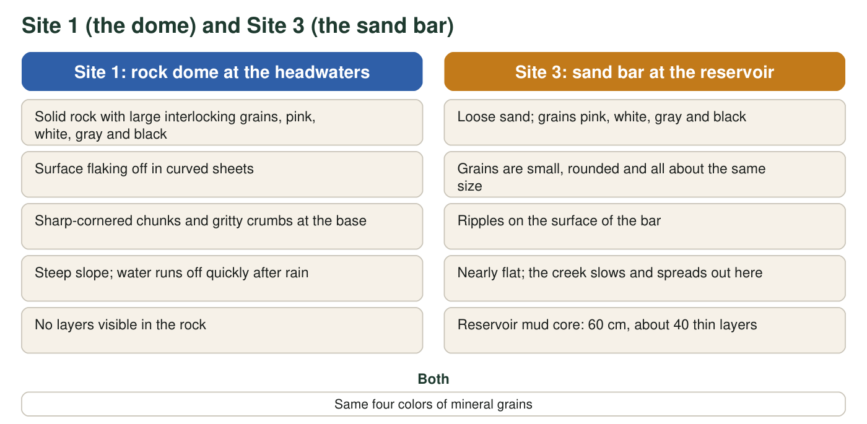
Observations recorded at the top and bottom of Pine Creek. Compare the two columns line by line.

Part A: Notice and wonder
1. I notice... Write at least four observations from the notes or the figure. Use only things that were actually observed, not guesses about causes. At least one observation must compare two sites.
______________________________________________________________________________________
______________________________________________________________________________________
______________________________________________________________________________________
______________________________________________________________________________________
______________________________________________________________________________________
2. I wonder... Write at least three questions the scene raises for you. Try to include one question about where material came from, one about what moves it, and one about how long something takes.
______________________________________________________________________________________
______________________________________________________________________________________
______________________________________________________________________________________
______________________________________________________________________________________
______________________________________________________________________________________
3. The chunks at Site 1 have sharp corners. The cobbles at Site 2 are rounded. Describe what could happen to a chunk between Site 1 and Site 2 that would explain the difference.
______________________________________________________________________________________
______________________________________________________________________________________
______________________________________________________________________________________

Part B: What do you already think?
4. Which statement is closest to what you believe right now about where sand comes from? Circle one. There is no penalty for any choice.
○ A. Sand is its own kind of material; it was never part of solid rock.
○ B. Sand is made of tiny pieces broken off larger rock.
○ C. Sand is made only by the ocean, so this sand must have come from the sea.
○ D. Sand is made by living things, like shells or plants.
5. The reservoir core is 60 cm long with about 40 layers, and the dam is 40 years old. Calculate how much mud piles up in a typical year. Then estimate how many years after the dam was finished the mud would reach 3 m (300 cm) deep if the rate stays the same. Show your work.
______________________________________________________________________________________
______________________________________________________________________________________
______________________________________________________________________________________

Part C: Your first explanation
6. Write your best explanation of the sand bar at Site 3. Where did the grains come from? What evidence from the notes supports that? What moved them from Site 1 to Site 3, and what supplies the energy for that movement?
______________________________________________________________________________________
______________________________________________________________________________________
______________________________________________________________________________________
______________________________________________________________________________________
______________________________________________________________________________________
______________________________________________________________________________________
______________________________________________________________________________________
7. Predict: suppose the sand at Site 3 keeps getting buried by more sand and mud for millions of years, deeper and deeper. What do you think it will turn into, and why?
______________________________________________________________________________________
______________________________________________________________________________________
______________________________________________________________________________________
8. A geologist tells the club that the rock dome at Site 1 formed from molten rock that cooled many kilometers underground. Write one question you would need answered to explain how that rock is now sitting at the surface in the open air.
______________________________________________________________________________________
______________________________________________________________________________________
______________________________________________________________________________________

Sentence frames for noticing
If you are not sure how to start, use these frames: 'At Site 1 I notice ____, but at Site 3 I notice ____.' 'The grains at both sites are ____.' 'The mud core shows ____.' For Part C, try: 'I think the sand came from ____ because ____. I think it was moved by ____, which gets its energy from ____.'

A bar that is not pink
A second creek enters the same reservoir from a valley whose rock is dark gray and fine-grained, with no visible crystals. Predict what the sand bar at its mouth looks like and explain your prediction. Then describe one measurement the club could make on both sand bars that would test whether sand grains really come from the rock upstream, and say what result would support the idea and what result would weaken it.

