Angela's Tools · Chapter 17: The Rock Cycle · Worksheet 4 of 10

Reading a Cliff, Then Drawing the Cycle: A Model with Energy Arrows (Teacher answer key)
Learning target: I can interpret a cross-section of rock layers to work out which rock-cycle processes made each layer, and draw my own rock-cycle model that shows the processes and the energy driving each one.
Diagrams and models · about 45 minutes · individual · Standards: MS-ESS2-1 (assesses)

Standards connections
MS-ESS2-1 (assesses): Part B asks students to develop a model of the cycling of Earth's materials that labels melting, crystallization, weathering, deformation and sedimentation and marks the energy source of each arrow. That is the PE as written, so the drawing and its labels are evidence toward it. No mineral naming is required.

Answers with reasoning

Part A: Read the cliff
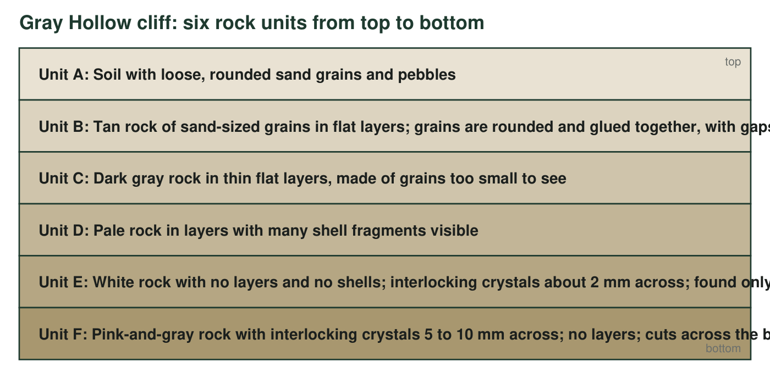
A cross-section through Gray Hollow cliff, top to bottom. Unit F (the lowest) does not lie flat under the others; it cuts across the bottoms of units D and E like a dome pushing up from below.
1. Which units are sedimentary rock? For each, name the clue in its description that tells you.
Answer: Units B, C and D. B: rounded sand-sized grains glued together in flat layers with gaps between them (compacted and cemented sediment). C: thin flat layers of grains too small to see (fine mud that settled and was compacted). D: layers containing shell fragments (remains of organisms deposited in layers).
Reasoning: Layering plus grains or shells is the sedimentary signature. Unit A is loose sediment, not rock yet; E and F are crystalline.
Also acceptable: A student who includes Unit A as 'sediment, not yet sedimentary rock' is reasoning correctly; do not deduct if they explain the distinction.
Full credit must include:
• Names B, C and D
• Gives a layer, grain or shell clue for each
2. Unit F has interlocking crystals 5 to 10 mm across and no layers. Which rock type is it, and did it form at the surface or underground? Use the crystal size to explain.
Answer: Igneous rock that cooled underground (intrusive). Interlocking crystals show it crystallized from a melt, and crystals 5 to 10 mm across need a long cooling time, which happens only when magma is insulated by surrounding rock below the surface. Lava at the surface cools too fast to grow crystals that large.
Reasoning: This is the slow-cooling, large-crystal rule applied to evidence.
Also acceptable: Naming granite is fine but not required.
Full credit must include:
• Says igneous and intrusive (or underground)
• Links large crystals to slow cooling
3. Unit E has the same pale color as Unit D and sits right beside it, but it has no shells, no layers and interlocking crystals, and it occurs only within 30 m of Unit F. Explain what Unit E used to be, what happened to it, and why it is found only near Unit F. Your answer must say whether Unit E melted.
Answer: Unit E used to be the same shelly sedimentary rock as Unit D. When the magma that became Unit F pushed in beneath it, heat flowed from the magma into the nearby rock (by conduction). The heat made the rock's crystals regrow into larger, interlocking crystals, which erased the shells and the layering; this is recrystallization, a metamorphic change. Unit E did not melt: it stayed solid while its crystals rearranged, which is why it is still a separate unit next to D instead of having mixed into F. It is found only within 30 m of F because that is as far as enough heat reached; rock farther away stayed too cool to change.
Reasoning: Full credit requires the parent rock (D), the heat source (F), recrystallization without melting, and the distance explanation. This is contact metamorphism, though the term is not required.
Also acceptable: Accept 'baked' for the heating as long as the student says the rock stayed solid. A student who says E melted and re-hardened has the chapter's key misconception and should revise.
Full credit must include:
• Identifies Unit D as the original rock
• Names heat from Unit F as the cause
• States that E stayed solid (did not melt) while crystals regrew
• Explains the 30 m limit as how far the heat reached
4. Unit F is at the bottom of the cliff, but it is not the oldest unit. What clue in the figure tells you that, and what does it tell you about the order of events?
Answer: Unit F cuts across the bottoms of D and E instead of lying flat beneath them. A body that cuts through other rock must have arrived after that rock already existed. So the order was: D was deposited first; later, magma intruded from below to form F and changed the nearby part of D into E. (The figure does not show whether B and C were already on top when F arrived, though F's large crystals mean some rock covered it.)
Reasoning: This is the cross-cutting relationship: an intrusion is younger than any rock it cuts. Students need only the logic, not the name.
Also acceptable: Accept 'F pushed up into D after D was already there.'
Full credit must include:
• Cites the cutting-across clue
• Concludes F is younger than D (and E formed when F arrived)
5. Complete the table for five of the units.
Answer: Unit B: weathering, erosion and deposition of sand, then compaction and cementation; Sun and gravity. Unit D: deposition of shells (remains of organisms) in layers, then compaction and cementation; Sun and gravity (life at the surface runs on the Sun; settling runs on gravity). Unit E: recrystallization of solid rock by heat (and pressure) from the intrusion; Earth's interior. Unit F: melting of older rock, then slow cooling and crystallization of magma underground; Earth's interior. Unit A: weathering of the rock units below and nearby, with erosion and deposition of the grains; Sun and gravity.
Reasoning: The table is the heart of the sheet: every unit traced to a process and an energy source. The common error is assigning Unit E to the Sun because it 'looks like' D.
Also acceptable: For Unit D accept 'chemical/biological sedimentation' if the student explains shells. For Unit F accept 'cooling of magma' without the melting step.
Full credit must include:
• Correct process for each of the five units
• Correct energy source for each
6. The loose grains in Unit A are the same colors as the crystals in Unit F, even though F is at the bottom of the cliff. Suggest how material from F could be at the top, and name the processes involved.
Answer: Somewhere nearby, at a higher level than the cliff top (for example on a hill upslope), Unit F has been uplifted and exposed at the surface. Weathering breaks the exposed pink-and-gray rock into loose crystals, and erosion by water and gravity carries the grains downhill (wind can also blow sand), where they are deposited on top of the cliff as part of the soil. The processes are uplift and exposure, weathering, erosion and deposition.
Reasoning: Students must recognize that material from the bottom rock can reach the top only after exposure somewhere and transport. Accept a nearby outcrop upslope as the source.
Also acceptable: Accept 'grains washed down from a hill of the same rock above the cliff.'
Full credit must include:
• Says F must be exposed somewhere higher up or within reach of wind (after uplift and erosion)
• Names weathering and erosion/deposition as the movers

Part B: Draw the rock cycle
☐ Three rock boxes: igneous, sedimentary, metamorphic
☐ Two material boxes: magma and sediment
☐ At least seven arrows, each labeled with its process
☐ At least one arrow showing that a rock can skip steps (for example, igneous straight to metamorphic, or metamorphic straight to sediment)
☐ Each arrow marked with its energy source: write S for Sun and gravity, or E for Earth's interior
☐ A one-sentence title that says what the model shows
Draw your rock-cycle model here. Boxes for the three rock types and the two materials; labeled arrows for the processes; S or E on every arrow. Make the arrows show a web, not a single loop.
Expected drawing: A complete model shows five boxes (igneous, sedimentary, metamorphic, magma, sediment) and at least seven labeled arrows, for example: magma to igneous (cooling and crystallization, E); igneous to sediment (weathering and erosion, S); sediment to sedimentary (deposition, compaction and cementation, S and gravity); sedimentary to metamorphic (heat and pressure: deformation or recrystallization, E); metamorphic to magma (melting, E); igneous to metamorphic (heat and pressure, E); metamorphic to sediment (weathering and erosion after uplift, S); sedimentary to sediment (weathering and erosion, S); sedimentary to magma (melting, E). At least one arrow skips a step so the model is a web. Every arrow has S or E. A title such as 'How rock material cycles and what energy drives each change.'
Reasoning: Score against the checklist. The web requirement and the energy marks are what make this a model of 'the cycling of Earth's materials and the flow of energy that drives this process' rather than a memorized loop.
7. Pick one arrow you marked E and one you marked S. For each, explain in one sentence why that energy source, and not the other, drives the process.
Answer: Example E arrow: sedimentary to metamorphic, because the heat and pressure that change solid rock exist only deep underground, supplied by Earth's hot interior and plate motion, which the Sun cannot reach. Example S arrow: igneous to sediment, because weathering and erosion are done by rain, rivers, ice and wind, and sunlight is what heats the air and evaporates the water that makes those happen (gravity pulls the water and grains downhill).
Reasoning: Each explanation must say why the other source could not do the job, not just name the source.
Also acceptable: Accept gravity as a co-source for S arrows.
Full credit must include:
• One E arrow explained with reference to depth or interior heat
• One S arrow explained with reference to surface water, wind or ice powered by sunlight
8. Trace Unit E's history on your model with a highlighter or by listing the boxes and arrows it passed through, from its earliest stage you can justify to the white rock in the cliff.
Answer: Sediment (shells and shell fragments settling in layers) → sedimentary rock (compaction and cementation, S and gravity) → metamorphic rock (recrystallization by heat from the intruding magma, E). The earliest justified stage is the sediment; going back further (what rock the shells' material came from) is not supported by the cliff's clues.
Reasoning: This ties Part A to Part B. Students should stop where the evidence stops.
Also acceptable: A student who starts at 'living things built shells from dissolved minerals' is adding a reasonable earlier step; accept it.
Full credit must include:
• Path runs sediment → sedimentary → metamorphic
• Processes and energy marks match the model

Teacher notes
Gray Hollow is fictional but follows real patterns: shelly limestone next to a granite intrusion is recrystallized into marble within a zone whose width depends on the size and heat of the intrusion, and an intrusion is always younger than the rock it cuts. Keep the vocabulary at the level of 'rock types and processes'; students may name limestone, marble, shale, sandstone and granite but the PE's assessment boundary excludes mineral identification, so do not grade on mineral names. Collect the Part B drawings as the chapter's main model artifact; the same checklist can score the synthesis in W10. Watch for three errors: Unit E described as melted, Unit F called the oldest because it is at the bottom, and models drawn as a single loop with no skip arrows.

