Angela's Tools · Chapter 17: The Rock Cycle · Worksheet 4 of 10

Reading a Cliff, Then Drawing the Cycle: A Model with Energy Arrows
Learning target: I can interpret a cross-section of rock layers to work out which rock-cycle processes made each layer, and draw my own rock-cycle model that shows the processes and the energy driving each one.
Diagrams and models · about 45 minutes · individual · Standards: MS-ESS2-1 (assesses)
Name: ____________________________ Date: ____________ Period: ______

Directions
Part A gives you a cross-section of a cliff, drawn as a stack of rock units from top to bottom, with a description of each. The cliff is a teaching example built from patterns geologists see in real places. Read every description before answering; the clues depend on each other. Part B is yours to draw: a rock-cycle model from scratch. Use the checklist so that nothing required is missing, and label every arrow with a process and an energy source.

Part A: Read the cliff
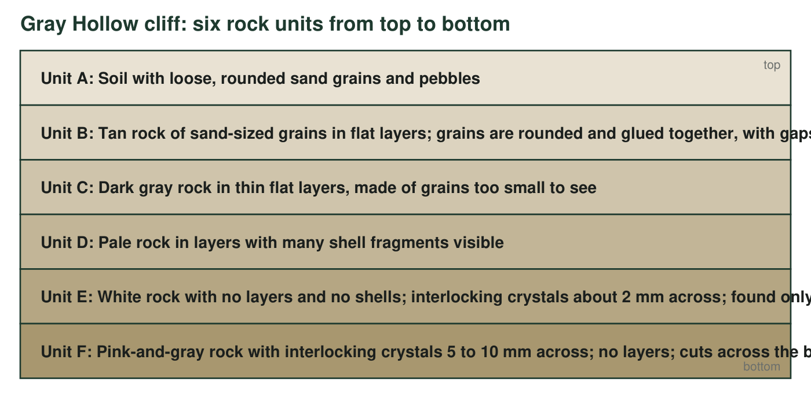
A cross-section through Gray Hollow cliff, top to bottom. Unit F (the lowest) does not lie flat under the others; it cuts across the bottoms of units D and E like a dome pushing up from below.
1. Which units are sedimentary rock? For each, name the clue in its description that tells you.
______________________________________________________________________________________
______________________________________________________________________________________
______________________________________________________________________________________
2. Unit F has interlocking crystals 5 to 10 mm across and no layers. Which rock type is it, and did it form at the surface or underground? Use the crystal size to explain.
______________________________________________________________________________________
______________________________________________________________________________________
______________________________________________________________________________________
3. Unit E has the same pale color as Unit D and sits right beside it, but it has no shells, no layers and interlocking crystals, and it occurs only within 30 m of Unit F. Explain what Unit E used to be, what happened to it, and why it is found only near Unit F. Your answer must say whether Unit E melted.
______________________________________________________________________________________
______________________________________________________________________________________
______________________________________________________________________________________
______________________________________________________________________________________
______________________________________________________________________________________
4. Unit F is at the bottom of the cliff, but it is not the oldest unit. What clue in the figure tells you that, and what does it tell you about the order of events?
______________________________________________________________________________________
______________________________________________________________________________________
______________________________________________________________________________________
5. Complete the table for five of the units.
Rock-cycle process that made it | Energy source (Sun and gravity, or Earth's interior)
Unit B (tan sandy rock)
Unit D (shelly rock)
Unit E (white crystalline rock)
Unit F (pink-and-gray crystalline rock)
Unit A (soil and loose grains)

6. The loose grains in Unit A are the same colors as the crystals in Unit F, even though F is at the bottom of the cliff. Suggest how material from F could be at the top, and name the processes involved.
______________________________________________________________________________________
______________________________________________________________________________________
______________________________________________________________________________________

Part B: Draw the rock cycle
☐ Three rock boxes: igneous, sedimentary, metamorphic
☐ Two material boxes: magma and sediment
☐ At least seven arrows, each labeled with its process
☐ At least one arrow showing that a rock can skip steps (for example, igneous straight to metamorphic, or metamorphic straight to sediment)
☐ Each arrow marked with its energy source: write S for Sun and gravity, or E for Earth's interior
☐ A one-sentence title that says what the model shows
Draw your rock-cycle model here. Boxes for the three rock types and the two materials; labeled arrows for the processes; S or E on every arrow. Make the arrows show a web, not a single loop.

7. Pick one arrow you marked E and one you marked S. For each, explain in one sentence why that energy source, and not the other, drives the process.
______________________________________________________________________________________
______________________________________________________________________________________
______________________________________________________________________________________
8. Trace Unit E's history on your model with a highlighter or by listing the boxes and arrows it passed through, from its earliest stage you can justify to the white rock in the cliff.
______________________________________________________________________________________
______________________________________________________________________________________
______________________________________________________________________________________

Clue-to-process cheat sheet
Rounded grains glued together with gaps between them: sediment that was compacted and cemented. Shell fragments: remains of living things settled in layers. Interlocking crystals with no layers: crystals grew in place, from a melt (igneous) or in solid rock (metamorphic). Large interlocking crystals: slow cooling underground. A rock body that cuts across other layers: it arrived after them. A changed zone found only near a crystalline body: heat from that body changed the neighbor. For Part B, draw the five boxes first in a ring, then add arrows; the skip-a-step arrows go across the middle.

Add the fourth dimension
Real rock-cycle changes take very different amounts of time. Add a rough time label to at least four arrows of your model (for example 'days', 'thousands of years', 'millions of years'), and explain your choices in a short paragraph. Then answer: if someone watched Gray Hollow cliff for a human lifetime, which arrow of your model would they actually be able to see happening, and which would they have to infer from clues? Finally, redraw Unit F's edge on the cliff figure to show how far the changed zone (Unit E) would extend if Unit F had been a much larger, hotter body, and justify your drawing.

