Angela's Tools · Chapter 18: The Water Cycle · Worksheet 1 of 10

Three Meters of Snow, Then Dust: Where Did the Mountain's Water Go? (Teacher answer key)
Learning target: I can observe a seasonal change in a mountain's water, record what I notice and wonder, and write a first explanation of where the water could have gone.
Phenomenon exploration · about 30 minutes · individual · Standards: MS-ESS2-4 (practice)

Standards connections
MS-ESS2-4 (practice): MS-ESS2-4 is placed in Grade 6 in California's integrated sequence; this seventh-grade lesson revisits it. Students begin building the model of water cycling driven by the sun and gravity by proposing where a vanished snowpack went, which is the first draft of the model the PE asks for.

Answers with reasoning

The scene
April 2. A snow surveyor near Echo Summit in the Sierra Nevada pushes a hollow metal tube down through the snow until it hits soil. The snow is 3.1 meters deep. The trees are buried to their lower branches. Nothing is melting yet; the morning air is −4 °C and the creek below the meadow is a trickle you could step across.
July 20. The same surveyor returns. The meadow is dry grass and dust. There is no snow anywhere below the ridge. The creek is running knee-deep and cold. A rancher in the valley 40 km away says her well, which was low in March, is full again. The sky has been cloudless for six weeks, and not one drop of rain has fallen since early May.
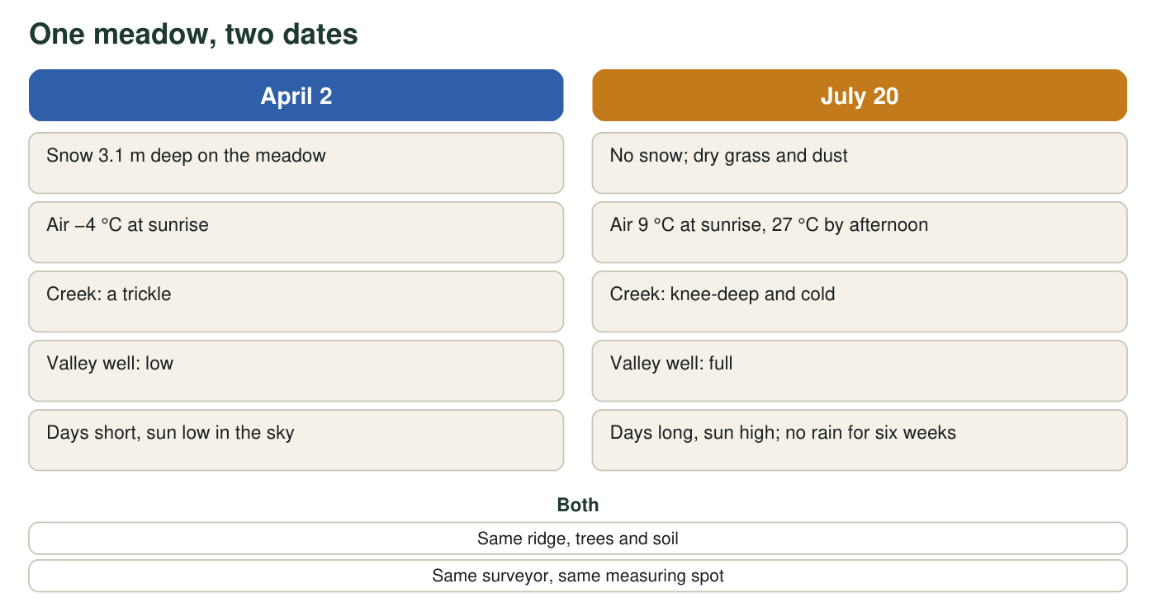
The same meadow on two dates. Snow depth, creek size, and the well in the valley are all different. The ridge, the trees, and the soil are the same.

Part A: Notice and wonder
1. List at least four things that changed between April 2 and July 20. Use the figure and the two descriptions. Be specific (give numbers where the text gives them).
Answer: Any four: snow depth went from 3.1 m to none; sunrise air temperature went from −4 °C to 9 °C (27 °C by afternoon); the creek went from a trickle to knee-deep; the valley well went from low to full; days went from short with a low sun to long with a high sun; the weather went from snow-covered to six rain-free weeks; the meadow surface went from snow to dry grass and dust.
Reasoning: This is an observation item. Credit precise, text-based changes; a number from the text counts as specific.
Also acceptable: Accept 'the trees are no longer buried' as a change in snow depth.
Full credit must include:
• At least four distinct changes
• At least two are specific (a number or a direct comparison)
2. List two things that did not change. Why is it useful for a scientist to notice what stayed the same?
Answer: The ridge, the trees and the soil did not change; the surveyor measured at the same spot both times. Noticing what stayed the same lets a scientist rule things out: the water did not leave because the land changed shape or because the measuring spot moved, so the cause must be something that acted on the snow itself.
Reasoning: Students should connect constants to ruling out alternative causes, which is the logic of a controlled comparison.
Also acceptable: Accept 'so we know the difference is really about the water and the weather, not the place.'
Full credit must include:
• Two unchanged things from the figure
• A reason tied to ruling out causes or making the comparison fair
3. Write three questions you would want answered before you could explain where the snow went. Start each with How, Why, or Where.
Answer: Sample questions: How does snow turn into something that can leave the meadow? Why did the creek grow when there was no rain? Where did the water in the well come from? How much of the snow went into the air versus into the ground? Why does the sun matter if the air at sunrise was still cold?
Reasoning: Any three investigable questions that start with How, Why or Where and connect to the scene earn full credit.
Also acceptable: Questions about the measuring tube or the rancher are acceptable if they lead toward the water.
Full credit must include:
• Three questions
• Each begins with How, Why or Where
• Each is about the phenomenon, not unrelated

Part B: What you already know
4. Think of a time you watched water disappear or appear: a puddle drying, a cold drink sweating, frost on a car, a towel drying on a line. Describe one example and say what you think happened to the water.
Answer: Open response. Example: 'A puddle on the playground was gone by lunch on a sunny day. I think the water turned into a gas and went into the air, even though it never boiled.' Or: 'My cold water bottle got wet on the outside; I think water from the air turned into drops when it touched the cold bottle.'
Reasoning: This surfaces prior ideas. Record common misconceptions you hear (water 'soaks into the sky', drops on a cold bottle 'leak through the plastic') for the misconception worksheet later.
Also acceptable: An inaccurate explanation still earns full credit here; this item is diagnostic.
Full credit must include:
• A real, specific example
• A stated idea about what happened to the water
5. Three meters of snow does not simply vanish. Name every place you think the water from that snow could be on July 20. Aim for at least three places.
Answer: Possible places: in the air as invisible water vapor; in the creek and downstream rivers; in lakes or reservoirs; underground as groundwater (which is why the well filled); in the soil; inside plants (taken up by roots, later released by leaves); in the ocean, if it traveled far enough; evaporated and already fallen as rain somewhere else.
Reasoning: At least three places. Students who say only 'the creek' are missing the invisible routes (air, underground), which q7 and the table are meant to prompt.
Also acceptable: Accept 'clouds' as the air; accept 'the well' as groundwater.
Full credit must include:
• At least three distinct locations
• At least one is not a visible body of water (air, underground, plants)

Part C: Where Earth keeps its water
Scientists have estimated how Earth's water is divided among its storage places. These are real reference values, rounded. Use them to check whether the places you named in q5 are places where water is actually found.
Where Earth's water is stored (real estimates, rounded)
Storage place | Share of all Earth's water (%) | Mostly fresh or salt?
Oceans | 96.5 | salt
Glaciers, ice caps and permanent snow | 1.74 | fresh
Groundwater (in soil and rock pores) | 1.69 | about half fresh, half salty
Lakes | 0.013 | about half fresh, half salty
Soil moisture | 0.001 | fresh
Atmosphere (vapor, cloud droplets, ice crystals) | 0.001 | fresh
Rivers | 0.0002 | fresh

Values are widely cited estimates from the United States Geological Survey, based on Gleick (1996). Percentages are of all water on Earth, salt water included. They do not add to exactly 100 because of rounding and small stores not listed (permafrost, swamps, living things).
6. Add up the shares for glaciers and ice, groundwater, lakes, soil moisture, atmosphere and rivers. About what percent of Earth's water is not in the oceans? Show your addition.
Answer: 1.74 + 1.69 + 0.013 + 0.001 + 0.001 + 0.0002 = 3.4452, about 3.4 percent. (Checking the other way: 100 − 96.5 = 3.5 percent; the small difference is rounding and the tiny stores not listed, such as permafrost and swamps.)
Reasoning: The sum of the listed non-ocean stores is about 3.4 percent; the complement of the ocean figure is 3.5 percent. Either method with work shown earns full credit.
Also acceptable: Accept 3.4, 3.45 or 3.5 percent with the calculation shown.
7. The atmosphere holds only about 0.001 percent of Earth's water, yet rain and snow fall somewhere on Earth every day. What does that tell you about how fast water must move through the atmosphere compared with how much is stored there?
Answer: The atmosphere stores very little water at any moment, but water keeps falling out of it as rain and snow, so water must be entering and leaving the atmosphere quickly. It is a fast-moving pathway, not a big storage tank: the same small amount is replaced over and over.
Reasoning: Students should distinguish the amount stored (small) from the rate of flow (large). The average water molecule spends on the order of days in the atmosphere.
Also acceptable: Accept 'water goes up and comes down again fast' or 'the atmosphere is like a short line that many people pass through.'
Full credit must include:
• States that the stored amount is small
• Concludes that water must move through the atmosphere quickly (be replaced often)

Part D: Your first explanation
8. Write your first explanation of the phenomenon. Where did the three meters of snow go between April 2 and July 20, and what caused it to move? Explain how the creek can be bigger in July than in April even though no rain has fallen, and how the valley well could fill. Use at least two of these words: energy, sun, gravity, downhill, underground, air. It is fine to mark parts you are unsure about with a question mark.
Answer: Model explanation: As spring turned to summer, the sun was higher and the days longer, so the snow gained energy and melted into liquid water. Some of that liquid water, and some of the snow directly, turned into invisible water vapor and went into the air. The rest of the meltwater was pulled downhill by gravity: some ran over the surface into the creek, which is why the creek is bigger in July even without rain (it is fed by melting snow, not rain). Some meltwater soaked into the ground and moved slowly downhill underground, which is why the valley well filled weeks later. No rain is needed for any of this: the snow was the stored water, the sun supplied the energy, and gravity moved the liquid water down.
Reasoning: This is a first explanation; full credit does not require correct vocabulary, only a reasonable mechanism naming an energy source and a downhill mover. Flag answers that have the water 'disappear' with no destination, or that require rain to explain the creek.
Also acceptable: A student who says the creek is fed by 'snow higher up the mountain that is still melting' is correct and has noticed that the ridge may still hold snow. A student who leaves the well unexplained with a question mark should still earn credit for the sun and gravity parts.
Full credit must include:
• Names the sun (or warming) as the energy source for melting or evaporating
• Names gravity or downhill flow for the creek
• Gives a route for the well water (underground)
• Uses at least two of the required words
9. After comparing with your partner: write one idea your partner had that you did not, or one place where you disagreed.
Answer: Open response; any specific idea or disagreement from the partner conversation.
Reasoning: This records that the comparison happened. Accept any specific idea; do not accept 'we agreed on everything' without a stated idea.
Also acceptable: If partners agreed entirely, accept one thing the student would add after talking.
Full credit must include:
• Names one specific idea or disagreement

Teacher notes
This sheet activates ideas before instruction; collect it and return it at the end of the chapter so students can revise q8 (the Lesson Summary pages, printed 243 / PDF 279, make a good checkpoint). The scene is fictional but realistic: California's snow surveys near Echo Summit do measure snow depth and water content with a hollow tube, and Sierra snowmelt typically peaks in May and June. The storage table uses the standard USGS figures based on Gleick (1996); groundwater's 1.69 percent splits into about 0.76 fresh and 0.93 saline, and lakes' 0.013 into about 0.007 fresh and 0.006 saline. Science points to listen for: the snow 'melting' into the air (sublimation, snow to vapor) is real and is fine to accept; water leaving the surface does not need to boil; the creek is fed by melt and by groundwater, not by rain; water moves underground because of gravity, slowly. Do not correct misconceptions yet; note them. The lesson text itself (printed 234-241 / PDF 270-277) supplies the vocabulary in later worksheets.

