Angela's Tools · Chapter 18: The Water Cycle · Worksheet 1 of 10

Three Meters of Snow, Then Dust: Where Did the Mountain's Water Go?
Learning target: I can observe a seasonal change in a mountain's water, record what I notice and wonder, and write a first explanation of where the water could have gone.
Phenomenon exploration · about 30 minutes · individual · Standards: MS-ESS2-4 (practice)
Name: ____________________________ Date: ____________ Period: ______

Directions
Read the two scene descriptions and study the comparison figure. Work on your own for Part A and Part B. Then turn to a partner for Part C, compare your explanations, and finish Part D alone. There are no wrong answers in Part B; your job is to be specific and honest about what you already know and what you are unsure of.

The scene
April 2. A snow surveyor near Echo Summit in the Sierra Nevada pushes a hollow metal tube down through the snow until it hits soil. The snow is 3.1 meters deep. The trees are buried to their lower branches. Nothing is melting yet; the morning air is −4 °C and the creek below the meadow is a trickle you could step across.
July 20. The same surveyor returns. The meadow is dry grass and dust. There is no snow anywhere below the ridge. The creek is running knee-deep and cold. A rancher in the valley 40 km away says her well, which was low in March, is full again. The sky has been cloudless for six weeks, and not one drop of rain has fallen since early May.
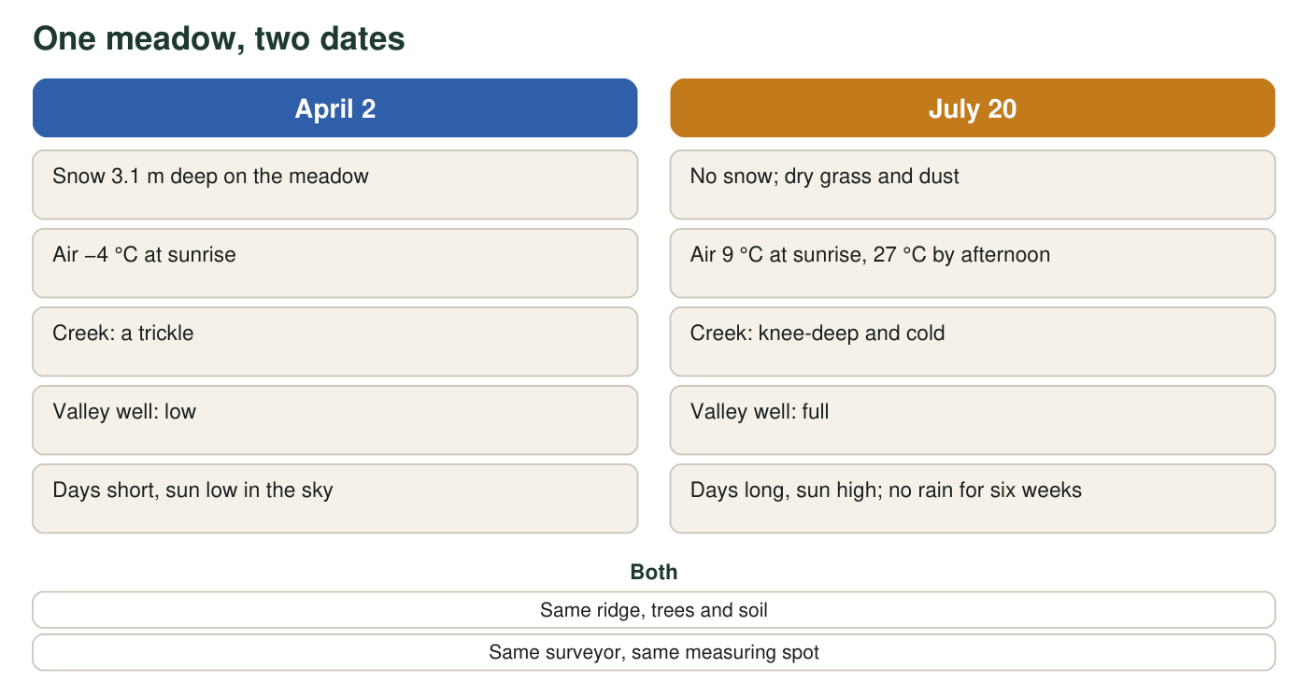
The same meadow on two dates. Snow depth, creek size, and the well in the valley are all different. The ridge, the trees, and the soil are the same.

Part A: Notice and wonder
1. List at least four things that changed between April 2 and July 20. Use the figure and the two descriptions. Be specific (give numbers where the text gives them).
______________________________________________________________________________________
______________________________________________________________________________________
______________________________________________________________________________________
______________________________________________________________________________________
2. List two things that did not change. Why is it useful for a scientist to notice what stayed the same?
______________________________________________________________________________________
______________________________________________________________________________________
______________________________________________________________________________________
3. Write three questions you would want answered before you could explain where the snow went. Start each with How, Why, or Where.
______________________________________________________________________________________
______________________________________________________________________________________
______________________________________________________________________________________
______________________________________________________________________________________

Part B: What you already know
4. Think of a time you watched water disappear or appear: a puddle drying, a cold drink sweating, frost on a car, a towel drying on a line. Describe one example and say what you think happened to the water.
______________________________________________________________________________________
______________________________________________________________________________________
______________________________________________________________________________________
______________________________________________________________________________________
5. Three meters of snow does not simply vanish. Name every place you think the water from that snow could be on July 20. Aim for at least three places.
______________________________________________________________________________________
______________________________________________________________________________________
______________________________________________________________________________________

Part C: Where Earth keeps its water
Scientists have estimated how Earth's water is divided among its storage places. These are real reference values, rounded. Use them to check whether the places you named in q5 are places where water is actually found.
Where Earth's water is stored (real estimates, rounded)
Storage place | Share of all Earth's water (%) | Mostly fresh or salt?
Oceans | 96.5 | salt
Glaciers, ice caps and permanent snow | 1.74 | fresh
Groundwater (in soil and rock pores) | 1.69 | about half fresh, half salty
Lakes | 0.013 | about half fresh, half salty
Soil moisture | 0.001 | fresh
Atmosphere (vapor, cloud droplets, ice crystals) | 0.001 | fresh
Rivers | 0.0002 | fresh

Values are widely cited estimates from the United States Geological Survey, based on Gleick (1996). Percentages are of all water on Earth, salt water included. They do not add to exactly 100 because of rounding and small stores not listed (permafrost, swamps, living things).
6. Add up the shares for glaciers and ice, groundwater, lakes, soil moisture, atmosphere and rivers. About what percent of Earth's water is not in the oceans? Show your addition.
______________________________________________________________________________________
______________________________________________________________________________________
______________________________________________________________________________________
7. The atmosphere holds only about 0.001 percent of Earth's water, yet rain and snow fall somewhere on Earth every day. What does that tell you about how fast water must move through the atmosphere compared with how much is stored there?
______________________________________________________________________________________
______________________________________________________________________________________
______________________________________________________________________________________

Part D: Your first explanation
8. Write your first explanation of the phenomenon. Where did the three meters of snow go between April 2 and July 20, and what caused it to move? Explain how the creek can be bigger in July than in April even though no rain has fallen, and how the valley well could fill. Use at least two of these words: energy, sun, gravity, downhill, underground, air. It is fine to mark parts you are unsure about with a question mark.
______________________________________________________________________________________
______________________________________________________________________________________
______________________________________________________________________________________
______________________________________________________________________________________
______________________________________________________________________________________
______________________________________________________________________________________
______________________________________________________________________________________
9. After comparing with your partner: write one idea your partner had that you did not, or one place where you disagreed.
______________________________________________________________________________________
______________________________________________________________________________________
______________________________________________________________________________________

Sentence starters for q8
If the blank page is hard to start, use these frames and fill in the rest: 'Some of the snow turned into ___ because the ___ gave it energy.' 'Some of the snow turned into liquid water and then moved ___ because of ___.' 'The creek is bigger in July because ___.' 'The well filled because water went ___.' You do not have to use every frame, and you may change them.

Budget the snow
Suppose the meadow is 1 hectare (10,000 square meters) and 3.1 m of snow holds the same water as about 1.0 m of liquid water (snow is mostly air). Calculate how many cubic meters of liquid water were sitting on that one hectare on April 2. Then estimate what fraction you think went into the creek, into the ground, and back into the air, and write one sentence explaining what evidence you would need to check your estimate.

