Angela's Tools · Chapter 18: The Water Cycle · Worksheet 4 of 10

Reading One Loop, Drawing the Whole Web: Modeling the Water Cycle (Teacher answer key)
Learning target: I can interpret a water cycle diagram, identify where the sun's energy and gravity act and where water changes state, and draw my own model that shows more than one pathway.
Diagrams and models · about 40 minutes · individual · Standards: MS-ESS2-4 (assesses)

Standards connections
MS-ESS2-4 (assesses): MS-ESS2-4 is a California Grade 6 PE revisited here. Part B asks students to develop their own model of water cycling with the sun and gravity labeled as drivers and changes of state marked, which is direct evidence toward the PE as written. The latent-heat assessment boundary is respected: energy is described qualitatively.

Answers with reasoning

Part A: Interpret the given diagrams
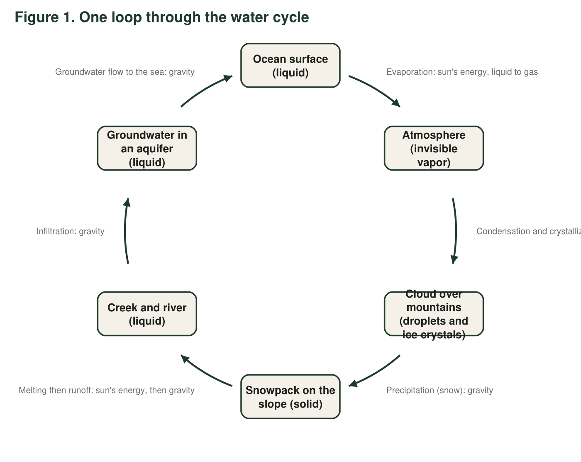
Figure 1. One possible loop through the water cycle. Each arrow is labeled with the process that moves water from one node to the next. This diagram shows only one route; real water takes many.
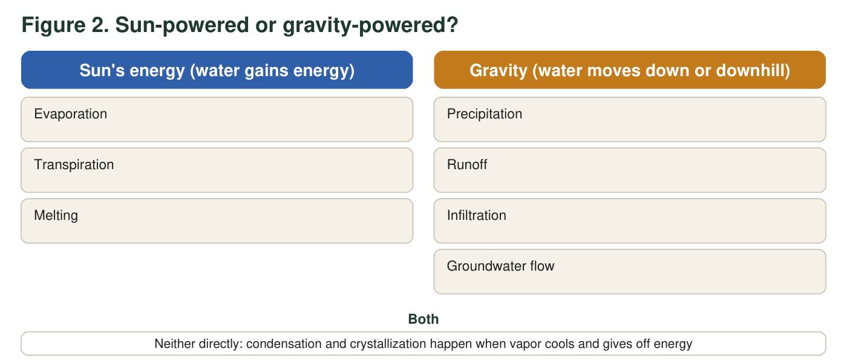
Figure 2. The same nine processes sorted by what drives them. Use it with Figure 1.
1. In Figure 1, at which arrows does water change state? For each one, name the change (for example, liquid to gas) and say whether water gains or gives off energy there.
Answer: Arrow 1 (ocean to atmosphere): liquid to gas, water gains energy. Arrow 2 (atmosphere to cloud): gas to liquid droplets and gas to ice crystals, water gives off energy. Arrow 4 (snowpack to creek): solid to liquid when the snow melts, water gains energy. Arrows 3, 5 and 6 move water without a required change of state (snow falls as a solid; runoff, infiltration and groundwater flow move liquid water).
Reasoning: Three arrows involve changes of state. Evaporation and melting take energy in; condensation and crystallization give it off.
Also acceptable: A student who notes that falling snow may partly melt on arrow 3 is adding a correct detail.
Full credit must include:
• Identifies arrows 1, 2 and 4 as the state changes
• Names each change correctly
• Gains energy for 1 and 4, gives off energy for 2
2. Which arrows in Figure 1 would stop if the sun went dark but gravity kept working? Which would keep going for a while? Explain using the arrow labels.
Answer: Evaporation (arrow 1) and melting (part of arrow 4) would stop, because they need the sun's energy. Precipitation, runoff, infiltration and groundwater flow (arrows 3, 5, 6 and the runoff part of 4) would keep going for a while, because gravity still acts on the water already in clouds, on slopes and underground. Condensation (arrow 2) would continue as long as there was vapor left in the air to cool, then stop because no new vapor would be made.
Reasoning: This separates the sun-driven steps from the gravity-driven steps. The 'for a while' is important: without new evaporation, the gravity-driven steps run out of water.
Also acceptable: Accept 'the whole cycle would slowly stop because nothing lifts the water back up.'
Full credit must include:
• Evaporation and melting stop
• Gravity-driven arrows continue temporarily
• Recognizes that the gravity steps eventually run out of water
3. The arrow from the snowpack to the creek is labeled with two drivers: 'sun's energy, then gravity.' Why does this one arrow need both? What would happen if only gravity acted on the snowpack?
Answer: Snow is solid and stuck in place; gravity alone cannot make it flow downhill as a creek. The sun's energy first melts the snow into liquid water, and then gravity pulls the liquid downhill as runoff. With gravity alone the snowpack would just sit on the slope (it might slowly slide as a glacier does, but it would not run into a creek).
Reasoning: The arrow couples a state change (sun) with a transport (gravity). Glacier creep is a nice extension but not required.
Also acceptable: Accept 'snow would pile up and never become a creek.'
Full credit must include:
• Sun melts solid to liquid first
• Gravity moves the liquid
• States that solid snow would stay put under gravity alone
4. Figure 1 is a useful model, but it leaves things out. Name three real pathways of water that Figure 1 does not show. (Hint: think about where else evaporation happens, what plants do, and whether rain must fall on a mountain.)
Answer: Any three: evaporation from lakes, rivers, wet soil and puddles (not only the ocean); transpiration from plants; precipitation as rain falling directly on the ocean, on a lake or on flat land (not only snow on a mountain); runoff and groundwater that reach a lake rather than the sea; water taken up by plant roots from the soil; sublimation from snow straight to vapor; water evaporating from the creek or river before it reaches the ocean.
Reasoning: The textbook's Key Science Concept diagram also shows a single loop, so this item builds the habit of reading a cycle diagram as 'some routes', not 'the route'.
Also acceptable: Accept 'rain that falls back into the ocean' and 'water that evaporates from the river on the way.'
Full credit must include:
• Three distinct missing pathways
• At least one involves evaporation from somewhere other than the ocean or transpiration
5. A student looking at Figure 1 says, 'The water cycle starts at the ocean and ends at the aquifer.' Use the shape of the diagram and one fact about the water cycle to explain why this is wrong.
Answer: The diagram is a loop with arrows all the way around, so there is no first node and no last node; the aquifer's arrow leads back to the ocean. The water cycle has no beginning and no end: water is in every one of these places all the time, and a molecule can enter the loop anywhere. 'Starts at the ocean' is just where this diagram's author chose to begin reading.
Reasoning: Students should use both the circular shape and the no-starting-point fact.
Also acceptable: Accept 'you could start reading at any node.'
Full credit must include:
• Uses the closed loop shape as evidence
• States that the cycle has no start or end
6. In Figure 2, condensation and crystallization are placed in the middle box, not under the sun. Explain why they do not belong under 'sun's energy' even though the sun drives the whole cycle.
Answer: The sun supplies energy; condensation and crystallization happen when water vapor loses energy, which occurs when the air cools (for example as it rises over the mountain). So the sun makes the vapor that will later condense, but the sun does not cause the condensing itself; cooling does. Putting them under the sun would say the opposite of what happens to the energy.
Reasoning: This is the accuracy point against the textbook's 'sun or gravity' framing for all nine processes.
Also acceptable: Accept 'the sun makes the vapor, cooling makes the cloud.'
Full credit must include:
• Condensation and crystallization require losing energy / cooling
• Distinguishes the sun driving the cycle overall from directly causing these steps

Part B: Build your own model
Your scene is a forested valley with a lake in the bottom, a farm field on one side, a hill with a spring on the other side, and the sun in the sky. Your model must show at least two different routes that a water molecule could take from the lake back to the lake. Follow the checklist below as you draw.
☐ The sun is drawn and at least three arrows are labeled as powered by its energy.
☐ At least four arrows are labeled as moved by gravity.
☐ Every arrow has a process name from the lesson (evaporation, transpiration, melting, condensation, crystallization, precipitation, runoff, infiltration, groundwater flow).
☐ Water vapor is shown as invisible (for example, dashed arrows or the word 'invisible'); clouds are drawn as droplets or crystals, not as vapor.
☐ Each place where water changes state is marked with a small star and the states named (for example, 'liquid to gas').
☐ The spring on the hill is connected to groundwater by an arrow that shows where that water came from.
☐ Two different routes from the lake back to the lake are traced with two different colors or line styles.
Draw your water cycle model of the forested valley here. Include the lake, the farm field, the hill with the spring, the forest, clouds and the sun. Label every arrow with a process and mark its driver (S for sun's energy, G for gravity, C for cooling).
Expected drawing: A full-credit drawing shows the six places; the sun; at least three S arrows (evaporation from the lake, transpiration from the forest and the farm field, and melting if the student adds snow on the hill or ice on the lake); at least four G arrows (precipitation, runoff down the hill and off the field, infiltration into the soil, groundwater flow to the spring and to the lake); clouds drawn as droplets or crystals with a C arrow for condensation (and crystallization if snow is shown); dashed or labeled invisible vapor; stars at each change of state with the states named; the spring fed by a groundwater-flow arrow; and two routes in two colors, for example Route 1: lake, evaporation, condensation, precipitation on the hill, runoff, lake; Route 2: lake, evaporation, condensation, precipitation on the hill, infiltration, groundwater flow, spring, runoff, lake.
Reasoning: Score against the checklist. Accept any sensible arrangement. Common errors: clouds labeled 'water vapor'; a single loop; the spring with no arrow feeding it; transpiration drawn as plants 'drinking' with no vapor leaving the leaves; precipitation labeled S instead of G; condensation labeled S instead of C.
7. Describe Route 1 from your drawing in words: list the places and processes in order, starting and ending at the lake.
Answer: Example Route 1: Lake (liquid), evaporation (S) to the air as vapor, cooling and condensation (C) into cloud droplets, precipitation (G) as rain on the hill, runoff (G) down the hill into the lake.
Reasoning: Any correct closed route with processes in a sensible order earns full credit.
Also acceptable: A route through the forest (transpiration) or the field is equally valid.
Full credit must include:
• Starts and ends at the lake
• Places and processes in a sensible order
• Processes match the drawing
8. Describe Route 2. It must differ from Route 1 in at least two processes. Underline the two processes that make it different.
Answer: Example Route 2: Lake, evaporation (S), condensation (C), precipitation (G) as rain on the hill, infiltration (G) into the hillside soil, groundwater flow (G) through the hill to the spring, runoff (G) from the spring to the lake. The underlined differences from Route 1 are infiltration and groundwater flow (and the spring stop).
Reasoning: The route must differ in at least two processes; infiltration plus groundwater flow, or transpiration plus a different landing place, are the usual choices.
Also acceptable: A route with rain landing on the forest, roots taking up water, transpiration returning it to the air, and a second precipitation into the lake is a strong alternative.
Full credit must include:
• Differs from Route 1 by at least two processes
• Differences underlined
• Matches the drawing
9. Point to the spring in your drawing. Explain, using your arrows, how water can come out of a hillside on a day when no rain has fallen for a month.
Answer: The spring is fed by groundwater. Rain that fell weeks or months ago soaked into the hill by infiltration and has been moving slowly downhill through connected pores under gravity (groundwater flow). Where the water-filled layer meets the hillside surface, the water comes out as a spring. Because groundwater moves slowly, the spring keeps flowing long after the last rain.
Reasoning: Students should trace the spring back to infiltration of earlier rain and explain the time lag by slow groundwater flow.
Also acceptable: Accept 'the hill is like a sponge that drips for a long time after it is wet.'
Full credit must include:
• Spring fed by groundwater flow
• Water entered by infiltration of earlier rain
• Slow flow explains flow during a dry month
10. Every model leaves something out. Name one thing your drawing cannot show about the real water cycle (for example, about time, size, or what water vapor looks like) and say why that matters.
Answer: Possible limitations: it cannot show how long each step takes (minutes for rain to fall, years for groundwater to cross a hill); it cannot show that water vapor is invisible (the arrow is drawn even though the vapor cannot be seen); it cannot show that most of Earth's water is in the ocean and almost none is in the air at any moment; it cannot show molecules speeding up and slowing down; it shows a few routes when real water takes thousands. Each matters because a reader might think all steps are equally fast, that clouds are vapor, or that the loop is the only route.
Reasoning: Any real limitation with a stated consequence earns full credit; this is a modeling practice item.
Also acceptable: Accept 'it does not show the energy' if the student explains that the sun's role is more than a picture in the corner.
Full credit must include:
• Names a genuine limitation
• Explains why it could mislead a reader

Teacher notes
Figure 1 is deliberately a single loop so that q4 and q5 can expose the 'one compulsory route' reading that the textbook's Key Science Concept spread (printed 240-241 / PDF 276-277) invites; that spread also shows evaporation only from the ocean. Figure 2 corrects the spread's claim that every process is powered by the sun or gravity: condensation and crystallization happen when vapor cools and gives off energy. The drawing is the assessment-bearing item; use the checklist as a 7-point scoring guide and the drawing key's common-error list for feedback. Evidence toward MS-ESS2-4 comes from the drivers (S, G, C) and the starred changes of state, not from artistic quality. If students ask what happens in the cloud in detail, keep it qualitative; the latent heat of vaporization is outside the assessment boundary.

