Angela's Tools · Chapter 18: The Water Cycle · Worksheet 4 of 10

Reading One Loop, Drawing the Whole Web: Modeling the Water Cycle
Learning target: I can interpret a water cycle diagram, identify where the sun's energy and gravity act and where water changes state, and draw my own model that shows more than one pathway.
Diagrams and models · about 40 minutes · individual · Standards: MS-ESS2-4 (assesses)
Name: ____________________________ Date: ____________ Period: ______

Directions
Part A: study Figure 1 and Figure 2 and answer the interpretation questions; every answer must refer to a node or an arrow by name. Part B: draw your own model in the box, following the checklist, then answer the labeling questions about your drawing. Use a pencil so you can revise.

Part A: Interpret the given diagrams
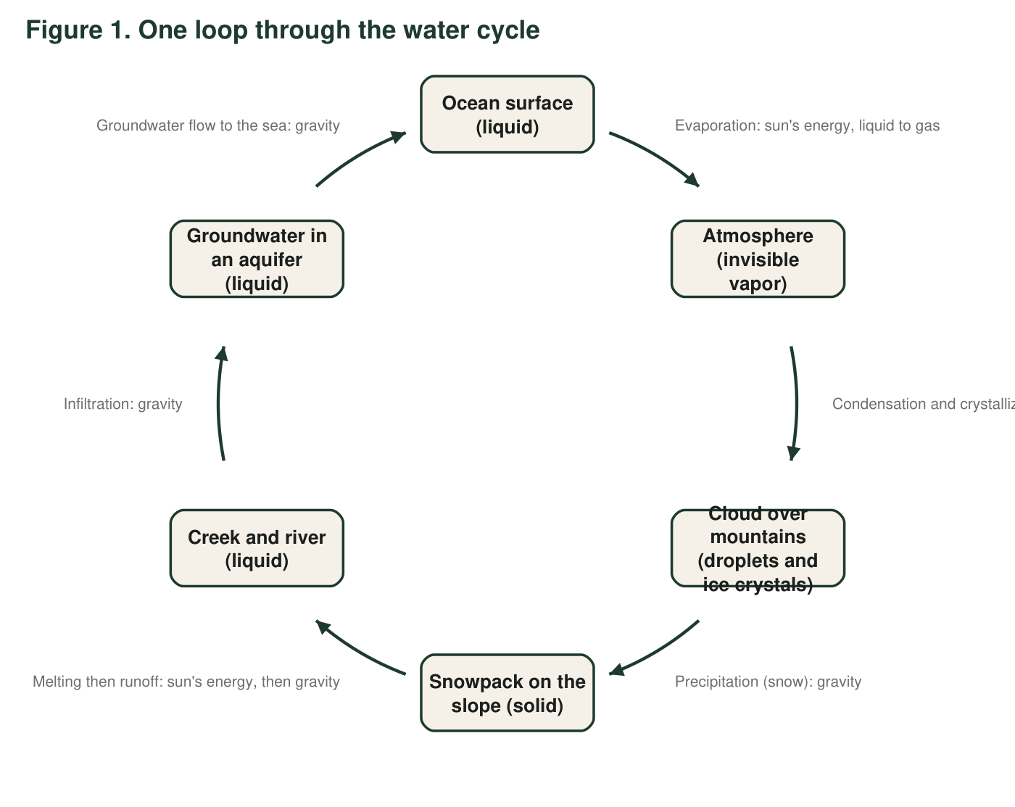
Figure 1. One possible loop through the water cycle. Each arrow is labeled with the process that moves water from one node to the next. This diagram shows only one route; real water takes many.
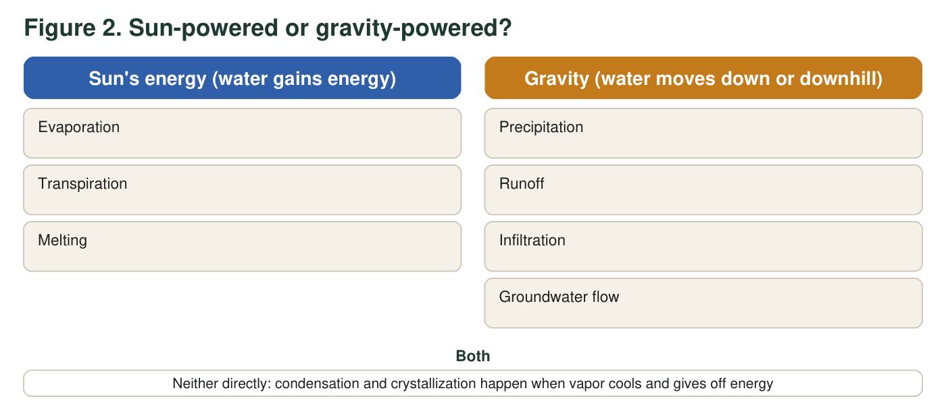
Figure 2. The same nine processes sorted by what drives them. Use it with Figure 1.
1. In Figure 1, at which arrows does water change state? For each one, name the change (for example, liquid to gas) and say whether water gains or gives off energy there.
______________________________________________________________________________________
______________________________________________________________________________________
______________________________________________________________________________________
2. Which arrows in Figure 1 would stop if the sun went dark but gravity kept working? Which would keep going for a while? Explain using the arrow labels.
______________________________________________________________________________________
______________________________________________________________________________________
______________________________________________________________________________________
3. The arrow from the snowpack to the creek is labeled with two drivers: 'sun's energy, then gravity.' Why does this one arrow need both? What would happen if only gravity acted on the snowpack?
______________________________________________________________________________________
______________________________________________________________________________________
______________________________________________________________________________________
4. Figure 1 is a useful model, but it leaves things out. Name three real pathways of water that Figure 1 does not show. (Hint: think about where else evaporation happens, what plants do, and whether rain must fall on a mountain.)
______________________________________________________________________________________
______________________________________________________________________________________
______________________________________________________________________________________
______________________________________________________________________________________
5. A student looking at Figure 1 says, 'The water cycle starts at the ocean and ends at the aquifer.' Use the shape of the diagram and one fact about the water cycle to explain why this is wrong.
______________________________________________________________________________________
______________________________________________________________________________________
______________________________________________________________________________________
6. In Figure 2, condensation and crystallization are placed in the middle box, not under the sun. Explain why they do not belong under 'sun's energy' even though the sun drives the whole cycle.
______________________________________________________________________________________
______________________________________________________________________________________
______________________________________________________________________________________

Part B: Build your own model
Your scene is a forested valley with a lake in the bottom, a farm field on one side, a hill with a spring on the other side, and the sun in the sky. Your model must show at least two different routes that a water molecule could take from the lake back to the lake. Follow the checklist below as you draw.
☐ The sun is drawn and at least three arrows are labeled as powered by its energy.
☐ At least four arrows are labeled as moved by gravity.
☐ Every arrow has a process name from the lesson (evaporation, transpiration, melting, condensation, crystallization, precipitation, runoff, infiltration, groundwater flow).
☐ Water vapor is shown as invisible (for example, dashed arrows or the word 'invisible'); clouds are drawn as droplets or crystals, not as vapor.
☐ Each place where water changes state is marked with a small star and the states named (for example, 'liquid to gas').
☐ The spring on the hill is connected to groundwater by an arrow that shows where that water came from.
☐ Two different routes from the lake back to the lake are traced with two different colors or line styles.
Draw your water cycle model of the forested valley here. Include the lake, the farm field, the hill with the spring, the forest, clouds and the sun. Label every arrow with a process and mark its driver (S for sun's energy, G for gravity, C for cooling).

7. Describe Route 1 from your drawing in words: list the places and processes in order, starting and ending at the lake.
______________________________________________________________________________________
______________________________________________________________________________________
______________________________________________________________________________________
______________________________________________________________________________________
8. Describe Route 2. It must differ from Route 1 in at least two processes. Underline the two processes that make it different.
______________________________________________________________________________________
______________________________________________________________________________________
______________________________________________________________________________________
______________________________________________________________________________________
9. Point to the spring in your drawing. Explain, using your arrows, how water can come out of a hillside on a day when no rain has fallen for a month.
______________________________________________________________________________________
______________________________________________________________________________________
______________________________________________________________________________________
10. Every model leaves something out. Name one thing your drawing cannot show about the real water cycle (for example, about time, size, or what water vapor looks like) and say why that matters.
______________________________________________________________________________________
______________________________________________________________________________________
______________________________________________________________________________________

Start with the places, then the arrows
Draw the six places first and leave space between them: sun (top corner), cloud (top middle), hill with spring (one side), forest, farm field, lake (bottom). Then draw arrows one at a time and ask for each: Is water going up? Then it is vapor, and the sun supplied the energy. Is water going down or downhill? Then gravity is moving it. Is water turning into droplets or ice? Then it cooled. Label as you go rather than at the end.

Add a city
Redraw a corner of your model with a city added beside the lake: paved streets, a storm drain, a water treatment plant that pumps from the lake, and lawns that are watered. Add at least four new arrows showing how the city changes the routes water takes (think about infiltration under pavement, runoff into drains, evaporation from lawns and transpiration from street trees). Then write three sentences on which natural pathways the city reduced and which it increased.

