Angela's Tools · Chapter 19: Earth's Natural Resources · Worksheet 1 of 10

A Line of Copper Mines: Why Here and Not There? (Teacher answer key)
Learning target: I can describe a pattern in where a natural resource is found and propose a first explanation that connects the pattern to processes inside Earth.
Phenomenon exploration · about 25 minutes · individual · Standards: MS-ESS3-1 (supports)

Standards connections
MS-ESS3-1 (supports): Noticing that the world's largest copper mines line up along present and past convergent plate boundaries is the entry point to the explanation this PE asks for. This sheet only records observations, prior knowledge and first ideas; the explanation is built in later worksheets.

Answers with reasoning

The phenomenon: a crooked line of mines
Copper is in nearly everything that carries electricity: the wires in a wall, the motor in a fan, the tiny circuits in a phone. The world uses more than 20 million tonnes of newly mined copper every year. You might expect copper mines to be spread out wherever people need copper. They are not. A geologist who marks the largest copper mines on a world map sees a crooked line running down the western edge of the Americas, from Arizona and Utah through Mexico, Peru and Chile. A few more big mines sit on islands and mountain ranges in the western Pacific and in central Asia. Huge regions have no large copper mine at all: the flat farmland of the central United States, the Florida peninsula, the Hawaiian Islands, most of Europe. Those places have rock, rain and plenty of people who would like cheap copper. What they do not have is copper ore, rock with enough copper in it to be worth mining.
Seven of the world's largest copper mines (real reference facts)
Mine | Country | Landscape | Plate setting when the ore formed
Escondida | Chile | Atacama Desert, in the Andes | Above the zone where the Nazca Plate sinks beneath South America; still active today
Chuquicamata | Chile | Northern Chilean Andes | Same subduction zone as Escondida; still active today
Cerro Verde | Peru | Andes near Arequipa | Same subduction zone; still active today
Bingham Canyon | United States (Utah) | Oquirrh Mountains near Salt Lake City | Magma that rose above an ancient subduction zone tens of millions of years ago; no longer active there
Morenci | United States (Arizona) | Mountains of southeastern Arizona | Magma above an ancient subduction zone tens of millions of years ago; no longer active there
Grasberg | Indonesia | High mountains of Papua | Near the collision of the Australian and Pacific plates; still active today
Oyu Tolgoi | Mongolia | Gobi Desert | An ancient chain of volcanoes above a subduction zone hundreds of millions of years ago; the plates have since rearranged

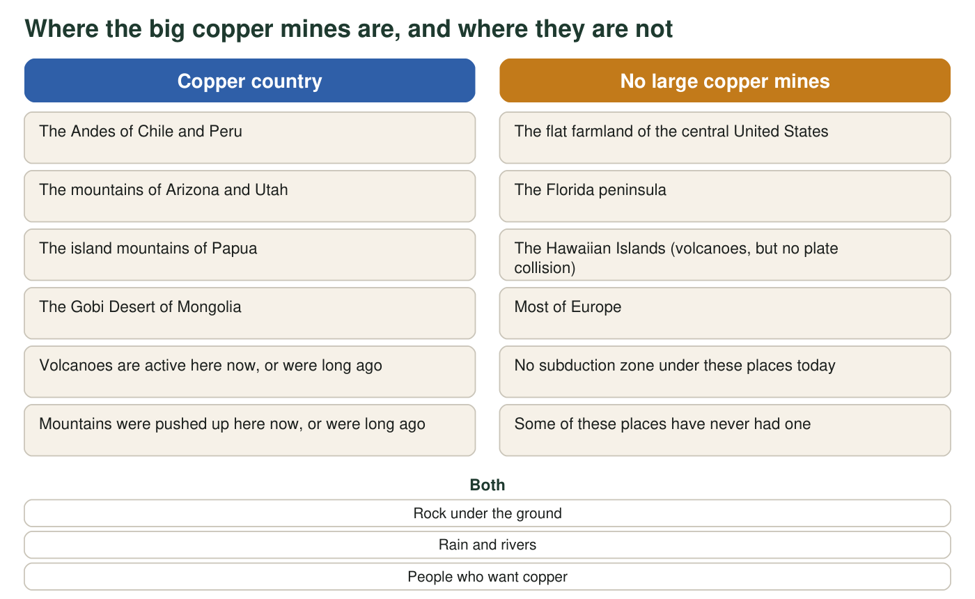
The pattern in one picture. Both columns describe real places; the mines in the left column are the ones in the table.

Part A: Notice and wonder
1. Record three things you notice and three things you wonder. A notice must point to something on this page, not to a guess. A wonder must be a question you could investigate.
Answer: Any three notices tied to the page, for example: all seven mines sit on or near mountains; three are in Chile and Peru on the same subduction zone; two mines (Bingham Canyon, Oyu Tolgoi) are far from any active boundary today; the right column lists places without a subduction zone; both columns have rock, rain and people. Any three investigable wonders, for example: does magma put copper into rock; why does Hawaii have volcanoes but no copper; how long ago did the Utah copper form; are there small copper mines in the 'no mines' places.
Reasoning: This is an observation record. Credit any notice that can be pointed to on the page and any wonder phrased as a question that evidence could answer.
Also acceptable: A notice such as 'four of the seven are in the Americas' is a valid count from the table.
Full credit must include:
• Three notices, each traceable to the table or figure
• Three wonders, each a question rather than a statement
2. Read the last column of the table. What single feature do all seven mines share, even though they are on four different continents?
Answer: Every mine formed where one plate was sinking beneath another (a subduction zone) or where plates were colliding, either now or in the past.
Reasoning: The last column was written so that the shared feature is a convergent plate setting, present or ancient. Students should not answer 'mountains' or 'deserts', which do not fit all seven.
Also acceptable: Accept 'they are all where plates push together or did in the past.'
Full credit must include:
• Names subduction, a sinking plate, or colliding plates
• Includes both present and past boundaries
3. Which statement best describes the pattern in the figure?
Answer: C. Copper mines are found where plates collide today or collided long ago, and are absent where that never happened.
Reasoning: Option A is contradicted by the farmland and Florida; option B fails for Bingham Canyon, Morenci and Grasberg, which the table places in mountains rather than deserts (Grasberg's mountains are rainy and tropical); option D is contradicted by the clustering.
Also acceptable: None.

Part B: What you already know
4. From earlier lessons on plate tectonics: name two things that happen at a boundary where one plate sinks beneath another.
Answer: Any two: the sinking plate carries water down and the mantle above it melts, so magma forms; volcanoes build on the overriding plate; the crust is squeezed and mountains rise; earthquakes are frequent; a deep ocean trench forms at the boundary.
Reasoning: Prior knowledge from the plate tectonics lessons. Magma formation and volcanoes are the ideas that will matter most for copper.
Also acceptable: Accept 'volcanoes and earthquakes' as a minimal correct answer.
Full credit must include:
• Two correct features of a subduction boundary
5. Hawaii has active volcanoes but no copper mines, and it is in the right-hand column of the figure. What is different about Hawaii's volcanoes compared with the volcanoes of the Andes?
Answer: Hawaii's volcanoes sit over a hot spot in the middle of the Pacific Plate, not above a sinking plate. No plate is being pushed under Hawaii, so the particular kind of magma and fluids that make copper ore at subduction zones do not form there.
Reasoning: Students may only know that Hawaii is 'in the middle of a plate'; that is enough. The deeper point, that subduction-zone magma is water-rich and produces the hot salty fluids that concentrate copper, is taught in W4.
Also acceptable: Accept 'Hawaii is in the middle of a plate, the Andes are at the edge.'
Full credit must include:
• States that Hawaii's volcanoes are not at a plate boundary or are over a hot spot

Part C: Your first explanation
6. Write a first explanation for why copper ore is found along the crooked line and not in the flat farmland. Use at least two pieces of evidence from this page and at least one idea from Part B. Begin with 'I think copper ore forms where...'
Answer: Model response: I think copper ore forms where one plate sinks beneath another. Evidence: all seven mines in the table are at a present or past subduction zone, and the figure shows that the places with no mines have no subduction zone under them. From Part B I know that magma forms above a sinking plate and feeds volcanoes. So I think the magma carries copper up into the crust, and when it cools the copper is left behind in the rock as ore. The flat farmland has never had a sinking plate under it, so no copper-carrying magma ever rose there.
Reasoning: This is a first explanation, so science accuracy beyond the evidence is not required. Full credit needs a cause (plate boundary or magma), two pieces of page evidence, one Part B idea, and a reason the farmland lacks mines.
Also acceptable: A student who proposes that mountain-building squeezes copper out of rock has a wrong mechanism but a reasonable first explanation; credit the structure and plan to revisit after W4.
Full credit must include:
• Proposes a cause connected to plate boundaries or magma
• Cites at least two pieces of evidence from the table or figure
• Uses one idea from Part B
• Explains the absence of mines in the farmland
7. Bingham Canyon and Oyu Tolgoi are not near an active plate boundary today, yet they are copper country. What does this tell you about when the copper formed, and what does it suggest about the kind of explanation you need?
Answer: The copper at those mines formed long ago, when a subduction zone was active there; the boundary has since shut down or moved, but the ore stayed in the rock. So the explanation has to be about past processes as well as present ones: where a resource is found today depends on what happened there millions of years ago.
Reasoning: This is the core of MS-ESS3-1 ('past and current geoscience processes'). Students should recognize that the ore outlasted the process that made it.
Also acceptable: Accept 'the plates moved but the copper stayed.'
Full credit must include:
• States that the ore formed in the past when the boundary was active
• Says the explanation must include past processes, not just today's map
8. Write two questions you would need answered before you could be confident in your explanation.
Answer: Any two investigable questions, for example: Does magma from subduction zones contain more copper than other magma? How does copper get concentrated enough to be worth mining? How long does ore take to form? Why do some subduction zones have big mines and others not? Why is Hawaii different?
Reasoning: Questions should be answerable with evidence and connected to the explanation in q6.
Also acceptable: Questions about mining methods or prices are off target; redirect toward formation.
Full credit must include:
• Two questions
• Each is relevant to testing or improving the explanation

Teacher notes
All seven mines and their settings are real. Escondida, Chuquicamata and Cerro Verde lie above the active Nazca subduction zone; Bingham Canyon (Utah) and Morenci (Arizona) are porphyry copper deposits formed from subduction-related magma tens of millions of years ago when the western United States was an active margin; Grasberg (Papua, Indonesia) formed only a few million years ago in the Australia-Pacific collision; Oyu Tolgoi (Mongolia) formed in a volcanic island arc roughly 370 million years ago. The '20 million tonnes a year' figure is a rounded world mine-production figure for the 2020s. Do not let students settle on 'mountains cause copper' as the pattern; press on Hawaii (hot spot, no subduction) and on the Gobi (desert, ancient arc). The 'past and current processes' idea in q7 is the thread that W3, W4 and W6 pick up.

