Angela's Tools · Chapter 19: Earth's Natural Resources · Worksheet 1 of 10

A Line of Copper Mines: Why Here and Not There?
Learning target: I can describe a pattern in where a natural resource is found and propose a first explanation that connects the pattern to processes inside Earth.
Phenomenon exploration · about 25 minutes · individual · Standards: MS-ESS3-1 (supports)
Name: ____________________________ Date: ____________ Period: ______

Directions
Read the phenomenon and study the table and the figure. The table lists real mines; the figure sums up the pattern. Fill in your notice-and-wonder chart before you talk to anyone. Then share one notice and one wonder with a partner and add anything new to your chart. Finish by writing your own first explanation. It does not need to be right; it needs to be yours, and it needs to use the evidence on this page.

The phenomenon: a crooked line of mines
Copper is in nearly everything that carries electricity: the wires in a wall, the motor in a fan, the tiny circuits in a phone. The world uses more than 20 million tonnes of newly mined copper every year. You might expect copper mines to be spread out wherever people need copper. They are not. A geologist who marks the largest copper mines on a world map sees a crooked line running down the western edge of the Americas, from Arizona and Utah through Mexico, Peru and Chile. A few more big mines sit on islands and mountain ranges in the western Pacific and in central Asia. Huge regions have no large copper mine at all: the flat farmland of the central United States, the Florida peninsula, the Hawaiian Islands, most of Europe. Those places have rock, rain and plenty of people who would like cheap copper. What they do not have is copper ore, rock with enough copper in it to be worth mining.
Seven of the world's largest copper mines (real reference facts)
Mine | Country | Landscape | Plate setting when the ore formed
Escondida | Chile | Atacama Desert, in the Andes | Above the zone where the Nazca Plate sinks beneath South America; still active today
Chuquicamata | Chile | Northern Chilean Andes | Same subduction zone as Escondida; still active today
Cerro Verde | Peru | Andes near Arequipa | Same subduction zone; still active today
Bingham Canyon | United States (Utah) | Oquirrh Mountains near Salt Lake City | Magma that rose above an ancient subduction zone tens of millions of years ago; no longer active there
Morenci | United States (Arizona) | Mountains of southeastern Arizona | Magma above an ancient subduction zone tens of millions of years ago; no longer active there
Grasberg | Indonesia | High mountains of Papua | Near the collision of the Australian and Pacific plates; still active today
Oyu Tolgoi | Mongolia | Gobi Desert | An ancient chain of volcanoes above a subduction zone hundreds of millions of years ago; the plates have since rearranged

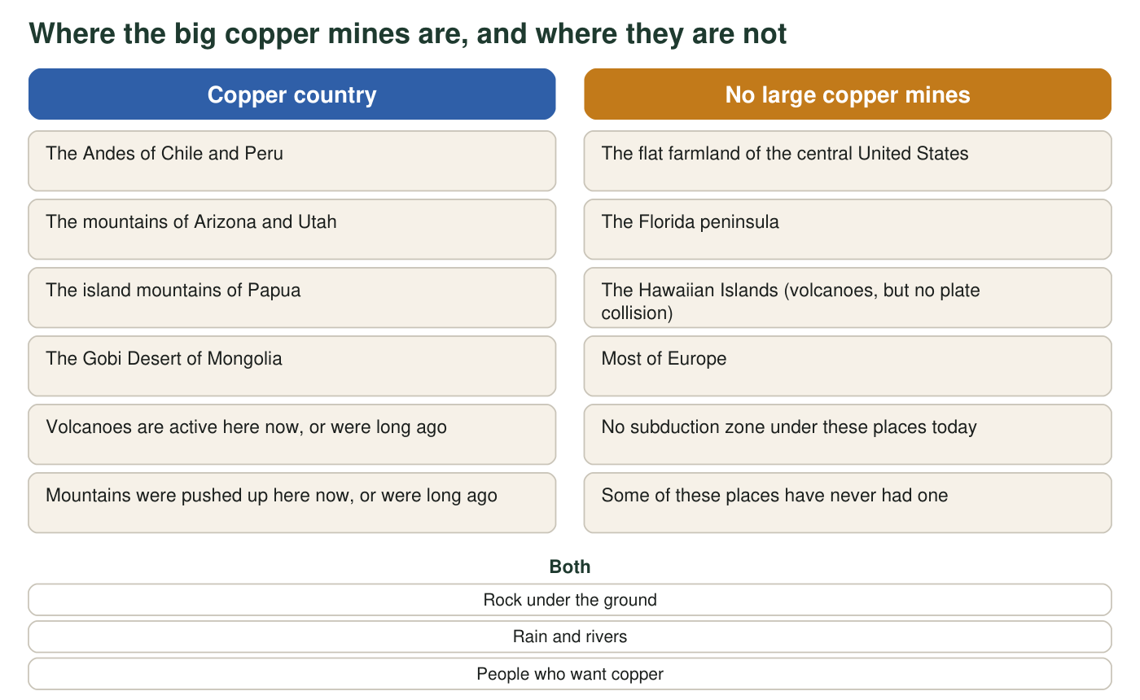
The pattern in one picture. Both columns describe real places; the mines in the left column are the ones in the table.

Part A: Notice and wonder
1. Record three things you notice and three things you wonder. A notice must point to something on this page, not to a guess. A wonder must be a question you could investigate.
I notice (something I can point to in the table or figure) | I wonder (a question it raises)
1
2
3

2. Read the last column of the table. What single feature do all seven mines share, even though they are on four different continents?
______________________________________________________________________________________
______________________________________________________________________________________
______________________________________________________________________________________
3. Which statement best describes the pattern in the figure?
○ A. Copper mines are found wherever people need a lot of copper.
○ B. Copper mines are found in deserts.
○ C. Copper mines are found where plates collide today or collided long ago, and are absent where that never happened.
○ D. Copper mines are found on every continent in roughly equal numbers.

Part B: What you already know
4. From earlier lessons on plate tectonics: name two things that happen at a boundary where one plate sinks beneath another.
______________________________________________________________________________________
______________________________________________________________________________________
______________________________________________________________________________________
5. Hawaii has active volcanoes but no copper mines, and it is in the right-hand column of the figure. What is different about Hawaii's volcanoes compared with the volcanoes of the Andes?
______________________________________________________________________________________
______________________________________________________________________________________

Part C: Your first explanation
6. Write a first explanation for why copper ore is found along the crooked line and not in the flat farmland. Use at least two pieces of evidence from this page and at least one idea from Part B. Begin with 'I think copper ore forms where...'
______________________________________________________________________________________
______________________________________________________________________________________
______________________________________________________________________________________
______________________________________________________________________________________
______________________________________________________________________________________
______________________________________________________________________________________
7. Bingham Canyon and Oyu Tolgoi are not near an active plate boundary today, yet they are copper country. What does this tell you about when the copper formed, and what does it suggest about the kind of explanation you need?
______________________________________________________________________________________
______________________________________________________________________________________
______________________________________________________________________________________
8. Write two questions you would need answered before you could be confident in your explanation.
______________________________________________________________________________________
______________________________________________________________________________________
______________________________________________________________________________________

Sentence frames for the first explanation
If the blank page is hard to start, use these frames and fill the gaps: 'All seven mines are located where ______ (from the table).' 'At that kind of plate boundary, ______ happens (from Part B).' 'So I think copper ore forms when ______.' 'That would explain why the farmland has no mines, because ______.' You can also point at the figure: the left column lists what copper country has that the right column lacks.

A second map, a second pattern
Geothermal power plants and hot springs also cluster in a pattern on the world map. Predict, before looking, whether that pattern overlaps the copper line, and explain why it might. Then check your prediction using a map of the world's plate boundaries and a list of countries with geothermal plants (Iceland, New Zealand, Indonesia, the Philippines, Kenya, the United States). Write three sentences: what overlapped, what did not, and one difference between how copper ore and geothermal heat are 'made'.

