Angela's Tools · Chapter 19: Earth's Natural Resources · Worksheet 2 of 10

Nature's Clock and Our Rate: Working With the Resource Words (Teacher answer key)
Learning target: I can use the words renewable, nonrenewable, sustainable, aquifer, ore and the resource names correctly, labeling a resource by how long nature takes to replace it and judging a use by comparing how fast it is used with how fast it is replaced.
Vocabulary in action · about 30 minutes · individual · Standards: MS-ESS3-1 (supports)

Standards connections
MS-ESS3-1 (supports): The PE's clarification says these resources are limited and typically nonrenewable. Students cannot explain that honestly until they can keep two ideas apart: the label, which comes from how long nature takes to replace a resource compared with a human lifetime, and the sustainability of a use, which compares the use rate with the replacement rate. This sheet builds that language.

Answers with reasoning
natural resource: Any material or source of energy that people take from Earth and use, such as water, oil, metal ore, soil, heat from inside Earth or wood.
replenish: To refill or replace. Rain replenishes a lake; weathering and decay replenish soil; nothing replenishes an oil field on a human timescale.
renewable resource: A resource that natural processes replace within about a human lifetime, such as river water or a replanted forest. It can still run short in a place where people use it faster than it is replaced.
nonrenewable resource: A resource that takes far longer than a human lifetime to form, usually thousands to millions of years, so the supply shrinks as people use it.
sustainable: Describes a way of using a resource that leaves enough of it, in good condition, for people in the future: it is used no faster than it is replaced.
groundwater: Water that has soaked into the ground and fills the tiny spaces and cracks in soil and rock.
aquifer: A body of rock or sediment that stores groundwater and lets it flow, so wells can pump it out. Some aquifers refill in months; others hold water that soaked in thousands of years ago.
petroleum: Crude oil: a liquid that formed over millions of years when the buried remains of tiny sea organisms were changed by heat deep underground.
geothermal energy: Energy from the heat inside Earth, used to warm buildings or, where hot water is close to the surface, to make electricity.
ore: Rock that holds enough of a valuable metal or mineral that mining it can pay for itself. The same copper in ordinary rock is not ore.
soil fertility: How well a soil supports plant growth, which depends mostly on the nutrients, organic matter and water it holds.
distribution: Where on Earth a resource is found and how much of it is in each place.

Part A: Two questions for every resource
Picture a bathtub with the tap running and the drain open. The tap is nature refilling a resource; the drain is people using it. The first question is about the tap alone: could nature refill this tub within about a human lifetime? If yes, the resource is renewable; if it would take thousands of years or more, it is nonrenewable. The second question compares the tap with the drain: if the drain is no faster than the tap, the use is sustainable; if the drain is faster, the tub empties and the use is not sustainable, even when the resource is renewable. 'It depends' is allowed when the situation does not tell you enough, but you must say what it depends on.
1. Complete the table. In the first column write renewable or nonrenewable and add nature's refill time in a few words. In the second column write yes, no, or 'it depends on' and finish the sentence.
Answer: Row 1: renewable (the river refills the lake every year); yes, sustainable: a village of 400 uses far less than the river brings. Row 2: nonrenewable (refilling would take thousands of years); no, not sustainable: pumping is ten times the recharge. Row 3: renewable (pine regrows in 25 years, well within a lifetime); yes, sustainable: each cut waits for the regrowth. Row 4: nonrenewable on a human timescale (600 years to regrow); no, not sustainable: a clear-cut removes in one season what took six centuries. Row 5: nonrenewable (30 million years to form); no, not sustainable: 60 years of mining removes ore that nature will not replace. Row 6: renewable (heat keeps flowing up from Earth's interior and the water is returned); it depends on whether the plant pumps hot water faster than the rock reheats it: with reinjection at a matched rate, yes.
Reasoning: Column 1 is decided by nature's refill time alone, compared with a human lifetime; column 2 compares the use rate with the replacement rate. Rows 1 and 3 show renewable resources used sustainably. Row 6 rewards 'it depends' in column 2 only: geothermal energy stays renewable, but one field can be drawn down if pumping outruns reheating. A student who labels row 2 nonrenewable 'because it is running out' has the right label for the wrong reason; look for the refill-time words.
Also acceptable: For row 1, accept 'it depends on how big the lake is' in column 2 only if the student also notes that 400 people is a small use; the intended answer is yes. For row 6, accept 'yes' in column 2 if the student says the water is returned and pumping is matched to reheating.
Full credit must include:
• Column 1 labels follow from nature's refill time compared with a human lifetime
• Column 2 judgments follow from comparing the use rate with the replacement rate
• Row 6 is renewable in column 1 and 'it depends on the pumping rate' (or yes, because the water is returned at a matched rate) in column 2
2. Rows 3 and 4 are both about wood. Using the word replenish, explain why one forest is renewable and the other is not, then say whether each harvest is sustainable.
Answer: The pine plantation is replenished in about 25 years, well within a human lifetime, so it is renewable, and because each cut waits for the regrowth, the harvest is sustainable. The 600-year forest would take far longer than a human lifetime to replenish, so on a human timescale it is nonrenewable, and clear-cutting it in one season is not sustainable. Same material, wood; different regrowth times, so different labels.
Reasoning: This targets the misconception that renewability belongs to a species. The regrowth time compared with a human lifetime decides the label; the harvest rate compared with regrowth decides whether the cutting is sustainable.
Also acceptable: Accept an answer that says taking only a few old trees at a time, no faster than they regrow, would be a sustainable use; the old forest itself is still nonrenewable on a human timescale.
Full credit must include:
• Uses 'replenish' or a form of it
• Labels each forest by its regrowth time compared with a human lifetime
• Judges each harvest as sustainable or not by comparing cutting with regrowth
• Concludes that the label depends on the forest's regrowth time, not on 'wood'

Part B: Complete the concept map
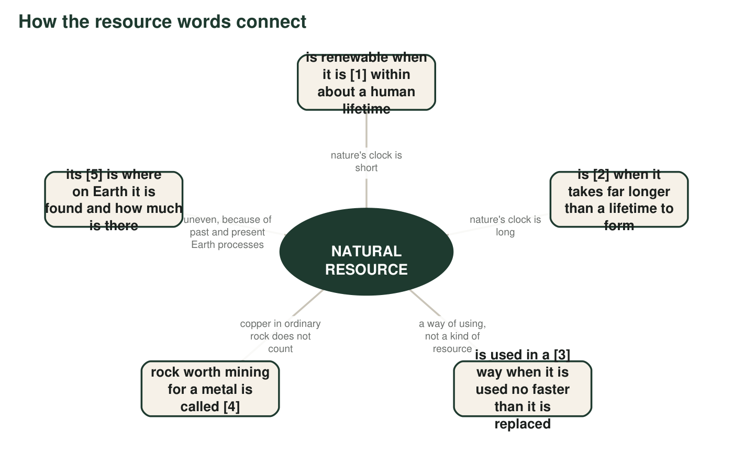
Five boxes are missing a word. Every missing word is in the word bank. The hub is filled in.
3. Write the five missing words in order: [1] ______ [2] ______ [3] ______ [4] ______ [5] ______
Answer: [1] replenished [2] nonrenewable [3] sustainable [4] ore [5] distribution
Reasoning: Each blank is cued by the definition language in the word bank. The map keeps the label (spokes 1 and 2, nature's clock) separate from 'sustainable' as a way of using (spoke 3).
Also acceptable: Accept 'replaced', 'refilled' or 'regrown' for [1].

Part C: Which term fits?
4. A layer of cracked sandstone 80 meters down holds water that a town's wells pump out. The sandstone layer is an ______.
Answer: aquifer
Reasoning: A rock layer that stores groundwater and lets wells pump it is the definition of an aquifer.
Also acceptable: None.
5. A rock contains 1 percent copper, and a mining company can make money removing it. The rock is called ______.
Answer: ore
Reasoning: Rock with enough metal to be mined at a profit is ore; the 1 percent figure is a realistic copper grade.
Also acceptable: Accept 'copper ore'.
6. In Iceland, water heated by hot rock below the surface warms most of the homes in the capital city. The source of that heat is called ______.
Answer: geothermal energy
Reasoning: Heat from Earth's interior carried by hot water is geothermal energy; direct heating of buildings is one of its two main uses.
Also acceptable: Accept 'geothermal'.
7. A farming community plants cover crops and rotates fields so that the soil keeps its nutrients for the next generation. This way of farming is ______.
Answer: sustainable
Reasoning: A practice that keeps the resource available for the next generation is sustainable by definition.
Also acceptable: None.
8. A dark liquid pumped from 2 kilometers underground is refined into gasoline and plastic. The liquid is ______.
Answer: petroleum
Reasoning: Crude oil refined into gasoline and plastics is petroleum.
Also acceptable: Accept 'oil' or 'crude oil'.

Part D: Use the words to say something true
9. A classmate says, 'Geothermal energy is unlimited, so we can never use too much of it.' Using the words renewable and sustainable, write a more accurate statement. (Hint: the heat deep inside Earth is vast, but a geothermal plant uses hot water from one patch of rock.)
Answer: Model: 'Geothermal energy is renewable because heat keeps flowing up from inside Earth and water keeps seeping back into the rock, but a geothermal plant draws hot water from one small area. If it pumps hot water out faster than the rock can reheat new water, that field cools and is not being used sustainably. Renewable does not mean we can use it as fast as we like.'
Reasoning: The textbook describes Earth's interior heat as inexhaustible; students should learn that the heat supply is vast while any one geothermal reservoir can be overdrawn. Both target words must be used correctly.
Also acceptable: A student who writes that reinjection is what keeps the use sustainable has the idea.
Full credit must include:
• Uses 'renewable' to describe the continuing supply of heat and water
• Uses 'sustainable' to describe the rate of use at one plant
• Corrects 'unlimited' or 'never too much'
10. Explain how groundwater can be a renewable resource in one town and a nonrenewable resource in another. Use aquifer and replenish.
Answer: In a town where rain and snowmelt soak into a shallow aquifer every year, nature replenishes the aquifer within a few years, well inside a human lifetime, so its groundwater is renewable (and pumping it is sustainable as long as the wells take no more than the yearly recharge). In a dry town whose aquifer is deep, or holds water that soaked in thousands of years ago, hardly any new water replenishes it, so refilling would take far longer than a lifetime and the groundwater there is nonrenewable. Same resource, different replenishing time, so different labels.
Reasoning: This is the accurate version of the textbook's 'most groundwater is nonrenewable': the label depends on how long the particular aquifer takes to refill. How fast a town pumps does not change the label; it decides whether the use is sustainable.
Also acceptable: An answer that contrasts only pumping rates (one aquifer, a small town and a big city) describes sustainable and unsustainable use, not renewable and nonrenewable water; give partial credit and ask what would make the water itself nonrenewable.
Full credit must include:
• Uses 'aquifer' and 'replenish'
• Describes a fast-refilling case and a slow-refilling case
• Concludes that each aquifer's refill time, compared with a human lifetime, decides the label
11. Write three sentences about copper that use all of these words correctly: ore, nonrenewable, distribution.
Answer: Model: 'Copper ore is rock that contains enough copper to be worth mining, and it forms over millions of years from hot fluids released by magma at plate boundaries. Because it takes millions of years to form, far longer than a human lifetime, copper ore is a nonrenewable resource. Its distribution is uneven: large deposits lie along present and past subduction zones such as the Andes, and almost none lie under the flat farmland of the central United States.'
Reasoning: Each word must be used in a way that shows its meaning: ore as mineable rock, nonrenewable as a formation time far beyond a human lifetime, distribution as where and how much.
Also acceptable: A student may use the words in any order or in fewer than three sentences if all three are used correctly.
Full credit must include:
• 'Ore' used as rock worth mining
• 'Nonrenewable' tied to a formation time far longer than a human lifetime
• 'Distribution' used to describe where copper is and is not found
• All three sentences scientifically accurate

Teacher notes
The definitions in the word bank are deliberately more careful than the textbook's. The book defines renewable partly by a 'such great supply' clause and calls Earth's interior heat inexhaustible; here, as in chapter.json and the slides, renewable means nature replaces the resource within about a human lifetime, and sustainable is a separate comparison of the use rate with the replacement rate, so an overused lake is still renewable but its use is unsustainable. Row 6 of q1 and q9 are where that matters. The book also says 'most groundwater is nonrenewable'; q10 asks for the accurate version. Collect q1 and q9 as a quick check before W5 and W7, which both depend on keeping the two questions apart.

