Angela's Tools · Chapter 19: Earth's Natural Resources · Worksheet 2 of 10

Nature's Clock and Our Rate: Working With the Resource Words
Learning target: I can use the words renewable, nonrenewable, sustainable, aquifer, ore and the resource names correctly, labeling a resource by how long nature takes to replace it and judging a use by comparing how fast it is used with how fast it is replaced.
Vocabulary in action · about 30 minutes · individual · Standards: MS-ESS3-1 (supports)
Name: ____________________________ Date: ____________ Period: ______

Directions
Start with the word bank and read every definition once. Part A asks you to apply the most important idea on this page: every resource gets two separate questions. First, how long does nature take to replace it, compared with a human lifetime? That decides renewable or nonrenewable. Second, are people using it faster than nature replaces it? That decides whether the use is sustainable. Parts B and C check that you can tell the words apart. Part D asks you to use the words to say something true about the world. Write in complete sentences wherever a line is given.
natural resource: Any material or source of energy that people take from Earth and use, such as water, oil, metal ore, soil, heat from inside Earth or wood.
replenish: To refill or replace. Rain replenishes a lake; weathering and decay replenish soil; nothing replenishes an oil field on a human timescale.
renewable resource: A resource that natural processes replace within about a human lifetime, such as river water or a replanted forest. It can still run short in a place where people use it faster than it is replaced.
nonrenewable resource: A resource that takes far longer than a human lifetime to form, usually thousands to millions of years, so the supply shrinks as people use it.
sustainable: Describes a way of using a resource that leaves enough of it, in good condition, for people in the future: it is used no faster than it is replaced.
groundwater: Water that has soaked into the ground and fills the tiny spaces and cracks in soil and rock.
aquifer: A body of rock or sediment that stores groundwater and lets it flow, so wells can pump it out. Some aquifers refill in months; others hold water that soaked in thousands of years ago.
petroleum: Crude oil: a liquid that formed over millions of years when the buried remains of tiny sea organisms were changed by heat deep underground.
geothermal energy: Energy from the heat inside Earth, used to warm buildings or, where hot water is close to the surface, to make electricity.
ore: Rock that holds enough of a valuable metal or mineral that mining it can pay for itself. The same copper in ordinary rock is not ore.
soil fertility: How well a soil supports plant growth, which depends mostly on the nutrients, organic matter and water it holds.
distribution: Where on Earth a resource is found and how much of it is in each place.

Part A: Two questions for every resource
Picture a bathtub with the tap running and the drain open. The tap is nature refilling a resource; the drain is people using it. The first question is about the tap alone: could nature refill this tub within about a human lifetime? If yes, the resource is renewable; if it would take thousands of years or more, it is nonrenewable. The second question compares the tap with the drain: if the drain is no faster than the tap, the use is sustainable; if the drain is faster, the tub empties and the use is not sustainable, even when the resource is renewable. 'It depends' is allowed when the situation does not tell you enough, but you must say what it depends on.
1. Complete the table. In the first column write renewable or nonrenewable and add nature's refill time in a few words. In the second column write yes, no, or 'it depends on' and finish the sentence.
Renewable or nonrenewable? (nature's refill time compared with a human lifetime) | Is this use sustainable? (yes / no / it depends on...)
A lake fed by a mountain river supplies a village of 400 people.
A city pumps a deep desert aquifer, filled by rain thousands of years ago, ten times faster than rain refills it today.
A pine plantation is cut every 25 years and replanted the same year.
A forest of trees that took 600 years to grow is clear-cut.
A copper deposit that formed 30 million years ago is mined for 60 years.
A geothermal plant pumps hot water out and injects the cooled water back into the same rock.

2. Rows 3 and 4 are both about wood. Using the word replenish, explain why one forest is renewable and the other is not, then say whether each harvest is sustainable.
______________________________________________________________________________________
______________________________________________________________________________________
______________________________________________________________________________________

Part B: Complete the concept map
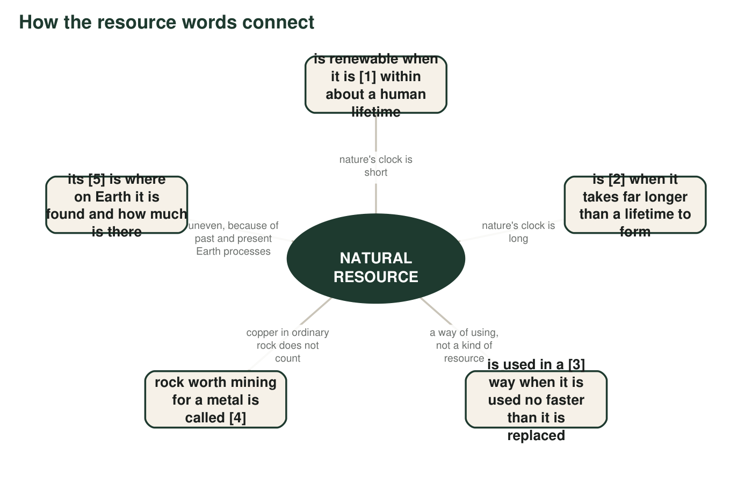
Five boxes are missing a word. Every missing word is in the word bank. The hub is filled in.
3. Write the five missing words in order: [1] ______ [2] ______ [3] ______ [4] ______ [5] ______
______________________________________________________________________________________
______________________________________________________________________________________
______________________________________________________________________________________

Part C: Which term fits?
4. A layer of cracked sandstone 80 meters down holds water that a town's wells pump out. The sandstone layer is an ______.
______________________________________________________________________________________
______________________________________________________________________________________
______________________________________________________________________________________
5. A rock contains 1 percent copper, and a mining company can make money removing it. The rock is called ______.
______________________________________________________________________________________
______________________________________________________________________________________
______________________________________________________________________________________
6. In Iceland, water heated by hot rock below the surface warms most of the homes in the capital city. The source of that heat is called ______.
______________________________________________________________________________________
______________________________________________________________________________________
______________________________________________________________________________________
7. A farming community plants cover crops and rotates fields so that the soil keeps its nutrients for the next generation. This way of farming is ______.
______________________________________________________________________________________
______________________________________________________________________________________
______________________________________________________________________________________
8. A dark liquid pumped from 2 kilometers underground is refined into gasoline and plastic. The liquid is ______.
______________________________________________________________________________________
______________________________________________________________________________________
______________________________________________________________________________________

Part D: Use the words to say something true
9. A classmate says, 'Geothermal energy is unlimited, so we can never use too much of it.' Using the words renewable and sustainable, write a more accurate statement. (Hint: the heat deep inside Earth is vast, but a geothermal plant uses hot water from one patch of rock.)
______________________________________________________________________________________
______________________________________________________________________________________
______________________________________________________________________________________
10. Explain how groundwater can be a renewable resource in one town and a nonrenewable resource in another. Use aquifer and replenish.
______________________________________________________________________________________
______________________________________________________________________________________
______________________________________________________________________________________
11. Write three sentences about copper that use all of these words correctly: ore, nonrenewable, distribution.
______________________________________________________________________________________
______________________________________________________________________________________
______________________________________________________________________________________
______________________________________________________________________________________
______________________________________________________________________________________

Two questions for every row
For Part A, ask the same two questions about every situation. (1) How long does nature take to make more of this? If it is within about a human lifetime (roughly 80 years), write renewable; if it is thousands of years or longer, write nonrenewable. (2) Are these people using it faster than nature replaces it? If not, the use is sustainable; if so, it is not. If the situation does not tell you what you need for a question, write 'it depends on' and name the missing information.

The word that is not on the list
The words limited and nonrenewable are often used as if they meant the same thing. They do not. Fresh surface water is renewable but limited: a river carries only so much each year. Write a short paragraph that uses one example from this lesson to show the difference, then explain why a renewable resource can still run short in a particular place during a particular year. Finish with one sentence on why the word 'limited' matters for how a community plans.

