Angela's Tools · Chapter 19: Earth's Natural Resources · Worksheet 4 of 10

From Magma to Mine, From Mud to Oil: Reading and Building Resource Models (Teacher answer key)
Learning target: I can read a model of how copper ore and petroleum form, use it to explain where each is found, and build my own labeled model of a geothermal system.
Diagrams and models · about 40 minutes · individual · Standards: MS-ESS3-1 (practice)

Standards connections
MS-ESS3-1 (practice): Interpreting the formation flow and the trap layers, then constructing a geothermal cross-section, builds the process models students will cite as evidence when they explain uneven resource distribution in W6 and W10.

Answers with reasoning
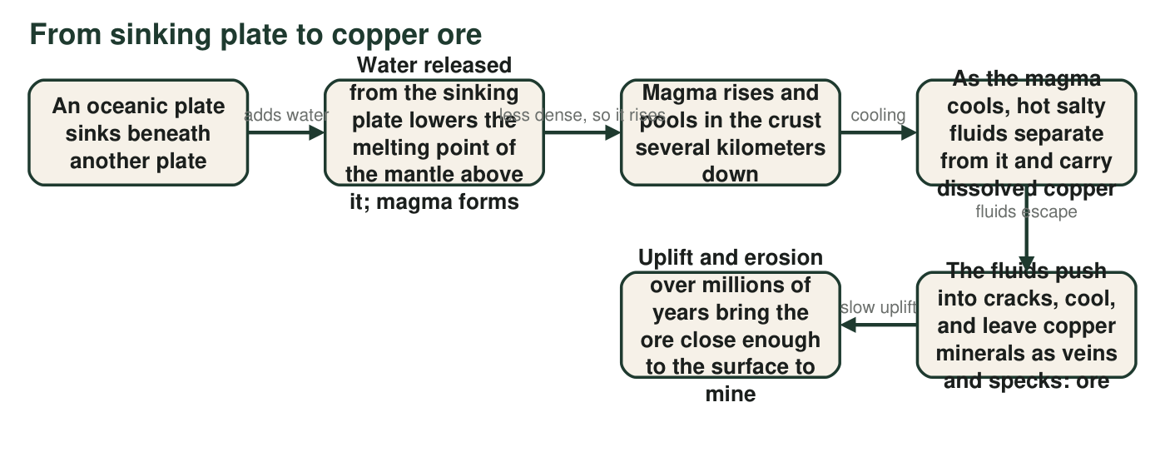
Figure 1. How copper ore forms above a subduction zone. Read left to right. The whole chain takes millions of years; the last step can take tens of millions more.
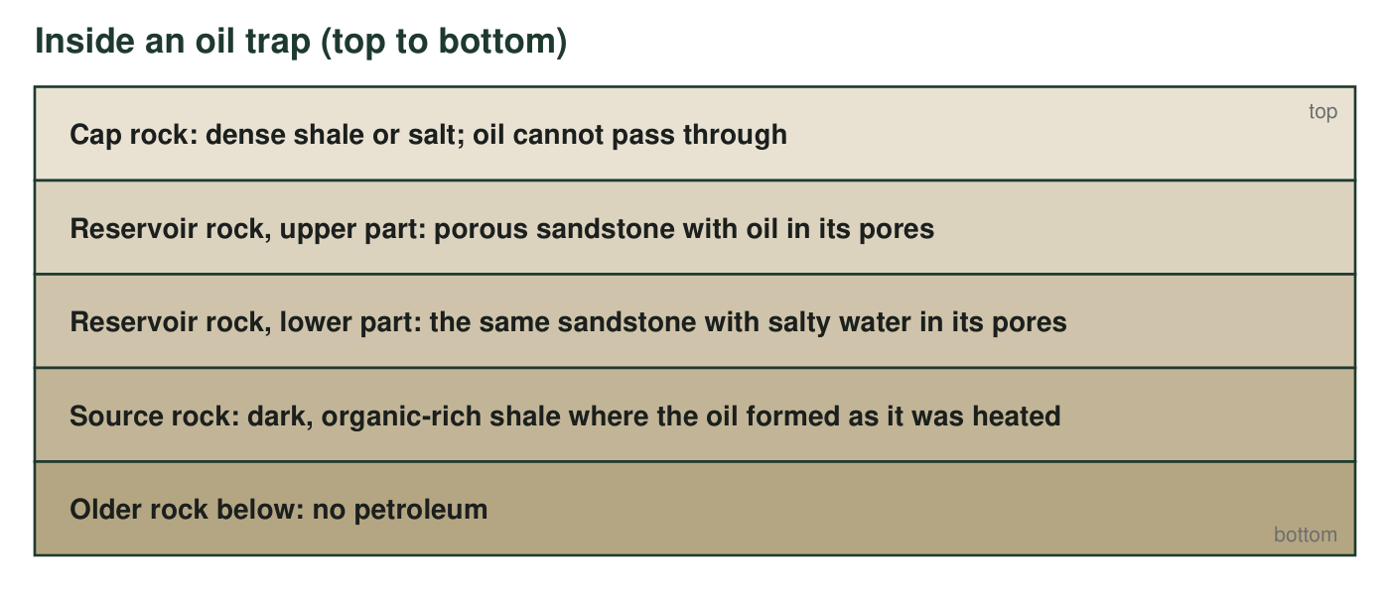
Figure 2. A petroleum trap, drawn from the top down. Imagine the whole stack folded gently into an arch, so the oil gathers under the crest of the cap rock.

Part A: Read the models
1. Which step in Figure 1 is the reason copper mines cluster near plate boundaries? Explain how that step connects the boundary to the ore.
Answer: The second step, in which water from the sinking plate causes the mantle to melt and form magma. The magma rises only above a subduction zone, and it is the cooling magma that releases the copper-carrying fluids, so ore can form only where a plate is sinking (or was sinking in the past).
Reasoning: Students may also name the first step (the sinking plate); the point is that magma forms above subduction zones and the rest of the chain follows from the magma.
Also acceptable: Accept step 4 (fluids carrying copper) if the student explains the fluids come from subduction-zone magma.
Full credit must include:
• Names the melting/magma step (or the sinking plate step)
• Explains that the magma, and so the fluids and ore, exist only above a subduction zone
2. Name the two steps in Figure 1 that are slowest, and explain why copper ore is therefore nonrenewable even though new ore is forming somewhere on Earth right now.
Answer: Slowest steps: the sinking of the plate and the melting that follows, which happen at the speed plates move (centimeters per year), and the final uplift and erosion that bring the ore within reach, which takes millions to tens of millions of years. Because a deposit takes millions of years to form and expose, far longer than a human lifetime, copper ore is nonrenewable even though the process never stops; a mine that empties a deposit in decades removes ore that will not be replaced on any human timescale.
Reasoning: This applies the chapter's definition from W2 (nature's replacement time compared with a human lifetime) to the flow model. The caption gives the time scales.
Also acceptable: Accept 'magma cooling' as one of the slow steps; large bodies of magma take hundreds of thousands of years to cool.
Full credit must include:
• Names two slow steps
• Gives formation times of millions of years and compares them with a human lifetime (or with decades of mining)
• Concludes nonrenewable because replacement takes far longer than a lifetime
3. In Figure 2, which layer keeps the oil from rising all the way to the surface?
Answer: B. The cap rock, because oil cannot pass through it.
Reasoning: The cap rock is the impermeable seal. The source rock is below the oil, not above it; the water-filled reservoir and older rock are also below.
Also acceptable: None.
4. In Figure 2 the oil sits above the water inside the same sandstone layer. What property of oil explains this, and what does the same property tell you about which direction oil moves after it forms in the source rock?
Answer: Oil is less dense than water, so it floats above the water inside the pores of the sandstone. The same property means that after oil forms in the source rock it moves upward through any porous rock, until the cap rock stops it.
Reasoning: Density explains both the layering in the trap and the direction of migration.
Also acceptable: Accept 'oil is lighter than water' with the upward-movement conclusion.
Full credit must include:
• Names lower density (or 'oil floats')
• Concludes that oil migrates upward
5. Predict: if a region has source rock and reservoir rock but the cap rock was eroded away long ago, what would a geologist expect to find there today, and why?
Answer: The geologist would expect no oil field, or only traces: with no cap rock, the oil that formed rose through the reservoir rock all the way to the surface and escaped, leaving seeps or tar, or it was broken down by bacteria and weathering at the surface. Oil might still be forming in the source rock, but nothing holds it.
Reasoning: Extends the trap model to a missing-piece case; connects to the La Brea example from W3.
Also acceptable: Accept 'tar at the surface' as the prediction.
Full credit must include:
• Predicts little or no trapped oil
• Explains that oil escaped upward without a seal
• May mention surface seeps or tar
6. Complete the comparison table using the two figures. The last column must name the kind of place and the reason, not just a country.
Answer: Copper ore: hot salty fluids from cooling magma above a subduction zone carried copper into cracks where it crystallized; millions of years to form plus millions more to be uplifted; found near present or past convergent plate boundaries (the Andes, the mountains of the western United States) because that is where such magma rises. Petroleum: remains of tiny sea organisms were buried in an oxygen-poor sea, heated at 2 to 4 km for millions of years, then moved up into reservoir rock and were held by a cap rock; millions of years; found where ancient shallow seas were later buried and gently folded into traps (Persian Gulf region, Gulf of Mexico), because that is the only place the whole chain can happen.
Reasoning: The last column must name the kind of place and the reason; a country name alone does not show understanding.
Also acceptable: Accept 'tens of millions of years' for either.
Full credit must include:
• Each process sentence names the key agent (magma fluids; buried heated sea life)
• Time scales of millions of years for both
• Place described as a kind of setting with a reason

Part B: Build a model of a geothermal system
In a flash-steam geothermal plant, a production well is drilled down to rock that is hot because it sits above a region of magma or very hot rock, usually near a plate boundary. Groundwater in that rock is far hotter than boiling, but it stays liquid because of the pressure deep underground. The well brings the hot water up; at the surface the pressure drops and part of the water flashes into steam. The steam spins a turbine that turns a generator. The steam is then cooled back into water, and an injection well sends it back down into the same hot rock, where it is heated again. Earth's interior heat keeps flowing upward into the rock, and surface water keeps seeping down, so the cycle can continue for decades if the plant does not pump faster than the rock reheats the water.
Draw a cross-section (a side view, like a slice of cake) of a geothermal power plant and the rock beneath it. Your model must show and label: (1) hot rock or magma at depth, (2) the aquifer of hot groundwater above it, (3) the production well, (4) where the water flashes to steam, (5) the turbine and generator, (6) the injection well, and (7) at least two arrows: one showing heat flowing up from Earth's interior and one showing water moving around the loop. Add a one-line title that names the plate setting where such a plant can be built.
Expected drawing: A side-view cross-section with (from bottom) magma or very hot rock, a labeled hot aquifer above it, ordinary rock, the ground surface and a plant box; a production well descending into the hot aquifer; a point at the top of the production well or inside the plant labeled 'pressure drops, water flashes to steam'; turbine and generator inside the plant; an injection well returning cooled water to the aquifer; a red arrow rising from the magma labeled 'heat from Earth's interior' and a loop of blue arrows showing water up the production well, through the plant and down the injection well. Title names a plate boundary setting (for example 'Built above a divergent or convergent boundary where magma is close to the surface').
Reasoning: Check all seven required labels and the title. The key science is that heat flows up continuously while water circulates in a loop, which is why geothermal energy is renewable, and why a plant's use of it stays sustainable only when the pumping rate is matched to reheating.

Part C: Use your model
7. Iceland and the Geysers area of northern California both have large geothermal plants; Florida has none. Use your model to explain why: what does the rock under Iceland and the Geysers have that the rock under Florida lacks?
Answer: Under Iceland and the Geysers, magma or very hot rock lies close to the surface because they sit at or near plate boundaries (Iceland on the divergent Mid-Atlantic Ridge; the Geysers near the boundary zone of the western edge of North America), so groundwater there is heated to hundreds of degrees at shallow depth. Florida sits on a stable, thick stack of limestone far from any plate boundary; the rock gets warmer with depth only at the ordinary slow rate, so there is no shallow hot aquifer to tap.
Reasoning: The uneven distribution of geothermal energy follows from where hot rock is shallow, which follows from plate setting.
Also acceptable: Accept 'hot rock close to the surface' without naming the boundary type.
Full credit must include:
• Links Iceland and the Geysers to plate boundaries or shallow magma
• Says Florida lacks shallow hot rock because it is far from a boundary
8. Explain why the injection well matters. What would happen to the resource over time if a plant pumped hot water out but sent nothing back and pumped faster than the rock could reheat new water?
Answer: The injection well returns the water so the aquifer stays full and the loop continues. Without it, and with pumping faster than the rock can reheat new water, the aquifer would lose pressure and water, the temperature of the water reaching the plant would fall, and the plant's output would drop: the plant would be using the field faster than it is replenished, which is unsustainable use, even though geothermal energy is still renewable and Earth's interior heat is still there.
Reasoning: This is the accurate version of 'geothermal is inexhaustible': the heat source is vast, but one field can be drawn down. The Geysers itself declined in the 1980s and recovered partly after treated wastewater began to be injected.
Also acceptable: Accept 'the plant would run out of steam' if the student also mentions pumping faster than reheating.
Full credit must include:
• Explains that injection keeps the water and pressure in the aquifer
• Predicts declining water, pressure or temperature without it
• Connects the outcome to sustainability (use faster than replenishment), not to the resource stopping being renewable
9. Figures 1 and 2 and your drawing show three resources that all depend on heat inside Earth. For each resource, say in one sentence what the heat does, and then explain why only one of the three is renewable on a human timescale.
Answer: Copper ore: heat melts the mantle above a sinking plate, and the cooling magma releases the copper-bearing fluids. Petroleum: heat at 2 to 4 km breaks buried organic matter into oil over millions of years. Geothermal: heat warms groundwater in shallow hot rock so it can be pumped up and flashed to steam. Only geothermal energy is renewable on a human timescale, because the heat keeps flowing upward and the water keeps circulating, so nature keeps replacing it, well within a human lifetime; a well-run plant matches its pumping to that rate, so its use is sustainable too. Copper ore and petroleum are products that the heat finished making millions of years ago; using them removes them, and the heat cannot remake them within human lifetimes.
Reasoning: Synthesis across the three models. The distinction is between a continuing flow (heat and water) and a stored product (ore, oil).
Also acceptable: A student who adds that geothermal can be overdrawn locally is giving the most complete answer.
Full credit must include:
• One accurate sentence for the role of heat in each resource
• Identifies geothermal as the renewable one
• Explains the difference as flow versus stored product, or as replacement time compared with a human lifetime

Teacher notes
Figure 1 is the standard porphyry-copper story simplified for grade 7: water from the subducting slab lowers the mantle's melting point, the magma is water-rich, and copper is carried in hot brines that exsolve as the magma cools, then deposited in fractures. Figure 2 is an anticline trap; remind students that the real stack is folded, since the renderer draws flat layers. The geothermal text is accurate for flash-steam plants such as those at the Salton Sea and Coso fields; the Geysers itself is mainly dry steam, which q-drawing's alternatives allow. If students ask whether Florida has geothermal heat at all, say yes, every place does, but it is too deep and too cool there to make electricity; this reinforces that distribution is about where the heat is shallow, not whether it exists.

