Angela's Tools · Chapter 19: Earth's Natural Resources · Worksheet 4 of 10

From Magma to Mine, From Mud to Oil: Reading and Building Resource Models
Learning target: I can read a model of how copper ore and petroleum form, use it to explain where each is found, and build my own labeled model of a geothermal system.
Diagrams and models · about 40 minutes · individual · Standards: MS-ESS3-1 (practice)
Name: ____________________________ Date: ____________ Period: ______

Directions
Study Figure 1 (a flow model) and Figure 2 (a layer model). Every box in Figure 1 is a step; the arrows say what each step leads to. Answer Part A using the figures as your evidence. Then, in Part B, build your own model of a third resource, geothermal energy, in the drawing box. Your model must be labeled well enough that a classmate could explain it without you. Finish with the Part C questions.
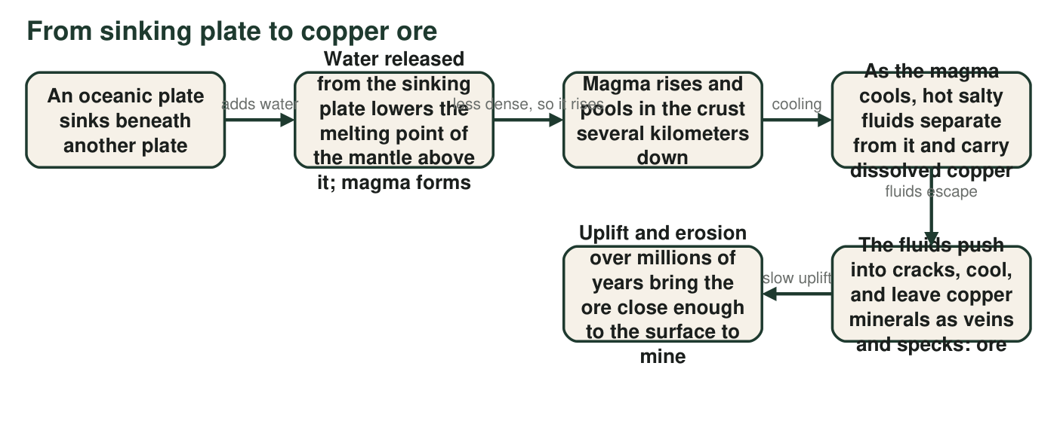
Figure 1. How copper ore forms above a subduction zone. Read left to right. The whole chain takes millions of years; the last step can take tens of millions more.
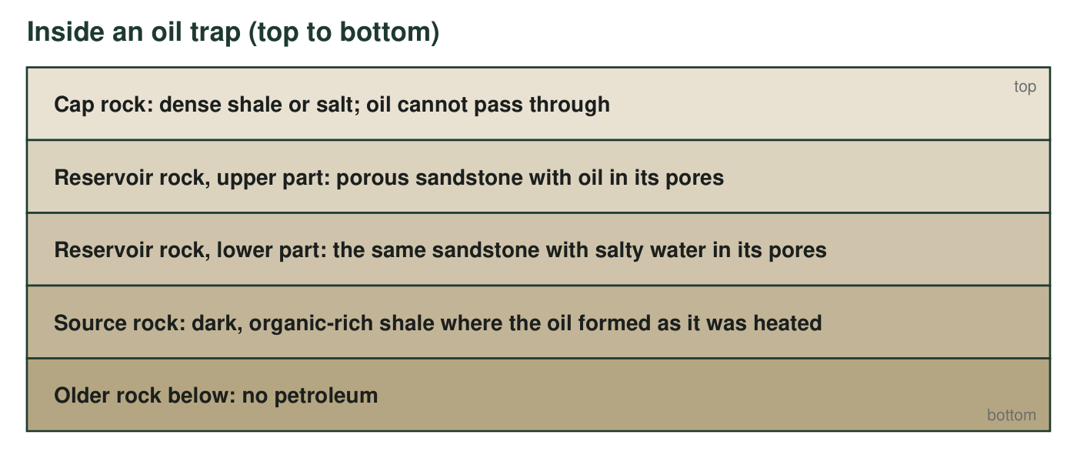
Figure 2. A petroleum trap, drawn from the top down. Imagine the whole stack folded gently into an arch, so the oil gathers under the crest of the cap rock.

Part A: Read the models
1. Which step in Figure 1 is the reason copper mines cluster near plate boundaries? Explain how that step connects the boundary to the ore.
______________________________________________________________________________________
______________________________________________________________________________________
______________________________________________________________________________________
2. Name the two steps in Figure 1 that are slowest, and explain why copper ore is therefore nonrenewable even though new ore is forming somewhere on Earth right now.
______________________________________________________________________________________
______________________________________________________________________________________
______________________________________________________________________________________
3. In Figure 2, which layer keeps the oil from rising all the way to the surface?
○ A. The source rock, because it is where the oil formed
○ B. The cap rock, because oil cannot pass through it
○ C. The lower reservoir rock, because it is full of water
○ D. The older rock below, because it has no petroleum
4. In Figure 2 the oil sits above the water inside the same sandstone layer. What property of oil explains this, and what does the same property tell you about which direction oil moves after it forms in the source rock?
______________________________________________________________________________________
______________________________________________________________________________________
______________________________________________________________________________________
5. Predict: if a region has source rock and reservoir rock but the cap rock was eroded away long ago, what would a geologist expect to find there today, and why?
______________________________________________________________________________________
______________________________________________________________________________________
______________________________________________________________________________________
6. Complete the comparison table using the two figures. The last column must name the kind of place and the reason, not just a country.
Process that made it (one sentence) | How long it took | Where it is found today, and why
Copper ore
Petroleum

Part B: Build a model of a geothermal system
In a flash-steam geothermal plant, a production well is drilled down to rock that is hot because it sits above a region of magma or very hot rock, usually near a plate boundary. Groundwater in that rock is far hotter than boiling, but it stays liquid because of the pressure deep underground. The well brings the hot water up; at the surface the pressure drops and part of the water flashes into steam. The steam spins a turbine that turns a generator. The steam is then cooled back into water, and an injection well sends it back down into the same hot rock, where it is heated again. Earth's interior heat keeps flowing upward into the rock, and surface water keeps seeping down, so the cycle can continue for decades if the plant does not pump faster than the rock reheats the water.
Draw a cross-section (a side view, like a slice of cake) of a geothermal power plant and the rock beneath it. Your model must show and label: (1) hot rock or magma at depth, (2) the aquifer of hot groundwater above it, (3) the production well, (4) where the water flashes to steam, (5) the turbine and generator, (6) the injection well, and (7) at least two arrows: one showing heat flowing up from Earth's interior and one showing water moving around the loop. Add a one-line title that names the plate setting where such a plant can be built.

Part C: Use your model
7. Iceland and the Geysers area of northern California both have large geothermal plants; Florida has none. Use your model to explain why: what does the rock under Iceland and the Geysers have that the rock under Florida lacks?
______________________________________________________________________________________
______________________________________________________________________________________
______________________________________________________________________________________
8. Explain why the injection well matters. What would happen to the resource over time if a plant pumped hot water out but sent nothing back and pumped faster than the rock could reheat new water?
______________________________________________________________________________________
______________________________________________________________________________________
______________________________________________________________________________________
9. Figures 1 and 2 and your drawing show three resources that all depend on heat inside Earth. For each resource, say in one sentence what the heat does, and then explain why only one of the three is renewable on a human timescale.
______________________________________________________________________________________
______________________________________________________________________________________
______________________________________________________________________________________
______________________________________________________________________________________
______________________________________________________________________________________

Draw the rock first, then the pipes
For the drawing, start with four horizontal bands from bottom to top: magma or very hot rock, hot aquifer, ordinary rock, ground surface. Then draw the plant as a small box on the surface and add two vertical pipes from the box down into the hot aquifer; label the left one 'production well' and the right one 'injection well'. Finally add the arrows: a wavy red arrow rising from the magma band, and a loop of blue arrows up the production well, through the plant, and down the injection well. The steam, turbine and generator all live inside the plant box.

Three models, one grade of ore
Figure 1 explains where copper ore is, but not how rich it is. Most copper ore mined today is between 0.4 and 1 percent copper, and the average has fallen for a century because the richest ore was mined first. Add a seventh box to Figure 1 titled 'Humans mine the ore' and write two consequences of that step for the distribution of copper on Earth: one for the rock that stays in the ground and one for where copper ends up above ground. Then explain why recycling is sometimes described as 'mining the city.'

