Angela's Tools · Chapter 20: Resources in Living Systems · Worksheet 1 of 10

The Frog That Lost Its Poison (Teacher answer key)
Learning target: I can observe a phenomenon in which an organism's resources changed, record what I notice and wonder, and write a first explanation that names the resources involved.
Phenomenon exploration · about 25 minutes · individual · Standards: MS-LS2-1 (practice), MS-LS1-5 (supports)

Standards connections
MS-LS2-1 (practice): The phenomenon is a change in an organism caused by a change in the resources it can get (its wild diet). Students begin reasoning about cause and effect between resource availability and organisms, which is the heart of this PE, before they analyze population data later in the chapter.
MS-LS1-5 (supports): An environmental factor (diet) changes a trait of the organism. This is a Grade 6 PE in the California integrated sequence; here it is background that helps students see 'resource' as more than 'enough food.'

Answers with reasoning

The phenomenon: bright, tiny, and (sometimes) deadly
Poison dart frogs live on the floor of rainforests in Central and South America. Many are no longer than a paper clip, and they are painted in warning colors: yellow, orange, blue, and black. Their skin holds chemicals called alkaloids that make the frog bitter and poisonous to anything that tries to eat it. The golden poison frog of Colombia is one of the most toxic animals known; for generations, Emberá hunters rubbed blowgun darts on its skin, which is where the frogs' name comes from.
Here is the strange part. Zoos and hobbyists have bred these frogs for decades. A frog hatched and raised in a terrarium looks exactly like its wild relatives, same colors, same size, same behavior, but it is not poisonous at all. Even stranger: a frog caught in the wild and moved into a terrarium slowly loses its poison. Keepers feed it well, keep it warm and humid, and give it clean water, and still the toxins fade. Nothing about the frog's body seems broken. Something it had in the forest is missing in the glass box.
What researchers have found (real reference facts)
Question | Frogs in the wild | Frogs in captivity
What do they eat? | Mostly tiny arthropods picked off the leaf litter: ants, mites, small beetles, millipedes | Fruit flies, pinhead crickets, springtails raised by the keeper
Do their skin glands hold alkaloids? | Yes, dozens of kinds in some species | Captive-bred frogs: none detected
What happens to a wild-caught frog kept in a terrarium? | (not applicable) | Its alkaloid supply is not replaced and fades over months to years
What happens if captive frogs are fed insects dusted with alkaloids? | (not applicable) | The same alkaloids later show up in their skin

Summarized from published studies of dendrobatid frogs; the feeding experiments were done by chemists studying where the frogs' alkaloids come from.
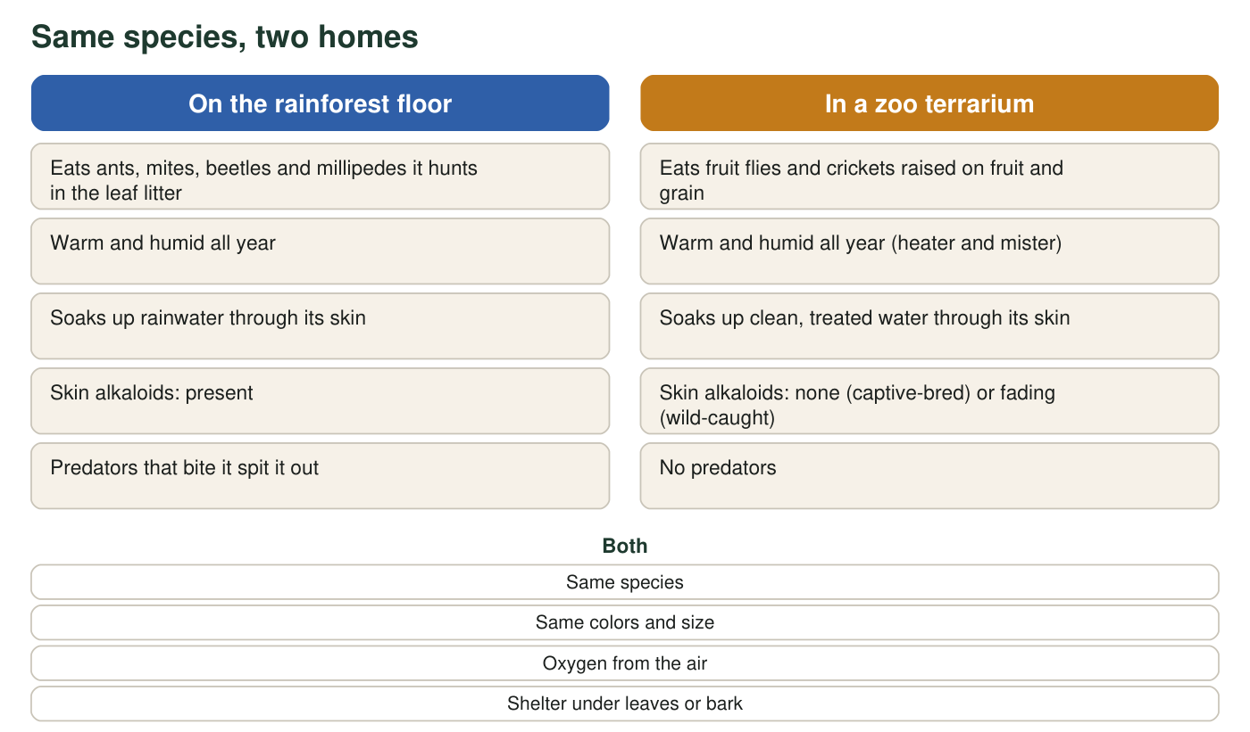
Compare the two columns. Most of what the frog needs is the same in both places.
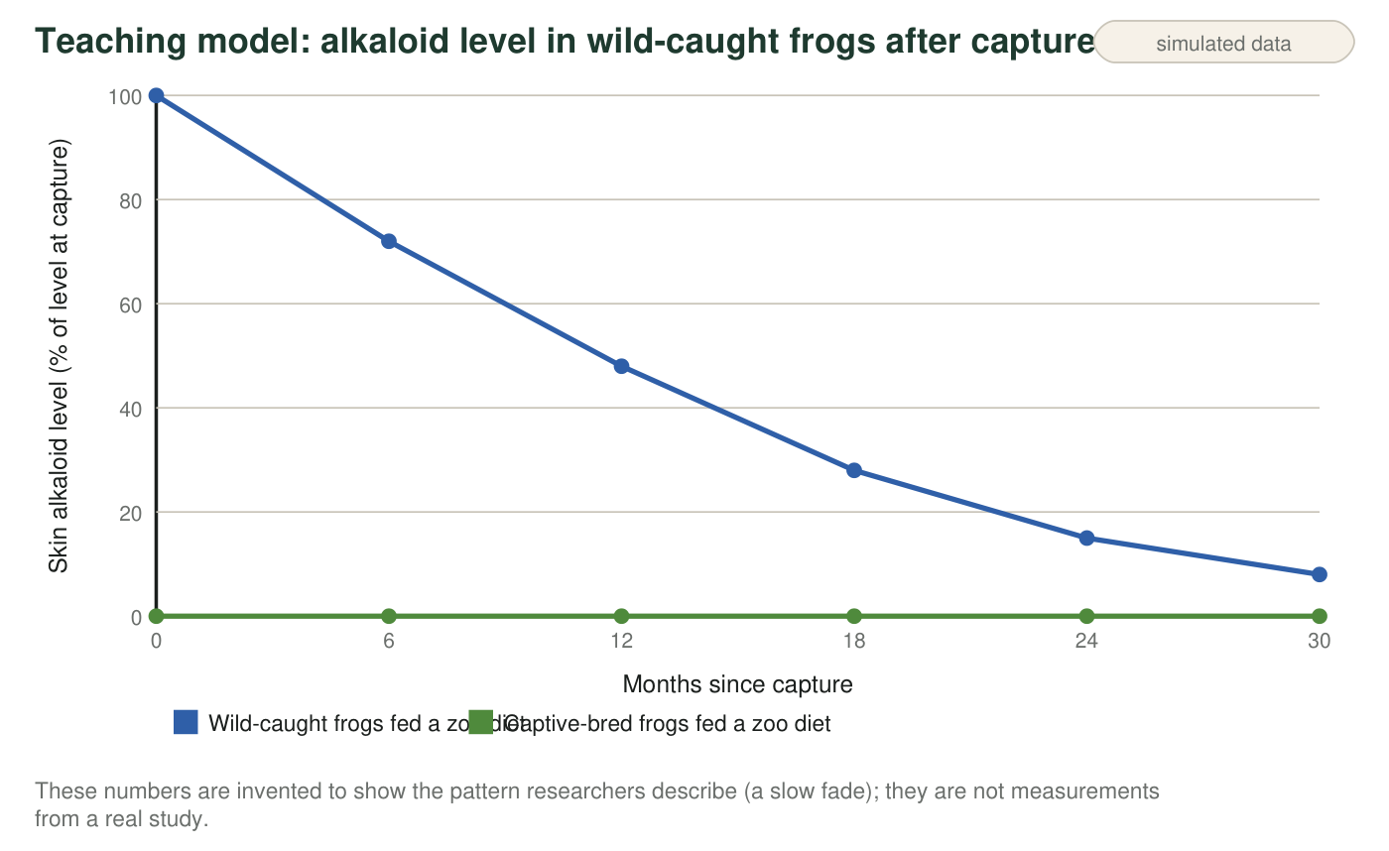

Part A: Notice and wonder
1. Write three things you notice in the text, table and figures. At least one must come from the table and at least one from a figure. Be specific: name the row or the line you are describing.
Answer: Any three accurate observations, for example: the wild diet is ants, mites, beetles and millipedes while the captive diet is fruit flies and crickets (table row 1); captive-bred frogs have no alkaloids at all (table row 2); feeding alkaloid-dusted insects puts alkaloids into the skin (table row 4); in the figure the wild-caught line drops to about 8% by 30 months while the captive-bred line stays at 0; most items in the compare figure are the same in both homes, and the diet row is the clearest difference.
Reasoning: This is a noticing task. Credit any observation that is actually in the materials and is stated specifically (names the row, line or column).
Also acceptable: Observations about the warning colors or the Emberá darts count if they come from the text, but the student still needs one table item and one figure item.
Full credit must include:
• Three observations
• At least one from the table and one from a figure
• Each observation is specific and accurate
2. Write three questions you wonder about. Try to make at least one of them a question that could be answered with an experiment.
Answer: Any three genuine questions. Experiment-ready examples: 'If we feed captive frogs wild ants, will they become poisonous?' 'Does the poison fade faster if the frog is fed only fruit flies?' 'Which arthropod in the wild diet supplies the alkaloids?' Other good questions: 'Why do the colors stay if the poison goes?' 'Do the frogs get sick from the alkaloids?'
Reasoning: Look for at least one question with a measurable outcome and something the experimenter could change.
Also acceptable: Questions about predators ('Do birds learn to avoid the colors?') are fine as the non-experimental questions.
Full credit must include:
• Three questions
• At least one could be tested by changing something and measuring a result

Part B: What do you already think?
3. Which explanation fits all four rows of the table best? Circle one, then write one sentence saying which row convinced you.
Answer: C: The frog cannot make the alkaloids itself; it collects them from the arthropods it eats in the wild and stores them in its skin. The convincing row is the last one: feeding alkaloid-dusted insects makes alkaloids appear in the skin, which only makes sense if the frog's supply comes from food.
Reasoning: A (forgetting) and B (climate) cannot explain row 4, since the terrarium climate and lack of attacks did not change when the diet changed. D is ruled out because captive-bred frogs are the offspring of the same species. Row 2 (captive-bred frogs have none) also supports C.
Also acceptable: Accept row 2 or row 3 as the 'convincing row' if the student explains the link to diet.
4. List five resources a poison dart frog needs to survive, grow and reproduce in the rainforest. Mark each one L if it comes from a living thing or N if it is nonliving.
Answer: Examples: arthropod prey such as ants and mites (L); oxygen from the air (N); water from rain and wet leaves (N); shelter under leaf litter or bark (leaf litter comes from living plants, so L is acceptable, as is N for a rock crevice); space on the forest floor to hunt and call for mates (N); alkaloids inside its prey (L); warmth from the environment is a condition rather than a resource, so do not count it as one of the five.
Reasoning: Students should name materials or energy the frog takes in or uses, and label the source correctly. Temperature is a common wrong entry; it is a condition the frog experiences, not something it uses up.
Also acceptable: Accept 'a mate' as a living resource for reproduction. If a student lists temperature, note that it is a condition and ask for a replacement.
Full credit must include:
• Five items that are materials, energy, space or shelter the frog uses
• Each labeled L or N correctly

Part C: Your first explanation
5. Write your first explanation of the phenomenon in 4-6 sentences. Use the word resource at least once, say what the frog gets in the forest that it does not get in the terrarium, and explain why a wild-caught frog fades slowly instead of losing its poison overnight.
Answer: Model response: In the rainforest the frog eats ants, mites and other tiny arthropods, and those animals contain alkaloids. The frog stores the alkaloids in its skin, so the alkaloids are a resource it gets from its food, not something its body builds. In the terrarium the frog eats fruit flies and crickets, which have no alkaloids, so the frog has no source of poison. A wild-caught frog starts with a stored supply in its skin; that supply is used up or lost little by little and is never replaced, so the poison fades over months instead of disappearing at once. A captive-bred frog never had a supply, so it was never poisonous.
Reasoning: This is a first explanation, so accuracy of every detail is not required, but the resource logic must be there: the chemical comes from food, food differs between the two homes, and the slow fade is a stored supply running down.
Also acceptable: A student who proposes that the frog's body slowly breaks down the alkaloids has given a reasonable mechanism for the fade and earns full credit.
Full credit must include:
• Uses 'resource' correctly
• Names the wild diet as the source of the alkaloids
• Names what the terrarium diet lacks
• Explains the slow fade as a stored supply that is not replaced
6. Which single row of the table is the strongest evidence that the poison comes from the frog's diet rather than from its body? Explain why that row rules out the other ideas in q3.
Answer: Row 4 (feeding alkaloid-dusted insects makes alkaloids appear in captive frogs' skin). It rules out 'forgetting' and 'wrong climate' because nothing about attacks or climate changed, only the food, and the poison came back. It rules out 'different species' because the very same captive frogs became poisonous.
Reasoning: Row 4 is an intervention: one thing (diet) was changed and the effect followed. Rows 2 and 3 are consistent with diet but could also fit other explanations on their own.
Also acceptable: Row 2 with the reasoning 'these frogs have the same body and climate but never ate wild prey' earns most of the credit; push the student to see that row 4 is a direct test.
Full credit must include:
• Chooses row 4 (or argues well for row 2)
• Explains why the other q3 options cannot explain that row
7. Predict: a zoo starts feeding its captive-bred frogs the same kinds of ants and mites they would eat in the forest. What do you expect to happen to the frogs' skin over the next year, and what would you measure to find out?
Answer: Prediction: the frogs' skin should begin to hold alkaloids within months, rising over the year, as long as the ants and mites fed to them are the alkaloid-containing kinds. To find out, measure the amount of alkaloids in a tiny skin sample (or in skin secretions) before the diet change and every few months afterward, and compare with frogs kept on the fruit-fly diet.
Reasoning: The prediction should follow from the diet explanation and name a measurement with a comparison group.
Also acceptable: A student who adds 'only if the right species of ants are used' is showing good caution; not all arthropods carry alkaloids.
Full credit must include:
• Predicts toxins appear or increase
• Names something measurable (alkaloid level in skin)
• Includes a comparison or a before-and-after
8. A keeper says, 'The frogs are fed plenty, so they have all the resources they need.' Using this phenomenon, explain why 'plenty of food' and 'the right resources' are not the same thing.
Answer: The captive frogs get enough energy and grow normally, so in terms of amount of food they have plenty. But a resource is any material or energy an organism needs, and the specific alkaloids in wild prey are a material the frog needs for the chemical defense that protects it from predators in the wild. The zoo diet is plentiful but is missing that particular resource, so 'plenty of food' does not mean 'every needed resource.'
Reasoning: This question sets up the chapter idea that resources are specific, and that a missing resource can change an organism even when others are abundant.
Also acceptable: Accept an answer framed as 'the frogs need the right food, not just a lot of food.'
Full credit must include:
• Distinguishes amount of food from the kinds of materials in it
• Identifies the alkaloid source as the missing resource

Teacher notes
The reference facts are well established: dendrobatid frogs sequester alkaloids from arthropod prey (ants, mites, beetles, millipedes); captive-bred frogs raised on fruit flies and crickets lack skin alkaloids; wild-caught frogs lose them gradually; and feeding experiments in the 1990s showed that frogs given alkaloid-dusted insects accumulate those same alkaloids in their skin. The golden poison frog (Phyllobates terribilis) was used by the Emberá of Colombia to poison blowgun darts. Do not claim the frog is 'the most poisonous animal on Earth'; say 'one of the most toxic known.' The line figure is a teaching model of a slow fade, not published data. Expect many students to choose option A or D in q3; the discussion of row 4 is the key move. Keep students' q5 answers so they can revise them in W10's synthesis.

