Angela's Tools · Chapter 20: Resources in Living Systems · Worksheet 1 of 10

The Frog That Lost Its Poison
Learning target: I can observe a phenomenon in which an organism's resources changed, record what I notice and wonder, and write a first explanation that names the resources involved.
Phenomenon exploration · about 25 minutes · individual · Standards: MS-LS2-1 (practice), MS-LS1-5 (supports)
Name: ____________________________ Date: ____________ Period: ______

Directions
Read the description and study the table and the two figures. Do not look anything up yet. In Part A write what you notice and what you wonder. In Part B use what you already know. In Part C write your best first explanation. It is fine to be unsure; the point is to put your thinking on paper so you can compare it with your thinking at the end of the chapter.

The phenomenon: bright, tiny, and (sometimes) deadly
Poison dart frogs live on the floor of rainforests in Central and South America. Many are no longer than a paper clip, and they are painted in warning colors: yellow, orange, blue, and black. Their skin holds chemicals called alkaloids that make the frog bitter and poisonous to anything that tries to eat it. The golden poison frog of Colombia is one of the most toxic animals known; for generations, Emberá hunters rubbed blowgun darts on its skin, which is where the frogs' name comes from.
Here is the strange part. Zoos and hobbyists have bred these frogs for decades. A frog hatched and raised in a terrarium looks exactly like its wild relatives, same colors, same size, same behavior, but it is not poisonous at all. Even stranger: a frog caught in the wild and moved into a terrarium slowly loses its poison. Keepers feed it well, keep it warm and humid, and give it clean water, and still the toxins fade. Nothing about the frog's body seems broken. Something it had in the forest is missing in the glass box.
What researchers have found (real reference facts)
Question | Frogs in the wild | Frogs in captivity
What do they eat? | Mostly tiny arthropods picked off the leaf litter: ants, mites, small beetles, millipedes | Fruit flies, pinhead crickets, springtails raised by the keeper
Do their skin glands hold alkaloids? | Yes, dozens of kinds in some species | Captive-bred frogs: none detected
What happens to a wild-caught frog kept in a terrarium? | (not applicable) | Its alkaloid supply is not replaced and fades over months to years
What happens if captive frogs are fed insects dusted with alkaloids? | (not applicable) | The same alkaloids later show up in their skin

Summarized from published studies of dendrobatid frogs; the feeding experiments were done by chemists studying where the frogs' alkaloids come from.
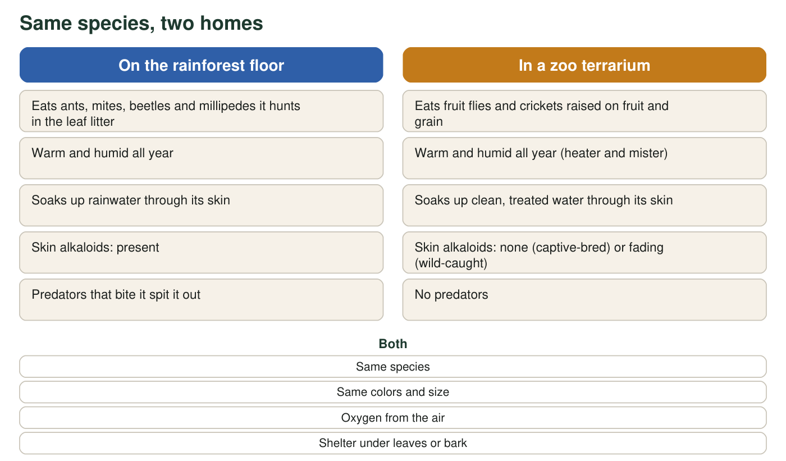
Compare the two columns. Most of what the frog needs is the same in both places.
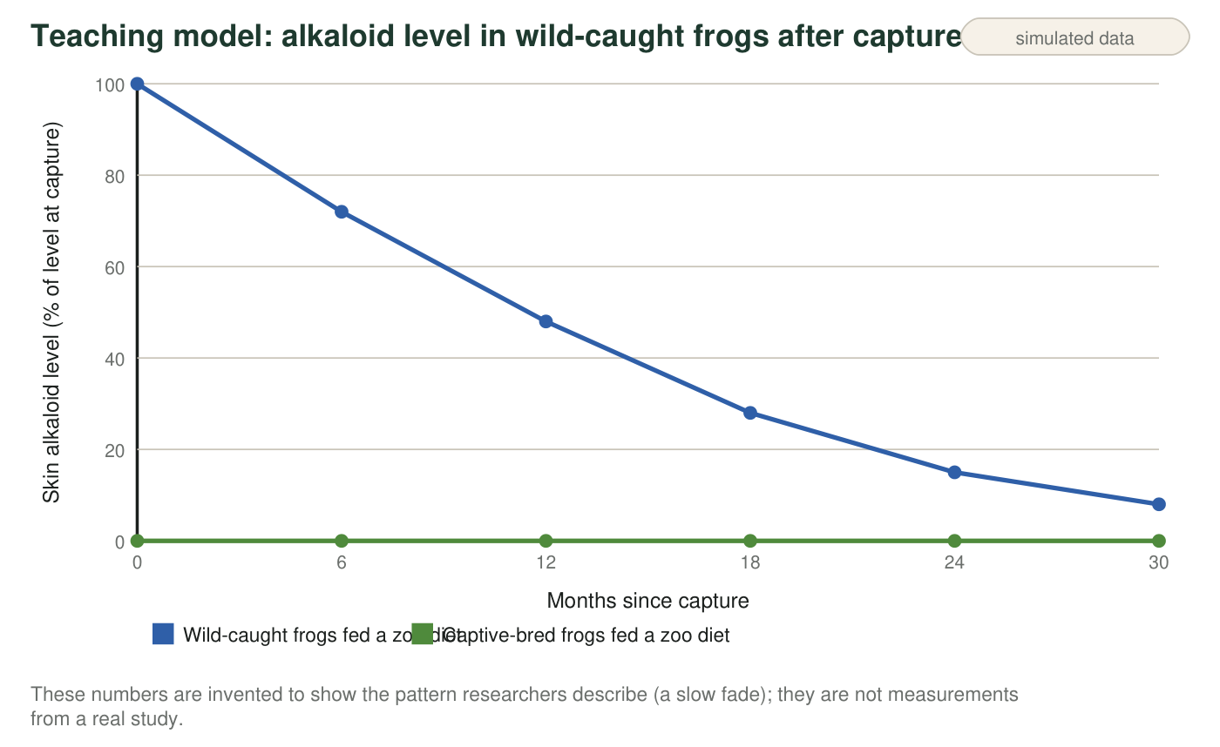

Part A: Notice and wonder
1. Write three things you notice in the text, table and figures. At least one must come from the table and at least one from a figure. Be specific: name the row or the line you are describing.
______________________________________________________________________________________
______________________________________________________________________________________
______________________________________________________________________________________
______________________________________________________________________________________
______________________________________________________________________________________
2. Write three questions you wonder about. Try to make at least one of them a question that could be answered with an experiment.
______________________________________________________________________________________
______________________________________________________________________________________
______________________________________________________________________________________
______________________________________________________________________________________
______________________________________________________________________________________

Part B: What do you already think?
3. Which explanation fits all four rows of the table best? Circle one, then write one sentence saying which row convinced you.
○ A. Captive frogs forget how to make poison because they are never attacked.
○ B. The terrarium is not warm or humid enough for the frog's skin glands to work.
○ C. The frog cannot make the alkaloids itself; it collects them from the arthropods it eats in the wild and stores them in its skin.
○ D. Captive-bred frogs are a different, harmless species that only looks the same.
4. List five resources a poison dart frog needs to survive, grow and reproduce in the rainforest. Mark each one L if it comes from a living thing or N if it is nonliving.
______________________________________________________________________________________
______________________________________________________________________________________
______________________________________________________________________________________
______________________________________________________________________________________

Part C: Your first explanation
5. Write your first explanation of the phenomenon in 4-6 sentences. Use the word resource at least once, say what the frog gets in the forest that it does not get in the terrarium, and explain why a wild-caught frog fades slowly instead of losing its poison overnight.
______________________________________________________________________________________
______________________________________________________________________________________
______________________________________________________________________________________
______________________________________________________________________________________
______________________________________________________________________________________
______________________________________________________________________________________
6. Which single row of the table is the strongest evidence that the poison comes from the frog's diet rather than from its body? Explain why that row rules out the other ideas in q3.
______________________________________________________________________________________
______________________________________________________________________________________
______________________________________________________________________________________
7. Predict: a zoo starts feeding its captive-bred frogs the same kinds of ants and mites they would eat in the forest. What do you expect to happen to the frogs' skin over the next year, and what would you measure to find out?
______________________________________________________________________________________
______________________________________________________________________________________
______________________________________________________________________________________
8. A keeper says, 'The frogs are fed plenty, so they have all the resources they need.' Using this phenomenon, explain why 'plenty of food' and 'the right resources' are not the same thing.
______________________________________________________________________________________
______________________________________________________________________________________
______________________________________________________________________________________

Sentence frames for Part C
If you are not sure how to begin q5, try these frames: 'In the forest the frog gets ______ by eating ______.' 'In the terrarium it eats ______ instead, which does not contain ______.' 'A resource is ______, so ______ counts as a resource because ______.' 'The poison fades slowly because ______.' You do not have to use the frames word for word; replace them with your own sentences once you have the idea.

Another animal that borrows its defense
Monarch butterfly caterpillars eat only milkweed, and milkweed leaves contain bitter chemicals (cardenolides) that the caterpillar stores in its body; birds that bite an adult monarch usually spit it out. Write a paragraph comparing the monarch to the poison dart frog: what resource supplies the defense in each case, what would happen to monarchs raised on a milkweed-free artificial diet, and why a scientist would call both of these 'resource' stories rather than 'genetics' stories.

