Angela's Tools · Chapter 20: Resources in Living Systems · Worksheet 4 of 10

Reading an S-Curve: Two Tubs of Duckweed (Teacher answer key)
Learning target: I can read a population growth curve, identify the phases of growth and the carrying capacity, connect the shape of the curve to a limiting resource, and draw a predicted curve for a new situation.
Diagrams and models · about 35 minutes · individual · Standards: MS-LS2-1 (practice)

Standards connections
MS-LS2-1 (practice): Students interpret a graph of population size under two resource supplies and explain the leveling-off as the effect of a limiting resource. Reading a given curve builds toward analyzing their own data in W5 and the labs.

Answers with reasoning

Part A: Read the graph
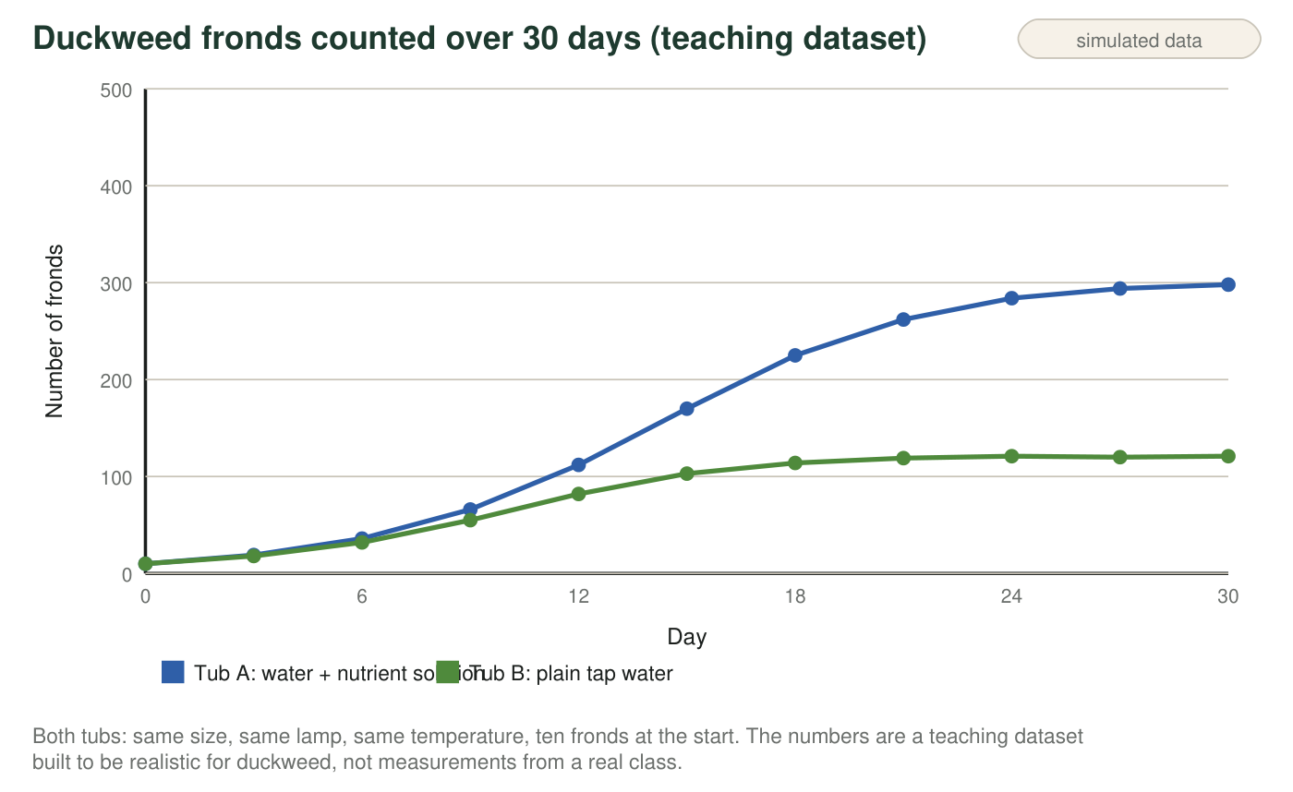
Reading tip
A curve that starts slow, speeds up, then flattens is called an S-curve. Scientists describe it in three phases: a slow start (few plants, so few new plants each day), rapid growth (many plants, each making more, and resources still plentiful), and leveling off (resources per plant are now scarce, so births barely outnumber deaths). The flat height the curve approaches is the carrying capacity for that tub.
1. For the first six days the two curves are almost on top of each other. Explain why the nutrient solution made little difference at first, even though it makes a big difference later.
Answer: With only ten to thirty plants in a whole tub, even plain tap water held enough nutrients for every plant, so nutrients were not yet scarce and both populations grew at nearly the same rate. The nutrient solution only matters once there are enough plants to run short of what plain water supplies.
Reasoning: A resource limits growth only when demand approaches supply; early on, demand is tiny. This is also why the curves separate as the numbers rise.
Also acceptable: Accept 'both tubs had more than enough for a few plants.'
Full credit must include:
• Says nutrients were not scarce at first because there were few plants
• Links the later difference to rising demand
2. Calculate the average number of new fronds per day in Tub A between day 9 and day 15. Show the subtraction and the division.
Answer: Day 15: 170 fronds; day 9: 66 fronds. 170 − 66 = 104 new fronds over 6 days. 104 ÷ 6 ≈ 17.3 new fronds per day.
Reasoning: Change in fronds divided by elapsed days. This is the rapid-growth phase.
Also acceptable: Accept 17 per day.
3. Now calculate the average number of new fronds per day in Tub A between day 24 and day 30. Compare it with your answer to q2 in one sentence.
Answer: Day 30: 298; day 24: 284. 298 − 284 = 14 fronds over 6 days. 14 ÷ 6 ≈ 2.3 new fronds per day. This is less than one seventh of the rate in q2 (about 17 per day): growth has almost stopped.
Reasoning: The contrast between the two rates is the numerical face of 'leveling off.'
Also acceptable: Accept 2 per day; any correct comparison sentence.
4. Complete the table for Tub A by reading the graph: give the day range for each phase and one piece of evidence from the curve.
Answer: Slow start: about day 0-6; the curve rises only from 10 to 36 and is nearly flat. Rapid growth: about day 6-18 (accept 9-18); the curve is steepest, adding about 50 fronds every three days around day 12-15. Leveling off: about day 18-30 (accept 21-30); each three-day gain shrinks (37, 22, 10, 4) and the curve flattens near 300.
Reasoning: Phase boundaries are judgment calls; any range within a few days of these with matching evidence is correct.
Also acceptable: A student who places the rapid phase at 9-21 is reading the steep section reasonably.
Full credit must include:
• Three ranges in the right order and roughly right
• Evidence that cites the curve's steepness or the size of the gains
5. Estimate the carrying capacity of each tub. Write both numbers with the word 'fronds.'
Answer: Tub A: about 300 fronds. Tub B: about 120 fronds.
Reasoning: The flat level each curve approaches; Tub A's last counts are 294 and 298, Tub B's hover at 119-121.
Also acceptable: Accept 295-300 and 118-122.
6. Why did growth in Tub A slow down after day 18, even though the lamp and the temperature never changed?
Answer: B: With hundreds of plants crowded together, the nutrients, light and surface space available to each plant fell, so new fronds were produced about as fast as old ones died.
Reasoning: A contradicts how duckweed reproduces (new fronds are young plants); C is ruled out because temperature was held constant; D is not supported by the smooth curve. B is the limiting-resource explanation.
Also acceptable: None.
7. Tub B leveled off at a much lower number. Name the resource that was most likely limiting in Tub B, and give two pieces of evidence from the graph or the setup that point to it rather than to light or temperature.
Answer: Dissolved nutrients (minerals such as nitrogen and phosphorus compounds). Evidence: (1) the only difference in the setup between the tubs was the nutrient solution, and the lamp and temperature were the same, so light and temperature cannot explain the difference between A and B; (2) Tub B leveled off at about 120 while A reached about 300, roughly in step with the only resource that differed; (3) the two curves matched early on and separated only as numbers rose, which fits a resource being used up rather than a condition that would have acted from day one.
Reasoning: Students should reason from the controlled setup, and the early match is a sophisticated clue.
Also acceptable: Accept 'minerals in the water' or 'plant food' for nutrients.
Full credit must include:
• Names nutrients
• Two pieces of evidence, at least one from the setup and one from the graph

Part B: Build a model for a third tub
The class sets up Tub C: identical to the others, ten fronds at the start, nutrient solution for the first 15 days. On day 15 they pour out the nutrient water and refill the tub with plain tap water, keeping the same plants. They keep counting until day 45.
Draw a graph for Tub C from day 0 to day 45. Label the axes (Day; Number of fronds) with the same scale as the figure (0 to 300 fronds). Lightly copy the Tub A curve up to day 15 so your starting point is right, then draw your predicted curve for days 15 to 45 as a solid line. Mark and label: the day the nutrients were removed, the highest point your curve reaches, and the level it ends up near. Add one sentence under the graph that says what the new carrying capacity is and why.
Expected drawing: A curve that follows Tub A to about 170 fronds at day 15, continues rising briefly (to roughly 180-220 over the next three to six days as plants use nutrients already stored in their tissues), then declines over the following two or three weeks and levels off near Tub B's carrying capacity, about 120 fronds, by day 40-45. Labels: 'nutrients removed' at day 15; the peak; the final level near 120. Sentence: the new carrying capacity is about 120 fronds because the tub now holds only the nutrients that plain tap water supplies, the same as Tub B.
Reasoning: The model should show that removing a resource lowers the carrying capacity and that the population falls toward the new capacity rather than to zero. A curve that drops immediately at day 15 without a brief overshoot is acceptable if the final level is about 120.
8. Explain the shape you drew after day 15. Why might the count keep rising for a few days before it falls, and why does it not fall all the way to zero?
Answer: The count may keep rising for a few days because the plants still hold nutrients absorbed before the change and the fronds already forming will still appear. Then deaths outnumber births and the count falls. It does not fall to zero because plain tap water still supplies enough nutrients for about 120 fronds, as Tub B showed; the population drops toward that lower carrying capacity.
Reasoning: Full credit requires both the brief lag and the non-zero floor explained by Tub B.
Also acceptable: A student who skips the lag but explains the non-zero floor earns most of the credit.
Full credit must include:
• Explains the lag with stored nutrients or fronds already forming
• Explains the floor using Tub B's carrying capacity
9. On day 30, a student scoops half the fronds out of Tub A (leaving about 150) and keeps the nutrient solution the same. Predict what the curve does over the next two weeks and explain why, using the phrase 'resources per plant.'
Answer: The curve drops to about 150 on day 30, then rises again and levels off near 300 within about two weeks. Removing half the plants doubles the resources per plant (the nutrient supply, light and surface space are now shared by 150 instead of 300), so the survivors reproduce quickly, just as in the rapid-growth phase, until the tub is crowded again.
Reasoning: Carrying capacity did not change because the resource supply did not change; only the population was reduced.
Also acceptable: Accept a prediction that it takes somewhat longer than two weeks.
Full credit must include:
• Predicts regrowth back toward about 300
• Uses 'resources per plant' to explain why

Teacher notes
The dataset is simulated and shaped like a logistic curve with carrying capacities of 300 and 120; real duckweed (Lemna) can double in two to three days under good conditions, so the pace is realistic. If students object that duckweed also needs carbon dioxide and light, agree: those were the same in both tubs, so the only resource that differed was dissolved nutrients, which is why it is the limiting one here. The three-phase vocabulary (slow start, rapid growth, leveling off) is informal; the standard terms are lag, exponential and plateau phases, and strong students can be given them. Save the Tub C drawings; Lab 2 (if run) can test this prediction with real duckweed. The extension's doubling times: 19 to 36 takes about 3 days, 36 to 66 about 3 days, 66 to 112 about 3 days, while 170 to 262 takes 6 days and is only a 1.5 times increase, showing the doubling time lengthening as resources per plant fall.

